# Experiment Number: 3rd

|  |  |
| --- | --- |
| **Student Name**: Hemant Sharma | **UID:** 20BCS3600 |
| **Branch:** CSE (Information Security) | **Section & Group**: 20BIS-1/B |
| **Semester:** 5th | **Date**: 23th August 2022 |
| **Course Name**: Network Defence Essential Lab | **Course Code**: 20CSB-331 |

1. **Aim/Overview of the Practical:**

Implement password policy using windows group policy object (GPO).

# Steps for Experiment:

* 1. Firstly, we need to download Group Policy Editor from the browser.
  2. Then, we need to unzip that file and run the file in the command prompt as run as administrator.
  3. Then we have to open the windows tool through the search bar in windows.
  4. And then we have to open Local Security Policy and there we to click on Account Policies.
  5. Then click on Password Policies and then on minimum password length.
  6. Then we can change the minimum password length and then click on apply and ok.
  7. Then we need to create a new user for windows by clicking on add account.
  8. Then we just simply have to enter details and check the password policy.

# Output (Screenshots):

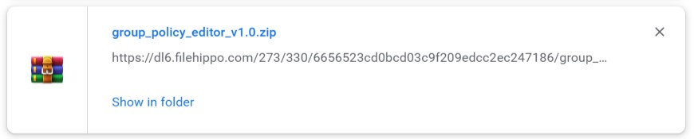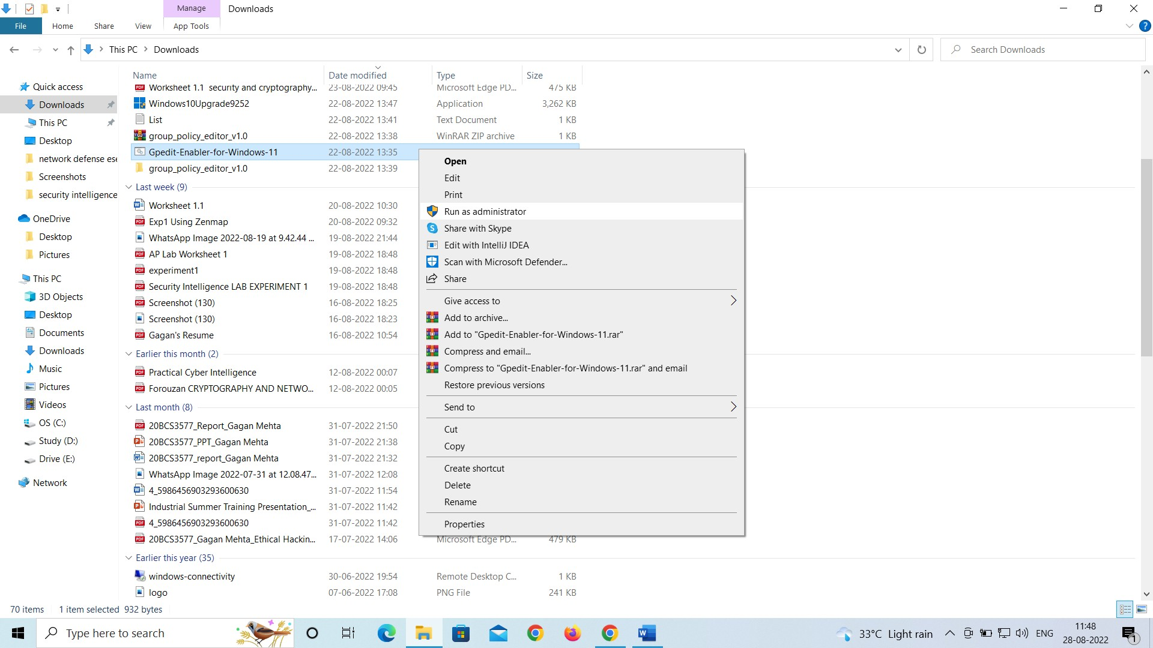

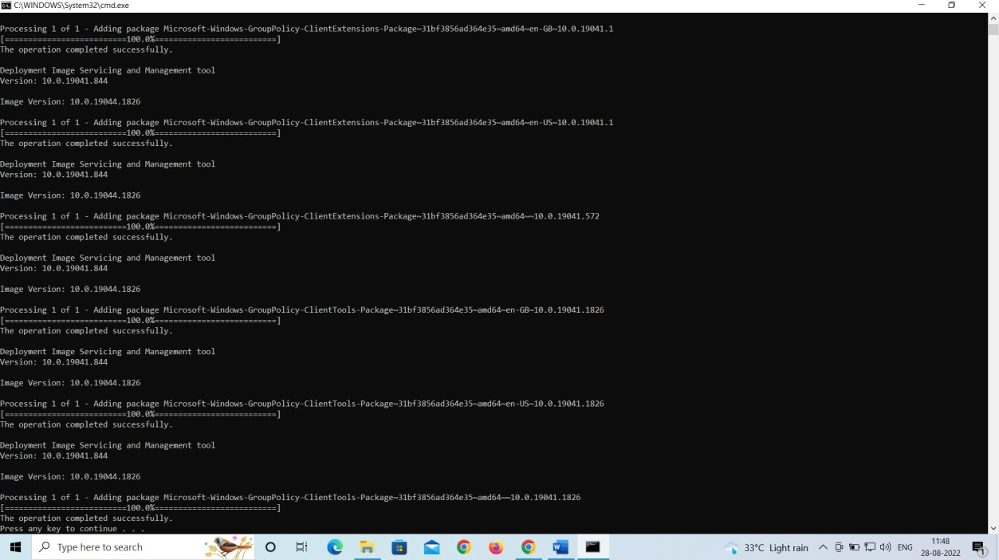

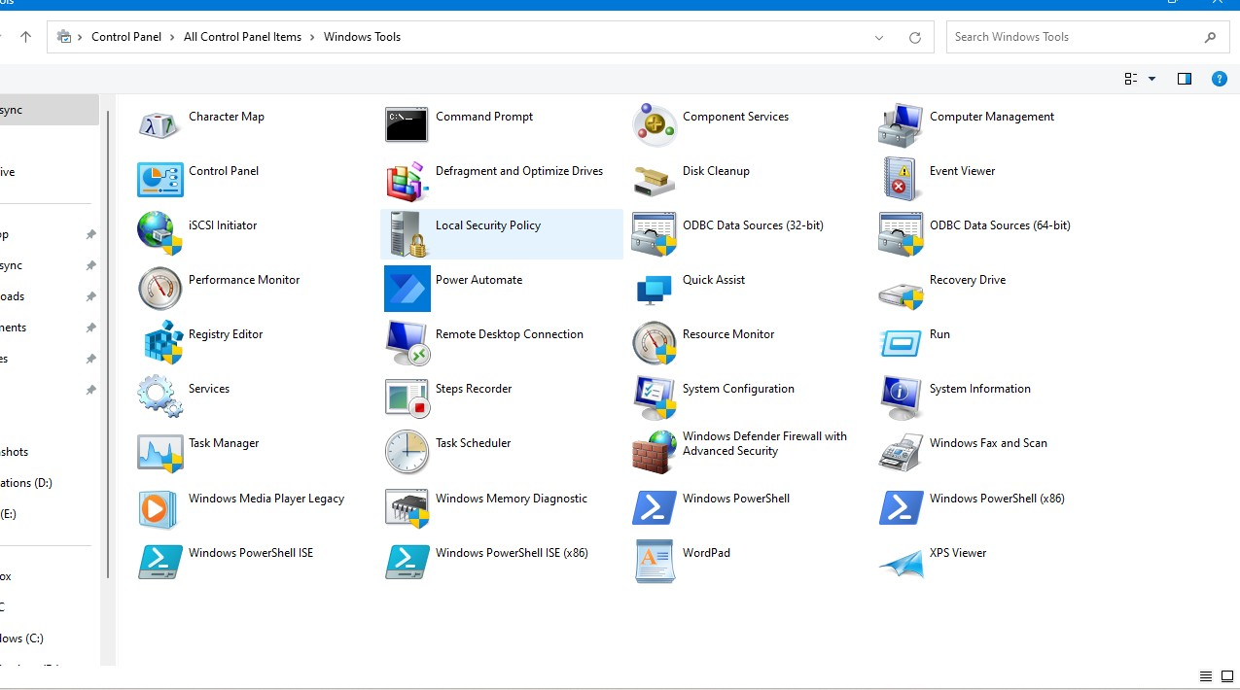

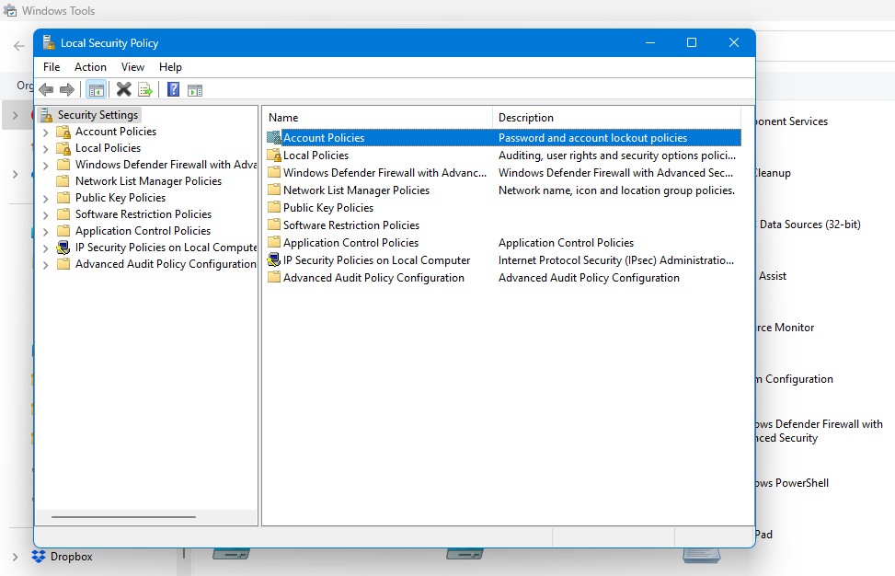

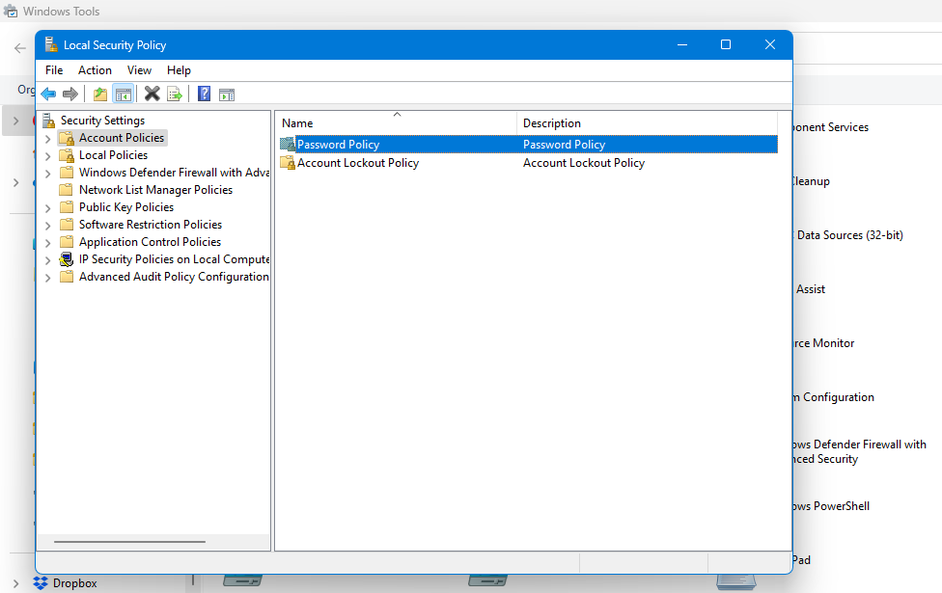

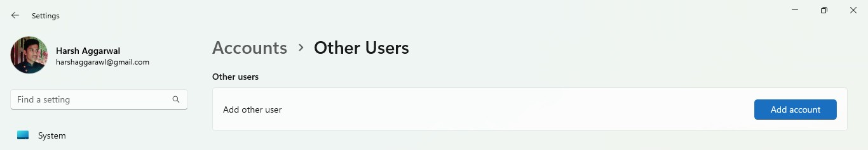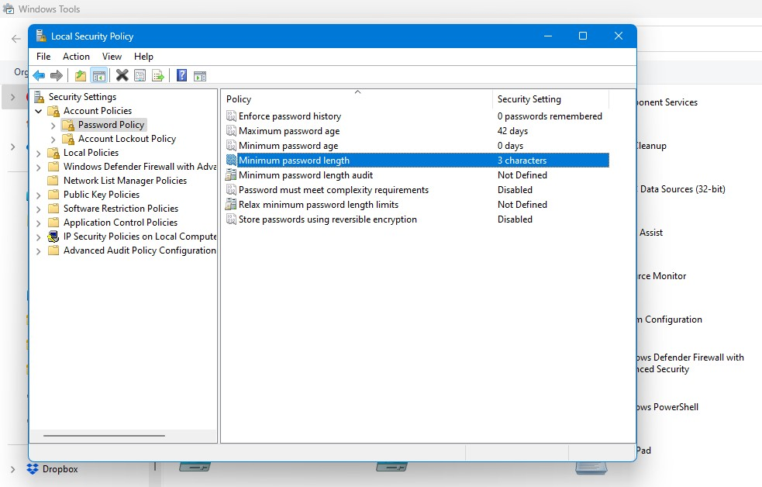

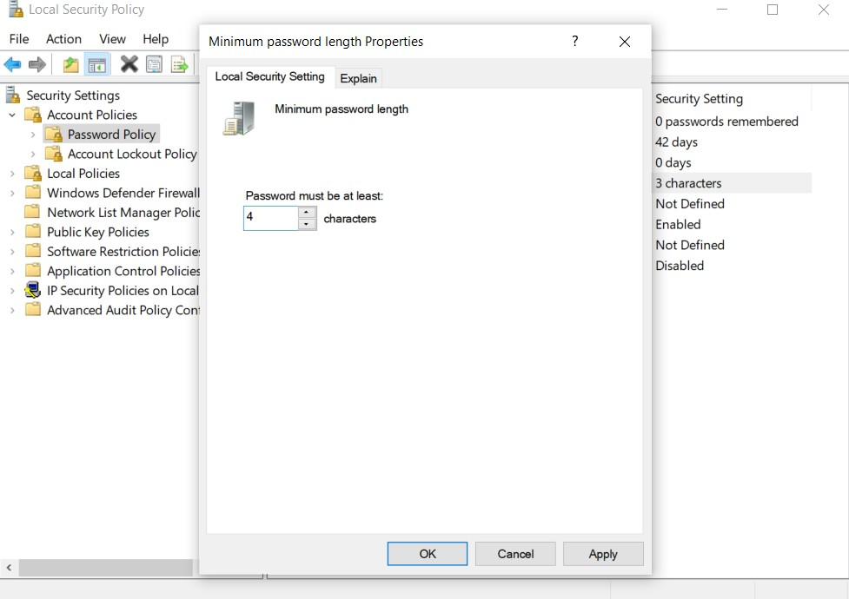

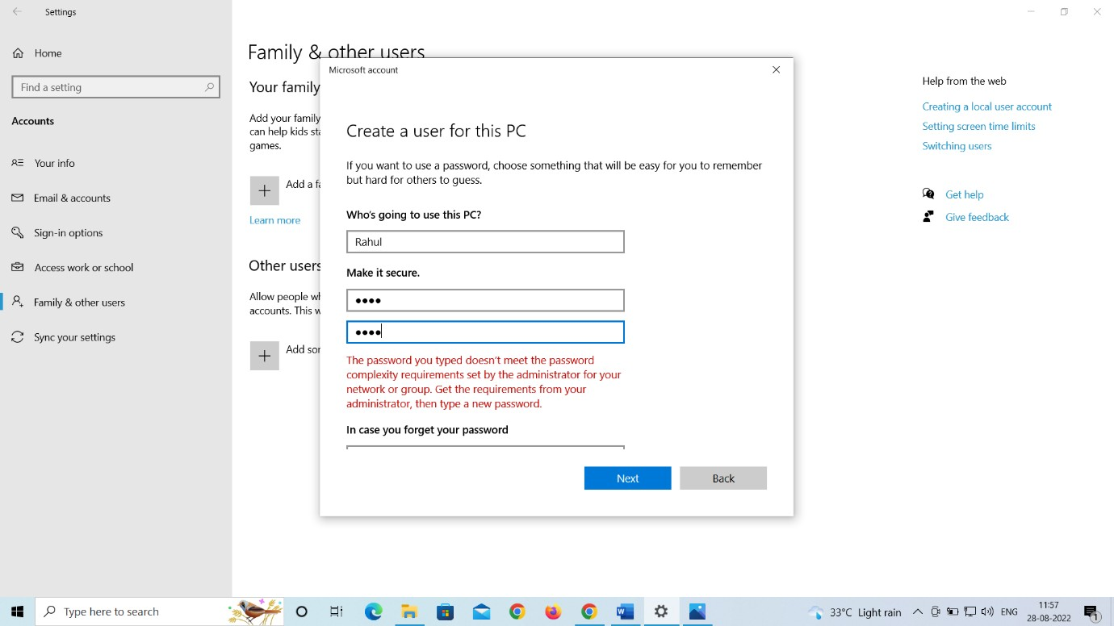

**Learning Outcomes (What I have learnt):**

1. Learnt to change password policy.
2. Learnt to create a new user.
3. Learnt about different types of password policy.
4. Learnt to install the setup on the command prompt.
5. Learnt to change minimum password lenght.

**Evaluation Grid (Created as per the Assessment Model):**

|  |  |  |  |
| --- | --- | --- | --- |
| Sr. No. | Parameters | Marks Obtained | Maximum Marks |
| 1. | Worksheet completion |  | 8 |
| 2. | Conduct of Experiment |  | 12 |
| 3. | Quiz/Viva Voce |  | 10 |
|  | Total |  | 30 |