**EXPERIMENT NUMBER: 4**

|  |  |
| --- | --- |
| **Student Name**: Lagan Verma | **UID:** 20BCS3515 |
| **Branch:** CSE (Information Security) | **Section & Group**: 20BIS-1/A |
| **Semester:** 5th | **Date**: 03/09/ 2022 |
| **Course Name**: NDE LAB | **Course Code**: 20CSB-331 |

**1. Aim/Overview of the practical:**

Implementing the host-based firewall protection with IP tables.

**2. Task to be done:**

Use the IP tables commands to block the website by firewall.

Use the command to delete the rule on that particular website.

**3. Steps for experiment/practical:**

IP Tables are used to block the IP address.

chain INPUT (policy ACCEPT 1 packet,40 bytes) pkts bytes target

(It will put the firewall rule on the website cuchd.in)

iptables -t[tables] -options[chain] [matching component] [Action component]

>filter >A-Append -j(for Jump)

>Not >D-Delete ACCEPT

>Mangle >I-Insert DROP

>Raw >R-Replace REJECT

>Security >f-Flush

x> Delete chain

z-zero counters

L- list

P-policy

E-Rename

N-New user define chain

1.**Command:** sudo iptables -L -n -v (list, numeric format, verbose)

**Command**: sudo iptables -A INPUT -s cuchd.in -j DROP

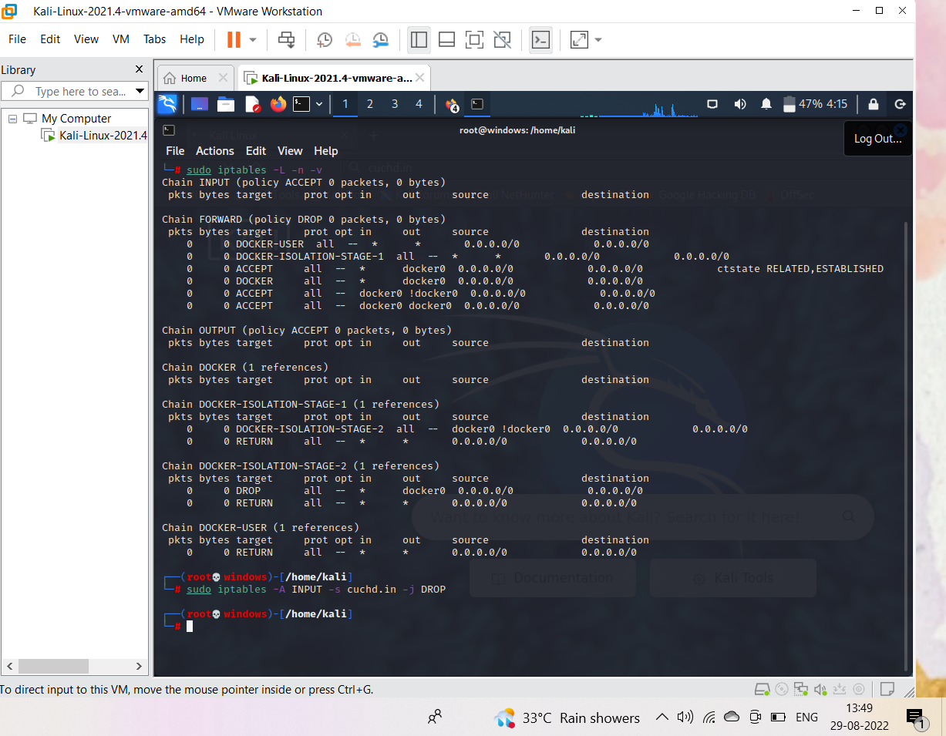

By running that command in the terminal will enable firewall which blocks the access to the website.

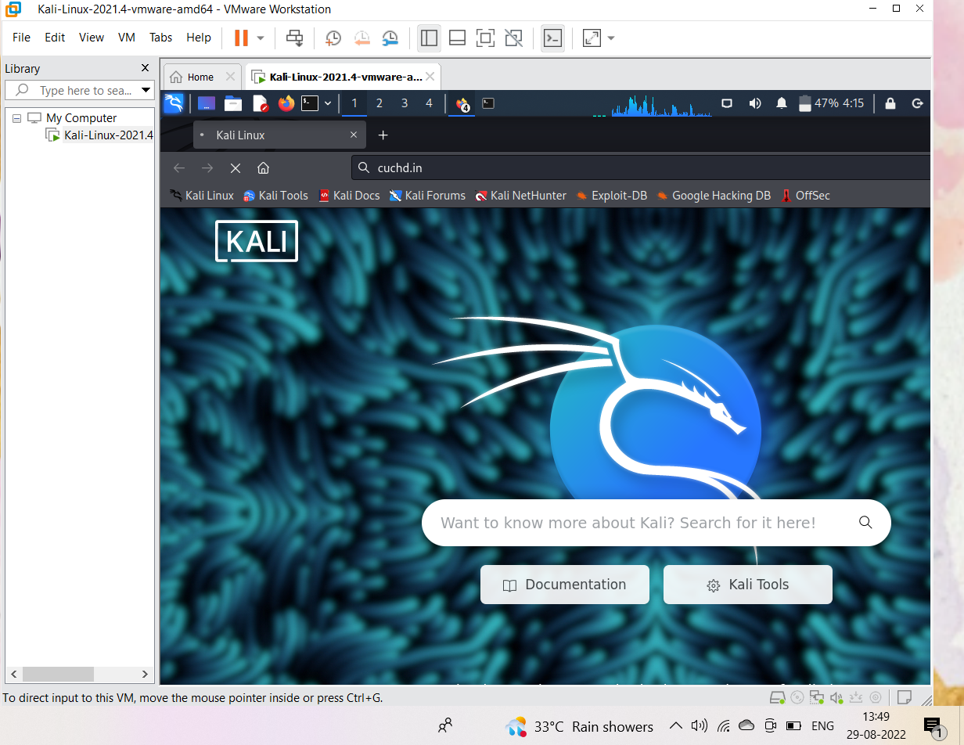

**2.Command:** sudo iptables -D INPUT 1

It will delete the rule 1 which was applied earlier.

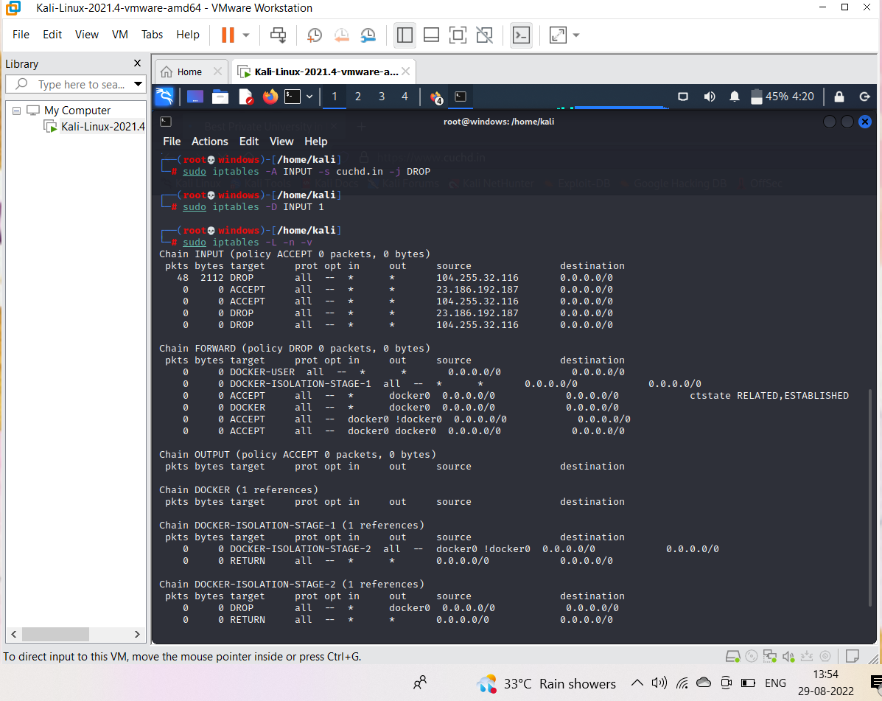

By deleting the rule, the access to the website is accessible.

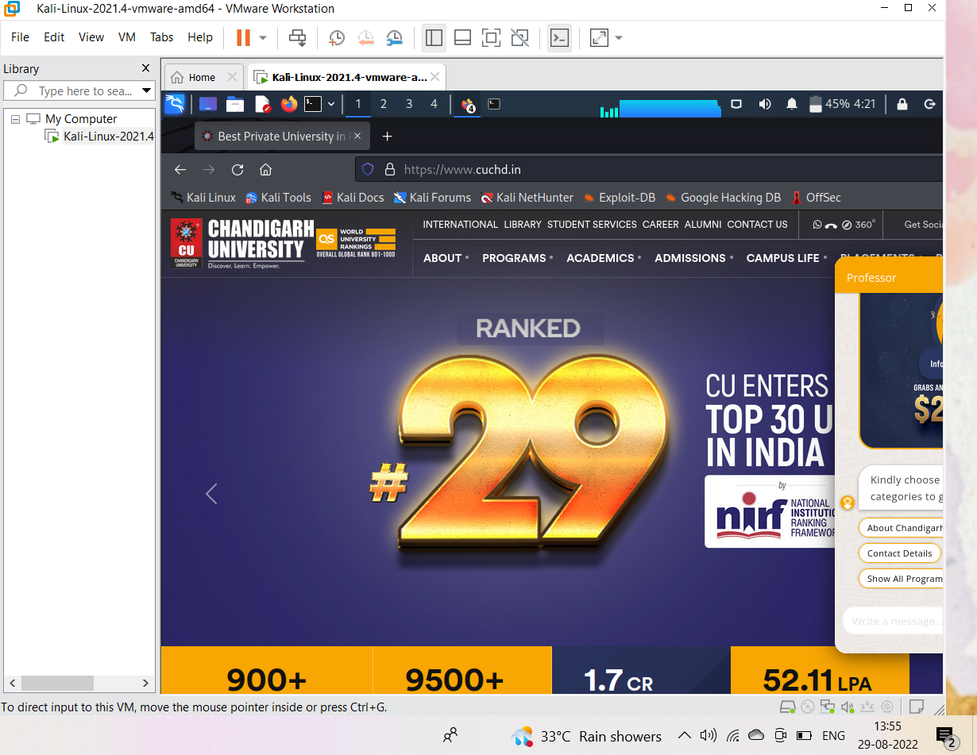

**Learning outcomes (What I have learnt):**

1. Learnt about the usage of the IP tables commands and the importance of it as it is powerful tool.

2.Implemented the concept to apply the host-based firewall.

3. Understood the concept to create a simple firewall to protect your server from basic attacks.

Evaluation Grid (Created as per the Assessment Model):

|  |  |  |  |
| --- | --- | --- | --- |
| Sr. No. | Parameters | Marks Obtained | Maximum Marks |
| 1. | Worksheet completion |  | 8 |
| 2. | Conduct of Experiment |  | 12 |
| 3. | Quiz/Viva Voce |  | 10 |
|  | Total |  | 30 |