Experiment Number: 6

|  |  |
| --- | --- |
| **Student Name**: Lagan Verma | **UID:** 20BCS3515 |
| **Branch:** CSE (Information Security) | **Section & Group**: 20BIS-1/A |
| **Semester:** 5th | **Date**: 10/11/ 2022 |
| **Course Name**: NDE LAB | **Course Code**: 20CSB-331 |

1. **Aim/Overview of the practical:** Establishing Virtual Private Network Connection using Soft-Ether VPN.
2. **Task to be done**: setting up a Soft-Ether VPN connection for a virtual private network.
3. **Procedure:**

SoftEther is an open-source and free-to-use VPN protocol that provides quick and secure client-to-server and site-to-site communications. Another part of this software is the VPN bridge that supports the aforementioned types of communication.

The SoftEther project also includes a SoftEther VPN server that allows the usage of several [VPN](https://dataprot.net/guides/what-is-openvpn/) [protocols such as OpenVPN,](https://dataprot.net/guides/what-is-openvpn/) SSTP, IPSec, L2TP/IPSec, and SoftEther itself.

In essence, the SoftEther VPN project gives users the option to connect to a SoftEther VPN server with or without the SoftEther VPN client software. It also provides users with the ability to set up their servers. Users can move from one protocol to another in a few easy steps.



Here are the other main specifications for SoftEther:

* + SoftEther runs deep-inspect package logging.
  + The protocol avoids firewalls thanks to SSL-VPN tunneling through HTTPS.
  + It uses the most sophisticated encryption methods, such as RSA-4096 and AES-256.
  + SoftEther protocol's throughput reaches around 1 Gbps-class high-speed.
  + SoftEther doesn't need fixed or static IP addresses; it has installed NAT-traversal and dynamic-DNS options.
  + With its OpenVPN clone function, SoftEther supports legacy OpenVPN clients.
  + It also supports IPv4/IPv6 dual stacking and RSA certificate authentication.
  + You can set up all settings via the GUI.

We can download SOFTEATHER from https:[//w](http://www.softether.org/5-download)ww[.softether.org/5-download](http://www.softether.org/5-download) . The SOFTEATHER download consists of a 60 MB self extracting executable file.

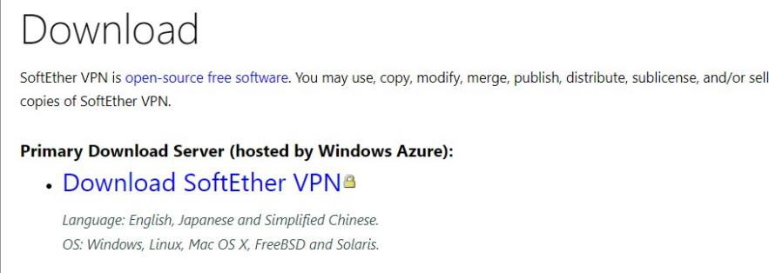

# Working of SOFTEATHER

After installing softeather setup, following menu will be appear, Now from this select the local host, then edit setting.

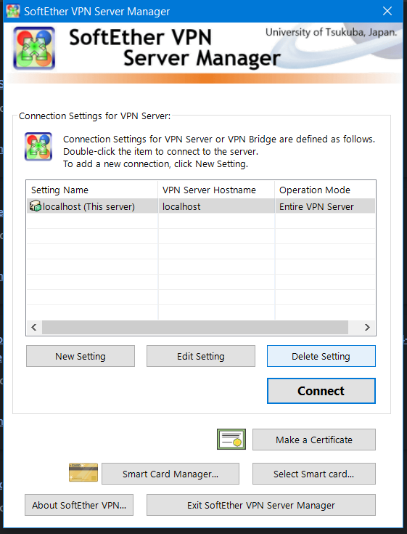

# Selecting the Proper Connection Method:

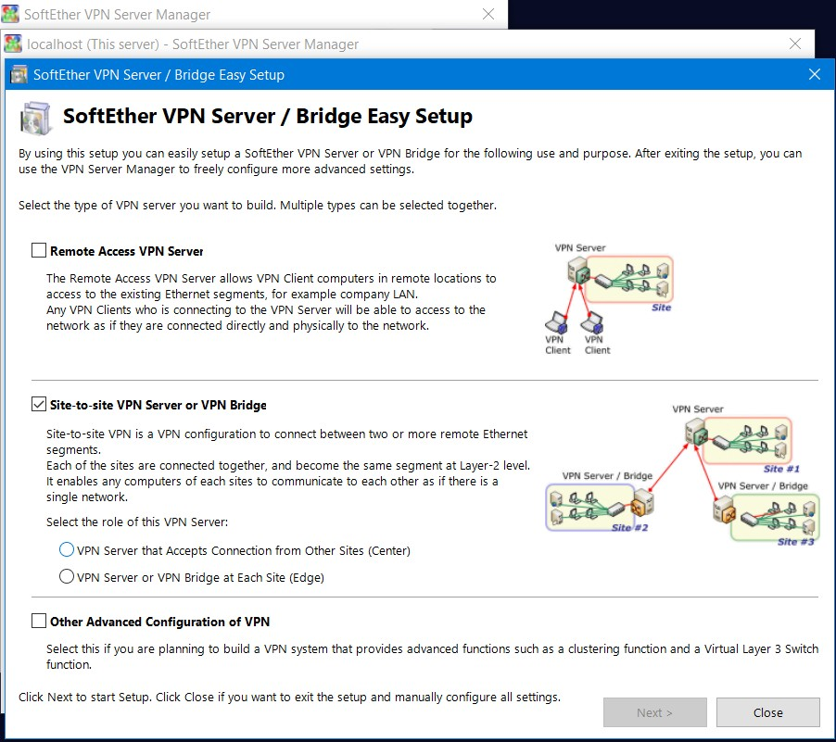

**After this Select whether to enable VPN AZURE or Not.**

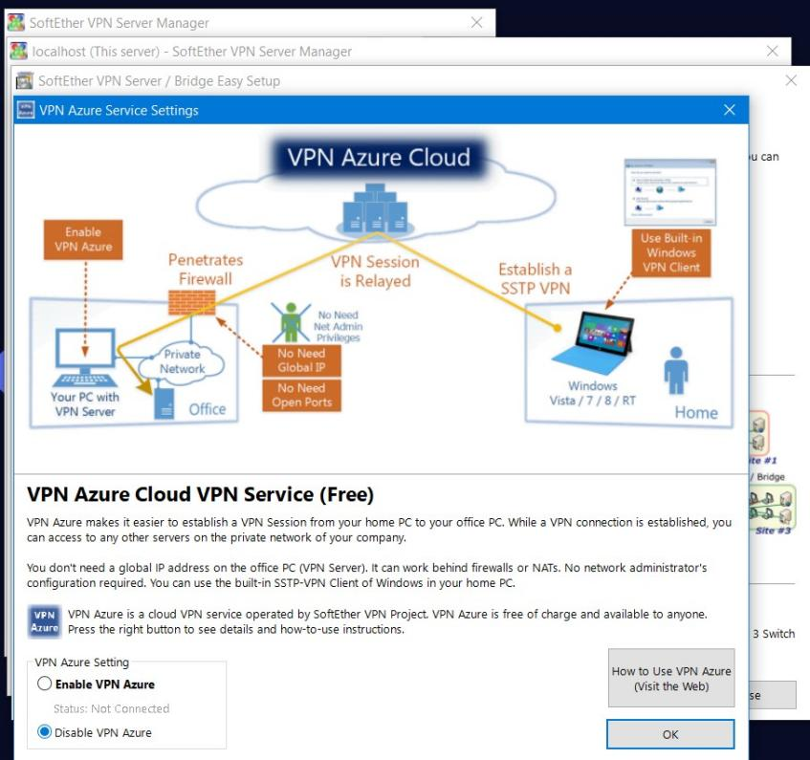

# Now click on Close:

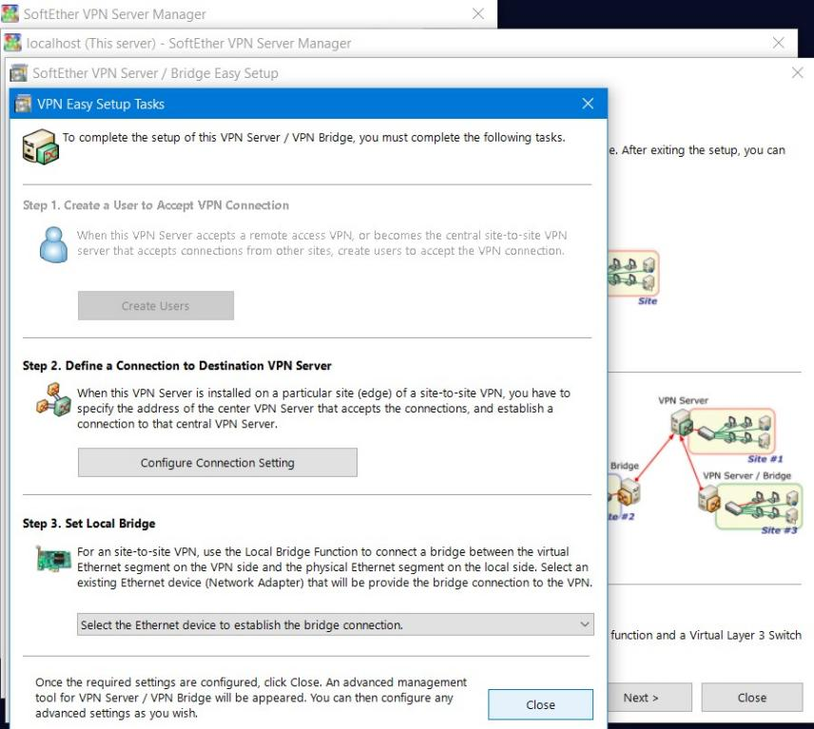

* + **So the softeather vpn connection has now been setup**

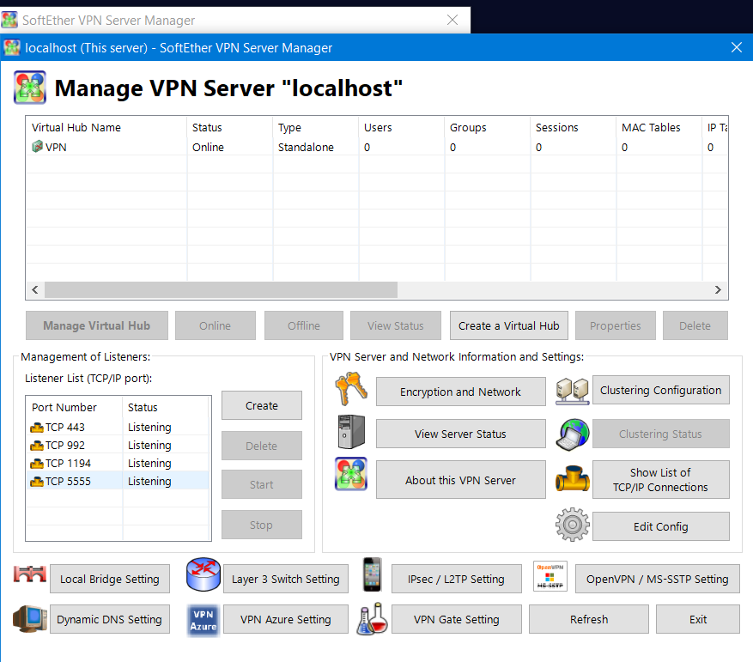

Learning Outcomes:

* Learned about SOFTEATHER VPN.
* Learned about protocols and TCP, UDP and FTP.
* Practical Implementation of HOW TO ESTABLISH A VPN CONNECTION

Evaluation Grid (Created as per the Assessment Model):

|  |  |  |  |
| --- | --- | --- | --- |
| Sr. No. | Parameters | Marks Obtained | Maximum Marks |
| 1. | Worksheet completion |  | 8 |
| 2. | Conduct of Experiment |  | 12 |
| 3. | Quiz/Viva Voce |  | 10 |
|  | Total |  | 30 |