# Experiment Number: 8th

|  |  |
| --- | --- |
| **Student Name**: Lagan Verma | **UID:** 20BCS3515 |
| **Branch:** CSE (Information Security) | **Section & Group**: 20BIS-1/A |
| **Semester:** 5th | **Date**: 10/11/ 2022 |
| **Course Name**: NDE LAB | **Course Code**: 20CSB-331 |

1. **Aim/Overview of the Practical:**

Securing IoT Device Communication using TLS/SSL, Calculate One-way Hashes using HashCalc and Create a Self-signed Certificate.

# Task to be Done:

Securing IoT Device Communication using TLS/SSL, Calculate One-way Hashes using HashCalc and Create a Self-signed Certificate.

# Theory

One of the most versatile SSL tools is OpenSSL which is an open source implementation of the SSL protocol. There are versions of OpenSSL for nearly every platform, including Windows, Linux, and Mac OS X. OpenSSL is commonly used to create the CSR and private key for many different platforms, including Apache. However, it also has hundreds of different functions that allow you to view the details of a CSR or certificate, compare an MD5 hash of the certificate and private key (to make sure they match), verify that a certificate is installed properly on any website, and convert the certificate to a different format.

# Steps:

* + **Generate a new private key and Certificate Signing Request**

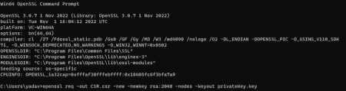

openssl req -out CSR.csr -new -newkey rsa:2048 -nodes -keyout privateKey.key

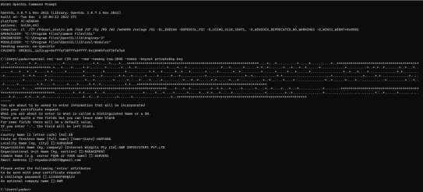

* + **Generate a self-signed certificate:**

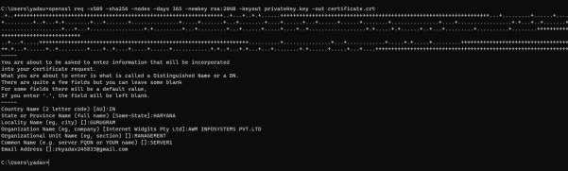

openssl req -x509 -sha256 -nodes -days 365 -newkey rsa:2048 -keyout privateKey.key

-out certificate.crt

* + **Check a certificate**

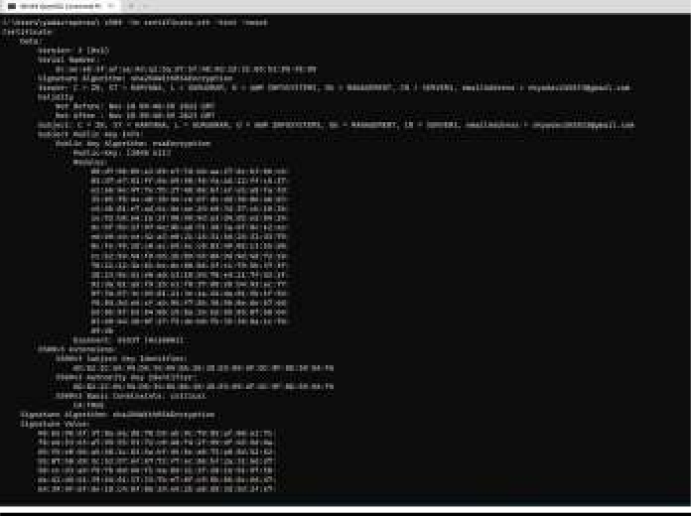

openssl x509 -in certificate.crt -text -noout

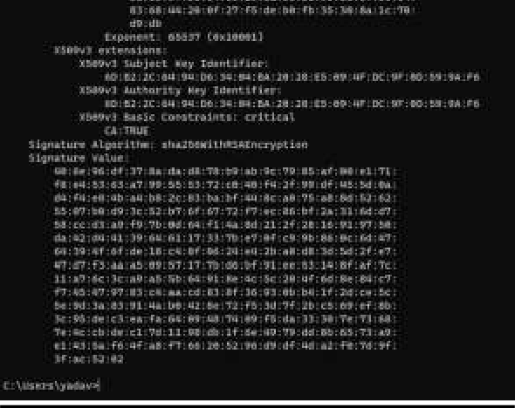

# Learning Outcomes (What I have learnt):

1. Learned about open ssl
2. Learned about Digital Certificate
3. Generating Digital Certificate using open ssl

**Evaluation Grid (Created as per the Assessment Model):**

|  |  |  |  |
| --- | --- | --- | --- |
| Sr. No. | Parameters | Marks Obtained | Maximum Marks |
| 1. | Worksheet completion |  | 8 |
| 2. | Conduct of Experiment |  | 12 |
| 3. | Quiz/Viva Voce |  | 10 |
|  | Total |  | 30 |