Experiment Number: 9

|  |  |
| --- | --- |
| Student Name: Gautam Sharma | UID: 20BCS3548 |
| Branch: CSE-IS | Section & Group: 20BIS1/A |
| Semester: 5th | Date: 10/11/2022 |
| Course Name: Network Defense Essentials Lab | Course Code: 20CSB-331 |

1. **Aim/Overview of the practical:** Perform Disk Encryption using VeraCrypt, File Recovery using EaseUS Data Recovery Wizard and Backing Up and Restoring Data in Windows
2. **Task to be done**:Perform Disk Encryption using VeraCrypt, File Recovery using EaseUS Data Recovery Wizard and Backing Up and Restoring Data in Windows
3. **Procedure:**

Veracrypt is open-source, which makes it very secure. You can encrypt simple containers or the whole disk with various top-of-the-line encryption algorithms and a choice of hash algorithms. The option to use keyholes and PIM (Personal Iterations Multiplier) makes the encrypted data extremely safe..

# How to Encrypt your Windows PC with VeraCrypt.

After installing softeather setup, following menu will be appear, Now from this select the local host, then edit setting.

To protect your Windows PC (System Drive & Contents) with VeraCrypt

1. Download and Install VeraCrypt on your PC. *

* Note: Always install VeraCrypt with local administrative privileges.

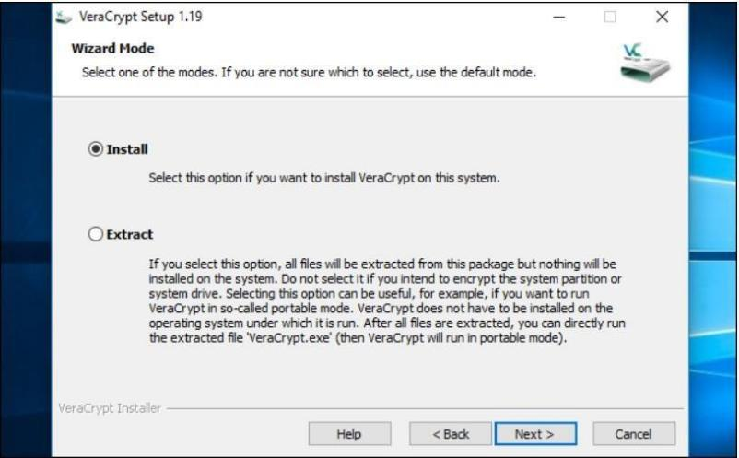

# Once VeraCrypt is installed, open your Start menu and launch the “VeraCrypt”

**shortcut.**

# Click System > Encrypt System Partition/Drive in the VeraCrypt window to get started.

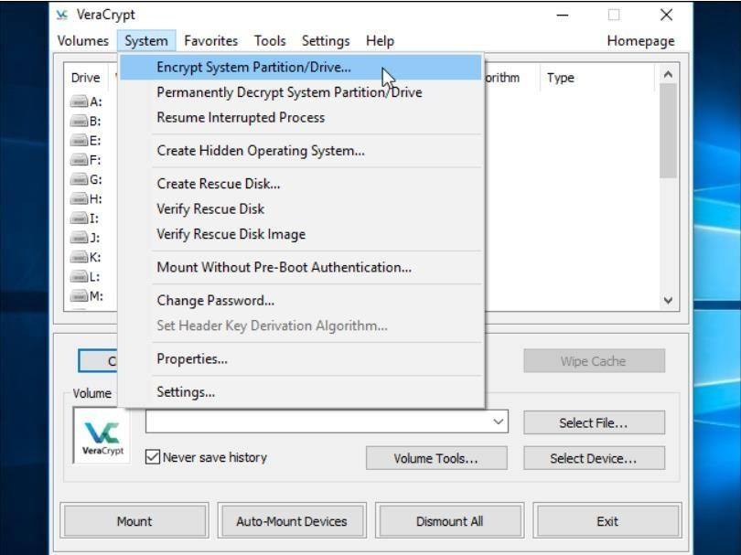

**The Normal option encrypts the system partition or drive normally.**

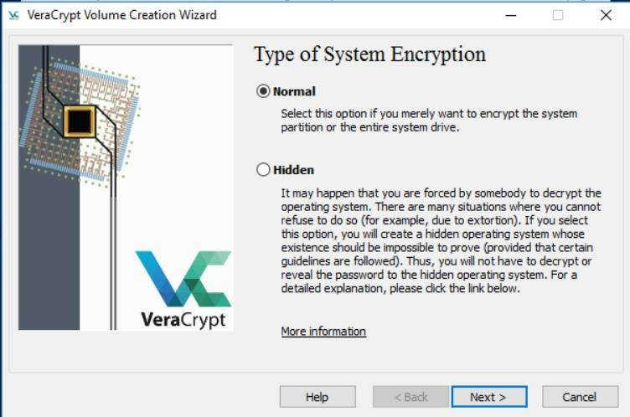

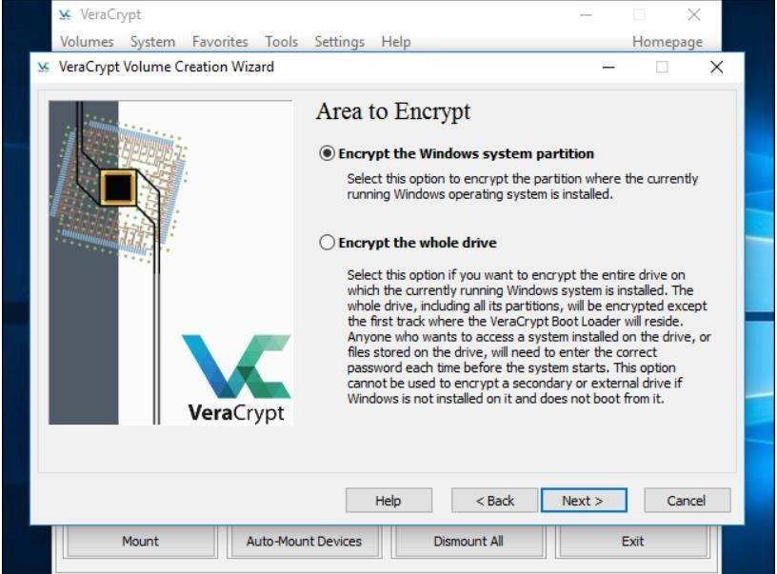If you have multiple partitions with sensitive data—for example, a system partition at C: and a files partition at D:—select “Encrypt the whole drive” to ensure all your Windows partitions are encrypted.

You’ll then be asked to choose which type of encryption you want to use. While there are multiple

options available, we recommend sticking with the default settings. “AES” encryption and the “SHA-256” hash algorithm are good choices. They’re all solid encryption schemes.

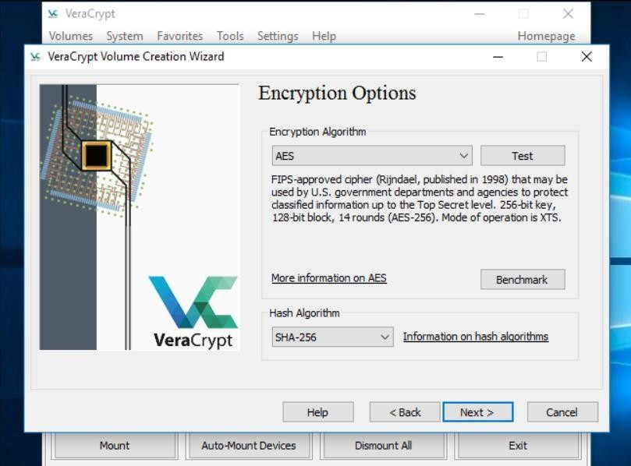

After setting up password. VeraCrypt will ask you to move your mouse randomly around inside the window. It uses these random mouse movements to increase the strength of your encryption keys. When you’ve filled up the meter, click “Next”.

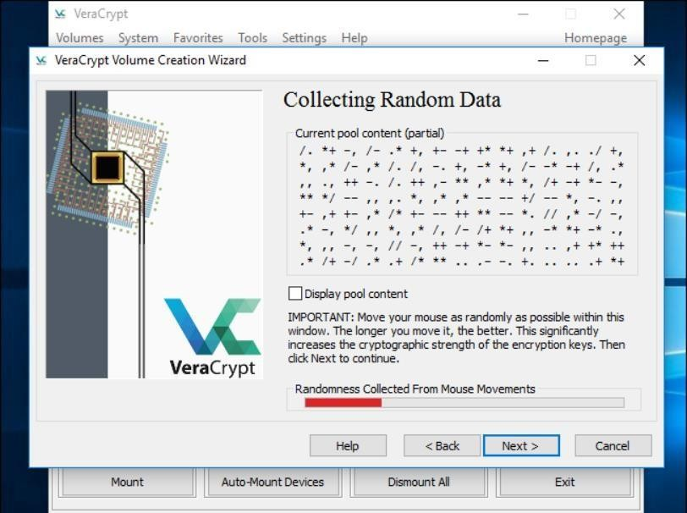

Click the “Encrypt” button to actually encrypt your PC’s system drive.

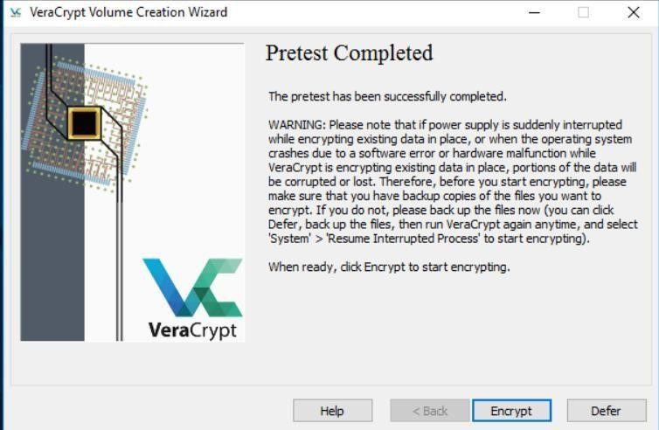

Learning Outcomes:

* Learned about Encrypting a system.
* Learned about Veracrypt.
* Practical Implementation of how to encrypt a system using veracrypt

Evaluation Grid (Created as per the Assessment Model):

|  |  |  |  |
| --- | --- | --- | --- |
| Sr. No. | Parameters | Marks Obtained | Maximum Marks |
| 1. | Worksheet completion |  | 8 |
| 2. | Conduct of Experiment |  | 12 |
| 3. | Quiz/Viva Voce |  | 10 |
|  | Total |  | 30 |