**Google Docs:** [**https://docs.google.com/document/d/1s_HdIZbuWpWUmdnPcx8QCkgu22U-SwwZgtN3B7c51HU/edit**](https://docs.google.com/document/d/1s_HdIZbuWpWUmdnPcx8QCkgu22U-SwwZgtN3B7c51HU/edit)

**Why we are doing this article**

We are taking a quick break from the usual alumni interviews to feature another set of superstars: you, the readers! Some of the best insights come from current students, whose countless collective experiences and lessons learned can be democratized for the betterment of future generations.

Due to several frantic requests made by my freshmen mentees about finding that perfect summer internship, I noticed this trend was prevalent across the entire class. As on-campus recruiting (OCR) was pushed to the Fall for the first time, from the moment freshmen set foot on campus, an overwhelming presence of professionally-clad upperclassmen with leather padfolios would have made any regular person panic. To alleviate their worries, I made a public post (https://www.facebook.com/laura.gao.10/posts/1237703422989418) asking upperclassmen to talk about their freshman summer plans. After collecting nearly **70** responses, I conducted a data analysis to accomplish three things:

1. Paint a more transparent picture for future freshmen regarding summer information
2. Provide compelling evidence that freshmen summer has **little** correlation towards future plans
3. Connect students to upperclassmen with all types of summers

**Survey Breakdown**

For each participant, I asked the following:

(insert table of excel sheet here)

1. 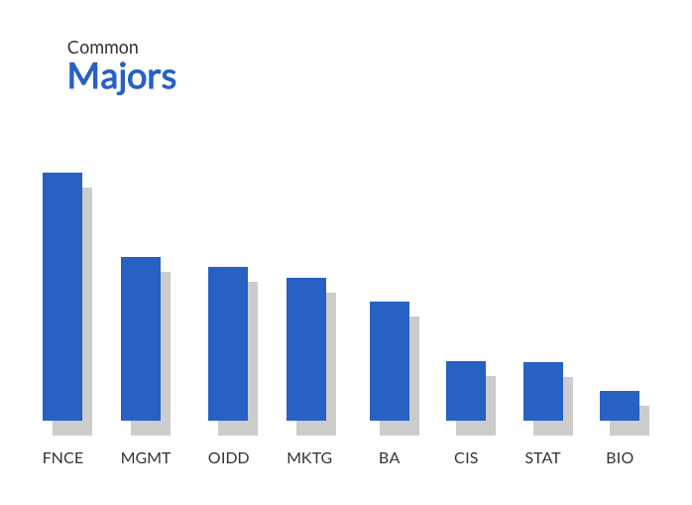

*FNCE = Finance, MGMT = Management, OIDD = Operations & Information Decisions, MKTG = Marketing, BA = Business Analytics, CIS = Computer & Information Sciences, STAT = Statistics, BIO = Biology or Pre-med

**Not shown (<3 people): Cognitive Science, Marketing & Operations Management, Health Care Management, Behavioral Economics, Accounting, Fine Arts, Mechanical Engineering & Applied Mechanics, International Studies, Computer Engineering, Real Estate, Retail, Mathematics, Actuarial Science, Business Economics & Public Policy, Geology, Individualized in Product Design

With the help of one of The Sign.al’s newest writers, Sophia, we grouped all of the responses into five general types of summer plans:

(In decreasing order of number)

1. General Business Internship
2. Tech or Startup Internship
3. Research or Classes
4. Travel/Study Abroad
5. Non-Profit or High School Job

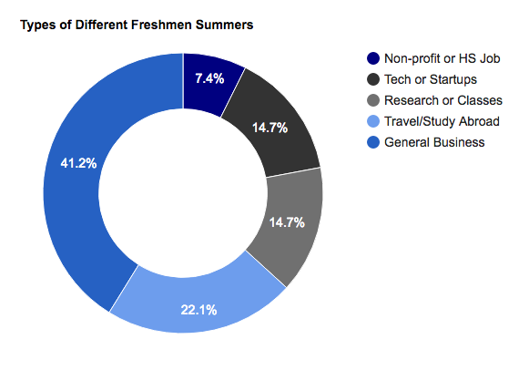

The methods participants used to attain these plans include, in decreasing percentage order:

1. Family or friend connection
2. Applied directly
3. Cold emailed
4. High school job continuation
5. Own startup
6. 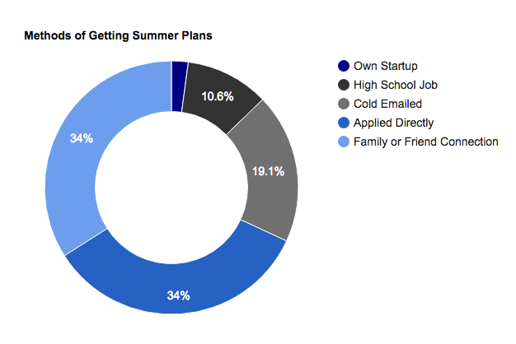

**Usefulness Scores and Redos:**

Two main metrics we used to determine overall perceptions of a successful summer were:

1. Usefulness scores
2. Percentage of people who would redo their summer

Usefulness scores were described to participants as a “combination of personal and professional development”. The average scores (out of 10) for each type of summer are shown below:

1. 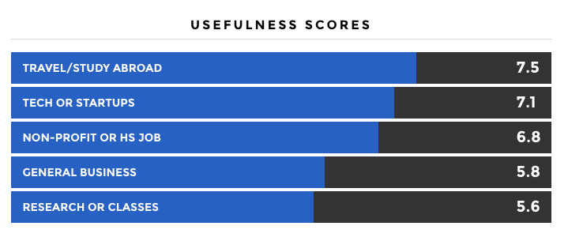
   1. **Key Takeaways:** 
      1. Students who traveled or studied abroad gave the highest perceived usefulness scores of 7.5/10
      2. Students who conducted research or took summer classes on campus gave the lowest perceived usefulness score of 5.6/10.

Participants were also asked if given the chance, whether or not to redo their summer. Those that worked at a non-profit or returned to their high school jobs would have kept their summer unchanged the most.

1. 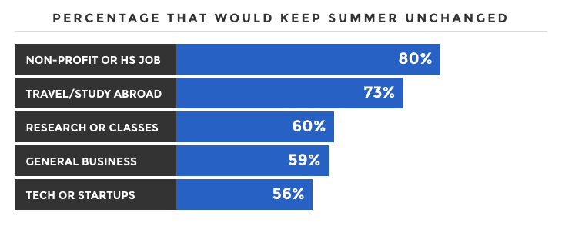
   1. **Key Takeaways**:
      1. Those who had a formal internship, regardless in general business or tech & startups, had the highest concentration of people who would redo their summer.

**Deeper look into reasons to redo summer:**

The split between students who would redo their summer vs. students who would keep it unchanged was 57% to 43%. We probed deeper into specific reasons behind these hypothetical decisions to find the most commons considerations.

Of the students who would choose to redo their summer, the most common reasons in descending order are that students wanted to...

1. Gain more useful skills
2. Explore a field more related to their interests
3. Take advantage of their last chance to travel, visit family, or have fun
4. Be more prepared before starting an internship

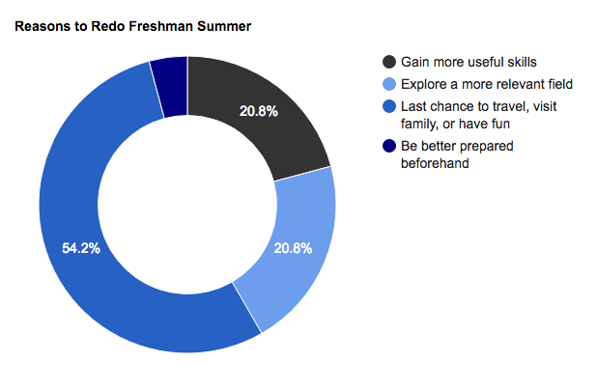

Of the students who would keep their summer unchanged, the most common reasons in descending order are that students were able to…

1. Have fun, travel, or stay with family
2. Gain connections
3. Grow personally
4. 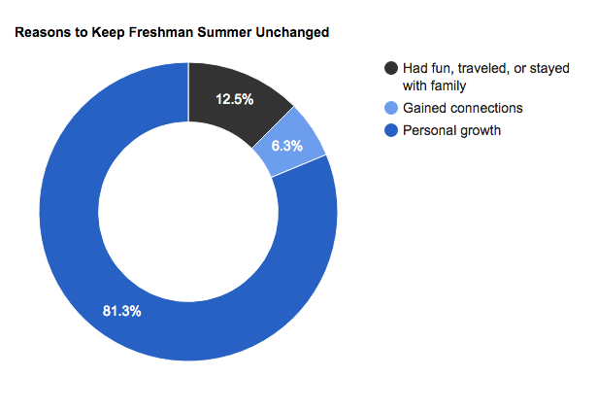
   1. Text analysis/quotes

**Comparing Freshmen Summer with Later Career Plans:**

A common fear perpetuated by the pre-professional environment is that the freshmen summer has significant correlation with a student’s future academic and career plans.

**However, the data shows that this couldn’t be further from the truth.**

Less than a third of the students surveyed (30%) are currently pursuing a career in the same field as that of their summer internship. The fields with the highest conversion rates are:

1. Tech and Startups - 60%
2. Financial Services - 53%*
3. Marketing & Analytics: 25%*

*General business internships was split into financial services and marketing & analytics for more accurate insights

The pathways chart below shows many of the pivots our participants made from freshmen summer to now:

1. 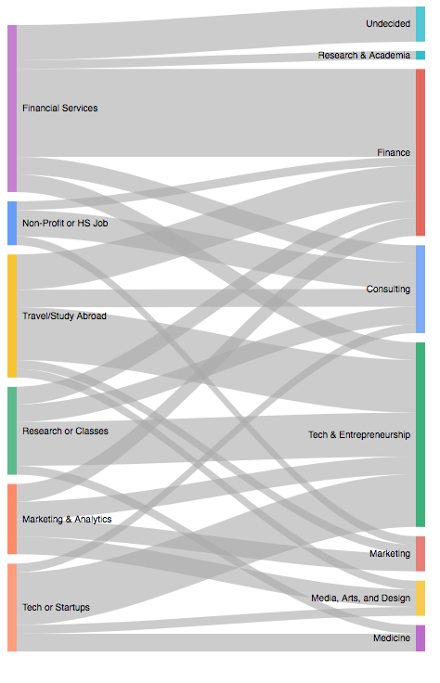

**Despite this, one trend that was apparent in the data was the connection between overall summer satisfaction and major pursued**. Participants were split evenly between those whose internship role matched with their current major and those whose did not. Those whose matched had a significantly higher usefulness score of 7.1/10, compared to only 4.3/10 for those whose did not. It is important to note that we did not collect data on changes in major. Thus, it is unclear if freshman summer experiences caused better alignment of major preference or initial major preferences caused a better summer experience.

* 1. Text analysis/quotes

**Typical Timeline for Summer Search:**

Lastly, we collected data on start and end dates of each participant’s search for summer plans. The average time spent searching was 2.5 months, with the average participant starting in February and finishing in April.

Average month start: February

These dates varied across the different summer types:

1. 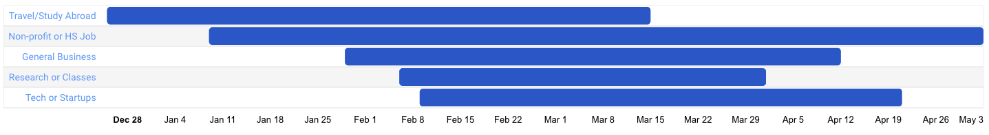

**Key takeaways:**

1. Students who traveled or studied abroad both started and finished the earliest. Such programs typically close applications in early Spring; thus we recommend freshmen who are pursuing these plans to prepare early.
2. Students who conducted research or took classes on campus had the shortest search timeline. These students recommend being proactive in inquiring professors about their work, and looking into CURF(link) and department-specific research grants.
3. When analyzing correlations between timelines and summer perceptions, there was no change in average usefulness scores regardless of the length of time spent searching for plans. Thus, searching for longer does not necessarily result in a “higher quality” summer.

This concludes our analysis of freshmen summers from upperclassmen insights. By democratizing this information, we aim to encourage future generations of Penn students to pursue more fulfilling and unique opportunities both in their summers and in post-grad ventures. Most importantly, we recognize the increasing pre-professional pressure caused by the ubiquity of students in suits around campus during the first few months of OCR. Freshman year is for making lifelong friends, developing stronger identities, and taking full advantage of being immersed in a youthful community of changemakers. From all of the writers at The Sign.al, we implore future Quakers to take these words to heart, calm down, and just enjoy the ride.

**Want to know exactly what our upperclassmen did their freshman summers?**

We weren’t kidding when we said we would democratize **everything**. We have included:

* (Make all separate links) A database of companies, non-profits, summer programs, and research opportunities curated by our participants
* Quotes from our participants about their summer plans of all types
* A select group of Sign.als free to chat on-campus or email remotely anytime:

Savi (Research, classes, abroad)

**David Ongchoco (startup, youthhack)**

Lea Chen (fashion)

Shaishvi (abroad, non-profit)

Lauren Anders (HS job, Taught robotics)

Yejin (finance)

Bryan Mena (penncap/minorities)

Database of Freshmen-Focused Summer Resources:

**Educational Programs/Research**

Horizons School of Technology: <http://www.joinhorizons.com/summer_immersive>

Penn Center for Undergraduate Research & Fellowship (CURF): <https://www.curf.upenn.edu/research-directory>

College of Arts & Sciences Summer Humanities Internships: <https://www.curf.upenn.edu/summer-humanities-internships>

Wharton Summer Program for Summer Research (SPUR): <https://undergrad-inside.wharton.upenn.edu/research/spur/>

Girls Who Invest: <http://www.girlswhoinvest.org/students/>

Penn On-Campus Courses: <http://www.sas.upenn.edu/summer/programs/on-campus>

Penn Online Summer Courses: <http://www.sas.upenn.edu/summer/programs/online>

GenHERation Discovery Days: <http://genheration.com/genheration-discovery-days-2017/>

Sans Institute CyberTalent Academy: <https://www.sans.org/cybertalent/immersion-academy/admissions#womens>

Jewish Studies Program Summer Research Funding: <https://ccat.sas.upenn.edu/jwst/news/2016/funds-available-summer-research>

**Summer Abroad**

Penn International Internship Program (IIP): <https://global.upenn.edu/iip/iip-placements>

Penn in Buenos Aires Program: <http://www.sas.upenn.edu/summer/courses/term/2016B/subject/PSAB/course/PSAB002959>

Penn Summer Abroad: <http://www.sas.upenn.edu/summer/programs/abroad>

Harvard Beijing Academy: <https://www.summer.harvard.edu/study-abroad/beijing-china>

London School of Economics Summer Program: <http://www.lse.ac.uk/study/summerSchools/summerSchool/Home.aspx>

Penn International Impact Consulting summer program: <http://www.penniic.com/>

The Paideia Institute Internship in Rome: <http://www.paideiainstitute.org/internship>

Research Internships in South Asia: <https://www.southasiacenter.upenn.edu/research-internships-south-asia>

LGBTQ Summer Program in South Asia: <https://www.southasiacenter.upenn.edu/kolkata-lgbt-movement-building>

Schwartz Family Penn Impact Lab Summer Program in Africa: <http://socialimpactstrategy.org/residential/impactlab/>

**Work Opportunities**

Penn Admissions Summer Tour Guide: <https://key.admissions.upenn.edu/register/?id=a80d350f-a58a-4752-9e53-abe9c0aced58>

Quakernet Database of All Penn Alumni: <https://quakernet-idp.alumni.upenn.edu/discovery/?entityID=https%3A%2F%2Fquakernet-idp.alumni.upenn.edu%2Fsp&return=https%3A%2F%2Fquakernet-idp.alumni.upenn.edu%2FShibboleth.sso%2FLogin%3FSAMLDS%3D1%26target%3Dss%253Amem%253Ae014c520753011fdba0ab0fb1e8f2fad77ace782a6bf4bf7efc1ae2b837b9d5c>

PennLink Database of All Company Internships: <http://www.vpul.upenn.edu/careerservices/pennlink_jobseekers.php>

Penn Internship Network for Penn Student Chats: <http://www.vpul.upenn.edu/careerservices/jobsandinternships/pin.php>

Penn Wharton Public Policy Initiative job board: <https://publicpolicy.wharton.upenn.edu/for-students/job-board/>

Wharton Social Impact Initiative job board: <https://socialimpact.wharton.upenn.edu/general-news/summer-impact-internship-funding-opportunities/>

WeissLabs Summer Entrepreneur Cohort: <https://weisslabs.typeform.com/to/zhhAxs>

Libra Tech Summer Internship: <http://www.libra.tech/>

Emerson Collective Social Innovation Summer Internship: <https://emersoncollective.app.box.com/v/Intern>

Penn Center for High Impact Philanthropy Summer Jobs: <http://www.impact.upenn.edu/about/employment-opportunities/>

Career Services Summer Funding for Unpaid Internships: <http://www.vpul.upenn.edu/careerservices/summerfunding.php>

Civic House Community Engagement Internship Program: <https://gallery.mailchimp.com/c0a42f3709599ee7044d1c477/images/19cfcb3c-6616-4151-9659-dbf6797d74a5.jpg>

Career Services Career Plans Survey Results: <http://www.vpul.upenn.edu/careerservices/reports.php#CP>

**Leadership Opportunities**

Penn College Achievement Program (PENNCAP): <http://www.vpul.upenn.edu/eap/penncap/>

Leadership in the Business World (LBW) Summer TA: <https://www.wharton.upenn.edu/leadership-business-world/>

Penn in Washington Summer Program: <https://piw.sas.upenn.edu/penn-washington-summer-program>

Penn Girls in Engineering, Maths, and Sciences (Penn GEMS) Counselor: <https://docs.google.com/a/wharton.upenn.edu/forms/d/e/1FAIpQLSdS4Lih49ZFkijvITlpaoPIlz7lguC-DkF1X0YU5AUgW-dZjA/viewform?c=0&w=1>

John Hopkins Center for Talented Youth Instructor Role: <http://cty.jhu.edu/jobs/summer>

**Code for this project, sources cited, thanks**

**--------------**

**QUOTES**

**--------------**

(LSE, Culinary school, Monk at monastery) Savi: get quote

(Startup accelerator, YouthHack) David on hands-on tech experience: “look for an internship that would have allowed me to gain a technical skillset or give me a hands-on experience working in an early stage technology startup. I would also spend time doing tutorials to improve my technical skillset in coding, design and marketing. My freshman summer really opened my eyes to the startup scene in South East Asia and gave me an opportunity to build my professional network through the investors, entrepreneurs and friends I got to meet in the various meetups and conferences I attended all over South East Asia. More than the professional experiences, it also opened my eyes to various cultures as well. Spending time building my network, working on side projects and travelling South East Asia definitely helped me diversify my experiences which definitely helped me recruit last summer and for this summer.”

(Hitchhiked China, LSE) Holly on finding yourself: “It was the best thing I ever did. I didn't end up talking about my Chinese adventures or my IR topics in any interview, but the perspective I gained from that summer inspired me-- "opened my eyes," if you will-- and I felt confident afterwards to pursue a lot of different interests sophomore year. Freshman summers are for finding yourself!”

(Investment company) Risha on fnce helping fnce: “Working at JP Morgan S&T in LA this summer and I think colony really really helped

Would not change anything about it. It was 8 weeks long from 8-5 pm everyday, and it was an awesome experience”

Shaishvi on building a school for disabilities: “If I could go back I'd use more scholarly research in developing the program, find a way to make it more sustainable beyond me leaving, and spend more time on it than I did (the whole summer rather than just one month). Basically I came with my dad while he visited his friend who runs the arushi School for people with disabilities and while they talked I went to play with/teach some of the students and really enjoyed it so asked how I could help, the guy knew two other people who wanted to volunteer somehow and so we came up with the program together and in association with the school”

(PE firm) Stephanie on how fnce helps with fnce: “I would have tried to be more confident in my work and also not be afraid to ask questions, because that’s how you get assessed to get more work. Also, when directions are not clear and you don’t know much, it can be much more time-consuming and costly to try to do it on your own than to simply ask and clarify. it was super relevant to my soph/jun internships”

(Penn in Buenos Aires) Savannah: “It was lit”

(Retail company) Jenny on choosing retail early: “I think it prepared me really well to go into retail, but also I felt like it basically made me choose retail quite early on

Which is fine because I like it but would be cautious of choosing an industry so early on if you're not sure you like it”

(Penn: Summer classes, Research Assistant, Summer tour guide) Andrea on being introduced to different types of work environments: I think this depends at how you look at it! In terms of impressiveness, I think it might be a 3 for getting future internships/jobs. In terms of personal understanding and growth, like 8.

My summer work truly helped me understand what kind of work environment I want to be in. For example, working as an RA was very quiet and although the work was interesting, I preferred working with people as a tour guide. I learned the most doing work for the Admissions Office, because I suddenly gained a lot of responsibility and was given the freedom to spearhead new projects. The adults in the office took me seriously and valued my opinions, so my confidence grew as I implemented more ideas. Because the Admissions Office is part of a large bureaucratic system, I also gained exposure to the limitations of a large system and how to manage relationships with multiple departments and compromise. Furthermore, juggling these three responsibilities, I learned how to manage my time better and a truer meaning of hard work.

(Penn: Summer classes, Research Assistant, Summer tour guide) Andrea on paying attention to health: “ 3) Unsure if this is what you're looking for but I wish I had taken my personal health more seriously. When my work/school life got really busy, my room would be a mess and my eating habits got really out of whack. I often shoved away exercise and personal time to get more work done and this was really unhealthy behavior that I didn't realize at the time!”

(Penn in Madrid) Rachel on taking advantage of her last “fun” summer: “it was my last "fun" summer where I didn't feel the pressure to get a good internship. I took advantage of that and studied abroad instead and that was an amazing experience I would not trade for anything.”

(Mobile Ads Startup internship) Sneha on not stressing out about internships: “I'd make sure to not stress out/majorly obsess over finding an internship. Looking back, the main thing employers focused on is about what you know, and not necessarily the experiences you have so learning practical skills doesnt have to come from an internship.”

(Harvard Beijing Academy) Olivia on working until you die: “summer after freshman year is a good time to not have an internship in my opinion since you'll be doomed to having one afterwards and then a job every summer until you die”

(Marketing at software company) Julia on finding the cooler topics: “I thought it would be useful to finding a sophomore internship, but it really wasn't, and nobody asked about it during junior OCR. I think it does help a little to see that you've done an internship, but my view is that you gotta get a big name company or do some work that recruiters will be like, "oh this sounds cool, tell me more"

(Quant Internship at biotech company) Kevin on switching majors and pursuing personal projects: “it made me realize the depth of CS and eventually helped sway my decision to switch majors

3) I would have asked more questions and tried to pursue my own projects sooner rather than later, simply because it's counterproductive to work on a project you aren't passionate about instead of something that you love.”

(Summer Classes at Penn) Brian on summer classes and research: “I would say the classes themselves weren't incredibly useful but the great thing about getting requirements out of the way is that it allowed me to have a lighter course load around OCR periods (junior + senior year) In addition, summer courses tend to be easier so you can argue that it also helped my gpa vs. if I had taken them normally during the fall/spring semesters. 3) If I could go back, I would still take classes but also do research with a Wharton professor in a field that I am interested in on the side. I knew a few students in my summer classes who did this and I think research experience does help you stand out during interviews.”

(Trust Fund) Kayvon on creating your own internship: “with freshman summer, it doesn't matter what you do, as long as it's fulfilling and you can talk about it. and if you get denied from every program, then you can start your own thing, and that's just as impressive, if not more impressive. Big takeaway: Freshman year summer is built on personal network. If you know someone, they can finesse you something quickly. So who has what isn't necessarily a function of who's more impressive than the other, but instead it's about who you know. So, if you don't know anyone, that's completely ok, there are so many other options. Take classes, do research, build your own entrepreneurial venture, or even better, DO ALL THREE AT THE SAME TIME! That's a super busy and exhilarating summer, will teach you a bunch, be great for a resume, and most importantly, ANYONE CAN DO IT. Essentially what that is. is it's creating your own internship program, which is awesome.”

(Phillipines Stock Exchange) Beatriz on upperclassmen giving advice: “I wish i followed my first instinct and gone to china to learn Chinese or to London to go to baking school. I kid you not freshman - it may seem like the upperclassmen are telling you to do something fun but then also told you that they did a "legit" internship freshmen year. They're not trying to give you false advice. They are giving you the advice they wish they had taken. Freshman year summer is that one chance to do something you love without consequence! Do it! And you'll even have a cool story to tell”

(Camp Counselor) Christina on personable skills learned around kids: “Would't change it for the world. (I could talk about adaptability and having to interact with parents versus kids in interviews) but ultimately no transferable skills except being personable.”

(B2B Growth Equity Firm) Ryan Clyde on doing little work: “I would have gone back and gotten a real job somewhere interesting (like a restaurant or something idk, I did construction for two years that paid well but it was too much physical labor) and made some money. Literally clicking around excel spreadsheets for 6 weeks was a huge waste of time. It was unpaid, and I basicially spent 6 weeks of my summer 8 hours a day filling out excel spreadsheets for them about research on various small companies that looked like interesting potential investments

I also got to sit in on several pitchdeck meetings, LP relations phone calls, a lot of in depth analytical work to make sure the business models of the companies they were investing in were going to continue to grow, etc.

Got to see some pretty cool stuff, but overall a big waste of time bc I was unpaid and did no real work”

**Concluding Thoughts, possible mistakes in the data**

**Board of People** to reach out to (Savi (Research, classes, abroad), David Ongchoco (startup, youthhack), Holly Li (hitchhiked abroad, LSE), Lea Chen (fashion), Shaishvi (abroad, non-profit), Lauren Anders (HS job, Taught robotics).

**Code for this project, sources cited, thanks**