REFERENCES :

# EDI, [How much does Mathematical Logic relate to Statistics?https://stats.stackexchange.com/questions/485109/how-much-does-mathematical-logic-relate-to-statistics](https://stats.stackexchange.com/questions/485109/how-much-does-mathematical-logic-relate-to-statistics)

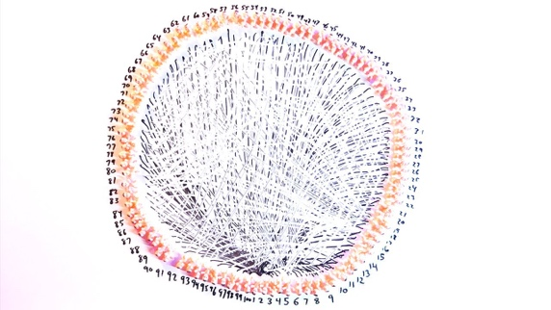

Vsauce2,18 december 2018,<https://www.youtube.com/watch?v=ofTb57aZHZs>

Mrs Lemetayer (math professor),2019, My mathematics lesson about birthday paradox

No author, no date, <https://betterexplained.com/articles/understanding-the-birthday-paradox/>