IDVision 2.0 Requirements and Configurations

For CASA Account Opening Flow of HSBC

**Aug 2019**

Version 1.1



© 2015 TransUnion LLC  
All Rights Reserved

No part of this publication may be reproduced or distributed in any form or by any means, electronic or otherwise, now known or hereafter developed, including, but not limited to, the Internet, without the explicit prior written consent from TransUnion LLC.

Requests for permission to reproduce or distribute any part of, or all of, this publication should be mailed to:

Law Department  
TransUnion  
555 West Adams   
Chicago, Illinois 60661

The “T” logo, TransUnion, and other trademarks, service marks, and logos (the “Trademarks”) used in this publication are registered or unregistered Trademarks of TransUnion LLC or their respective owners. Trademarks may not be used for any purpose whatsoever without the express written permission of the Trademark owner.

[transunion.com](http://www.transunion.com)

**Document History**

|  |  |  |  |
| --- | --- | --- | --- |
| **Version** | **Description** | **Prepared by** | **Date** |
| 1.0 | Initial Version | TU | 7/29/2019 |
| 1.1 | Updated the Applicant Consent | TU | 8/22/2019 |
|  |  |  |  |
|  |  |  |  |
|  |  |  |  |
|  |  |  |  |
|  |  |  |  |
|  |  |  |  |

Table of Contents

1 Introduction 5

1.1 Assumptions 5

2 Scope of Identity Documents & Channels 5

2.1 Identity Documents 5

2.2 Channels 5

3 IDVision Requirements 5

3.1 Data retention period for IDVision Service 5

3.2 Applicant Consent for IDVision Service 5

3.3 IDVision Input Elements 6

3.4 IDVision Output Elements 7

4 DecisionEdge Portal 7

# Introduction

This document provides an overview of the requirement and configuration options for IDVision. Included is a high level overview of the possible transaction path, modular features and their corresponding configuration options.

## Assumptions

1. IDVision service hours follow service hours of bureau service. The term of use should comply with subscriber agreement.
2. One IDVision transaction can support one document only. If subscriber requires to check two or more documents for the same applicant, they need to initiate separate transactions to IDVision for each of documents.

# Scope of Identity Documents & Channels

## Identity Documents

|  |
| --- |
| **Document Name** |
| Hong Kong Identity Card |

## Channels

This requirement is applicable to Mobile App (iOS & Andriod) with flash enabled.

# IDVision Requirements

## Data retention period for IDVision Service

Data retention period is 7 days

## Applicant Consent for IDVision Service

Applicant Consent must be obtained prior to sending initial request for IDVision service. The consent covers the following content which needs to be exactly presented to the applicant and the applicant must acknowledge by acceptance in order to proceed IDVision service provided by TransUnion. A flag to indicate whether the applicant has provided the consent will be included in the request. Only if the flag is “Y”, the request will be processed. Otherwise, an error will be returned in the response.

**English Version**

|  |
| --- |
| 1. I hereby give my consent to and authorize TransUnion Limited to use, process all information, including any photo images, vidoes or documents, provided by me [or HSBC Bank] and match against each other for the purpose of verifying my identity, documents, or any information in the process of account openingwith HSBC Bank and thereafter to process, use and transfer the result of the verification or any data arising therefrom to the HSBC Bank.      1. I further acknowledge and agree that TransUnion Limited may use all information provided by me in the manner described above and such use shall not be made the basis for any complaint, claim, suit, demand or cause of action or other proceedings against TransUnion Limited by me. |

**Traditional Chinese Version**

|  |
| --- |
| 1. 本人謹此同意及授權環聯資訊有限公司使用、處理所有由本人[或滙豐銀行]提供的所有資料（包括任何圖像、影像或文件）及作互相核對，作為有關本人於滙豐銀行開立戶口時核對本人的身份、文件或任何資料之用，及之後用作處理、使用及轉移驗證結果及因此而產生的資料予滙豐銀行。      1. 本人亦知悉及同意環聯資訊有限公司就有關取用及使用由本人提供的所有資料不能構成本人對環聯資訊有限公司作任何投訴、申索、訴訟、索求或訴訟理由或其他法律程序的基礎。 |

**Simplified Chinese Version**

|  |
| --- |
| 1. 本人特此同意并授权环联有限公司使用、处理所有本人【或汇丰银行】提供的所有信息（包括任何照片、影像或文件）并进行相互匹配，以用于在本人申请办理汇丰银行开户时验证本人身份、文件或任何信息，及随后进行处理、使用，并转交验证结果或由此产生的数据予汇丰银行。 2. 本人进一步认可并同意环联有限公司通过以上方式获取和使用本人提供的全部信息，本人不会基于该获取和使用而向环联有限公司提出任何投诉、索赔、诉讼、要求，或将其作为诉讼或其他法律程序的理由。 |

## IDVision Input Elements

Following are input elements for IDVision solutions.

|  |  |  |
| --- | --- | --- |
| **Input Elements** | **Mandatory** | **Remarks** |
| DocumentImage-Front | Y |  |
| DocumentVideo | Y |  |
| IDHead | Y |  |
| SelfieImage | Y |  |
| Consent Flag | Y | It is mandatory for IDVision service.  Y – Consent is obtained from applicant for IDVision service  N – Consent is not obtained from applicant for IDVision service |

## IDVision Output Elements

In this IDVision Solution, OCR Return, DA and MS result will be output.

# DecisionEdge Portal

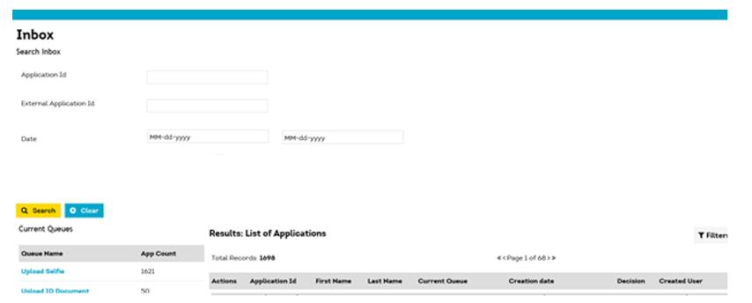

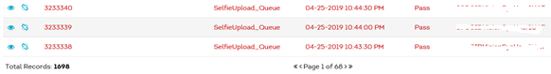

* By default View. Able to View All transaction. More pages will be available if no. of transactions more than one page
* Search Application options:
  + Application ID
  + External Application ID
  + Date Range