# Lesson 2: Solutions for exercises from lecture

## Exercise 2.1

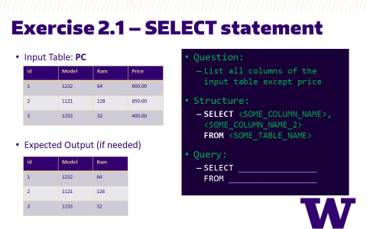

Select all columns except Price from input table PC except price

Answer:

SELECT id,

Model,

Ram

FROM PC

Selecting all columns is easy with *. When we need only a few columns then we must explicitly provide the exact column names (could be case sensitive depending on your flavor of SQL). Although rarely available, some modern flavors of SQL provide a way to select all columns except some using the EXCEPT keyword. eg. BigQuery and PrestoSQL

## Exercise 2.2

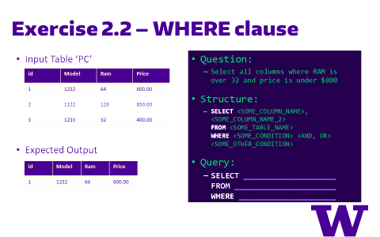

Select all columns where Ram is over 32 and Price is under 800, from input table PC

Answer:

SELECT *

FROM PC

WHERE Ram > 32

AND Price < 800

We are asked to select all columns. So, we simply use * with select statement. The conditions for row selection are given as Ram > 32 and Price < 800 in the WHERE portion

## Exercise 2.3

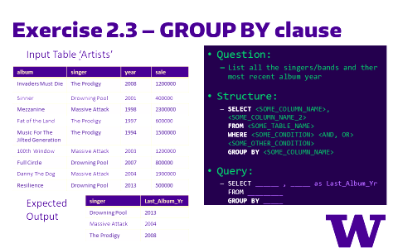

List all the singers/bands and their most recent album year.

Answer:

SELECT singer,

max(year) as Last_Album_Yr

FROM Artists

GROUP BY singer

We are calculating the max(year) for each singer (using Group by singer).

## Exercise 2.4

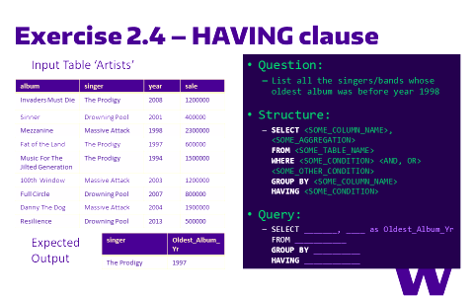

List all the singers/bands whose oldest album was before year 1998.

Answer:

SELECT singer,

min(year) as Oldest_Album_Yr

FROM Artists

GROUP BY singer

HAVING Oldest_Album_Yr < 1998

We are calculating the min(year) for each singer (using Group by singer) to get the Oldest Oldest_Album_Yr. Following that, the HAVING keyword filters the results and retains only those rows which have Oldest_Album_Yr < 1998

## Exercise 2.5

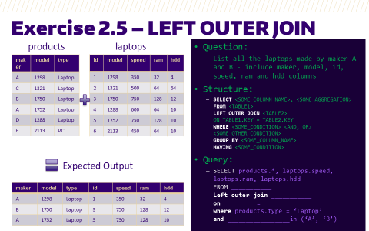

List all the laptops made by maker A and B - include maker, model, id, speed, ram and hdd columns

Answer:

SELECT products.*,

laptops.id,

laptops.speed,

laptops.ram,

laptops.hdd

FROM products

Left outer join laptops

on products.model = laptops.model

where products.type = ‘Laptop’

and products.maker in ('A', 'B')

We are left joining the laptops table onto the products table only for those rows in products table that have maker = either A or B and type = Laptop. We are also selecting all the additional columns (that are not present in Products table) from the laptops table.

## Exercise 2.6

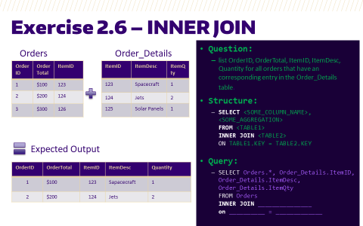

list AuthorID, AuthorName, BookID and BookName for all authors who have a book.

Answer:

SELECT Orders.*,

Order_Details.ItemID,

Order_Details.ItemDesc,

Order_Details.ItemQty

FROM Orders

INNER JOIN Order_Details

on Orders.ItemID = Order_Details.ItemID

We are inner joining the Order_Details table onto the Orders table. This results in only those rows that were able to successfully join. Order# 3 contains ItemID 126 which does not have a corresponding entry in the Order_Details table - hence it doesn't show up in the output.