**Lesson 4 Homework Assignment: DAX**

In this assignment, you will be required to calculate DAX measures and/or functions. The syntax (or the formula) will have to be written out and “tested” within a data set. The data set you will need is ***the Contoso Sales access db file****(which has already been provided to you). Please load the db into an excel file using Power Pivot (if you need assistance, please watch video tutorials for lesson 4). Use the excel file you create with the Contoso sales data model to calculate measures in the assignment, Please submit the excel file. Your completed assignment should be an excel file with the data model, measures and functions seen in the data view of the data model, measures seen in the pivot view in a pivot table and charts (where applicable)*

Please show all work in a power pivot table. Please follow the instructions.

1. For each of the measures that need to be calculated, show the syntax in the data view.
2. List the table in data view where measure/function/calculation has been saved
3. Show measure in pivot view – in a pivot table.
4. Show each measure in a separate tab of the excel file
5. Show measure in a chart (as needed)
6. Save your work as an excel file – ensure data model and pivot table/charts are included
7. Submit excel file

Below are list of measures to calculate:

1. Calculate **total profit** (Note: Total profit = Total sales – Total cost)
2. Show **total profit by chanel** in a graph (Note: Consider bar graph)
3. Calculate and show **total profit % by product category** in a graph (Note: Consider pie graph)
4. Calculate the **average amount of return and discount** (use averagex function. Note: You can add another filter such as channel type to this measure). Label the measure appropriately. Show average amount measure by calendar month
5. Calculate the **standard deviation of the unit cost for online channel** (use stdev.p function). Label the measure appropriately. Show in pivot table.
6. Show which year and for what product category have total sales greater than $250,000 (Note: use the TRUE function)

**NOTE: Mark the date table for the time based measures**

1. **Month To Date OR Quarter To Date OR Year To Date for total cost**. Show in pivot table view. Please see sample (YTD) view below:

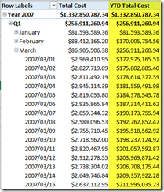

1. Use the SamePeriodLastYear function to calculate the **Month To Date total cost in the previous year.** Refer to function syntax here - <https://msdn.microsoft.com/en-us/library/ee634972.aspx> The power pivot view should show the previous period measure against current period. Sample for total cost YTD is shown below:

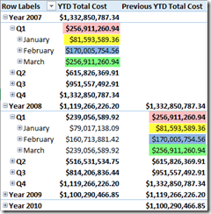

1. Calculate the **Total sales YOY (year over year) Growth Percent**. Divide the YOY Growth Total Sales Amount measure by the Previous Year Total Sales Amount measure to calculate the percent growth

Note: use IFERROR to avoid the error in first year.

1. Show the above measures as a chart – use any chart type you think is best to show the trending of the measure over time (NOTE: line graphs work well)