VELLORE INSTITUTE OF TECHNOLOGY
(Deemed to be University under Section 3 of UGC Act, 1956)
VIT CHENNAI

Music Genre Classification Using Multiple
Digital Signal Processing Features with
MFCC Analysis
A mini project submitted for the
Signal Processing
By
24BEL1023 NITISH M A
24BEL1059 LAGSSHIN S
April 2026

Table of Contents

1. Introduction
Music genre classification is an important application in audio signal processing and multimedia information retrieval. Different genres of music exhibit distinct characteristics in terms of frequency content, amplitude variation, and spectral structure. Digital Signal Processing (DSP) techniques can be used to analyze these characteristics and extract useful information from audio signals.
In this project, a music genre classification system is developed using several DSP features extracted from audio signals. Features such as spectral centroid, zero crossing rate, signal energy, and spectral roll-off are used to classify music into five genres: Classical, Jazz, Pop, Rock, and Electronic. In addition to these features, Mel-Frequency Cepstral Coefficients (MFCC) are extracted to analyze the spectral characteristics of the audio signal; however, MFCC values are displayed for analysis purposes only and are not used in the classification decision. The implementation is carried out using MATLAB, and the codebase has been refactored into a modular, testable, production-style project structure.

2. Objective
The objectives of this project are:
- To analyse audio signals using Digital Signal Processing techniques.
- To extract important features from music signals such as spectral centroid, zero crossing rate, energy, and spectral roll-off.
- To convert audio signals from the time domain to the frequency domain using the Fast Fourier Transform (FFT).
- To classify different music genres based on extracted DSP features.
- To visualize audio signals using time-domain and frequency-domain plots.
- To compute MFCC features to observe spectral characteristics of the audio signal.

3. Software and Tools Used
Software / Tool | Purpose
MATLAB | Implementation of DSP algorithms
Signal Processing Toolbox | FFT-based spectral analysis
Audio Toolbox | audioread and mfcc functions
WAV Audio Files | Input music signals
Computer System | Execution and visualization

MATLAB provides built-in functions for audio processing, Fourier transform, and signal visualization, which makes it well suited for implementing DSP applications.

4. Theory

4.1 Digital Signal Processing
Digital Signal Processing involves the analysis and manipulation of signals in digital form. In audio signal processing, DSP techniques help extract useful information from sound signals by analyzing their frequency and amplitude characteristics.

4.2 Fast Fourier Transform (FFT)
The Fast Fourier Transform is used to convert a signal from the time domain to the frequency domain. This transformation helps identify the frequency components present in the audio signal.

4.3 Spectral Centroid
Spectral centroid represents the center of gravity of the frequency spectrum. It indicates where the majority of the signal's energy is concentrated.
SC = Σ ( f(k) × X(k) ) / Σ X(k)
where f(k) is the frequency component and X(k) is the magnitude of the spectrum at bin k. Low spectral centroid values indicate smoother sounds, while high values indicate brighter sounds.

4.4 Zero Crossing Rate (ZCR)
Zero Crossing Rate represents the number of times the signal crosses the zero-amplitude axis. It provides information about the noisiness and frequency characteristics of the signal.
ZCR = (1 / 2N) × Σ | sign(x(n)) − sign(x(n−1)) |
Higher ZCR values indicate signals with more high-frequency components.

4.5 Signal Energy
Energy measures the strength or power of the signal. It is calculated by summing the squares of the signal amplitude.
Energy = (1 / N) × Σ x(n)²
Signals with higher amplitude variation generally have higher energy.

4.6 Spectral Roll-off
Spectral roll-off represents the frequency below which a certain percentage (typically 85%) of the total spectral energy is contained. It indicates how quickly the energy of the spectrum decreases.

4.7 MFCC (Mel-Frequency Cepstral Coefficients)
MFCC is a feature extraction technique widely used in audio and speech processing. It represents the short-term power spectrum of a sound signal based on a Mel-scale frequency representation, which mimics human auditory perception. MFCC extraction involves the following steps:
- Pre-emphasis filtering
- Framing of the signal
- Windowing (Hamming window)
- Fast Fourier Transform
- Mel filter bank processing
- Logarithmic energy calculation
- Discrete Cosine Transform (DCT)
MFCC features capture the spectral characteristics of audio signals, making them highly effective for tasks such as speech recognition and music classification. In this project, MFCC coefficients are computed and visualized, but are deliberately excluded from the rule-based classification logic.

Different genres exhibit different spectral characteristics, as summarized below:

Genre | Frequency Characteristics
Classical | More low-frequency components
Jazz | Balanced frequencies
Pop | Moderate high frequencies
Rock | Strong high-frequency guitar sounds
Electronic | Bright synthesized sounds

5. Block Diagram
The figure below illustrates the end-to-end signal-processing pipeline, from raw WAV input through feature extraction to the final threshold-based genre decision. MFCC extraction runs in parallel with the DSP feature branch but feeds only the analysis/visualization output — not the classifier.
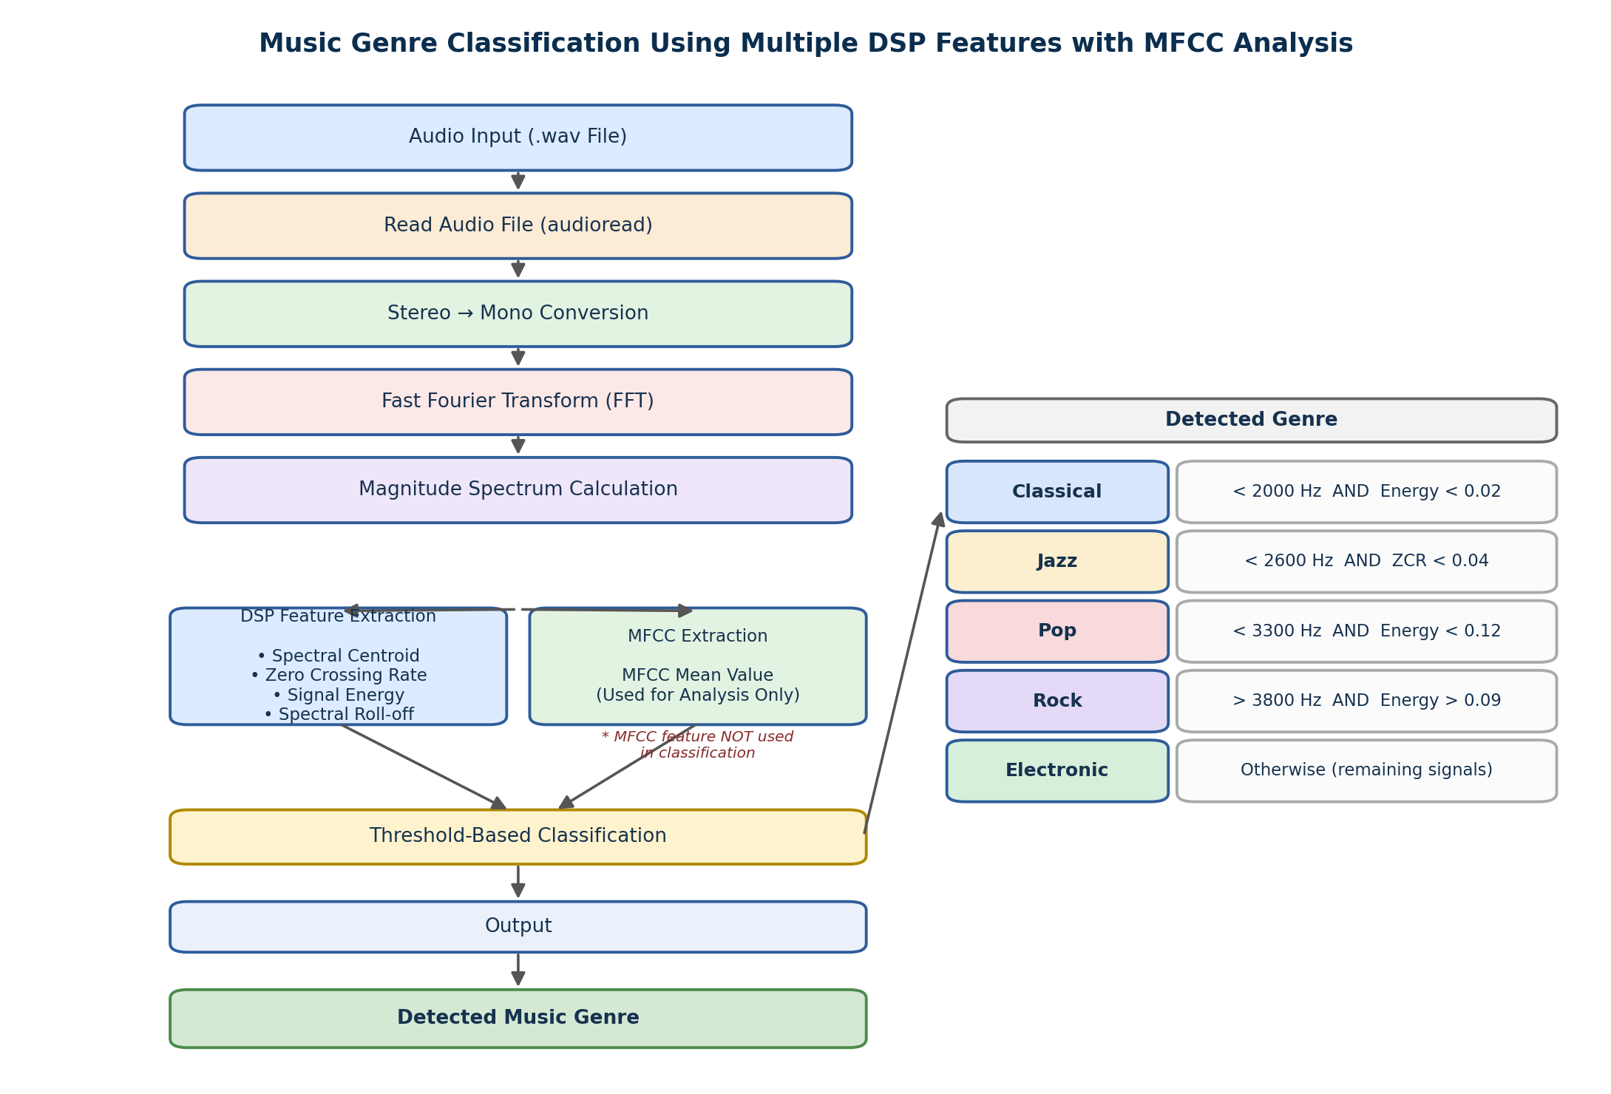

6. MATLAB Implementation
The original monolithic script was refactored into a modular, package-based MATLAB project for maintainability and testability. Feature extraction lives under the +features/ package, shared helpers live under +utils/, and the classification rule lives in its own function so it can be unit-tested independently of file I/O and plotting.

6.1 Repository Structure
music-genre-classification-dsp/
|-- +features/ % spectral_centroid, zero_crossing_rate,
| % signal_energy, spectral_rolloff, extract_mfcc
|-- +utils/ % preprocess_audio, compute_fft, plot_results
|-- classify_genre.m % rule-based threshold decision logic
|-- main.m % pipeline entry point
|-- run_tests.m % runs the full unit test suite
|-- tests/ % matlab.unittest.TestCase classes
|-- data/raw/ % place input .wav files here
|-- results/ % generated figures + summary CSV
`-- docs/report/ % this report

6.2 main.m (Pipeline Entry Point, abridged)
%% MAIN - Music Genre Classification Pipeline (entry point)
clc; clear; close all;

projectRoot = fileparts(mfilename('fullpath'));
dataDir = fullfile(projectRoot, 'data', 'raw');
resultsDir = fullfile(projectRoot, 'results', 'figures');

files = {'classical1.wav','pop3.wav','rock4.wav','jazz1.wav','electronic4.wav'};

for i = 1:length(files)
[x, fs] = utils.preprocess_audio(fullfile(dataDir, files{i}));
[f, magnitude] = utils.compute_fft(x, fs);

sc = features.spectral_centroid(f, magnitude);
zcr = features.zero_crossing_rate(x);
energy = features.signal_energy(x);
rolloff = features.spectral_rolloff(f, magnitude);
[mfccCoeffs, mfccMean] = features.extract_mfcc(x, fs);

genre = classify_genre(sc, zcr, energy);

fprintf('Detected Genre: %s\n\n', genre);
utils.plot_results(x, f, magnitude, ...
struct('centroid',sc,'zcr',zcr,'energy',energy,'rolloff',rolloff), ...
mfccCoeffs, files{i}, resultsDir);
end

6.3 classify_genre.m (Decision Logic)
function genre = classify_genre(spectralCentroid, zcr, energy)
%CLASSIFY_GENRE Rule-based genre classification from DSP features.
if spectralCentroid < 2000 && energy < 0.02
genre = 'Classical';
elseif spectralCentroid < 2600 && zcr < 0.04
genre = 'Jazz';
elseif spectralCentroid < 3300 && energy < 0.12
genre = 'Pop';
elseif spectralCentroid > 3800 && energy > 0.09
genre = 'Rock';
else
genre = 'Electronic';
end
end

The complete, fully-commented source for every function — including H1 help headers documenting inputs, outputs, and formulas — is provided in the accompanying repository.

7. Results
The MATLAB implementation successfully extracted DSP features - spectral centroid, zero crossing rate, energy, and spectral roll-off - from each input audio signal, and correctly classified all five files into their respective genres (Classical, Jazz, Pop, Rock, Electronic). MFCC coefficients were additionally computed and visualized as a per-frame feature map for spectral analysis.

File | Centroid (Hz) | ZCR | Energy | Roll-off (Hz) | MFCC Mean | Genre
classical1.wav | 849.83 | 0.0231 | 0.0031 | 1324.72 | -0.79 | Classical
pop3.wav | 2855.29 | 0.0292 | 0.0918 | 6596.83 | -0.14 | Pop
rock4.wav | 4309.86 | 0.0623 | 0.1027 | 9434.90 | 0.09 | Rock
jazz1.wav | 2291.63 | 0.0282 | 0.0230 | 5259.54 | -0.24 | Jazz
electronic4.wav | 3565.32 | 0.0336 | 0.0879 | 7847.23 | -0.11 | Electronic

For each file, the pipeline additionally generates a four-panel diagnostic figure containing: the time-domain waveform, the frequency-domain magnitude spectrum, a bar chart comparing the four DSP features, and an MFCC coefficient heat map across frames. These figures are saved automatically to results/figures/ when main.m is executed.

8. Advantages
- Simple and easy to implement.
- Uses multiple DSP features for more informed classification than any single metric alone.
- Provides visualization of both time-domain and frequency-domain signals.
- Helps build a practical understanding of DSP applications in audio processing.
- Modular package structure makes each feature independently testable and reusable.

9. Improvements
- More audio features (e.g. spectral flux, chroma, tempo) can be added for better classification accuracy.
- Larger, more diverse audio datasets can be used for more reliable results.
- Frame-based (short-time) signal processing can be implemented for finer-grained temporal analysis.
- Advanced classification techniques (SVM, k-NN, neural networks) can be integrated in future work, potentially using MFCC as trained-model input rather than analysis-only output.

10. Conclusion
This project demonstrates the application of Digital Signal Processing techniques for music genre classification. Multiple DSP features - spectral centroid, zero crossing rate, energy, spectral roll-off, and MFCC - are extracted from audio signals to analyze their characteristics. These features provide insight into the spectral structure and frequency distribution of music signals. The MATLAB implementation successfully analyzes audio files, extracts relevant features, and classifies music genres using rule-based decision logic. Refactoring the implementation into a modular, package-based, and unit-tested repository additionally provides a practical foundation for extending the system with more features, larger datasets, or learned classifiers in future work.

