CN Assignment 2

Muhammad Baqar Laghari
24K-0006
BAI-5A
Random seed = 6

Approach and assumptions
Both protocols are built on rdt 3.0 (checksum, sequence numbers, ACKs, timeout/retransmission) and extended with pipelining. The sender, receiver and an unreliable channel run inside one discrete-event simulator (a time-ordered event queue), so loss, corruption and delay are reproducible for a given seed. Assumptions: 2 Mbps link, 1000-byte packets (4 ms transmission time), one-way propagation 250 ms (RTT 500 ms); a delayed packet gets an extra 0.05 to 0.30 s; timeout 1.2 s (above the maximum RTT of 2 x 0.55 s + 4 ms = 1.104 s, so delay alone never causes a spurious timeout); data flows one way only; sequence numbers are k = 3 bits (modulo 8) and N = 4, which satisfies N <= 2k-1 for GBN and N <= 2k-1 for SR. Loss, corruption and delay apply independently to every data packet and every ACK. Throughput = delivered x 8000 bits / completion time.
Implementation
Channel and checksum.
A packet is lost with probability p loss ; otherwise it may be corrupted (a payload byte is flipped, or the ACK number is altered) and may be delayed. Each packet carries a 16-bit checksum over the sequence/ACK field and payload; the receiver (or sender, for ACKs) recomputes it and discards mismatches. Every send, receive, ACK, loss, corruption, timeout and retransmission is printed as a log line.
GBN.
Sender window is [base, base+N-1] with base = oldest unACKed packet and nextseqnum = next packet to send. ACKs are cumulative: ACK(n) means every packet up to n arrived, so base moves to n+1. One timer runs for the oldest unACKed packet (restarted when base advances, stopped when base = nextseqnum). On timeout all packets from base to nextseqnum-1 are resent. The receiver keeps only expectedseqnum: an in-order packet is delivered and ACKed; anything else (out-of-order or corrupt) is discarded and the ACK of the last in-order packet is repeated.
SR.
Both sender and receiver have a window of size N. The sender keeps a timer per packet and marks each packet when its individual ACK arrives; base slides forward over the acknowledged prefix. The receiver window starts at rcv_base: any packet inside [rcv_base, rcv_base+N-1] is buffered and individually ACKed, and when rcv_base arrives the buffered run is delivered in order. A packet from [rcv_base-N, rcv_base-1] is a duplicate and is re-ACKed (its earlier ACK was lost). On timeout only that packet is resent.

Experiments
task4.py runs both protocols with 200 packets, N = 4, k = 3, seed = 6 under: A. reliable channel; B. loss 0.10; C. mixed (loss 0.05, corruption 0.05, delay 0.10). Every run is checked for 200/200 delivery with correct payloads. As supplementary evidence each setting is also averaged over 30 seeds (6 to 35).

Results

Scenario | Protocol | Transmitted | Retrans. | Delivered | Time (s) | Throughput (kbps) | Exec. (ms)
A: Reliable | GBN | 200 | 0 | 200/200 | 25.21 | 63.5 | 1.2
A: Reliable | SR | 200 | 0 | 200/200 | 25.21 | 63.5 | 1.3
B: Loss 0.10 | GBN | 285 | 85 | 200/200 | 55.85 | 28.6 | 2.0
B: Loss 0.10 | SR | 254 | 54 | 200/200 | 65.42 | 24.5 | 2.3
C: Mixed | GBN | 350 | 150 | 200/200 | 82.52 | 19.4 | 4.8
C: Mixed | SR | 269 | 69 | 200/200 | 75.51 | 21.2 | 1.7
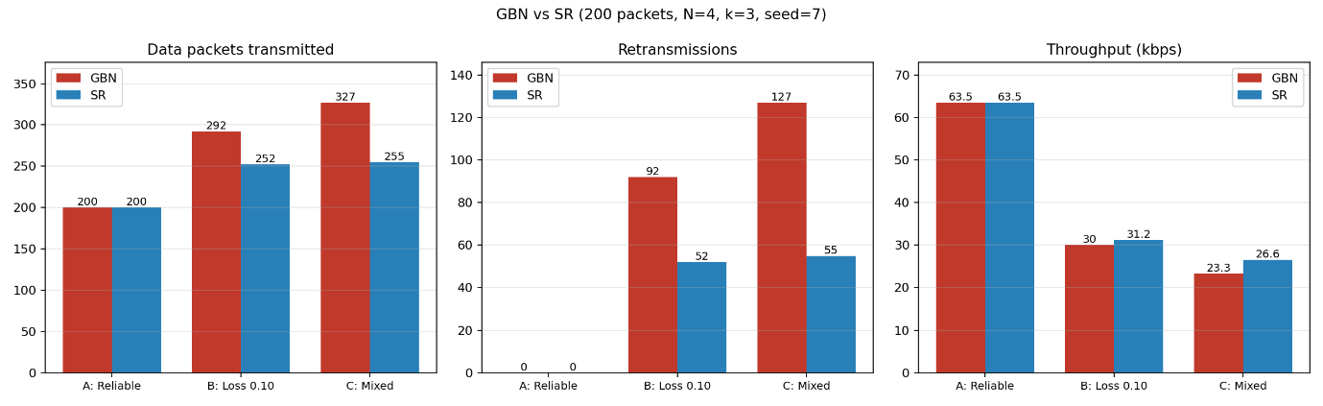
30-seed means (transmitted / retransmissions / kbps): B: GBN 286.8 / 86.8 / 28.5, SR 245.4 / 45.4 / 26.9. C: GBN 343.3 / 143.3 / 20.0, SR 246.8 / 46.8 / 25.8. All 30 runs of every setting delivered 200/200 correctly.

Comparison
On the reliable channel GBN and SR are identical (200 transmissions, no retransmissions) because the window never stalls. Under loss and errors GBN resends the whole outstanding window after each timeout and discards out-of-order packets, while SR buffers them and resends only the missing packet, so GBN retransmits 85 and 150 packets against SR's 54 and 69. This saves bandwidth and gives SR the higher throughput in the mixed scenario (21.2 vs 19.4 kbps; 25.8 vs 20.0 kbps over 30 seeds). With loss only (B) SR is not faster, because each lost packet waits for its own timer while the window is blocked at base, so its advantage there is fewer retransmissions rather than speed.
Conclusion
Both protocols delivered all 200 packets in order in every run (no failures in 200 extra seeds tested for scenarios B and C). GBN is simpler (one timer, one receiver variable) but wastes bandwidth under errors; SR needs per-packet timers and a receiver buffer but retransmits far less. Limitation: sequence numbers are only unambiguous if a packet cannot outlive the time to reuse its number. With a timeout of 1.0 s, below the maximum RTT, one of 30 SR runs under mixed errors accepted a stale duplicate after wraparound; setting the timeout above the maximum RTT removed this.

