LAB COAL # 6

Muhammad Baqar Laghari

24K-0006

BAI-3A

Task#1: 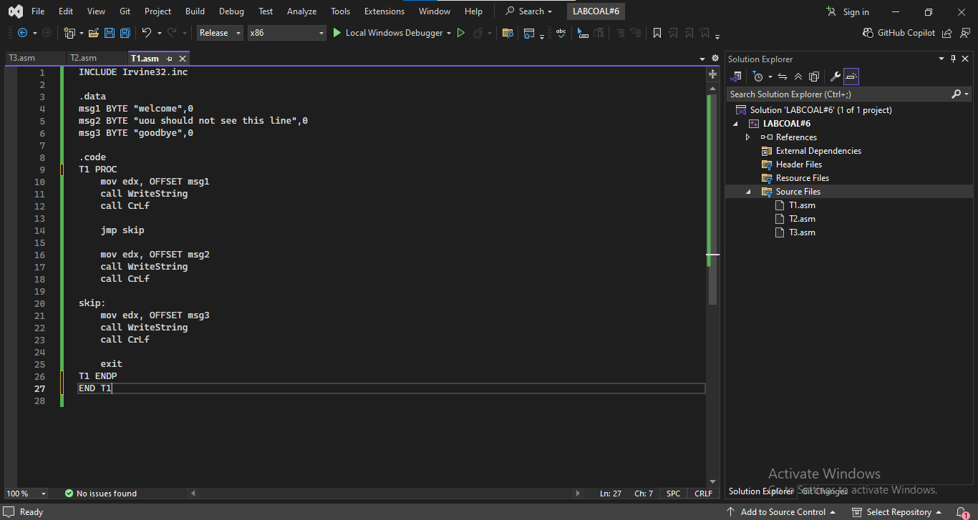

Output: 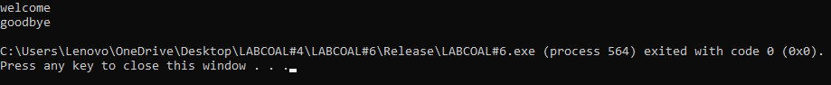

Task#2: 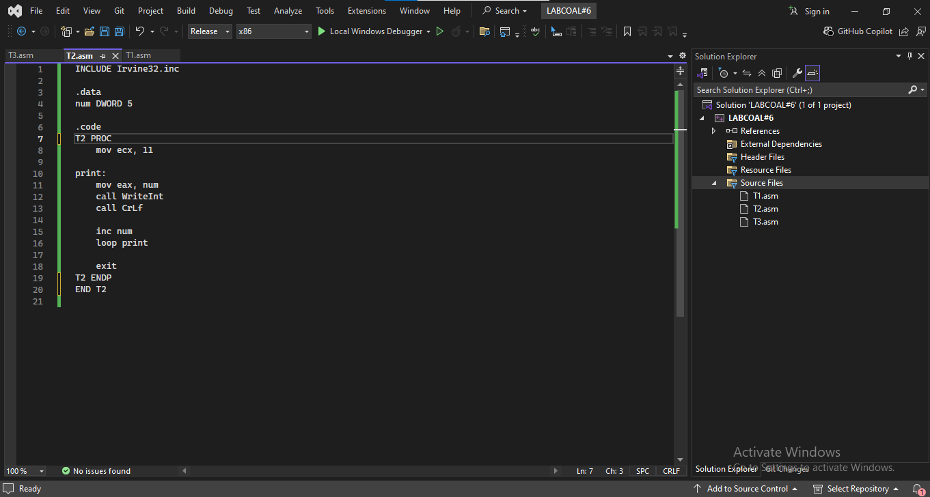

Output: 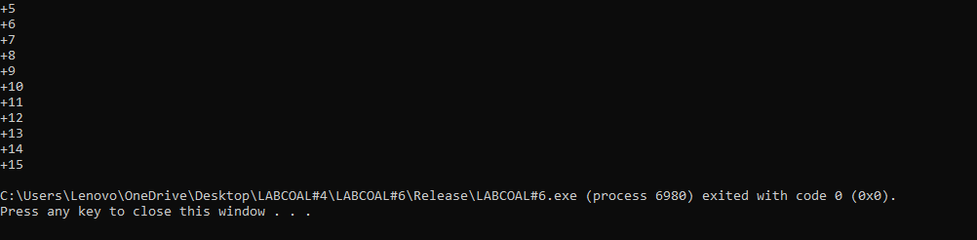

Task#3: 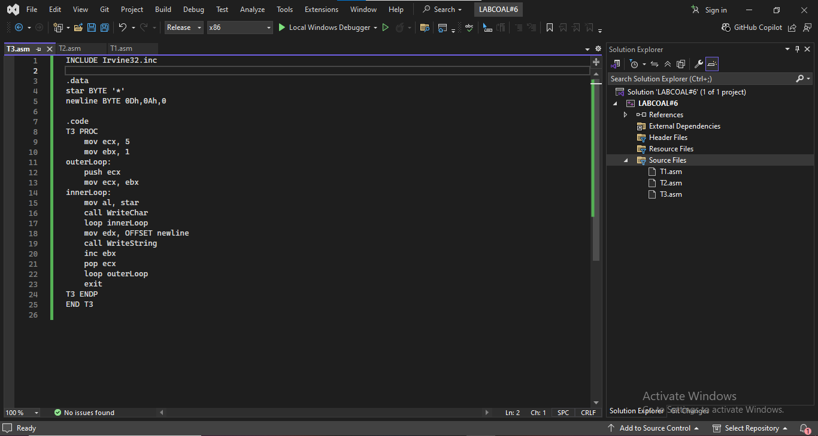

Output:

