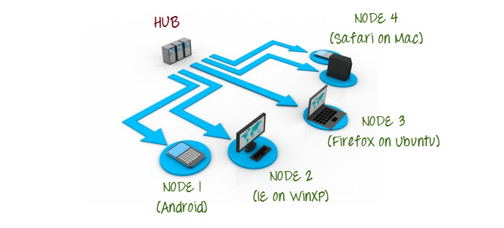

Commands in Hub Machine

1.Setting Up Hub:

**java -jar selenium-server-standalone-2.44.0.jar -role hub**

**C:\selenium_web_driver>java -jar selenium-server-standalone-3.141.59.jar -role hub**

**19:30:27.372 INFO [GridLauncherV3.parse] - Selenium server version: 3.141.59, revision: e82be7d358**

**19:30:27.756 INFO [GridLauncherV3.lambda$buildLaunchers$5] - Launching Selenium Grid hub on port 4444**

**2019-10-18 19:30:28.399:INFO::main: Logging initialized @1914ms to org.seleniumhq.jetty9.util.log.StdErrLog**

**19:30:31.112 INFO [Hub.start] - Selenium Grid hub is up and running**

**19:30:31.114 INFO [Hub.start] - Nodes should register to http://192.168.0.129:4444/grid/register/**

**19:30:31.114 INFO [Hub.start] - Clients should connect to http://192.168.0.129:4444/wd/hub**

**2.Validating Hub started**

[**http://localhost:4444/grid/console**](http://localhost:4444/grid/console)

Commands in Node Machine

**3.Accessing Hub from Node Machine**

[**http://iporhostnameofHub:4444/grid/console**](http://iporhostnameofmachinea:4444/grid/console)

**4.Registering Node with Hub**

**Java –jar selenium-server-standalone-2.44.0.jar –role webdriver –hub** <http://iporhostnameofHub:4444/grid/register -port 5566>

**Code in Hub Machine**

**import java.io.File;**

**import java.net.MalformedURLException;**

**import java.net.URL;**

**import java.util.concurrent.TimeUnit;**

**import org.junit.Test;**

**import org.openqa.selenium.Platform;**

**import org.openqa.selenium.WebDriver;**

**import org.openqa.selenium.firefox.FirefoxDriver;**

**import org.openqa.selenium.firefox.FirefoxProfile;**

**import org.openqa.selenium.remote.DesiredCapabilities;**

**import org.openqa.selenium.remote.RemoteWebDriver;**

**import org.testng.annotations.AfterMethod;**

**import org.testng.annotations.BeforeMethod;**

**public class Testparallel {**

**//protected ThreadLocal<RemoteWebDriver> threadDriver = null;**

**public static void main(String[] args) throws MalformedURLException {**

**WebDriver driver;**

**DesiredCapabilities capabilities = DesiredCapabilities.firefox();**

**capabilities.setCapability(FirefoxDriver.BINARY,new File("C:\\Program Files (x86)\\Mozilla Firefox\\firefox.exe").getAbsolutePath());**

**driver = new RemoteWebDriver(new URL("http://192.168.0.106:5566/wd/hub"), capabilities);**

**driver.get("http://google.com");**

**System.out.println(driver.getTitle());**

**}**

**}**