Selenium Grid:

Selenium-Grid allows you run your tests on different machines against different browsers

5 testcases

Selenium-Grid support distributed test execution.

You can also run the Tests in Parallel in multiple machines on Selenium Grid

HUB- IE 9 - chrome browser,IE11

50 testcases

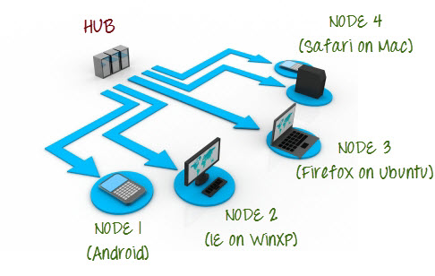

**What is Hub?**

* The Hub is the central point that will receive all the test request and distribute them the the right nodes.  
  There should only be one hub in a grid.  
  The machine containing the hub is where the tests will be triggered, but you will see the browser being automated on the node.
* **Node** :  
  Nodes are the Selenium instances that will execute the tests that you loaded on the hub. Nodes can be launched on multiple machines with different platforms and browsers.

Steps

1. Download Selenium server jar
2. Started the hub

java -jar selenium-server-standalone-3.8.1.jar -role hub

1. Login to another machine and register it as node for Hub
2. Download the selenium server jar in node machine as well/ Check java-
3. java -jar selenium-server-standalone-3.8.1.jar -role webdriver -hub >ipaddress>/grid/register -port 5566

( Check if java is configured in system variables)

6.Chrome driver.exe file geckodriver-