Table of Contents

# Partner Crucible



OpenHack

## Purpose

This project aims to serve as an *entry point* into the wealth of information and services available to Canadian Microsoft partners. The Partner Crucible will curate links, models, and insights to ensure our partners have an overview and a quick path forward.

## Contributing

This project welcomes contributions and suggestions.

This project has adopted the Microsoft Open Source Code of Conduct. For more information see the Code of Conduct FAQ or contact opencode@microsoft.com with any additional questions or comments.

## Legal Notices

Microsoft and any contributors grant you a license to the Microsoft documentation and other content in this repository under the Creative Commons Attribution 4.0 International Public License, see the [License](./License/License.md) file, and grant you a license to any code in the repository under the MIT License, see the [License-code](./License/License-code.md) file.

Microsoft, Windows, Microsoft Azure and/or other Microsoft products and services referenced in the documentation may be either trademarks or registered trademarks of Microsoft in the United States and/or other countries. The licenses for this project do not grant you rights to use any Microsoft names, logos, or trademarks. Microsoft’s general trademark guidelines can be found at http://go.microsoft.com/fwlink/?LinkID=254653.

Privacy information can be found at https://privacy.microsoft.com/en-us/

Microsoft and any contributors reserve all other rights, whether under their respective copyrights, patents, or trademarks, whether by implication, estoppel or otherwise.

# Contrbutors Guide

## How to contriute

The Partner Crucible is *heavily* inspired by the azure docs approch and leverages the guidance in the [Microsoft docs contributor guidance] (https://docs.microsoft.com/en-us/contribute/)

You will need to: 1. [Sign-up for Github](https://docs.microsoft.com/en-us/contribute/get-started-setup-github) 2. [Quick Edits](https://docs.microsoft.com/en-us/contribute/#quick-edits-to-documentation)

More advanced scenatios could involve: - [Long running changes](https://docs.microsoft.com/en-us/contribute/how-to-write-workflows-major)

## References

| Source | Description | Notes |
| --- | --- | --- |
| [Readme](README.md) | Github repositorty Readme |  |
| [Collection Template](Template.md) | A markdown template for contributing collections | … |
| [Azure docs contrbution guidelines](https://docs.microsoft.com/en-us/contribute/) |  |  |

# Partner Portals

## Purpose

The collection of links to Microsoft partner portals

## References

| Source | Description | Notes |
| --- | --- | --- |
| [Partner](https://partner.microsoft.com) | gain instant access to exclusive resources, programs, tools, and connections. Join a community designed to foster business growth | … |
| [Partner Center](https://partner.microsoft.com/en-us/dashboard) | Partner Center streamlines several business processes to make it easier for Microsoft partners to manage their relationship with Microsoft and their customers. Partner Center gives you access to the tools you need to get work done. | … |
| [Canadian Partner Zone](http://aka.ms/CanadaPartnerCommunity) | Forums for Canadian Partners |  |
| [Partner Community Webinar Series](https://aka.ms/partnercall) | Join us monthly for important product and program updates, including tutorials that will help both you and our customers down the road |  |
| [Microsoft for Startups](https://startups.microsoft.com/) | icrosoft for Startups Founders Hub brings together the technology, guidance, and support you need to hit your next milestone. |  |
| [Microsoft Customer Digital Experiences](https://cdx.transform.microsoft.com) | Microsoft Customer Digital Experiences (CDX), is a portfolio of immersed digital experiences to demonstrate Microsoft technology and product with hands-on interaction, orchestrated by Microsoft sellers, partners or marketers. | There are three major types of experiences:-Demos-Interactive guide-Customer Immersion Experience |
| [Azure for Partner](https://www.microsoft.com/azure/partners/) | Main page for Azure resources for Partners |  |
| [Azure for Services Partners](https://www.microsoft.com/azure/partners/practices/the-opportunity) | Grow your cloud services business with Azure | .. |
| [Azure for Technology Partners](https://azure.microsoft.com/en-us/partners/azure-technology-partners/) | Azure for resources independent software vendors (ISVs) | .. |
| [Microsoft 365 & Security for Partners](https://cloudpartners.transform.microsoft.com) | Partner *Transform Portal* for M365 and Security | Accessible based on MPN membership and competencies or solution partner standing) |
| [Microsoft Dynamics 365 Partner portal](https://dynamicspartners.transform.microsoft.com) | Partner *Transform Portal* for Business Apps | Accessible based on MPN membership and competencies or solution partner standing |
| [Microsoft Power Platform Partner Portal](https://powerplatformpartners.transform.microsoft.com) | Partner *Transform Portal* for Power Platform | Accessible based on MPN membership and competencies or solution partner standing |

# Partner Support Plans

## Purpose

### Global PArtner Services (GPS) Technical Team

The GPS Technical team will provide technical enablement as part of the build-with motion for your team. This would include the following: - Envisioning Briefing, Assessment – Technical Briefing, Roadmap Planning, Architecture Design Session (ADS), Build and Assist, Hackathon, Proof of Concept (POC), Technical Skills Enablement, Sales Skills Enablement, Sales Deal, Enablement (first 3 deals), Solution Technical Review, Deployment / Practice Review (Grow) - Note: This team does not technical support or troublehossting to delivery or operations team.

### Support for Partners

* Partners may have a number of customer and partner support contracts in place.
* Partner support options range from those included with the Microsoft Partner Network (MPN) membership to Advanced and Premier support intended for CSP and hosters.
* The cloud support options are described here: Compare Microsoft Partner Support Offerings

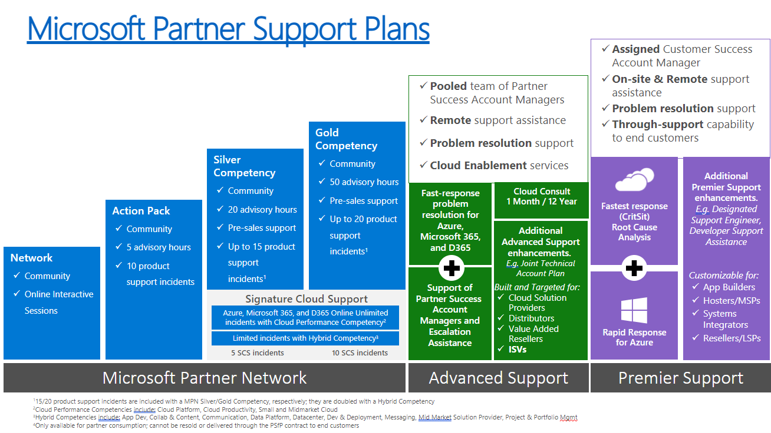

Partner Support Options

## Partner Support FAQ

| Question | Answer |
| --- | --- |
| Q. If the customer in on an EA, can a partner request support on behalf of the customer through ASfP? | - Yes. - The partner would have to “request a relationship” and have the proper affiliation with the customer because they likely did not purchase under CSP if they have an EA. - Nearly 100% of the time, because the ASfP tickets are “unlimited” and the EA may come with a limit or have a customer cost associated with them, the partner will encourage the EA customer to put the ticket through them (the partner). |
| When should a partner use is support contract versus customer contract? | It depends on the scenario: -A partner should always want to use “their support plan” versus the customers when it is ASfP or PSfP. □ If/When the customer has an EA or their own “Unified/Premier” support, except that the customer would have hours or incidents decremented from their plan and the customer may not want their time/incidents deducted from their support plan. - ASfP has “unlimited incidents, however, PSfP may also have incidents/time deducted (again, depends on the type of plan the partner has - - i.e. ASfP has unlimited tickets). -Can the end-customer engage with Microsoft support using the partner’s entitlement? |

## References

| Source | Description | Notes |
| --- | --- | --- |
| [Compare Partner Support Offerings](https://partner.microsoft.com/en-us/support/partnersupport) | Includes video and table with a comparison of:- MPN technical benefits - Advanced Support for Partners - Premier Support for Partners |  |
| [Technical Presales and Deployment Services](https://docs.microsoft.com/en-us/partner-center/technical-benefits) | Use Technical Presales and Deployment services (TPD) for remote, personalized, one-to-one consultations to build your technical capabilities faster, so you can increase sales, deploy more effectively, and accelerate app development. | *Not in scope*: sales pipeline planning, end-customer discussions, training delivery, licensing pricing, and price lists, Break-fix support/troubleshooting, hotfixes, on-site services, long-term consulting (over 25 hours per engagement), training delivery, direct-to-customer support, or hands-on support in a production environment, Code reviews/troubleshooting/performance tuning, application development beyond light proof-of-concepts. |
| [Submit TPDS Request](https://partner.microsoft.com/dashboard/mpn/membership/benefits/technical/createadvisoryhours-servicerequest) | To submit TPDS Request | Requires MPN membership and access to *Partner Center* |
| [Partner Premier Support Training](https://partner.microsoft.com/en-us/training/assets/collection/partner-premier-support-training#/) | Learn about Premier Support for Partners to help you increase your team’s technical capabilities and provide new service offerings to your customers. |  |
| [Providing Support to yourt customers under CSP](https://docs.microsoft.com/en-us/partner-center/customer-support) | Description of support requirements under CSP | .. |
| [Report problems on behalf of customers](https://docs.microsoft.com/en-us/partner-center/report-problems-on-behalf-of-a-customer) | Use the following steps to submit a service request on behalf of your customer | Scope:- Undocumented problems with services that aren’t operating according to service descriptions. -Unavailable services-Bugs and other irregularities that affect service appearance or operation-Large-scale network disruptions - Regional issues with multi-tenant impact |
| [Microsoft Security Response Centre](https://www.microsoft.com/en-us/msrc?rtc=1) | Report a vulnerability in a Microsoft product or service to the MSRC - Microsoft Security Response Center. You can track the status of your report as we work with you to investigate and resolve the issue. | … |
| [MSRC - Submit and Issue](https://msrc.microsoft.com/#:~:text=Microsoft%20follows%20Coordinated%20Vulnerability%20Disclosure%20%28CVD%29.%20We%20request,MSRC%27s%20Bug%20Bounty%20Programs%20and%20Terms%20and%20Conditions) | There is a single process to report issues, supported by Coordinated Vulnerability Disclosure (CVD) | … |

## Partner Architecture Desk

* Centralized team of experienced & qualified architects working through and an engagement model offering specific technical services: RFP/RFI Advice, Technical Briefing, Technical Skills Enablement, Architecture Design Session, Proof of Concept, and Deployment Review​
* Engage the partner Archiecture Desk through your Partner Development Manager or Partner Technology Strategist

What is it?

What it is Not?

Support is for only sell With opportunities (there should be a customer)

Collaborate with local CSA With Partner Architecture Desks Architects on different solution areas

Support for Sell-with related Technical Services

Better response time on key areas that need support

Support available remotely

PST Solution Area CSAs are engaged when needed

Practice or Solution Build-With Support

Attesting Partner’ s Architecture

Break-Fix, Troubleshooting

Implementation Support

Not for strategic or engagement that needs sustained efforts

Not for generic Q&A With no customer context

Dedicated CSA Support

It’s not a paid service or limited to defined hours

Staff Augmentation

Scale training

# Solution Partners

## Purpose

Collection of resources describing the evolution of the Microsoft Partner Network (MPN) to the Microsoft Cloud Partner Program and the streamlining the existing 18 competencies into six solutions partner designations that are aligned with the Microsoft Cloud.

## References

| Source | Description | Notes |
| --- | --- | --- |
| [Landing Page for Partners](https://partner.microsoft.com/en-us/membership/solutions-partner) | Starting October 2022, the new solutions partner designations will help identify your broad technical capabilities and experience in high-demand Microsoft Cloud solution areas. They’ll also showcase your demonstrated ability to deliver successful customer outcomes. | -Overview-FAQ-Benefits-Timeline |
| [Evolving the Microsoft Partner Network programs](https://partner.microsoft.com/en-us/training/assets/collection/evolving-the-microsoft-partner-network-programs#/) | Partner learning path | … |
| [FAQ](https://nam06.safelinks.protection.outlook.com/?url=https%3A%2F%2Fassetsprod.microsoft.com%2Fmpn%2Fen-us%2Ffaq-find-all-frequently-asked-questions.pdf&data=05%7C01%7CMarcAndre.Morisset%40microsoft.com%7Ce850176cc28f46da912e08da335681d8%7C72f988bf86f141af91ab2d7cd011db47%7C1%7C0%7C637878743966198676%7CUnknown%7CTWFpbGZsb3d8eyJWIjoiMC4wLjAwMDAiLCJQIjoiV2luMzIiLCJBTiI6Ik1haWwiLCJXVCI6Mn0%3D%7C3000%7C%7C%7C&sdata=C4ullPmAVSlQNxwVCTONoRSKmMde%2F%2BYkUOtB1fwzhsU%3D&reserved=0) | Comprehensive list of questions on program structure, evolution and associated timelines. | PDF |
| [Support Resources](https://partner.microsoft.com/en-US/support/?stage=2&topicid=15ae6033-aabe-59cd-af85-5895401a87c0) | response to some of the most popular questions from our partner community for your quick reference | - Explains PCS- Explains how to check current PCS by solution area |
| [Canadian Partner Post](https://www.microsoftpartnercommunity.com/t5/What-s-new-for-Canadian-partners/Evolution-of-the-Microsoft-partner-network/m-p/67215#M103) | … | … |
| [MPI Vodcast: Unwrapping the Microsoft Cloud Partner Program](https://www.youtube.com/watch?v=rmj0mMd5QU8&feature=youtu.be) | Tune in to our latest Microsoft Partner Innovation Vodcast episode, hosted by Jennifer Zarate, senior communications manager, Global Partner Solutions at Microsoft, as she sits down with Margaret Totten, managing director and CEO at Akari, and Deb McLeod, chief of staff at Solliance, to discuss the new Microsoft Cloud Partner Program and how the company is investing more in partners. | [Microsoft Partner Innovation Channel](https://www.youtube.com/channel/UCYUkW7seEYoQLNoYEEO32iQ) |

# Sandbox Environments

## Purpose

A collections of resources to create Microsoft Cloud sandbox environments at no (or low) cost

## References

| Source | Description | Notes |
| --- | --- | --- |
| [Visual Studio Azure Benefit](https://azure.microsoft.com/en-ca/pricing/member-offers/credit-for-visual-studio-subscribers/) | Learn how to use the Azure credits that are included in your Visual Studio subscription |  |
| [Dev/Test Subscriptions](https://azure.microsoft.com/en-us/pricing/dev-test/#overview) | Azure Dev/Test pricing |  |
| [Azure Access](https://gearup.microsoft.com/program/azure-access?tab=program-overview) | The Azure Access PoC program provides free Azure sandboxes to customers to showcase the value of Azure and help our field and partners accelerate Azure consumption | … |
| Azure VMWare Services | Provide top AVS partners an opportunity to try AVS free of cost for when they are building/improving AVS services practice. The FY22 AVS Pilot Program provides top AVS partners the opportunity to experience AVS free of charge with white glove support from Microsoft. | AVS Pilot (Trial SKU) provides 3 nodes free for 30-day/720-hours. At the end of 30-days, Trial SKU converts to a paid SKU automatically. One request per Partner (global). Qualification For AVS Advanced Specialization certified partners. Check partner certification status. • As the AVS Advanced Specialization recently launched, we are currently making the following exceptions for: • AVS Co-Sell Prioritized Partner with the commitment to getting certified in AVS Adv Spec in 6 months. • Any AVS partner with at least 1 active AVS customers in pipeline (each customer >= 3 nodes) AND the commitment to getting certified in AVS Adv Spec in 6 months. |
| Azure Virtual Desktop | Try it now during our promotional period We are pleased to offer a special promotion with no charge to access Azure Virtual Desktop for streaming applications to external users. This promotion is effective from July 14, 2021, to March 31, 2022. For additional pricing details, please read the product documentation page and FAQ below. |  |
| [Sentinel](https://azure.microsoft.com/en-us/pricing/details/microsoft-sentinel/) | Try Microsoft Sentinel free for the first 31 days. Microsoft Sentinel can be enabled at no additional cost on an Azure Monitor Log Analytics workspace, subject to the limits stated below. • New workspaces can ingest up to 10GB/day of log data for the first 31-days at no cost. Both Log Analytics data ingestion and Microsoft Sentinel charges are waived during the 31-day trial period. This free trial is subject to a 20 workspace limit per Azure tenant. • Existing workspaces can enable Microsoft Sentinel at no additional cost. Only the Microsoft Sentinel charges are waived during the 31-day trial period. Usage beyond these limits will be charged per pricing listed on this page. Charges related to additional capabilities for automation and bring your own machine learning are still applicable during the free trial. |  |
| Security Workshop | Azure credits for customer workshop delivery |  |

Microsoft 365 & Security for Partners - Cloud Accelerators Office 365 / E3 Office 365 E3| Microsoft (Free Trial) Microsoft Customer Digital Experiences||