„You will seek Me and find Me when you search for Me with all your heart.“ Jeremiah 29,13

Need a translation?
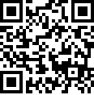English
Dear visitor, understanding of sermons is very important for you. We offer you a text translation of church service in your own language in real time. The only requirement is to have a Smartphone with Internet access.
Please follow the steps to setup it:
- Scan the QR Code or visit translator.seidheilig.de

- Type your name
- Select your language
- Press START
- Now wait for translations


Questions?
Please use „question“ Button in the top of your display if you have any question or problems.

God bless you.

