**System requirements:**

A suitable version of **Windows PowerShell** is available for these operating systems:

* Windows 10
* Windows 8.1 Pro
* Windows 8.1 Enterprise
* Windows 7 SP1
* Windows Server 2019
* Windows Server 2016
* Windows Server 2012 R2
* Windows Server 2008 R2 SP1

**Preparing the system:**

Go to start button right click on the *windows PowerShell* Run as *Administrator*

Check the ExecutionPolicy by running below command in console

Get-ExecutionPolicy

Set the ExecutionPolicy to Unrestricted

Set-ExecutionPolicy -ExecutionPolicy Unrestricted

**Getting the Token ID:**

Generate the new access token using below process.

login into the Canvas website uri (Ex:https://jlg.instructure.com)

Go to Account-->settings-->Approved integrations-->New Access Token

**Run Script:**

1. How to run the script?
2. Run the script by double clicking “CanvasApiMainScript.ps1”
3. Script will ask for **Uri** - Pass login canvas Uri (Ex: <https://jlg.instructure.com>)
4. Script will ask fir **Token ID -** Provide created Token id (Ex:4626~OhR7Arue1IhsaJnplrLYYeqj********)
5. Where files will be created?

Files will be created in the same directory where the script file is located.

1. What files will be created?

School.csv

Section.csv

Teacher.csv

Student.csv

StudentEnrollment.csv

TeacherRoster.csv

**Uploading files to School Data Sync:**

* Click this link <https://sds.microsoft.com>
* Login using your Global Admin account
* Click on Add Profile
* Enter sync profile Name
* Choose Sync method 🡪Upload CSV files
* Choose Type for Csv files you are using 🡪 CSV files: SDS Format
* Click start
* Sync options : choose new users or Existing usersA screenshot of a cell phone

  Description automatically generated
* Upload files: Select created 6 csv files (School.csv, Section.csv, Teacher.csv, Student.csv, StudentEnrollment.csv, TeacherRoster.csv)

* Select “Replace unsupported special characters” option A screenshot of a cell phone

  Description automatically generated
* When should we stop syncing this profile?

* Choose Teacher Options



Select licenses for Teachers

* Choose Student Options



Select licenses for Students

* Review all data and select Create profile



* Once Sync profile is submitted it will take some time to Create sync profile.

Once its created. It will show the status of sync



It will create new Teams in Teams Console

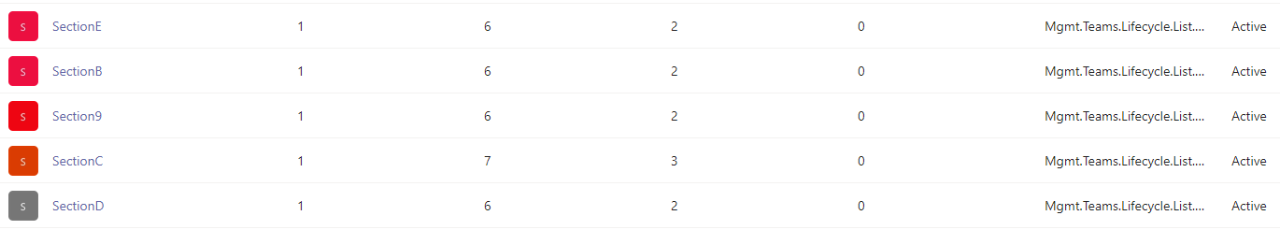

Once its done. It will create O365 groups as shown in below same will reflect in Teams

