Readme

The solution was created on Visual Studio 2017 with C# and Selenium. Bellow the steps to run and understand the solution:

* Coverage of functional scenarios, including corner cases.

The Solution Waes Heroes has the coverage for each Scenario

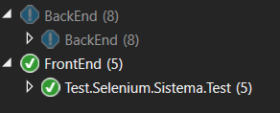

• A report with test results is automatically generated.

* The report was created to show the results on Visual Studio after each execution. Tis solution could be integrated with TFS and shows the results on TFS report. E.g.:

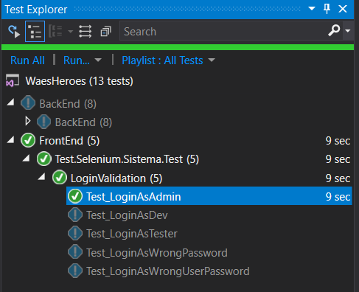

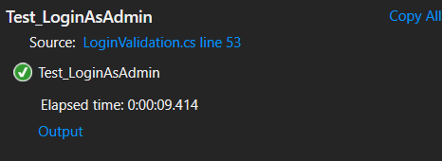

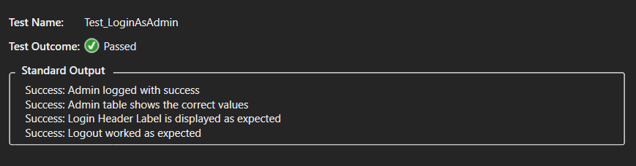

* Short analysis (in text) of the unit tests in the backend application.
  + The tests for backend were create to send the message, get the result in an array and validate with the expected result
* Clear README containing:
  + To run the scripts you should open the solution on Visual Studio and follow the steps bellow:
    - Open Test Explorer
    - Select the Test to run
  + Check report
    - Click on Output from test
    - Check the information from Test steps