 | The Voucher Assistant
The Voucher Assistant is an Activity Desk voucher system that combines an elegant, intuitive user interface with powerful features for both Guest Services and Accounting staff.  Gold Key Solutions designed The Voucher Assistant with Concierges and Accounting staff to be easy to use while providing the necessary features for managing all aspects of Activity Desk sales.  The Voucher Assistant shares activity reservation data with The Concierge  Assistant®. |  | 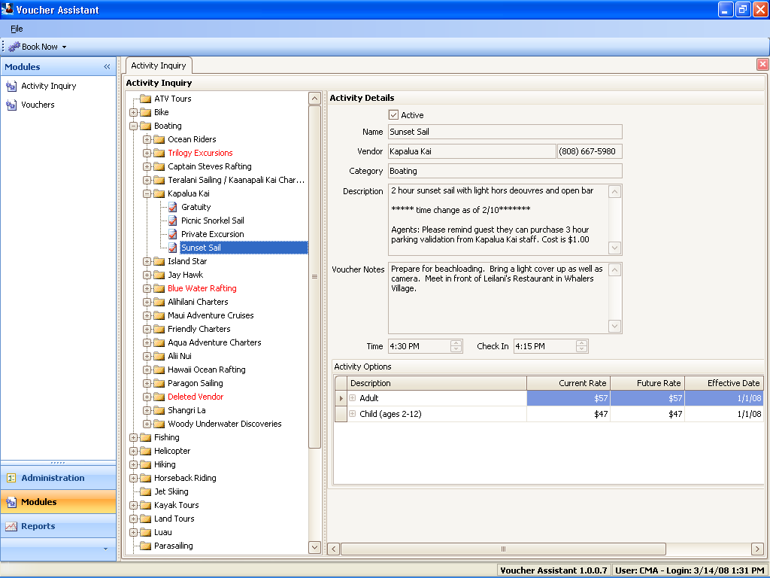
Guest Services Features |  | Accounting Features
- Activity Inquiry module provides an organized directory to make finding and booking activities simple.  - Reporting system to show daily sales, un-issued vouchers and activity manifest.  - Activity reservation data shared with The Concierge Assistant. |  | - Accounts Payable module to manage vendor payments and assist with invoice and voucher reconciliation.  - Reporting system to query and show period sales.  - Net Due calculator to ensure proper set up of complex activities with multiple fees and taxes.
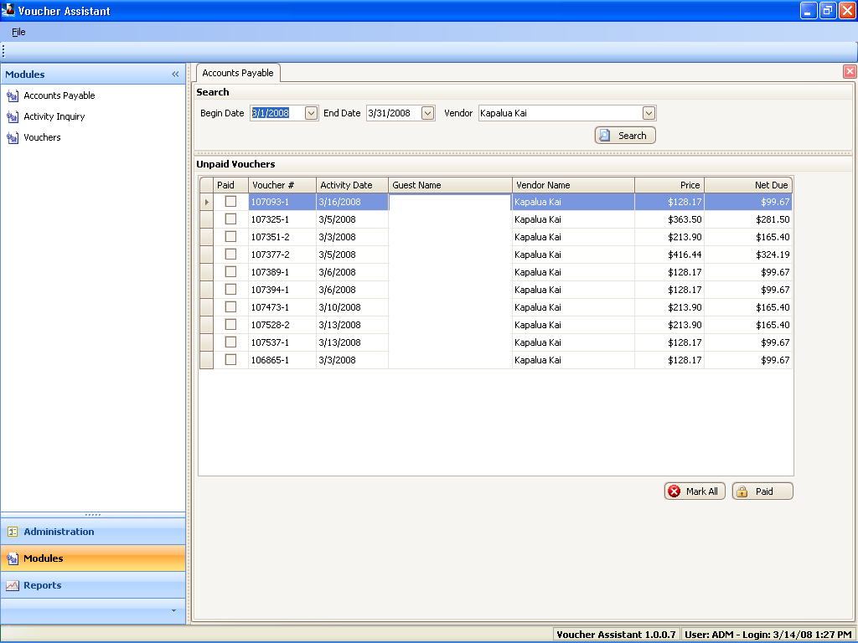 |  | System Requirements
- Microsoft Windows® 2000, XP, Vista
- Microsoft .NET Framework 2.0
- 100 MB available hard disk space
Gold Key Solutions 28720 Roadside Dr Suite 276 Agoura Hills, CA 91301
Phone: (818) 865-0006 Fax: (818) 597-2389
www.goldkeysolutions.com

