Media Sources



<http://imgkid.com/blue-background-gif.shtml>



<http://www.psdgraphics.com/file/blue-fantasy-lights.jpg>



<http://logo-kid.com/facebook-logo-png.htm>

C:\xampp\htdocs\wordpress\wp-content\themes\Theme\images\left-arrow.png

C:\xampp\htdocs\wordpress\wp-content\themes\Theme\images\right-arrow.png

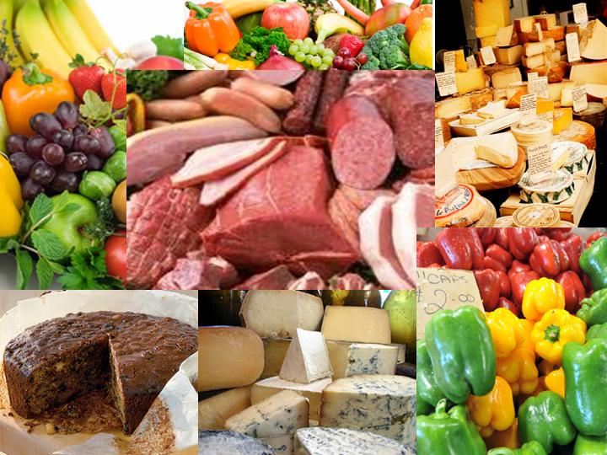

<http://hedgy.com/foodcollage.jpg>

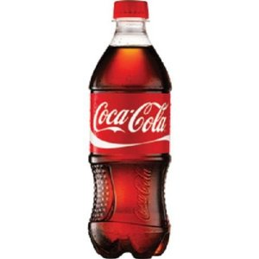

<http://www.amazon.com/Coca-Cola-Classic-20-Ounce-Containers/dp/B004I405P4>

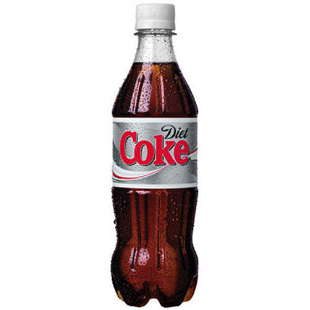

<http://www.samsclub.com/sams/diet-coke-16-9-oz-bottles-24-pk/185195.ip>

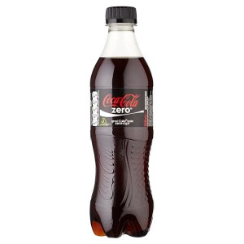

<http://www.latestfreestuff.co.uk/top-20-freebies/free-coke-zero/>

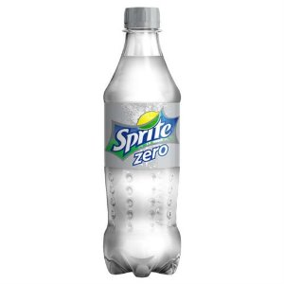

<http://www.amazon.co.uk/Sprite-Drink-500ml-Plastic-Bottle/dp/B00KG9TP4C>

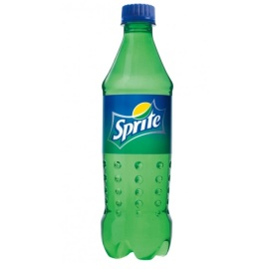

<https://pizzahut.lk/index.php/sprite-bottle-500ml.html>

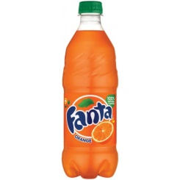

<http://www.tonyspizzamiami.com/prestashop/product.php?id_product=47>

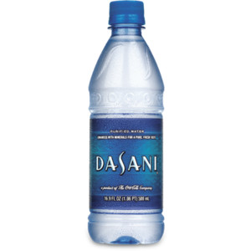

<http://www.polyvore.com/dasani_bottled_water/thing?id=69134372>

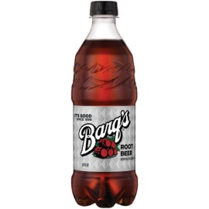

<https://secure.touchnet.com/C20208_ustores/web/product_detail.jsp?PRODUCTID=861>

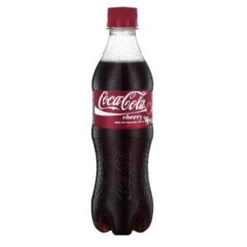

<http://becuo.com/cherry-coke-bottle>

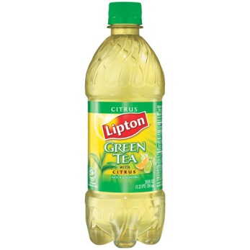

<http://pixshark.com/lipton-tea-bottle.htm>

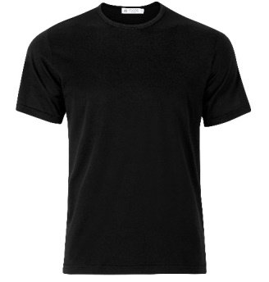

<http://www.sunspel.com/us/q82-superfine-crew-neck-t-shirt.html>

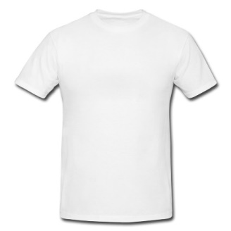

<http://www.egotailor.com/t-shirts/white/page/11>

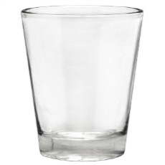

<http://pixshark.com/shot-glass-png.htm>

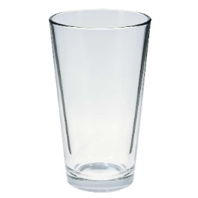

<http://www.numomfg.com/613-Pint-Glass-16-Ounces.html>

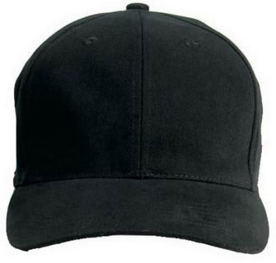

<http://www.armynavyshop.com/category/camo-baseball-caps.html>

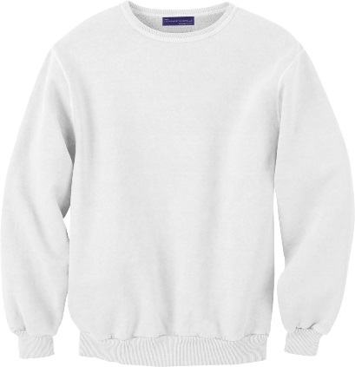

<https://www.justsweatshirts.com/crewneck_white_100_cotton_51044540.html>

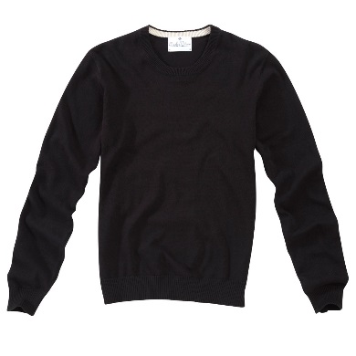

<http://www.cwclothes.co.uk/black-cotton-crew-neck-jumper.html>

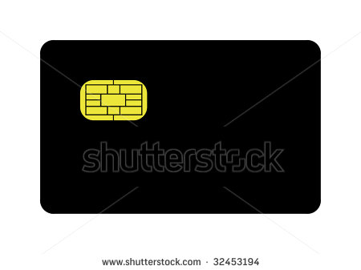

<http://www.shutterstock.com/pic-32453194/stock-photo-blank-black-credit-card-with-gold-emv-strip-isolated-on-white-background.html>

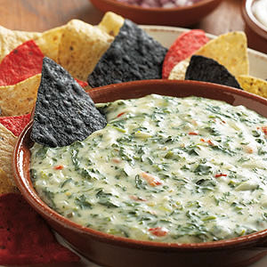

<http://www.recipe.com/cheesy-spinach-dip/>

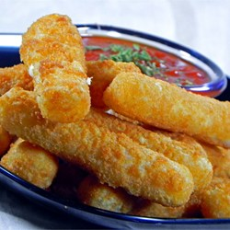

<http://allrecipes.com/recipe/fried-mozzarella-cheese-sticks/>

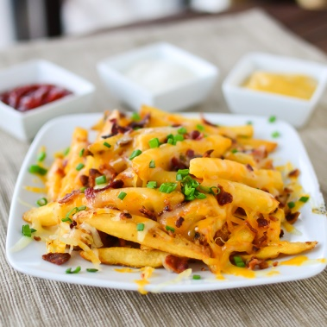

<http://www.justputzing.com/2013/03/bacon-cheese-fries.html>

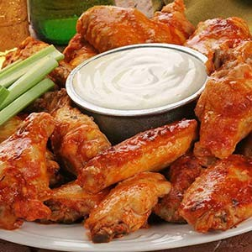

<http://www.visitbuffaloniagara.com/?attachment_id=36270>

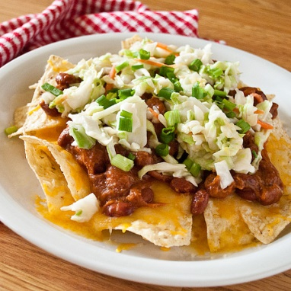

<http://realmomkitchen.com/wp-content/uploads/2011/04/>

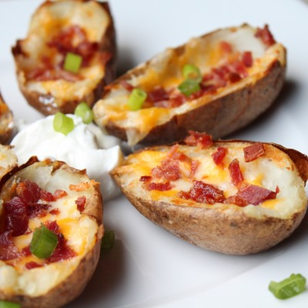

<http://itsybitsyfoodies.com/baked-potato-skins/>

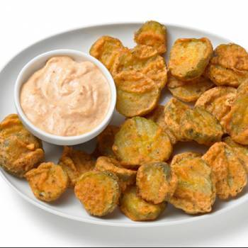

<http://www.ranker.com/list/texas-roadhouse-recipes/shutup-barry>

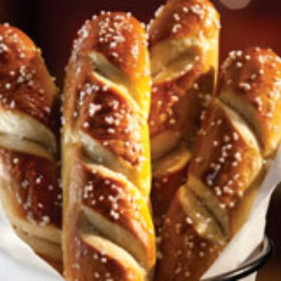

<http://jonryanspubs.com/pub/?page_id=919>

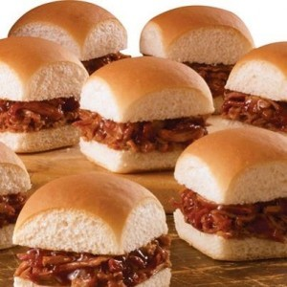

<http://www.palenquecoffeehouse.com/menu/fall-line-up/>

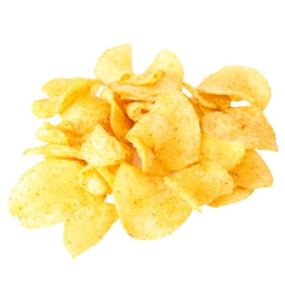

<https://www.amazonsupply.com/kettle-chips-spicy-thai-5-ounce/dp/B000G6MBXW>

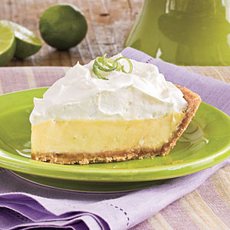

<http://www.southernliving.com/food/kitchen-assistant/key-lime-pie-recipes>

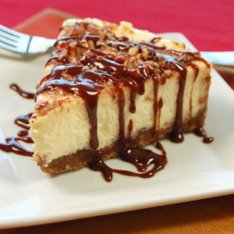

<http://www.cookingpanda.com/wp-content/uploads/2013/01/>

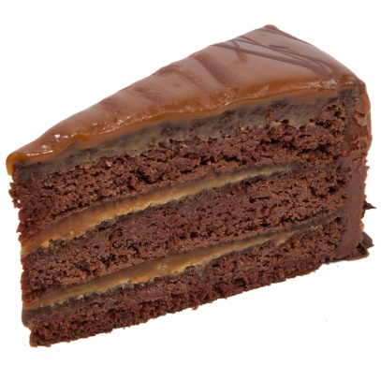

<https://www.pinterest.com/hiyaitsmebecky/year-8-pop/>

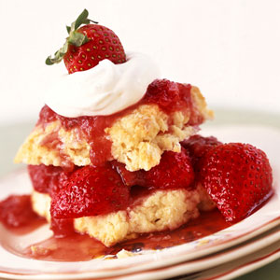

<http://www.recipes100.com/recipe+old+fashioned+strawberry+shortcake>

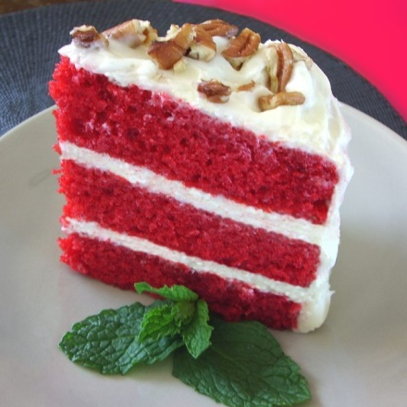

<http://ww.itimes.com/poll/most-delicious-cakes/result>

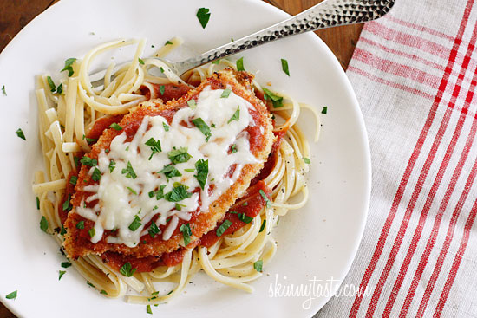

<http://www.skinnytaste.com/2009/04/baked-chicken-parmesan.html>

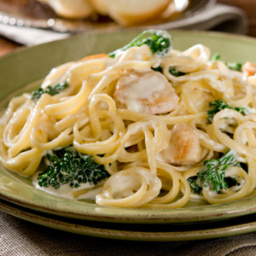

<http://www.oikosyogurt.com/greek-yogurt-recipes/dinner/>

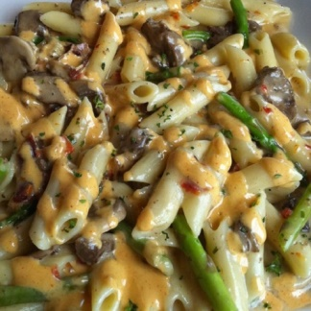

<http://www.mastercook.com/app/Recipe/WebRecipeDetails?recipeId=1161433>

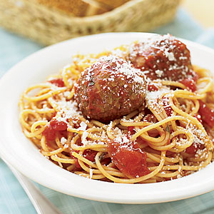

<http://www.myrecipes.com/recipe/ultimate-spaghetti-meatballs>

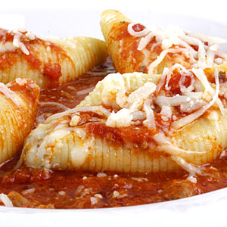

<http://www.recipes100.com/recipe+cheesy+shell-stuffed+shells>

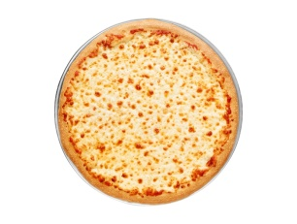

<http://www.brandeating.com/2014/09/news-pizza-hut-7-dollar-large-cheese-pizza-on-september-4th-and-5th.html>

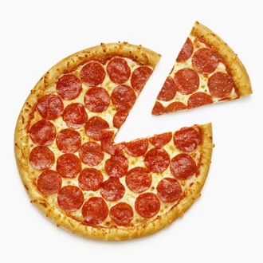

<http://www.sodahead.com/fun/you-can-either-have-potato-soup-or-some-leftover-pepperoni-pizza-which-do-you-choose/question-4719876/?link=ibaf&q=&esrc=s>

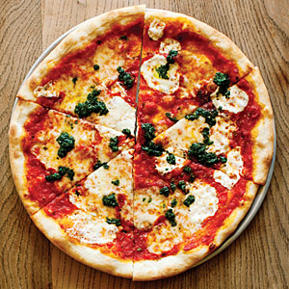

<http://www.myrecipes.com/recipe/pizzetta-211-margherita-pizza>

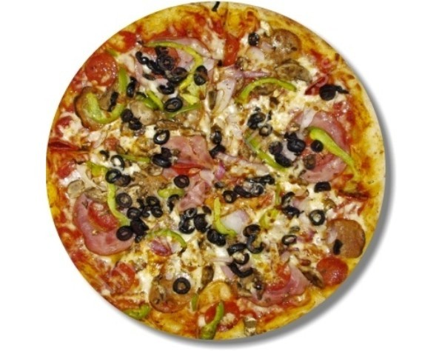

<https://www.etsy.com/market/supreme_pizza>

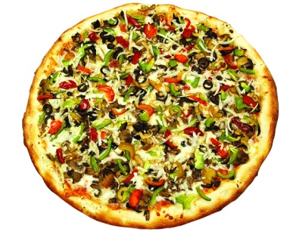

<http://www.misterpizzaelmwood.com/menu/specialty-pizzas.html>

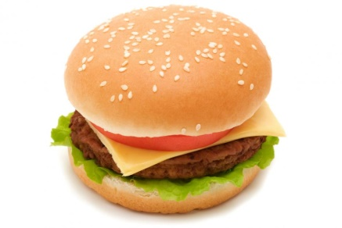

<http://askkissy.com/2015/02/woman-who-was-beat-myriah-pointer-bestfriends-speaks-out-and-says-it-was-all-over-a-hamburger-video/>

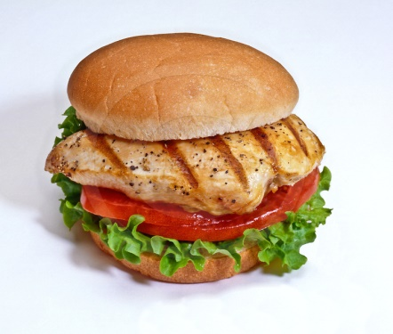

<http://suspendersnyc.com/recipes/grilled-chicken-sandwich-grilled-chicken-breast/>

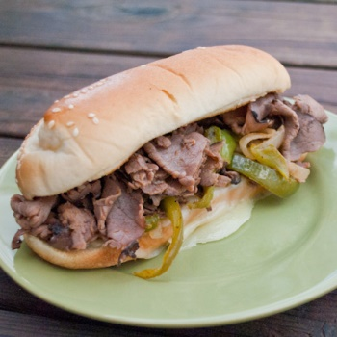

<http://realmomkitchen.com/wp-content/uploads/2010/09/>

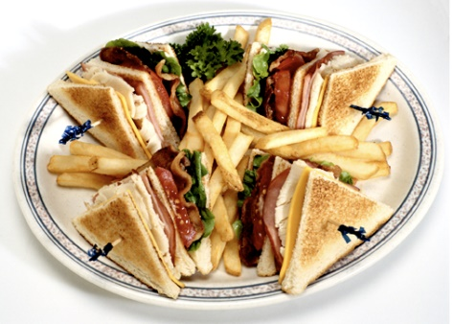

<http://pixshark.com/turkey-club-sandwich-recipe.htm>

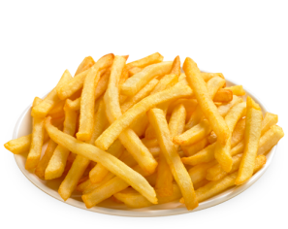

[www.texaschicken.com.sg](http://www.texaschicken.com.sg/menu-sides-french-fries.html)

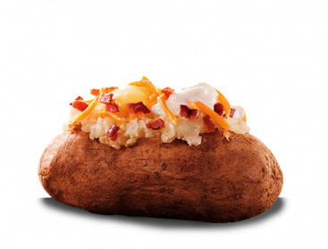

<http://www.backyardburgers.com/menu/sides/loaded-baked-potato>

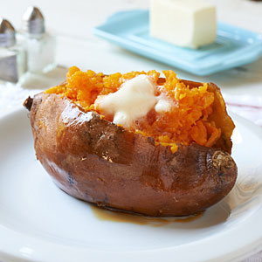

<http://www.recipes100.com/recipe+baked+whole+sweet+potatoes>

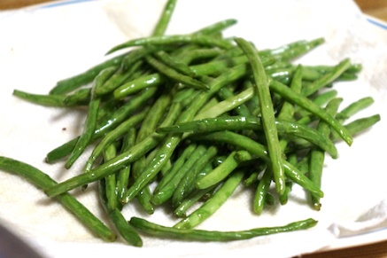

<https://chinesegrandma.com/2011/11/chinese-green-beans/>

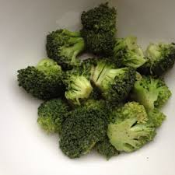

<http://www.purpleearthfoods.com/cgi-sys/suspendedpage.cgi>

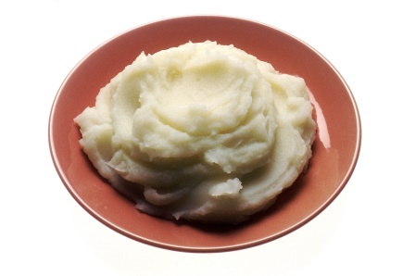

<http://en.wikipedia.org/wiki/Mashed_potato>

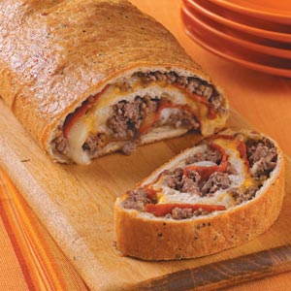

<http://www.tasteofhome.com/recipes/ground-beef-and-pepperoni-stromboli>

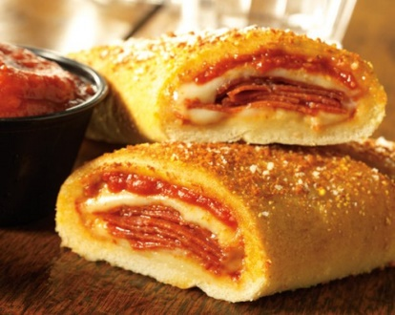

<https://www.flickr.com/photos/donatospizzaclt/3842026079>

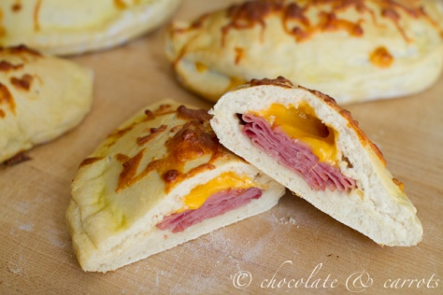

<http://chocolateandcarrots.com/2012/09/ham-cheese-calzones>

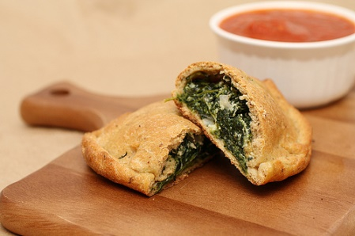

<http://www.adashofsass.com/2011/11/05/whole-wheat-spinach-ricotta-calzones/>

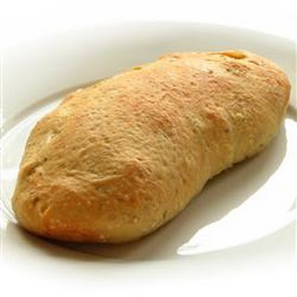

<http://www.yummly.com/recipes/broccoli-cheese-calzone>

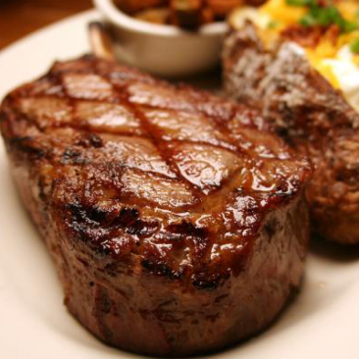

<http://ecfoods.com.hk/deals/8-us-grain-fed-prime-rib-eye-steak-10oz/>

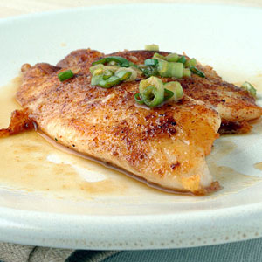

<http://www.myrecipes.com/how-to/cooking-questions/tell-when-fish-is-cooked>

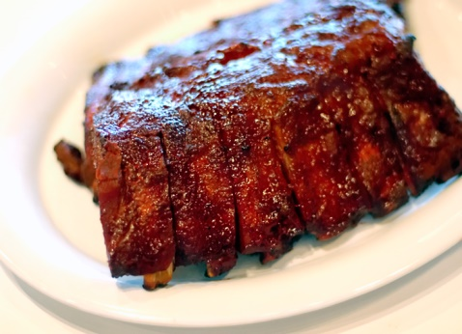

<http://genoapizzayorkville.com/ribs-chicken-and-fish/>

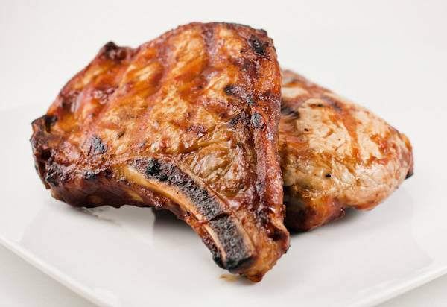

<http://www.grillingcompanion.com/bbq-pork-chops-on-the-grill/>

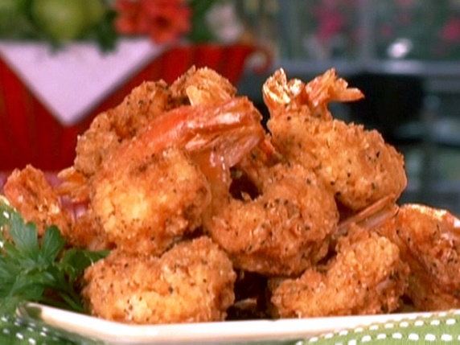

<http://www.thedeepfryerdepotinfo.com/cookware/counter-top-deep-fryers/1366-deep-fried-shrimp/>

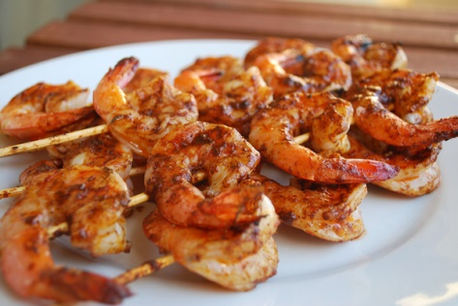

<http://www.saturdaydownsouth.com/2010/tailgating-recipes-week-6/>

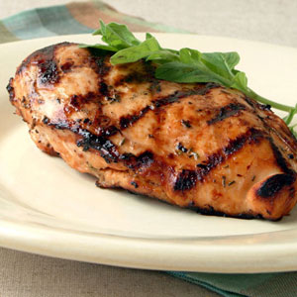

<http://www.myrecipes.com/recipe/lager-lemon-grilled-chicken>

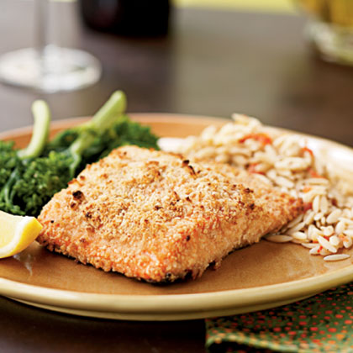

<http://kentuckianahealthwellness.com/almond-crusted-salmon-3>

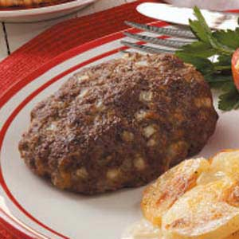

<http://www.tasteofhome.com/recipes/easy-chopped-steak>

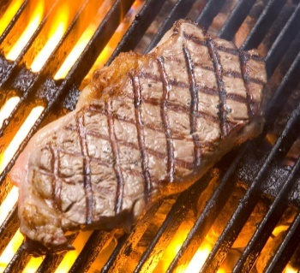

<http://www.mitchelldepot.com/steaks/>

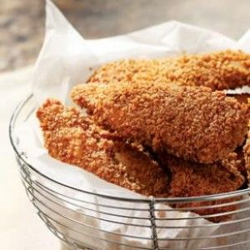

<https://www.pinterest.com/pin/104145810106087617/>

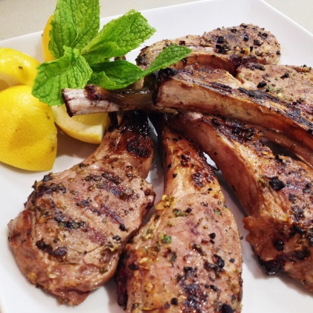

<http://soffiawardy.com/eat/lemony-greek-lambchops/>

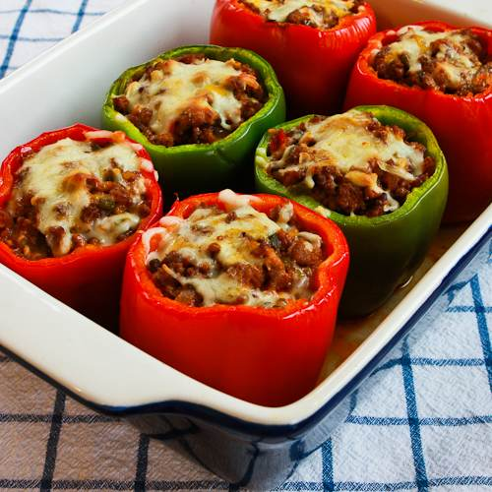

<http://www.kalynskitchen.com/2005/04/stuffed-peppers-with-italian-sausage.html>



<http://www.whatcausesbaldness.net/hair-loss-treatment.html>



<https://megpics.wordpress.com/2012/06/11/mens-hairstyle/>



<http://www.globaltelecomsbusiness.com/article/2451532/Interview-Phil-Male-of-Cable-and-Wireless-Worldwide.html#.VUmp7vlViko>



<http://www.uni-regensburg.de/Fakultaeten/phil_Fak_II/Psychologie/Psy_II/beautycheck/english/prototypen/prototypen.htm>



<http://www.vocativ.com/world/india/indias-pro-male-activists-feel-law/>



<http://alphamalelifestyle.com/the-best-mens-hairstyles-for-your-face-shape/>



<http://www.fanpop.com/clubs/bruce-wayne/images/35628088/title/bruce-wayne-wallpaper-photo>



<http://www.uni-regensburg.de/Fakultaeten/phil_Fak_II/Psychologie/Psy_II/beautycheck/english/prototypen/prototypen.htm>



<http://imgkid.com/female-face-side-view.shtml>