审定成绩：

重庆邮电大学《IT科技英语》
课程综合报告
 | 中文题目 | 大数据在中医药研究中的应用进展
 | 英文题目 | Recent Progress in the Application of Big Data in Chinese Medical Research
 | 学院名称 | 通信与信息工程学院
 | 学生姓名 | 雷宇航
 | 专 业 | 通信工程
 | 班 级 | 01012205
 | 学 号 | 2022210410
 | 任课教师 | 龚璞

2024年 12月

Recent Progress in the Application of Big Data in Chinese Medical Research
Yuhang Lei,
School of Communication and Information Engineering
Chongqing University of Posts and Telecommunications,
Chongqing, China.
1979613025@qq.com

Abstract—In the era of information technology development and digitization, big data has penetrated into various fields of Chinese medicine research and has been used throughout the entire process of data processing. In the study of drug efficacy, the use of chemical efficacy genomics and other means can accurately predict the efficacy of ingredients, saving costs and reducing time. In pharmaceutical process optimization, deep learning and neural networks can be used to dynamically adjust parameters to improve efficiency and maintain quality. Image recognition technology, especially the YOLO model, makes the quality control and classification of tablets more accurate and automated. These applications increase efficiency and empowerment, and help the modernization and inheritance of traditional Chinese medicine. In this paper, we analyze the shortcomings and summarize the relevant applications.
Keywords—big data; efficacy of Chinese medicine; deep learning; Chinese medicine tablets; pharmaceutical process

Introduction
Big data is a collection of data that is huge in size, diverse in type, and fast in processing, and it contains structured, semi-structured, and unstructured data. These data volumes are often so large that they exceed the ability of traditional database software to collect, store, manage, and analyze them. Big data technologies, on the other hand, refer to a range of tools, frameworks, and algorithms for processing and analyzing big data.
The core of big data technology lies in efficiently processing and analyzing data in order to extract valuable information and insights from it. This includes various aspects such as data collection, data storage, data cleansing, data integration, data mining and data analysis. Commonly used big data technologies include distributed storage systems such as Hadoop, real-time data processing systems such as Apache Storm, and algorithms and tools for data analysis and machine learning.
The applications of big data technologies are very broad, covering a wide range of fields such as finance, healthcare, education, transportation, and government. Through big data analytics, businesses and organizations are able to better understand customer needs, optimize business processes, and improve the quality of decision-making to gain an edge in the competitive market environment. With the development of cloud computing and artificial intelligence technology, big data technology is also advancing, bringing more innovative possibilities to various industries.

Basic concepts and principles

The concept of Chinese medicine research
Chinese medicine research refers to the scientific study of traditional Chinese medicine and pharmacology, aimed at exploring and verifying the efficacy, safety and mechanism of action of Chinese medicine. This field covers a wide range of topics from basic theory to clinical practice, including identification, extraction, pharmacology, clinical trials, and optimization of formulae and formulas:
Chinese medicine research not only focuses on the efficacy of individual herbs or compound prescriptions, but also involves the modernization and interpretation of Chinese medicine theories, such as yin and yang, five elements, internal organs and meridians. With the development of modern science and technology, Chinese medicine research is increasingly using advanced means such as molecular biology, genomics, proteomics, etc., with a view to revealing the principles of Chinese medicine and integrating them with modern medical knowledge.
In addition, research on Chinese medicine also includes the organization and study of the culture, history and literature of Chinese medicine, as well as the integration and application of Chinese medicine in the modern medical system. These researches help promote the modernization and of Chinese medicine, so that it can be more widely recognized and applied globally.

The general process of big data in Chinese medicine research
The general process of big data in TCM research includes the following steps:
1) Data collection and integration, collecting data related to Chinese medicine from hospitals, research organizations, literature databases, etc., such as clinical data, medical record information and medicinal material information.
2) Data cleansing and pre-processing to remove erroneous data, fill in missing values and standardize the format to ensure data quality and consistency. Based on this, feature extraction and selection is performed to extract key features from the data that are relevant to the study, such as drug composition and treatment effects, and filter them to optimize the efficiency of the analysis.
3) Use techniques such as machine learning, data mining or statistical analysis to build models and analysis to explore the efficacy and potential mechanisms of TCM in specific diseases or symptoms. The models should be validated and optimized to ensure their accuracy and reliability, and adjusted to enhance their predictive ability and practical application value.
4) Interpretation and application of results, translation of model findings into clinical practice or new directions for further research, and provision of scientific basis for modernization of Chinese medicine and transmission of traditional knowledge.
This process is usually an iterative cycle, with continuous improvement of data processing and analysis methods to deepen the research results.

The application of big data in traditional chinese medicine research

Research on the efficacy of Chinese medicine
In order to analyze the relationship between chemical components and traditional efficacy of traditional Chinese medicines, the researchers proposed the concept of “chemical efficacy grouping”. 26 Chinese medicines with hemostatic efficacy and 38 Chinese medicines with efficacy in activating blood circulation and removing blood stasis were taken as examples, and the chemical components were collected and standardized to express their efficacy and pharmacological effects, and then identified the Murcko skeleton of the components related to hemostatic and blood circulation and removing blood stasis efficacy with the use of the CDK algorithm and RDKit algorithm packages of KNIME 4.3.2. The KNIME 4.3.2 software CDK algorithm and RDKit algorithm package were used to identify the Murcko skeletons of the components related to the efficacy of stopping bleeding and activating blood circulation and removing blood stasis, and the results revealed the common features of the representative components of the efficacy of stopping bleeding and activating blood circulation and removing blood stasis, respectively. Chemical components have different pharmacological effects and play different functions, and the combination of different functions reflects the different efficacies of traditional Chinese medicine.
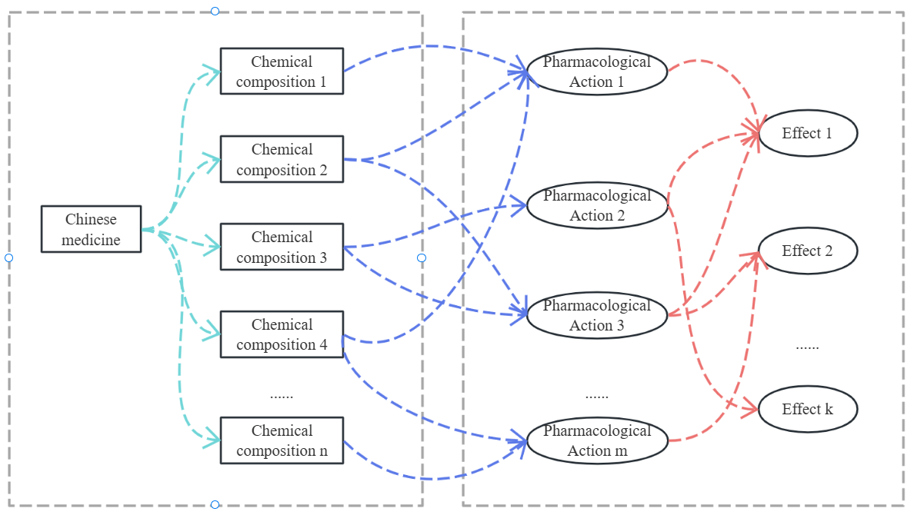
- Chemical efficacy genomics
Murcko backbone extraction is a method for extracting the core framework from complex molecules, which is used to identify the basic structural features of a molecule, removing peripheral branched chains and functional groups, and retaining only the ring system of the molecule and its directly connected main chains.
CDK and RDKit, adopted for Murcko skeleton extraction, are two commonly used open-source toolkits for chemical information, which are widely used in the fields of molecular feature extraction, virtual screening, molecular structure computation, and drug property design. They are mainly used for molecular structure analysis and manipulation.
CDK provides various calculations and manipulations of molecular structures, including analysis of topology and calculation of molecular descriptors. Its Murcko backbone calculation formula is:
whereis the set of atoms in the skeleton andis the set of corresponding bonds.
RDKit is a cheminformatics toolkit commonly used for molecular manipulation, virtual screening, and molecular similarity calculations. RDKit provides algorithms to generate Murcko skeletons and supports the calculation of many molecular descriptors such as molecular fingerprints. Its Murcko skeleton calculation formula is:
whereis the minimum set of rings in the extracted moleculeandis the main chain part of the ring system.

Process optimization of traditional Chinese medicine pharmaceutical processes
In the modern pharmaceutical industry of traditional Chinese medicine, the optimization of process parameters around the extraction process of traditional Chinese medicine is a key step to improve the quality of traditional Chinese medicine preparations. Through scientific and reasonable process optimization, the extraction efficiency of Chinese herbal medicines can be significantly improved to ensure the consistency between batches, which in turn improves the efficacy and safety of medicines. At the same time, the optimization process can also effectively reduce the waste of resources, improve the stability of the production process and environmental protection, and achieve higher economic benefits and social value.
In recent years, the application of modern algorithmic techniques such as numerical modeling and Artificial Neural Network (ANN) in process parameter optimization has gradually emerged. These methods have the ability to handle multifactor and multilevel combinations, and can perform stochastic nonlinear optimization of the process, leading to more accurate prediction and dynamic adjustment. For example, artificial neural networks can automatically capture the complex nonlinear relationships between process parameters and extraction efficiency and potency, which can not only cope with multivariate coupling problems in complex systems, but also achieve the global optimal solution through continuous training and optimization. The introduction of this type of intelligent technology provides a strong technical support for the innovative development of the traditional Chinese medicine pharmaceutical industry.
A dynamic optimization strategy based on deep reinforcement learning for traditional Chinese medicine (TCM) pharmaceutical process has been developed, which mainly consists of offline training of the model and online decision making of the process, see Fig. 2. The accuracy and ubiquity of the model mainly depend on the size and quality of the dataset, which can be sourced from the knowledge base of the TCM pharmaceutical process. The training of the model can be accomplished quickly through the transfer learning method, and the knowledge base can be expanded continuously and the decision-making accuracy can be improved gradually during the actual production process.
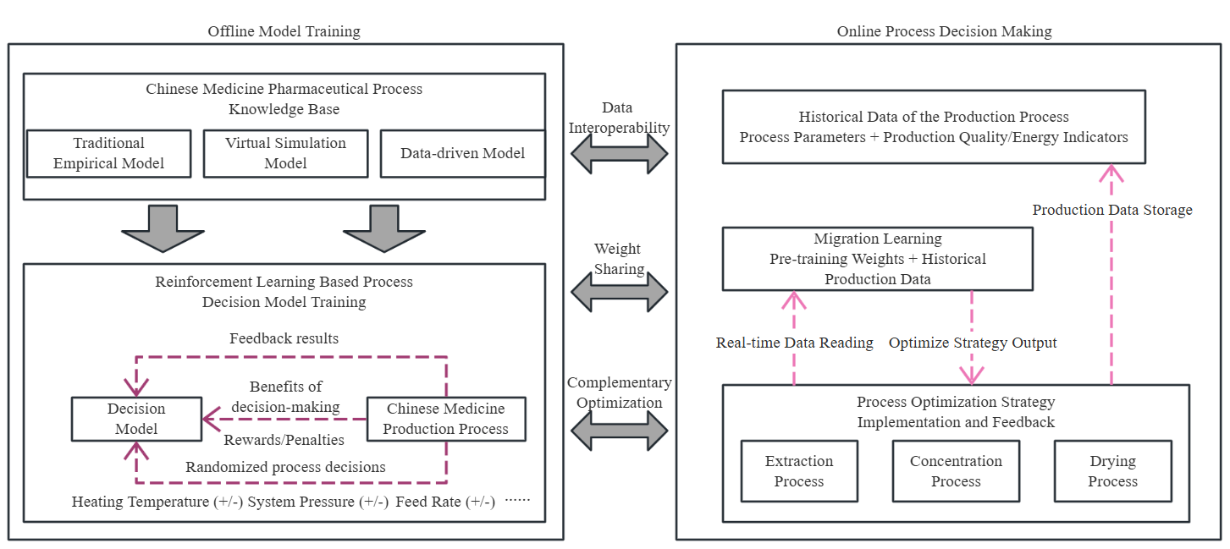
- Optimization of pharmaceutical process parameters of traditional Chinese medicine based on Deep Reinforcement Learning
The deep reinforcement learning model is the main part of the decision-making method for traditional Chinese medicine pharmaceutical process, and its performance determines the effect of decision-making. The training process of the reinforcement learning model is the continuous interaction between the intelligent body and the environment, where the intelligent body observes the current state and makes an action, the environment provides feedback on the action made by the intelligent body and gives incentives to the positive actions, and the intelligent body completes the training goal by making the action with the largest cumulative incentive value. This process is usually described using Markov Decision Process (MDP).
After the offline training is completed, the reinforcement learning model will be installed in the form of software in the industrial control computer, for the process with less trainable data can be used to quickly complete the training of the model, when the target data samples are fewer, the training effect of the task with insufficient samples can be significantly improved by the migration learning method. Reinforcement learning model based on the initial state of the production process, after a number of policy adjustments, the final output of the optimized process decision-making scheme and the expected product quality results. After the production starts, the optimization paths of the process parameters and the actual production process data will be stored in the database. On the one hand, the stored data will be used to expand the knowledge base for case accumulation and process model updating. On the other hand, the process data will be used for the training of the reinforcement learning model to further improve the decision-making accuracy of the reinforcement learning model. Over time, the decision-making effect of the reinforcement learning model will be gradually improved, and the productivity of the optimized process will be gradually increased.

Classification of qality grade of Chinese medicine tablets
The quality of Chinese medicine tablets is a key link to ensure the effectiveness and safety of clinical medication. However, traditional quality control of Chinese medicine tablets mainly relies on manual experience, which is highly subjective and uncertain and lacks systematic, objective and uniform standards. This mode of relying on individual knowledge may lead to inconsistent test results among different personnel, thus affecting the safety of medication and therapeutic efficacy.
With the development of computer science, image processing technology and artificial intelligence, image recognition technology has gradually become an effective means to improve the quality control of traditional Chinese medicine tablets. Some scholars have constructed image databases for hundreds of commonly used Chinese medicine tablets in practical application scenarios. During the data acquisition process, the researchers artificially set different light intensities, shooting angles and complex background factors to simulate diverse environmental conditions, so as to improve the robustness and generalization ability of the model in practical applications.
For model selection, the researchers adopted the deep learning-based YOLO (You Only Look Once) model for feature extraction and model training. The YOLO model has the ability of fast detection and localization, and is especially good at handling small target detection. By introducing a feature pyramid network (FPN) structure, the algorithm is able to effectively fuse feature information from different scales, which further improves the detection accuracy and generalization ability of the model. In addition, this innovative detection method also reduces the cost and time consumption of the traditional detection process, which provides a new idea for the intelligent quality control of traditional Chinese medicine tablets.
The recognition and classification of traditional Chinese medicine is to extract the features of the individual for classification and identification; therefore, the first step is to extract or segment the traditional Chinese medicine tablets from the image, and then the subsequent recognition, identification and analysis, so that the recognition of traditional Chinese medicine can be processed automatically. By designing a depth model-based algorithm for localization and detection of drinking tablets, localization is regarded as a two-class problem. At present, there are many target detection algorithms, commonly used R-CNN, Fast R-CNN, Faster R-CNN and YOLO, etc., of which the YOLO algorithm has the advantages of fast detection speed and high accuracy, so we choose to use the YOLO algorithm to realize the localization and detection of drinking slices, and its training flowchart, see Fig. 3.
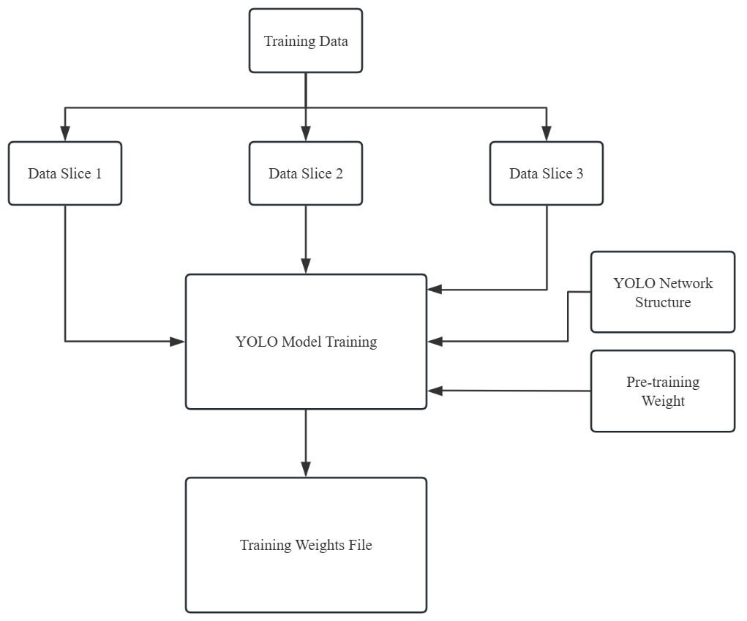
- Flowchart of YOLO model training
YOLO is a convolutional neural network (CNN)-based target detection model that converts the target detection problem into a regression problem by simultaneously predicting the targets and categories in an image through one network forward propagation, with an underlying layer that involves bounding box prediction and loss function selection.
1) Boundary box projections: The YOLO model predicts the location and size of the bounding box, usually by predicting the center coordinates, width and height of the bounding box. For each grid cell, the YOLO model predicts B bounding boxes, each of which predicts 4 values, representing the center coordinates and width and height of the bounding box. These values are usually normalized with respect to the size of the grid cell.
where,,, are the center coordinates and width and height of the predicted bounding box, ,,,are the predicted values of the network output,is the sigmoid function,, are the coordinates of the network cells, and, are the preset width and height of the anchor box.
2) Loss function:
where is the location loss, is the confidence loss, andis the categorization loss.andare weighting coefficients to balance the contribution of different loss terms to the total loss.
In order to accomplish the network's differentiation in terms of details of different classes of herbs of the same species, the network should be sufficiently large in terms of extracted features, i.e., a deeper number of network layers should be designed. Common network models are VGGNet, ResNet, DenseNet, etc. To address the need for a network with a large number of layers and the need to mitigate problems such as network degradation that can be brought about as the network deepens, ResNet can work well by introducing residual blocks, the structure of which is shown in Fig. 4. The network employs hopping connections, where the information from the previous residual block is directly transferred to the next residual block, improving the flow of information. The increase of such constant mapping will effectively solve the degradation problem of the network, which is conducive to deepening the network and extracting more advanced features of the image to complete the classification of the same species of different categories of herbs.
By obtaining the external visual features of traditional Chinese medicine, combining with advanced computer vision technology and using deep learning methods, the recognition and identification of different drinking tablets are realized, and the whole process is automated. And by deepening the number of network layers to extract more deep picture features, it will be beneficial to improve the identification accuracy. However, the increase in the number of layers alone will lead to problems such as network degradation and decrease in identification speed. By establishing an image database of Chinese herbal medicines, data enhancement can be realized and the generalization ability of the model can be improved.
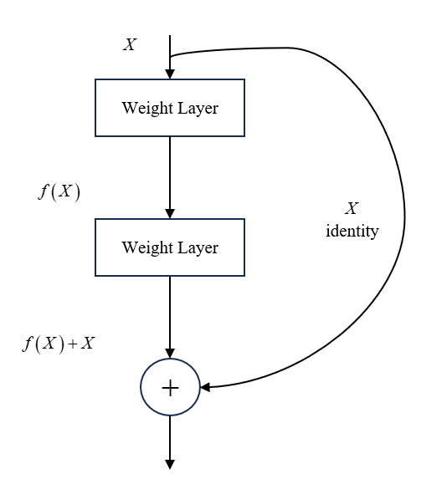
- Computation of residual blocks in ResNet

Deficiencies in the application of big data in the field of chinese medicine

Inadequate mechanisms for data standardization and sharing
There are a wide range of data sources in the field of Chinese medicine, including clinical medical data, Chinese herbal medicine data, ancient literature, etc. These data often lack uniform standards, leading to difficulties in data integration and analysis. In addition, the sharing mechanism of Chinese medicine data is not yet sound, and the phenomenon of data silos is more common, which affects the application effect of big data technology in the field of Chinese medicine. In order to solve this problem, it is necessary to establish and improve Chinese medicine data standards and norms, promote the classification and hierarchical management of Chinese medicine data, strengthen the construction of digital infrastructure in the Chinese medicine industry, and improve the capacity of data collection, production and governance, as well as encouraging the Chinese medicine industry to strengthen the sharing and opening up of data, promoting the circulation and trading of Chinese medicine data, and building an ecosystem of innovative utilization of Chinese medicine data.

Data security and privacy protection issues
With the application of big data technology in the field of Chinese medicine, the security of patient health information and medical data involved has become increasingly prominent. How to ensure the security of data in the process of collection, storage, processing and circulation, and to prevent data leakage and misuse is an urgent problem to be solved. In addition, the categorization and hierarchical protection, security norms and risk assessment mechanisms for TCM data are still imperfect, and a stricter system of data security management system needs to be established to safeguard the security and rational use of data.
Accelerate the formulation and revision of Chinese medicine information standards, improve the Chinese medicine information standard system, strengthen the research and formulation and revision of basic, management and technical standards of Chinese medicine information, vigorously promote the formulation and revision of standards related to the in-depth integration of new-generation information technology such as big data, Internet of Things, artificial intelligence and other Chinese medicines, and push forward the development of key technical standards for the access to Chinese medicine data, processing, storage, exchange, sharing, management, application and security. Promote the development of key technical standards for Chinese medicine data acquisition, processing, storage, exchange, sharing, management, application and security.
At the same time, it will strengthen the security of Chinese medicine data, implement data classification and protection, establish safety norms for the flow, development and utilization of Chinese medicine data and a security risk assessment mechanism, guarantee data security in the process of data collection, transmission, storage, processing, circulation and use, build a risk-controllable and credible security environment for the flow of data, implement the main responsibility for data security, and clarify the boundaries of responsibilities for data security among competent departments of the industry, units of data sources and units of data use. The main responsibility for data security should be implemented, the boundaries of data security responsibilities of competent industry departments, data source units and data-using units should be clarified, and data security standardization and standardization should be promoted to ensure the orderly circulation of Chinese medicine data.

Summarize
The application of big data technology in the field of traditional Chinese medicine is becoming more and more in-depth, covering a wide range of aspects such as quality control of traditional Chinese medicines, efficacy research, optimization of pharmaceutical processes and clinical diagnosis. Through techniques such as data mining and machine learning, researchers are able to predict the efficacy of Chinese medicine ingredients, optimize pharmaceutical processes, improve production efficiency, and enhance the quality control of Chinese medicine tablets through image recognition technology. These advances have not only improved the efficiency and accuracy of Chinese medicine research, but also provided a scientific basis for the modernization of Chinese medicine and the transmission of traditional knowledge.
In the future, with increased computing power and improved algorithms, the application of big data in the field of Chinese medicine is promising. It is expected that more innovative data analysis methods will be developed to process and analyze complex data in the field of TCM. In addition, with the further development of artificial intelligence and deep learning technologies, the prediction of the efficacy of TCM ingredients and the optimization of pharmaceutical processes will become more accurate and efficient. Image recognition technology will also become more mature, further improving the automated identification of Chinese medicine tablets. Overall, big data technology will provide strong support for the modernization and globalization of Chinese medicine and promote the deep integration of traditional Chinese medicine with modern technology.

References

- Y. Wang and H. Wang, "Application progress of intelligent diagnosis and treatment in the development of traditional Chinese medicine," 2023 2nd International Conference on Health Big Data and Intelligent Healthcare (ICHIH), Zhuhai, China, 2023, pp. 109-113.
- Y. Zhuang et al., "Research analysis on the application of big data and artificial intelligence in Chinese medicine diagnosis," 2022 International Conference on Cloud Computing, Big Data and Internet of Things (3CBIT), Wuhan, China, 2022, pp. 199-202.
- J. Liu, X. Zhai, A. Han, S. Ding, M. Wang and P. Yin, "The Future Development of Traditional Chinese Medicine from the Perspective of Artificial Intelligence with Big Data," 2018 IEEE 4th International Conference on Big Data Security on Cloud (BigDataSecurity),IEEE International Conference on High Performance and Smart Computing, (HPSC) and IEEE International Conference on Intelligent Data and Security (IDS), Omaha, NE, USA, 2018, pp. 204-209.
- Y. Guo, L. Me and Y. Sang, "Application of big data analysis in physical health monitoring of Chinese students," 2021 International Conference on Information Technology and Contemporary Sports (TCS), Guangzhou, China, 2021, pp. 294-297.
- W. Li et al., "Improved deep belief network model and its application in named entity recognition of Chinese electronic medical records," 2018 IEEE 3rd International Conference on Big Data Analysis (ICBDA), Shanghai, China, 2018, pp. 356-360.
.

