审定成绩：

重庆邮电大学《IT科技英语》
课程综合报告
 | 中文题目 | 大数据在中医药研究中的应用进展
 | 英文题目 | Current Progress of Big Data Utilization in Chinese Medical Research Fields
 | 学院名称 | 通信与信息工程学院
 | 学生姓名 | 王依琪
 | 专 业 | 信息工程
 | 班 级 | 01042203
 | 学 号 | 2022210490
 | 任课教师 | 王勇

2025年 6月

Current Progress of Big Data Utilization in Chinese Medical Research Fields
Yiqi Wang,
School of Communication and Information Engineering
Chongqing University of Posts and Telecommunications,
Chongqing, China.
441447981@qq.com

Abstract—In the era of information technology development and digitization, big data has penetrated into various fields of Chinese medicine research and has been used throughout the entire process of data processing. In the study of drug efficacy, the use of chemical efficacy genomics and other means can accurately predict the efficacy of ingredients, saving costs and reducing time. In pharmaceutical process optimization, deep learning and neural networks can be used to dynamically adjust parameters to improve efficiency and maintain quality. Image recognition technology, especially the YOLO model, makes the quality control and classification of tablets more accurate and automated. These applications increase efficiency and empowerment, and help the modernization and inheritance of traditional Chinese medicine. In this paper, we analyze the shortcomings and summarize the relevant applications.
Keywords—big data; efficacy of Chinese medicine; deep learning; Chinese medicine tablets; pharmaceutical process

Introduction
Big data denotes datasets characterized by extreme volume, variety, and velocity, encompassing structured, semi-structured, and unstructured information. Such data scales typically surpass the capabilities of conventional database systems in collection, storage, management, and analysis. Correspondingly, big data technologies refer to the integrated tools, frameworks, and algorithms designed for processing and analyzing these complex datasets.
The essence of big data technology resides in its capability to process and analyze data efficiently, aiming to derive actionable insights from massive datasets. This technological framework encompasses a full lifecycle of operations—data collection, storage, cleansing, integration, mining, and analytical modeling. Key implementations include distributed storage ecosystems like Hadoop, real-time processing frameworks such as Apache Storm, and advanced analytical tools combining machine learning algorithms.
The applications of big data technologies are very broad, covering a wide range of fields such as finance, healthcare, education, transportation, and government. Through big data analytics, businesses and organizations are able to better understand customer needs, optimize business processes, and improve the quality of decision-making to gain an edge in the competitive market environment. With the development of cloud computing and artificial intelligence technology, big data technology is also advancing, bringing more innovative possibilities to various industries.

Basic concepts and principles

The concept of Chinese medicine research
Chinese medicine research denotes the scientific inquiry into traditional Chinese medicinal theories and herbal pharmacology, with the aim of exploring, verifying, and elucidating the efficacy, safety, and action mechanisms of Chinese medicine. This interdisciplinary field spans the research continuum from basic theoretical exploration to clinical application, encompassing herb identification, active ingredient extraction, pharmacological analysis, clinical trial design, and formula optimization:
Chinese medicine research extends beyond evaluating the efficacy of single herbs or complex formulas, delving into the modern scientific interpretation of foundational theories—including yin-yang, the five elements, zang-fu organs, and meridian systems. Driven by advancements in molecular biology, genomics, and proteomics, this field aims to decode the scientific basis of traditional concepts and foster integration with modern medical knowledge.
Chinese medicine research additionally encompasses the systematic collation and scholarly inquiry into its cultural heritage, historical evolution, and literary corpus, alongside exploring its integration into modern healthcare systems. These efforts facilitate the modernization of Chinese medicine, enhancing its global recognition and applicability through evidence-based integration and cultural contextualization.

The general process of big data in Chinese medicine research
The general process of big data in TCM research includes the following steps:
1) Data collection and integration, collecting data related to Chinese medicine from hospitals, research organizations, literature databases, etc., such as clinical data, medical record information and medicinal material information.
2) Data cleansing and pre-processing to remove erroneous data, fill in missing values and standardize the format to ensure data quality and consistency. Based on this, feature extraction and selection is performed to extract key features from the data that are relevant to the study, such as drug composition and treatment effects, and filter them to optimize the efficiency of the analysis.
3) Use techniques such as machine learning, data mining or statistical analysis to build models and analysis to explore the efficacy and potential mechanisms of TCM in specific diseases or symptoms. The models should be validated and optimized to ensure their accuracy and reliability, and adjusted to enhance their predictive ability and practical application value.
4) Interpretation and application of results, translation of model findings into clinical practice or new directions for further research, and provision of scientific basis for modernization of Chinese medicine and transmission of traditional knowledge.
This process is usually an iterative cycle, with continuous improvement of data processing and analysis methods to deepen the research results.

The application of big data in traditional chinese medicine research

Research on the efficacy of Chinese medicine
In order to analyze the relationship between chemical components and traditional efficacy of traditional Chinese medicines, the researchers proposed the concept of “chemical efficacy grouping”. 26 Chinese medicines with hemostatic efficacy and 38 Chinese medicines with efficacy in activating blood circulation and removing blood stasis were taken as examples, and the chemical components were collected and standardized to express their efficacy and pharmacological effects, and then identified the Murcko skeleton of the components related to hemostatic and blood circulation and removing blood stasis efficacy with the use of the CDK algorithm and RDKit algorithm packages of KNIME 4.3.2. The KNIME 4.3.2 software CDK algorithm and RDKit algorithm package were used to identify the Murcko skeletons of the components related to the efficacy of stopping bleeding and activating blood circulation and removing blood stasis, and the results revealed the common features of the representative components of the efficacy of stopping bleeding and activating blood circulation and removing blood stasis, respectively. Chemical components have different pharmacological effects and play different functions, and the combination of different functions reflects the different efficacies of traditional Chinese medicine.
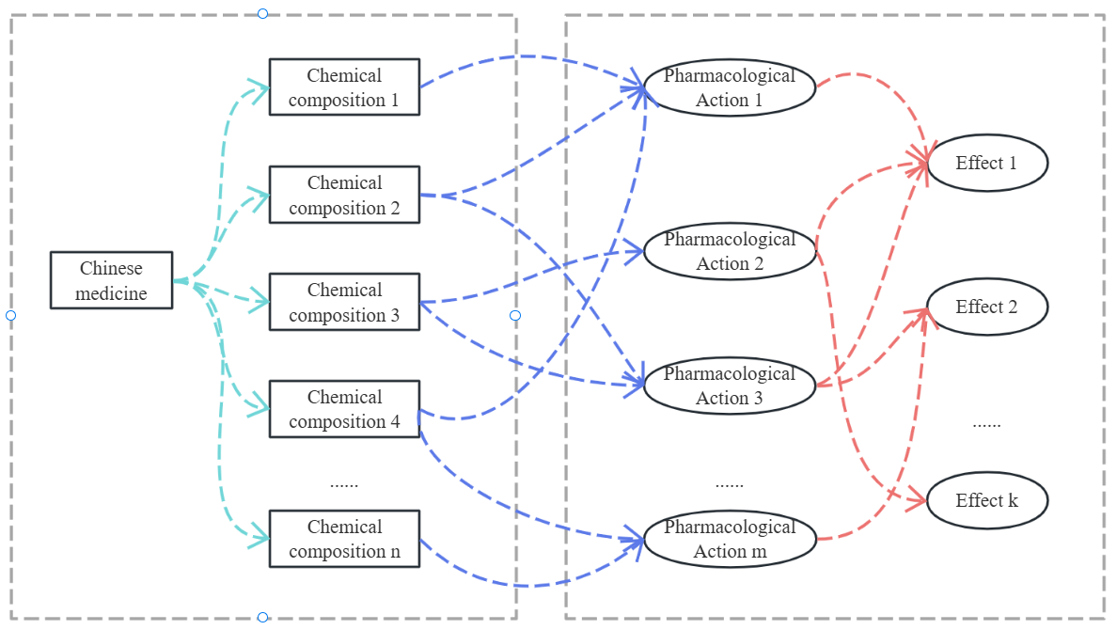
- Chemical efficacy genomics
Murcko backbone extraction is a method for extracting the core framework from complex molecules, which is used to identify the basic structural features of a molecule, removing peripheral branched chains and functional groups, and retaining only the ring system of the molecule and its directly connected main chains.
CDK and RDKit, adopted for Murcko skeleton extraction, are two commonly used open-source toolkits for chemical information, which are widely used in the fields of molecular feature extraction, virtual screening, molecular structure computation, and drug property design. They are mainly used for molecular structure analysis and manipulation.
CDK provides various calculations and manipulations of molecular structures, including analysis of topology and calculation of molecular descriptors. Its Murcko backbone calculation formula is:
whereis the set of atoms in the skeleton andis the set of corresponding bonds.
RDKit is a cheminformatics toolkit commonly used for molecular manipulation, virtual screening, and molecular similarity calculations. RDKit provides algorithms to generate Murcko skeletons and supports the calculation of many molecular descriptors such as molecular fingerprints. Its Murcko skeleton calculation formula is:
whereis the minimum set of rings in the extracted moleculeandis the main chain part of the ring system.

Process optimization of traditional Chinese medicine pharmaceutical processes
In modern traditional Chinese medicine pharmaceutical manufacturing, optimizing process parameters for herbal extraction serves as a critical step to enhance preparation quality. Scientific process optimization significantly elevates extraction efficiency, ensures batch-to-batch consistency, and thereby improves medicinal efficacy and safety. Additionally, such optimization reduces resource waste, enhances production process stability and environmental sustainability, yielding substantial economic and social value.
In recent years, modern algorithmic approaches—including numerical modeling and artificial neural networks (ANNs)—have emerged in process parameter optimization, enabling multi-factor, multi-level combinatorial analysis and stochastic nonlinear optimization. These methods facilitate precise process prediction and dynamic adjustment: for instance, ANNs automatically capture complex nonlinear correlations between process parameters and extraction efficiency/efficacy, addressing multivariate coupling in complex systems while achieving global optimization through iterative training. Such intelligent technologies provide robust technical support for innovative development in TCM pharmaceutical manufacturing.
A dynamic optimization strategy for traditional Chinese medicine (TCM) pharmaceutical processes, rooted in deep reinforcement learning (DRL), integrates offline model training with online process decision-making (as illustrated in Fig. 2). The model’s accuracy and generalizability hinge on dataset quality and scale, sourced from TCM pharmaceutical process knowledge bases. Transfer learning enables rapid model training, while continuous knowledge base expansion and decision accuracy enhancement occur during real-world production.
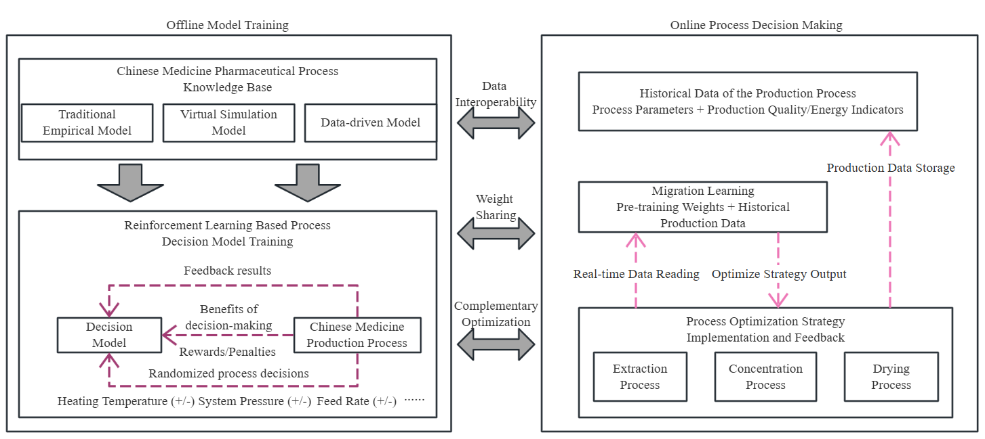
- Optimization of pharmaceutical process parameters of traditional Chinese medicine based on Deep Reinforcement Learning
The deep reinforcement learning (DRL) model serves as the cornerstone of decision-making in traditional Chinese medicine (TCM) pharmaceutical processes, with its performance directly influencing decision efficacy. The RL model training involves continuous agent-environment interaction: the agent observes the current process state, executes actions, receives environmental feedback on action validity, and accumulates rewards for optimal actions—ultimately aiming to maximize cumulative rewards. This process is formally modeled using the Markov Decision Process (MDP).
Upon completing offline training, the reinforcement learning (RL) model is deployed as industrial control software in manufacturing computers. For processes with limited training data, transfer learning enables rapid model adaptation—significantly enhancing performance when target samples are scarce. The RL model generates optimized process decisions and quality predictions by iteratively adjusting policies based on initial production states. During production, optimized parameter trajectories and real-time data are stored in databases, serving dual purposes: expanding the knowledge base for case accumulation/model updates and retraining the RL model to refine decision accuracy. Over time, this iterative learning loop progressively improves both model efficacy and process productivity.

Classification of qality grade of Chinese medicine tablets
The quality of Chinese medicine decoction pieces constitutes a critical factor for ensuring clinical efficacy and medication safety. However, traditional quality control (QC) relies predominantly on manual expertise, suffering from high subjectivity, uncertainty, and a lack of systematic, objective, and unified standards. This individual knowledge-dependent paradigm often leads to inconsistent testing outcomes across operators, thereby compromising medication safety and therapeutic effectiveness.
Driven by advancements in computer science, image processing, and artificial intelligence, image recognition technology has emerged as an effective tool for enhancing quality control (QC) of Chinese medicine decoction pieces. In practical applications, scholars have established image databases for hundreds of common TCM decoction pieces, deliberately introducing variable lighting intensities, shooting angles, and complex background conditions during data collection to simulate diverse real-world scenarios—thereby improving model robustness and generalization capabilities.
Researchers selected the YOLO (You Only Look Once) deep learning model for feature extraction and training, leveraging its strengths in fast detection, precise localization, and small-target handling. By integrating a Feature Pyramid Network (FPN) architecture, the algorithm effectively fuses multi-scale feature information, enhancing detection accuracy and generalization. This innovative approach also reduces the cost and time of traditional QC methods, offering a novel paradigm for intelligent quality control of TCM decoction pieces.
The recognition and classification of Chinese medicine decoction pieces rely on feature extraction for individual identification, requiring initial image segmentation to isolate the pieces before subsequent analysis. By designing a deep learning-based localization algorithm, the task is framed as a binary classification problem. Among prevalent object detection methods (R-CNN, Fast R-CNN, Faster R-CNN, YOLO), YOLO is chosen for its superior speed-accuracy balance, enabling automated localization and detection. The training workflow is illustrated in Fig. 3.
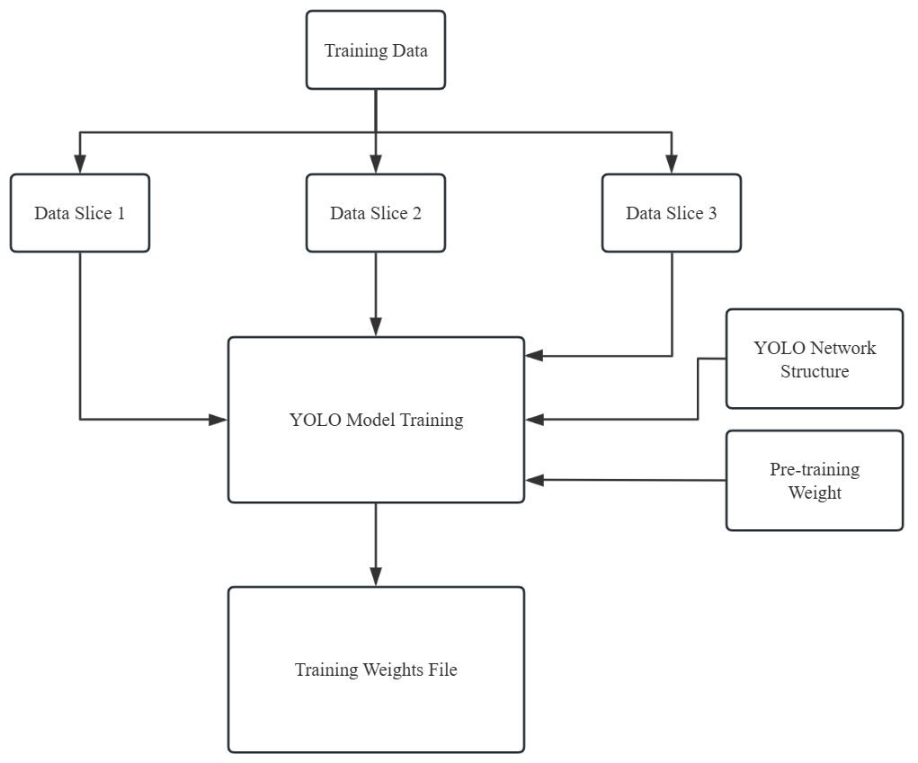
- Flowchart of YOLO model training
YOLO is a convolutional neural network (CNN)-based target detection model that converts the target detection problem into a regression problem by simultaneously predicting the targets and categories in an image through one network forward propagation, with an underlying layer that involves bounding box prediction and loss function selection.
1) Boundary box projections: The YOLO model predicts the location and size of the bounding box, usually by predicting the center coordinates, width and height of the bounding box. For each grid cell, the YOLO model predicts B bounding boxes, each of which predicts 4 values, representing the center coordinates and width and height of the bounding box. These values are usually normalized with respect to the size of the grid cell.
where,,, are the center coordinates and width and height of the predicted bounding box, ,,,are the predicted values of the network output,is the sigmoid function,, are the coordinates of the network cells, and, are the preset width and height of the anchor box.
2) Loss function:
where is the location loss, is the confidence loss, andis the categorization loss.andare weighting coefficients to balance the contribution of different loss terms to the total loss.
In order to accomplish the network's differentiation in terms of details of different classes of herbs of the same species, the network should be sufficiently large in terms of extracted features, i.e., a deeper number of network layers should be designed. Common network models are VGGNet, ResNet, DenseNet, etc. To address the need for a network with a large number of layers and the need to mitigate problems such as network degradation that can be brought about as the network deepens, ResNet can work well by introducing residual blocks, the structure of which is shown in Fig. 4. The network employs hopping connections, where the information from the previous residual block is directly transferred to the next residual block, improving the flow of information. The increase of such constant mapping will effectively solve the degradation problem of the network, which is conducive to deepening the network and extracting more advanced features of the image to complete the classification of the same species of different categories of herbs.
By obtaining the external visual features of traditional Chinese medicine, combining with advanced computer vision technology and using deep learning methods, the recognition and identification of different drinking tablets are realized, and the whole process is automated. And by deepening the number of network layers to extract more deep picture features, it will be beneficial to improve the identification accuracy. However, the increase in the number of layers alone will lead to problems such as network degradation and decrease in identification speed. By establishing an image database of Chinese herbal medicines, data enhancement can be realized and the generalization ability of the model can be improved.
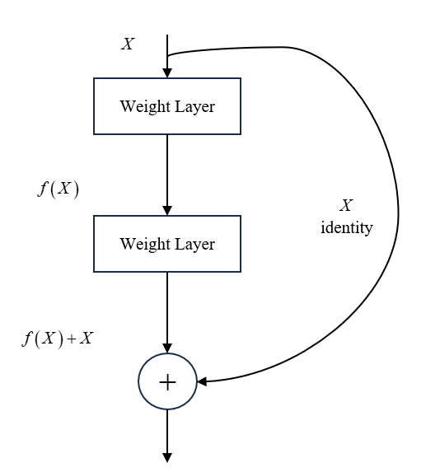
- Computation of residual blocks in ResNet

Deficiencies in the application of big data in the field of chinese medicine

Inadequate mechanisms for data standardization and sharing
The field of Chinese medicine (CM) encompasses diverse data sources—clinical records, herbal databases, ancient literature, etc.—but lacks unified standards, hindering data integration and analysis. Inadequate data sharing mechanisms and prevalent data silos further impede big data applications. Addressing these requires establishing CM data standards, promoting hierarchical data management, enhancing digital infrastructure, improving data governance capabilities, and fostering data sharing/circulation to build an innovative CM data ecosystem.

Data security and privacy protection issues
The application of big data in Chinese medicine (CM) has brought to the forefront the security of patient health information and medical data. Ensuring data security throughout collection, storage, processing, and circulation—while preventing leakage and misuse—has become a pressing challenge. Additionally, incomplete CM data classification, hierarchical protection frameworks, security norms, and risk assessment mechanisms necessitate the establishment of stricter data security management systems to safeguard data integrity and responsible use.
Expedite the formulation and revision of Chinese medicine (CM) information standards to improve the CM information standard system. Strengthen research and development of basic, managerial, and technical standards for CM information. Vigorously promote standards integrating next-generation technologies (big data, IoT, AI) with CM, and advance key technical standards for CM data in acquisition, processing, storage, exchange, sharing, management, application, and security.
Strengthen Chinese medicine (CM) data security by implementing classification-based protection, establishing security norms for data flow and utilization, and developing risk assessment mechanisms. Ensure data security across collection, transmission, storage, processing, circulation, and application. Build a trustworthy security environment that enables controlled data flow, assign primary data security responsibilities, clarify accountability boundaries among industry authorities, data source entities, and data users, and promote standardized security practices to facilitate orderly CM data circulation.

Summarize
Big data technology is being increasingly integrated into traditional Chinese medicine (TCM), spanning quality control, efficacy research, pharmaceutical process optimization, and clinical diagnosis. Through data mining and machine learning, researchers predict herb efficacy, optimize manufacturing processes, and enhance production efficiency. Image recognition technologies further strengthen TCM decoction piece quality control. These advancements not only improve TCM research efficiency and accuracy but also provide a scientific foundation for TCM modernization and traditional knowledge transmission.
With escalating computing power and algorithmic advancements, big data applications in traditional Chinese medicine (TCM) hold promising prospects. Anticipated innovations include the development of cutting-edge data analysis methods to process TCM’s complex datasets. Further progress in AI and deep learning will enhance the accuracy and efficiency of herb efficacy prediction and pharmaceutical process optimization, while matured image recognition technologies will advance automated TCM decoction piece identification. Collectively, big data will strongly support TCM modernization and globalization, fostering deep integration between traditional wisdom and modern technology.

References
- Y. Wang and H. Wang, "Application progress of intelligent diagnosis and treatment in the development of traditional Chinese medicine," 2023 2nd International Conference on Health Big Data and Intelligent Healthcare (ICHIH), Zhuhai, China, 2023, pp. 109-113.
- Y. Zhuang et al., "Research analysis on the application of big data and artificial intelligence in Chinese medicine diagnosis," 2022 International Conference on Cloud Computing, Big Data and Internet of Things (3CBIT), Wuhan, China, 2022, pp. 199-202.
- J. Liu, X. Zhai, A. Han, S. Ding, M. Wang and P. Yin, "The Future Development of Traditional Chinese Medicine from the Perspective of Artificial Intelligence with Big Data," 2018 IEEE 4th International Conference on Big Data Security on Cloud (BigDataSecurity),IEEE International Conference on High Performance and Smart Computing, (HPSC) and IEEE International Conference on Intelligent Data and Security (IDS), Omaha, NE, USA, 2018, pp. 204-209.
- Y. Guo, L. Me and Y. Sang, "Application of big data analysis in physical health monitoring of Chinese students," 2021 International Conference on Information Technology and Contemporary Sports (TCS), Guangzhou, China, 2021, pp. 294-297.
- W. Li et al., "Improved deep belief network model and its application in named entity recognition of Chinese electronic medical records," 2018 IEEE 3rd International Conference on Big Data Analysis (ICBDA), Shanghai, China, 2018, pp. 356-360.
.

