审定成绩：

重庆邮电大学《IT科技英语》
课程综合报告
 | 中文题目 | 大数据在电子商务平台中的应用
 | 英文题目 | Application of big data in e-commerce platforms
 | 学院名称 | 通信与信息工程学院
 | 学生姓名 | 雷宇航
 | 专 业 | 通信工程
 | 班 级 | 01012205
 | 学 号 | 2022210410
 | 任课教师 | 龚璞

2024年 12月

Application of big data in e-commerce platforms

Yuhang Lei
Chongqing University of Post of Telecommunication
Chongqing, China

Abstract—E-commerce has shown a spurt development trend under the background of the rapid development of big data technology and mobile Internet. E-commerce applies big data technology to all links and obtains greater economic benefits from it, thereby building a new business model. Based on the background of big data, e-commerce has developed rapidly, making e-commerce platforms present diversified goods and services, and e-commerce platforms can use big data technology to carry out accurate user analysis and comprehensive marketing, and promote the improvement of e-commerce platform business management level. The era of big data has brought great development vitality to all walks of life, and also brought great development challenges to enterprises. In the e-commerce industry, big data technology is indispensable and has played a great role in promoting the development of the industry. This paper discusses the application of big data technology in e-commerce, first introduces the concept of big data technology and e-commerce, then briefly summarizes the personalized recommendation algorithm of e-commerce in the big data environment, and finally analyzes the shortcomings of the application of big data technology in the field of e-commerce, and summarizes the full text.
Keywords—big data, e-commerce , apply, personalized recommendations

Introduction (Heading 1)

Big Data Technology
Big data technology refers to extracting certain effective information from a large amount of data according to certain rules or attributes. With the continuous development of digital economy and digital computing technology, it is very necessary to apply big data technology in e-commerce. Big data technology can be divided into the following types: (1) data acquisition technology; (2) data processing technology; (3) Data analysis technology. The application of big data technology in e-commerce is mainly reflected in the collection, analysis and processing of existing data through certain rules for some relevant data to help platforms or merchants make decisions and other activities. Big data technology is a way of data collection, which specifically deals with some data that cannot be collected and organized by everyday tools, optimize the data, and improve the insight and decision-making power of the data. Big data generally has the following characteristics: First, massive data information, big data database is a relatively large architecture. Second, the speed is fast, and the corresponding technology is used to process the data information, and the data information can be deeply analyzed and updated in a relatively short time [1]. Third, diversification, big data has a certain breadth, involves more content, can be applied to the development of all walks of life. It can be seen that the impact of big data has received more and more attention.

Electronic Commerce
E-commerce is a business form that relies on the development of Internet technology, and is a very representative business constructed by the Internet. The core technology of e-commerce industry is electronic technology, which breaks the traditional business model. E-commerce is a business form relying on the development of Internet technology, and is a very representative business constructed by the Internet. The purpose of e-commerce platform operation is to attract customers as much as possible, including a large number of potential users, so the design and operation of e-commerce platform must start from the perspective of convenience and speediness of the platform. In order to enable customers to fully experience convenience at the first transaction, e-commerce enterprises must analyze and compare all the data of previous customer consumption, so as to extract the consumer psychology and consumption behavior of customers related to their own products, accurately depict and position customers, deepen their understanding of customers, and formulate corresponding policies to promote consumption. In addition, the e-commerce platform can adapt the page interface or operation of the website according to the customer's non-consumption habits, only in this way can the actual needs of customers be fully met.

APPLICATION OF LARGE DATA IN E-COMMERCE MARKETING

Personalized Service
E-commerce platforms use big data to conduct comprehensive analysis and detailed division of customer groups, and adjust and optimize various services based on the analysis data, and then carry out targeted marketing to provide consumers with personalized services and promote the improvement of operational efficiency [2]. Usually, consumers will visit the e-commerce platform according to their own needs, so the consumer information obtained by the e-commerce platform is real and effective, and can accurately reflect the needs and concerns of consumers through big data analysis.

Achieve Accurate and Real-time E-commerce Marketing
Driven by e-commerce platforms, mobile terminals and other related devices, consumer-related data has achieved rapid growth. After that, consumer data is comprehensively collected through various channels, and then big data technology is used to analyze and process relevant data, so as to accurately grasp the needs of different consumers and accurately predict their consumer demand. And the use of complex analysis systems and cloud computing technology to fine manage consumer data, improve its operation speed. In addition, the mobile smart terminal can provide the specific geographical location of consumers, and continue to improve the service based on geographical location. Since the mobile smart terminal belongs to personal property, the analysis combined with its relevant data can provide consumers with one-to-one customized services. Therefore, the use of big data, cloud computing technology and smart terminal in the collection and analysis process of e-commerce platforms can enhance the intelligence of service and product push, so that the marketing of e-commerce platforms can achieve precision and real-time.

Timely Push of Messages
If the e-commerce platform wants to achieve timely push information, it needs to provide the corresponding information when the user needs it. The message pushed by the e-commerce platform can guide consumers to consume. Therefore, most e-commerce platforms will implement big data mining and analysis of consumers' periodic purchasing habits, so that e-commerce platforms can grasp the consumption cycle rules of consumers, and then push relevant information to customers in real time and trigger consumption [3].

E-COMMERCE PERSONALIZED RECOMMENDATION ALGORITHM IN BIG DATA ENVIRONMENT

Personalization Recommendation System
As shown in Figure 1, a complete personalized recommendation system usually consists of three parts: behavior record module, model analysis module and recommendation algorithm module. Behavior record module is mainly responsible for collecting user behavior information, such as browsing, evaluation, etc. The model analysis module analyzes the user's potential preferences and degree of preferences through the user's behavior records, and builds a model to describe the user's interest and preference information. The recommendation algorithm module performs calculation and screening based on the recommendation model, finds the products that the user may be interested in in the product set, and recommends them to the user.
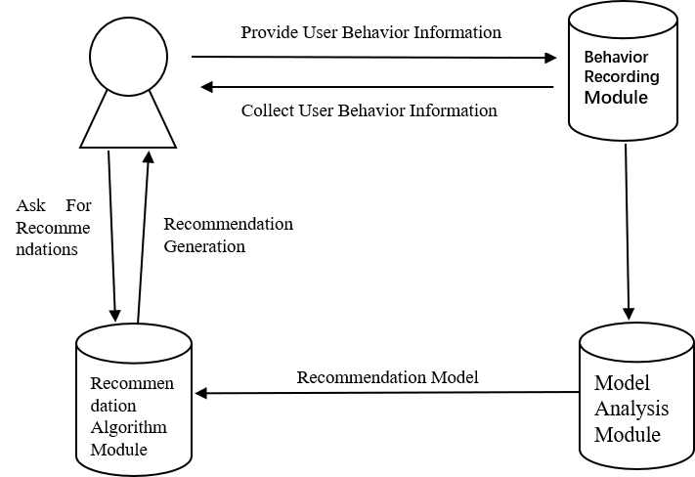
Fig 1. General Model of Recommendation System

Common Recommendation Techniques

Collaborative Filtering Recommendation
Collaborative filtering recommendation system is the first generation of personalized recommendation system. Because of its advantages of unlimited type of recommendation resources and strong adaptability, it has been widely used. As mentioned earlier, collaborative filtering is divided into two categories: memory-based and model-based. Among them, the memory-based algorithm can be further subdivided into two forms: user-based and project-based. The principle of user-based collaborative filtering is similar to that of project-based collaborative filtering. The following introduces the memory-based collaborative filtering algorithm based on user-based collaborative filtering.
Memory-based collaborative filtering, also known as memory-based collaborative filtering, is an algorithm that makes predictions based on all the over-punched product information in the system. The algorithm simulates the situation of mutual recommendation of information between people in human society, calculates the similarity of users through historical information, and then recommends the products that similar users like to the target users according to the similarity. Specific forecasting methods are as follows:
Set C = {$c_{1}$，$c_{2}，······，c_{N}$ } for a collection of all users in the system, S = {$s_{1}，s_{2}，······，s_{M}$} for the collection of all the products. Now to predict user c for its products s scores of 𝑟 𝑐, 𝑠, then the rate can be obtained by similar user ratings calculation of s. There are three types of forecast:
$$r_{c,s}=\frac{1}{N}\sum_{\hat{c}∈\hat{C}}{r_{\hat{c},s}}$$ | (1)
$$r_{c,s}=k\sum_{\hat{c}∈\hat{C}}{{sim(c,\hat{c})·r}_{\hat{c},s}}$$ | (2)
$$r_{c,s}=\overline{r_{c}}+k\sum_{\hat{c}∈\hat{C}}{{sim(c,\hat{c})·(r}_{\hat{c},s}-\overline{r_{\hat{c}}}）}$$ | (3)
$\hat{C }$said user c of similar users set, also known as the neighbor set, k is a standardized factor, generally take$k=1/\sum_{\hat{c}∈\hat{C}}{\left|sim(c,\hat{c})\right|}$,$sim(c,\hat{c})$ represents the target user similarity between c user $\hat{c}$with your neighbors. $\overline{r_{c} }$said user average grade of c. Such as formula (1), $r_{c,s}$ predict the easiest way for calculating the average score of similar users of product s. But what is more commonly used (2-2), the weighted average method, the more similar the neighbor has the greater weight is used to predict $r_{c,s}$, but this method also has some problems, it doesn't take into account different user evaluation scale is not the same problems. Therefore, on the basis of (2), the formula (3) is proposed to take the average scores of users into account and overcome this problem by measuring the score deviation. Generally speaking, the prediction accuracy is higher than that of (2-2). As for the problem of similarity calculation, the usual methods are: cosine similarity, modified cosine similarity and Pearson correlation coefficient.

Content-based Recommendations
Collaborative filtering only uses the rating data to make recommendations, and it does not take into account the attributes of the user and the project itself, such as the user's gender, age, geographical location, music style, language, brand and release time. In order to make full use of these attributes and obtain better recommendation quality, a content-based recommendation algorithm is proposed. Content-based algorithm recommendation process: Firstly extract the attribute characteristics of the project, construct the feature document of the project, and construct the user preference document according to the historical information, and then calculate the similarity between the two documents. In practical use, in addition to the project can be calculated and the similarity between users, can also calculate similarity between projects and project, the user and the user are recommended. Content-based recommendation has a high degree of personalization, but also can better cope with the cold start problem. In addition, the recommended items are highly matched with users' interests and preferences, and the recommended results are intuitive and easy to explain. However, its disadvantages are also obvious: (1) The project needs to have a good hierarchical structure to facilitate the extraction and representation of attribute features. For unstructured projects, such as images, sounds, etc., it is difficult to reflect the content features, so it is impossible to effectively extract their information for recommendation. (2) Can not produce new recommendations for users, that is, can only recommend items similar to the content of previous projects to users. (3) The problem of synonym, that is, can not distinguish between two documents with the same or similar keywords, but the style is not the same.

Association Rule Recommendation
The concept of association rules was first proposed by Agrawal et al in 1993. As an important technology in the field of data mining, the purpose of association rules is to dig out the correlation between items from a large amount of data. Association rules can analyze commodity transaction data, find out which commodities are frequently purchased at the same time, generate several rules, and then make recommendations to users based on their current purchasing behaviors. For this reason, association rules are often used for shopping cart analysis. The purpose of association rules is in a given transaction database D, dug up support and confidence level is greater than the given support threshold respectively and confidence threshold management rules. Problems of association rules are: (1) sparse and high dimensional data, makes the rules extraction is difficult, and difficult to guarantee quality of rules; (2) The rule base is built offline, which takes time to generate, and the latest opinions of users cannot be adopted in time; The system becomes more and more difficult to manage due to the increasing number of rules.

Hybrid Approaches
In order to avoid the defects of each algorithm and improve its accuracy, a hybrid recommendation technique is proposed. Hybrid recommendation refers to the recommendation based on algorithm fusion. Among them, the mixture of collaborative filtering and content-based recommendation algorithm is the most common mixing mode, which includes two modes: (1) Collaborative filtering and content-based recommendation generate a recommendation result respectively, and then combine the two results according to a certain strategy; (2) Take one recommendation algorithm as the framework and integrate another recommendation algorithm. In addition, the fusion of different types of algorithms in collaborative filtering algorithms is also a common mixing method, such as the mixing of user-based collaborative filtering and project-based collaborative filtering. Hybrid recommendation algorithm usually has high recommendation accuracy, but this kind of algorithm is complex, difficult to implement, and the execution efficiency is often inferior to the single recommendation algorithm. [3]
Table 1 Comparison of advantages and disadvantages of various recommendation algorithms
Recommendation Technology | Advantage | Shortcoming
Coordinated filtering recommendation | Generate novel recommendations, do not require domain knowledge, and deal with complex unstructured objectivity problems | Cold start problem, data sparsity problem, scalability problem
Cold start problem, data sparsity problem, scalability problem | The results are intuitive and easy to interpret | Unstructured object features are not easy to extract, can not produce new recommendations, synonym problems
Unstructured object features are not easy to extract, can not produce new recommendations, synonym problems | Show potential points of interest, no domain knowledge required | The extraction of rules is difficult and time-consuming, and the degree of individuation is low
Hybrid approaches | High accuracy | Complex, difficult to implement, low efficiency

INSUFFICIENT APPLICATION OF BIG DATA IN E-COMMERCE

The Efficiency of Application in E-commerce is still at a Telatively Low Level
With the continuous development of the network, the development of information technology is becoming more and more diversified, and the competition between e-commerce platforms is becoming more and more fierce. E-commerce platforms are independent of each other, which makes the lack of data exchange and interoperability between e-commerce platforms, the lack of data and sharing that can be interacted, resulting in e-commerce platforms and enterprises can not process the massive data existing in the network, which greatly hinders the application efficiency of big data in e-commerce platforms and enterprises.

The Combination of Big Data and The Innovation Ability of E-commerce Enterprises is not High
In recent years, big data continues to develop rapidly, its development prospects are also very potential, the application of big data technology in various business activities is more and more obvious, however, the application of big data technology in e-commerce system in China is still in its infancy, relative to Europe, the United States, Japan and other developed countries, there is still a certain distance. In the early stage of e-commerce development, many e-commerce platforms in our country were impacted by big data, resulting in the collapse of the entire platform, causing certain economic losses and data shadows to the platform. At present, because big data resources are not able to realize the interoperability and sharing between platforms, the innovation ability of e-commerce platforms or enterprises in the application of big data technology is relatively low, and the role of big data technology in e-commerce system cannot be fully played.

Data security and personal privacy are not effectively protected
Big data technology is used more and more frequently in the e-commerce system, which exposes the personal data collected, shared, analyzed and processed to the platform or enterprise, resulting in personal information and personal privacy is difficult to be effectively protected. The information left on the platform is easy to be stolen by criminals, causing economic and reputation losses to individuals. There are two main reasons for this effect: (1) There are many categories of e-commerce platforms in our country, and the information maintenance technology level and ability of each platform are different, and there is a certain technical gap between the platforms and the platforms, it is easy for a large number of customer information and corporate secrets to be stolen by illegal elements, and used in some illegal ways, which threatens the personal safety and reputation of enterprises and customers. (2) Due to the current applicable e-commerce laws in China, there is no set or regulation of the ownership and use of data in the platform. If the analysis and processing of customer data is not properly handled, it is easy to pose a great threat to the privacy of customers.

Recommendation services need to be further optimized
The basic condition for e-commerce platforms to provide users with various services is data. Therefore, after the changes in data scale and data storage methods, the recommendation services provided by e-commerce platforms also need to be transformed, so as to effectively cope with the constantly updated data environment. Under normal circumstances, the recommendation service provided by the e-commerce platform for users is obtained in the actual information search process, but not every piece of information recommended for users is effective, and users do not have too much time to check the product information. Therefore, such information recommendation service has shortcomings and needs to be further optimized. [4]

measures for the application of large data on e-commerce platforms

Big Data, Cloud Computing and Other Technologies are Adopted to Improve the Application Efficiency In E-commerce Systems
Applying big data to the efficiency of e-commerce system has always been a very confusing problem, and only using cloud computer books can solve the efficiency problem in reality. The so-called cloud meter is to automatically split the huge computing processing program into countless smaller subroutines through the network, and then to a huge system composed of multiple servers to search, calculate and analyze the processing knot back to the user. Cloud computing can be different e-commerce enterprises related data and information in the data center deployment, can realize the electronic commerce enterprise data sharing. The most important thing is that through Yunping, data can be stored on the sharing platform, thereby reducing the data storage and operation and maintenance costs of the e-commerce platform. The logic of cloud computing in e-commerce customer preference analysis is shown in Figure 2.
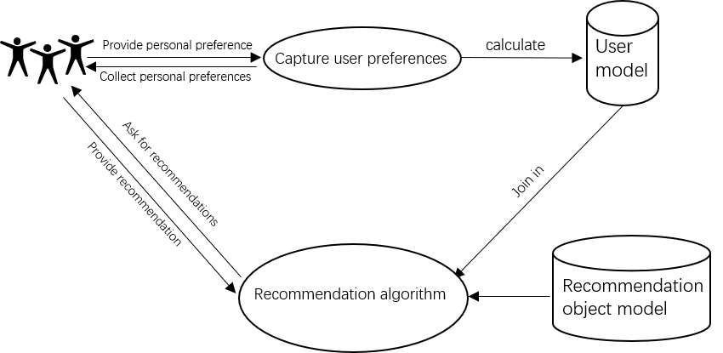
Figure 2 The logic of cloud computing in the analysis of e-commerce customer preferences

The State has Issued Relevant Policies to Protect Personal Privacy and Personal Data
The introduction of big data technology into China's e-commerce system is not enough for personal privacy and data protection measures in the network or on the e-commerce platform. Personal information can easily be used by criminals. However, it is unrealistic to rely solely on platforms or enterprises to protect data on the network. Therefore, only from the national level to introduce the corresponding policy to ensure the security of data. Local governments should also introduce some policies that can strengthen the Internet infrastructure, so as to build a relatively stable and safe information platform that can adapt to modern economic development. Increase support for big data-related industries, and give certain concessions to data processing related business enterprises, vigorously encourage the industrialization of big data results, and improve laws and regulations on the protection of intellectual property rights of industrial results.

Provide More Professional Services
Large platforms such as Tmall, JD.com, and Amazon occupy the vast majority of the market share of the domestic e-commerce industry, which largely hinders the development of small and medium-sized e-commerce platforms [5]. In the era of big data, small and medium-sized e-commerce platforms will develop their business in a more refined and specialized direction, which can be recognized by more users and increase their market share. If the development scale of the sub-segmented e-commerce platform is small and the number of customers is relatively small, it will help the platform to accurately analyze customer information and focus more on providing services to specific user groups.

SUMMARY
E-commerce industry is a rapidly developing new industry, in today's era, e-commerce industry to make full use of new technologies and tools, and constantly improve the level of development of the industry. The application of big data technology in e-commerce platforms has achieved certain innovative development, so the research on the application and innovation development strategies of big data in e-commerce platforms can improve the rationality and effectiveness of the application of big data in e-commerce platforms, and thus promote the development and innovation of e-commerce industry. Big data technology is a necessity for the development of The Times, but also the catalyst for the development of e-commerce industry, the two should fully cooperate, promote each other, give full play to their advantages, and grow together!

References
- YIN Xueting,ZHAO Min,LI Zhaoxia. Application of big data in customer management of e-commerce platform[J].Integrated Circuit Application,2022,39(02):294-296.DOI:10.19339/j.issn.1674-2583.2022.02.128.
- HU Zhixiang. Application of big data in e-commerce platform[J].Time-honored Brand Marketing,2022,(18):56-58.)
- YAN Kewen. Research on the application of personalized recommendation algorithm for e-commerce in big data environment[D].Hefei University of Technology,2016.
- LI Nannan. Research on the application of big data mining technology in the marketing of e-commerce enterprises[J].National Circulation Economy,2019(08):16-17.DOI:10.16834/j.cnki.issn1009-5292.2019.08.007.
- WEI Wujie. Research and application of big data technology in e-commerce[J].Electronic World,2017(12):191.DOI:10.19353/j.cnki.dzsj.2017.12.149.

