**91**

**Name: Venkata Lahari Goruputi**

**Role: DevOps Intern**

**Task: Prometheus and Grafana**

**Installing Prometheus and Grafana in EC2 Instance**

* Prometheus and Grafana are most popular open-source tools for monitoring especially for Kubernetes. Prometheus is the logs and metrics collector and Grafana will give us dashboards to visualize the details collected by Prometheus in the form graphs, tables and charts etc.

**What is Prometheus:**

* Prometheus and Grafana are most popular open-source tools for monitoring especially for Kubernetes. Prometheus is the logs and metrics collector and Grafana will give us dashboards to visualize the details collected by Prometheus in the form graphs, tables and charts etc.

[Know More About Prometheus](https://prometheus.io/)

* **Key Features of Prometheus:**
  + **Multi-dimensional Data Model:**
    - Metrics are stored with labels, allowing for flexible querying and aggregation.
  + **PromQL:**
    - Prometheus Query Language enables powerful querying of metrics.
  + **Service Discovery:**
    - Built-in support for discovering targets dynamically, including integration with Kubernetes and other service discovery mechanisms.
  + **Alerting:**
    - Supports alerting based on predefined rules and conditions.
  + **Scalability:**
    - Designed to be horizontally scalable to handle large-scale deployments.

**What is Grafana:**

* Grafana is an open-source platform for data visualization and monitoring. It allows users to create, explore, and share dashboards with data from various sources, including Prometheus.

[Know More About Grafana](https://grafana.com/)

[Know More About Grafana Dashboards](https://grafana.com/grafana/dashboards/)

* **Key Features of Grafana:**
  + **Visualization:**
    - Rich visualizations including graphs, charts, and tables.
  + **Dashboarding:**
    - Create and customize dashboards to display metrics and logs.
  + **Alerting:**
    - Define alert rules and receive notifications based on data thresholds.
  + **Data Source Integration:**
    - Grafana supports integration with numerous data sources, including Prometheus, to visualize and analyse metrics and logs.
  + **Plugins and Extensions:**
    - Extensible with plugins and extensions for additional features and integrations.

## **Integration and Use:**

## **Prometheus and Grafana Integration:**

* Prometheus metrics can be easily visualized and analysed in Grafana dashboards. Grafana supports Prometheus as a data source, allowing users to query Prometheus metrics using PromQL and create rich visualizations.
* **Common Use Cases:**
* Together, Prometheus and Grafana are commonly used for monitoring cloud-native applications, microservices architectures, containerized environments (like Kubernetes), and traditional infrastructure. They provide deep insights into system performance, resource utilization, and application health.

#### **Installing Prometheus:**

##### **Prerequisites:**

* **EC2 Instance:**
  + Ensure you have an EC2 instance running with appropriate permissions to install software.
* **SSH Access:**
  + Connect to your EC2 instance via SSH.
  + Logged into ubuntu server via ssh using **[ssh <server-username>@<publicIP-of-the-server>].**
* **Steps:**
  + After Login to the server, we need to update the packages using **[sudo apt update command].**
  + Then we need to download the stable or latest version of Prometheus from the official page of Prometheus.

[Download Prometheus](https://prometheus.io/download/)

* **Downloading Prometheus:**
  + Use **[wget]** command to download the tar file use the below links to download the Prometheus tar file.
  + wget https://github.com/prometheus/prometheus/releases/download/v2.43.0/prometheus-2.43.0.linux-amd64.tar.gz

[Download Prometheus tar file which I have used](https://github.com/prometheus/prometheus/releases/download/v2.43.0/prometheus-2.43.0.linux-amd64.tar.gz)

* The above command will download the Prometheus tar file in the home path of the server.



## **Extracting the downloaded Prometheus tar file:**

* After Downloading the tar file, we need to extract the tar file to get all the binaries required to install the Prometheus.
* Use the following command to extract the tar file

**[sudo tar xvfz prometheus-2.43.0.linux-amd64.tar.gz]**

* The above command will extract the tar file in the home path, after the extraction is done, we will get a folder named **prometheus-2.43.0.linux-amd64** which contains all the binaries and dependencies required to install the Prometheus.

## **Installation:**

* As part of Installation process, we need to move the Prometheus related filed and binaries to the appropriate directories in-order run the Prometheus.
* Follow the below steps for the Installation

sudo mv prometheus-2.43.0.linux-amd64/prometheus /usr/local/bin/

sudo mv prometheus-2.43.0.linux-amd64/promtool /usr/local/bin/

sudo mkdir /etc/prometheus

sudo mv prometheus-2.43.0.linux-amd64/consoles /etc/prometheus

sudo mv prometheus-2.43.0.linux-amd64/console_libraries /etc/prometheus

sudo mv prometheus-2.43.0.linux-amd64/prometheus.yml /etc/prometheus/

* The above commands will move the files to bin folder/PATH variable to let the **PATH** variable know the default location of the Prometheus.
* Because Executables are accessible system-wide by placing them in **/usr/local/bin/.**
* The consoles and **console_libraries** directories contain web console templates and libraries that Prometheus uses for its web UI.
* Configuration and related files are organized in **/etc/prometheus/** for easy management and adherence to standard Linux filesystem hierarchy conventions.
* Prometheus has access to necessary resources like console templates and its configuration file.

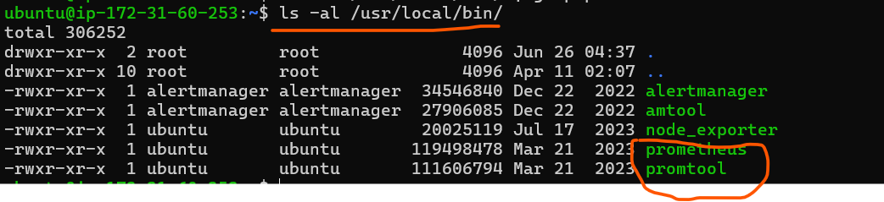

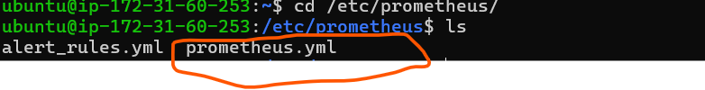

## **Creating User for Prometheus:**

* We need to create a dedicated user for Prometheus so that service follows best practices for Unix/Linux system administration. It helps in tracking and managing resources used by specific services and simplifies troubleshooting.
* So, we need create a user and change the ownership and permissions for the user accordingly.

sudo useradd --no-create-home --shell /bin/false prometheus

sudo chown -R prometheus:prometheus /etc/prometheus

sudo chown prometheus:prometheus /usr/local/bin/prometheus

sudo chown prometheus:prometheus /usr/local/bin/promtool

* The above steps will creates a user names prometheus and gives the prometheus user ownership for the directories which were required.

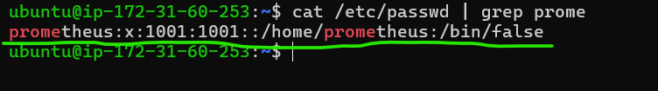

## **Create Prometheus Service:**

* Now we need to create the service for Prometheus using **[sudo nano /etc/systemd/system/prometheus.service]** (or) **[sudo vi /etc/systemd/system/prometheus.service]**
* Creating a new systemd service file for Prometheus is essential for managing Prometheus as a background service on a Linux system.
* The above command will create a service file for prometheus in **/etc/systemd/system** path with the service name as **prometheus**, then, we need to add the above content and save the file using **:wq!** in vi editor and **ctrl+X and Y** in 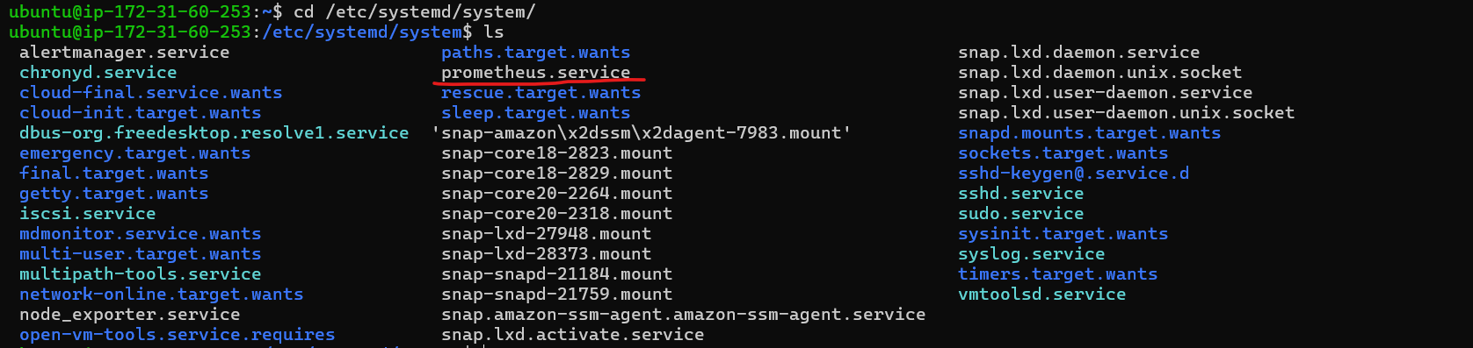nano editor, this service file contains the location of prometheus and other details.

[Unit]

Description=Prometheus Monitoring

Wants=network-online.target

After=network-online.target

[Service]

User=prometheus

Group=prometheus

Type=simple

ExecStart=/usr/local/bin/prometheus \

--config.file /etc/prometheus/prometheus.yml \

--storage.tsdb.path /var/lib/prometheus/ \

--web.console.templates=/etc/prometheus/consoles \

--web.console.libraries=/etc/prometheus/console_libraries

[Install]

WantedBy=multi-user.target

* **Run and Check Prometheus status:**
* Then we need to run commands which will restart the daemon and start and enables the prometheus service.

sudo systemctl daemon-reload

sudo systemctl start prometheus

sudo systemctl enable prometheus

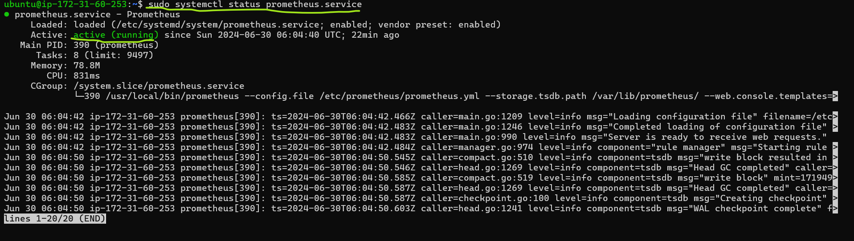

* After starting the we need to verify for the prometheus service status.
* Use sudo systemctl status prometheus command for the status verification of prometheus service.
* If our service is up and running, we can now able to access the prometheus UI in the browser using the public IP of the server on port 9090. **http://<public-ip>:9090**.

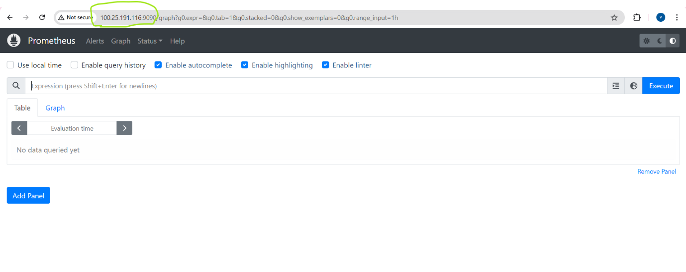

## **Configuring Prometheus:**

* Prometheus configuration files will be present in **/etc/prometheus** location.
* To configure prometheus we need to edit the prometheus.yml file which we be present in **/etc/prometheus.**
* **Installing Grafana:**
* We can install Grafana in the same instance where we have installed Prometheus.

## **Download Grafana:**

**[wget** [**https://dl.grafana.com/oss/release/grafana-9.3.6.linux-amd64.tar.gz**](https://dl.grafana.com/oss/release/grafana-9.3.6.linux-amd64.tar.gz)**]**

* Download the Grafana tar file using the above command or use wget and URL of the choice from official documentation.

[Download Grafana](https://grafana.com/grafana/download)

* Here, I have used **grafana-9.3.6.linux-amd64.tar.gz** to download Grafana.

## 

## **Extracting the downloaded Grafana tar file:**

* After Downloading the tar file, we need to extract the tar file to get all the binaries required to install the Grafana.

**[sudo tar xvfz grafana-9.3.6.linux-amd64.tar.gz]**

* This command will extract the tar file in the home path, after the extraction is done, we will get a folder named **grafana-9.3.6** which contains all the binaries and dependencies required to install the Grafana.



## **Move the Extracted Files:**

* Move the extracted Grafana directory to **/usr/local.**

**[sudo mv grafana-9.3.6 /usr/local/grafana]**

## **Create a Symbolic Link:**

* Create a symbolic link to make it easier to access Grafana.

sudo ln -s /usr/local/grafana/bin/grafana-server /usr/local/bin/grafana-server

sudo ln -s /usr/local/grafana/bin/grafana-cli /usr/local/bin/grafana-cli

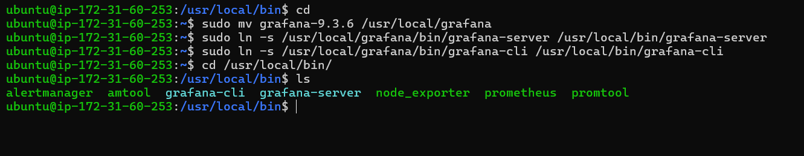

## **Create a Grafana User:**

* Create a new system user for running Grafana
* We need to create a dedicated user for grafana so that service follows best practices for Unix/Linux system administration.
* It helps in tracking and managing resources used by specific services and simplifies troubleshooting.
* So, we need create a user and change the ownership and permissions for the user accordingly.

sudo useradd --no-create-home --shell /bin/false grafana

sudo chown -R grafana:grafana /usr/local/grafana

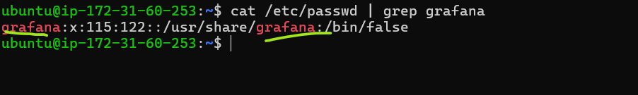

## **Create Grafana Service:**

* Now we need to create the service for Grafana. Creating a new systemd service file for Grafana is essential for managing Grafana as a background service on a Linux system.

**[sudo nano /etc/systemd/system/grafana.service]**

**(or)**

**[sudo nano /etc/systemd/system/grafana.service]**

* This above command will create a service file for prometheus in /etc/systemd/system path with the service name as grafana (Generally any service file will present in this location in linux).
* We need to add the above content in the service file to run grafana as a service.

[Unit]

Description=Grafana instance

After=network.target

[Service]

User=grafana

Group=grafana

Type=simple

ExecStart=/usr/local/grafana/bin/grafana-server --config=/usr/local/grafana/conf/defaults.ini --homepath=/usr/local/grafana

[Install]

WantedBy=multi-user.target

* After adding the above content in grafana.service file we need to save the file.
* Save the file using **:wq!** in vi editor and with **ctrl+X** and **Y** in nano editor.

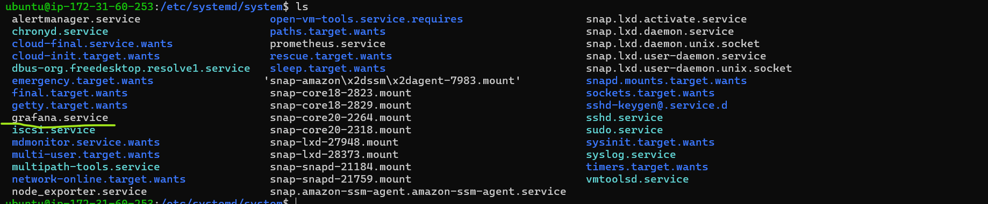

* **Run and Check Grafana Status:**
* After saving the service file we need to start and enable the grafana service.
* Then we need to run commands which will restart the daemon and start and enables the grafana service

sudo systemctl daemon-reload

sudo systemctl start grafana

sudo systemctl enable grafana

sudo systemctl status grafana

* If our service is up and running, we can now able to access the grafana UI in the browser using the public IP of the server on port 3000. **http://<public-ip>:3000**.

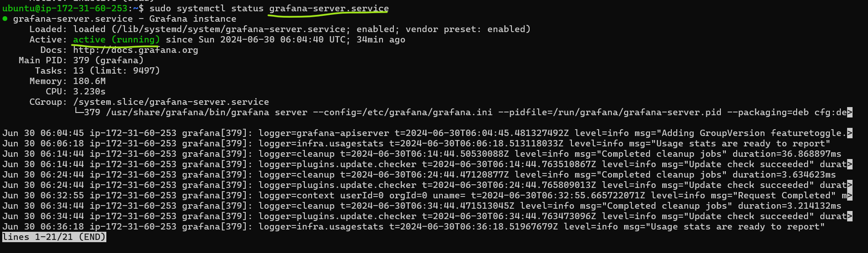

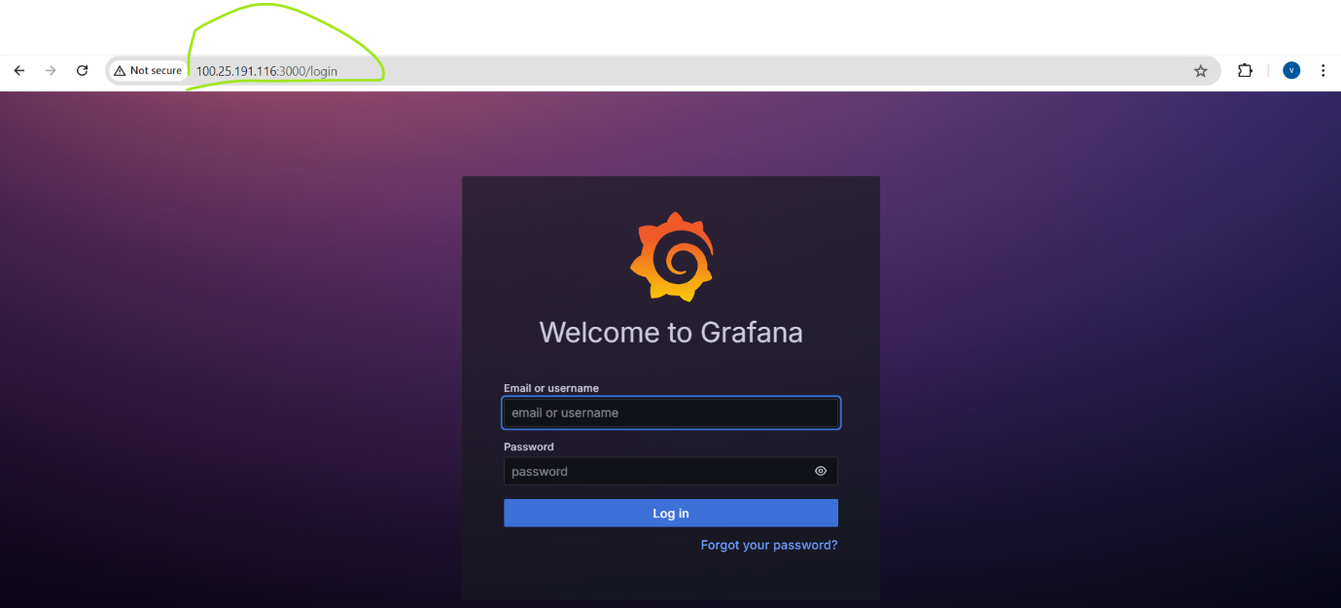

## **Access Grafana:**

* Login to Grafana using the default credentials then we need to update the password.
* **default username:** **admin**
* **default password:** **admin**

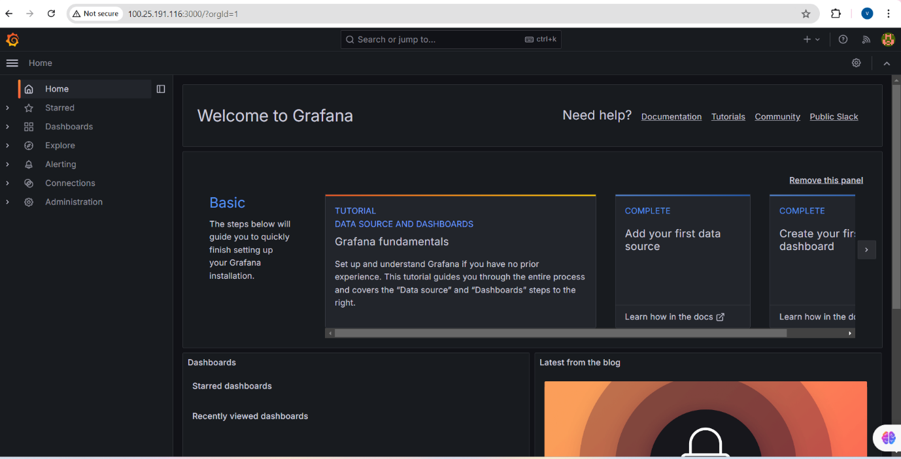

* This is the process to install Prometheus and Grafana in Ubuntu-22.04 EC2 instance.

**Thanks,**

**Lahari G**