WEEK 1
FIRST LLM API CALL
Connecting a Python application to Google's Gemini API

Student Name | Allamsetti Lahari
Course / Subject | Gen AI
Experiment | Week 1 – First LLM API Call

Objective
The objective of this experiment was to create a Python application that sends a text prompt to a Large Language Model (LLM) through an API and displays the generated response in the terminal. For this implementation, Google's Gemini API was used.

Tools and Technologies Used
Tool / Technology | Purpose
Python 3.11.9 | Programming language used to write and run the application.
Visual Studio Code | Code editor used to create and manage the project files.
Google Gemini API | Hosted LLM service used to generate text responses.
google-genai | Python SDK used to communicate with the Gemini API.
python-dotenv | Package used to load environment variables from the .env file.
PowerShell | Terminal used to activate the virtual environment and execute Python commands.

Project Setup
A project folder named week1-llm-call was created on the Desktop. A Python virtual environment named .venv was created to keep the project's Python packages separate from other Python projects.
Project location:
C:\Users\ADMIN\OneDrive\Desktop\week1-llm-call
Project structure:
week1-llm-call/
│
├── .venv/
├── .env
├── .gitignore
├── main.py
└── requirements.txt

Installing the Required Packages
The requirements.txt file contains the Python packages needed by the project:
google-genai
python-dotenv
The packages were installed in the activated virtual environment using:
python -m pip install -r requirements.txt
The google-genai package provides the Gemini client, while python-dotenv loads the API key from the .env file.

Environment Configuration
The .env file was created in the project folder. It stores the Gemini API key as an environment variable. The actual key is intentionally not included in this report.
GEMINI_API_KEY="YOUR_GEMINI_API_KEY"
The .gitignore file contains:
.env
.venv/
__pycache__/
.pytest_cache/
This prevents the API key, virtual environment, and temporary Python files from being committed to Git. The .env file must remain private.

Implementation
The main program was written in main.py. It loads the API key, creates a Gemini client, sends a prompt to the selected Gemini model, and prints the generated text.
Code used:
import os
from dotenv import load_dotenv
from google import genai

# Load environment variables from the .env file
load_dotenv()

# Read the Gemini API key
api_key = os.getenv("GEMINI_API_KEY")

# Check whether the API key is available
if not api_key:
raise ValueError("Gemini API key not found!")

# Create the Gemini API client
client = genai.Client(api_key=api_key)

# Send a prompt to the Gemini model
response = client.models.generate_content(
model="gemini-3.5-flash-lite",
contents="What is Artificial Intelligence? Explain in simple words."
)

# Display the generated response
print("\nLLM Response:")
print(response.text)

Execution
The program was executed from the VS Code PowerShell terminal while the .venv virtual environment was active. The command used was:
python main.py
After successful execution, the program returned a generated response. The output excerpt shared during the experiment was:
The big idea:
Regular computer software is like a calculator—it just follows math rules.
AI is more like a brain—it learns from experience and gets better over time.
This output confirms that the Python program sent a prompt to Gemini and received text from the model.

Screenshots
Screenshot 1: Project folder and files in Visual Studio Code
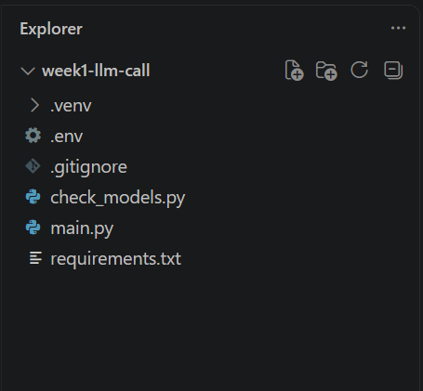
Screenshot 2: main.py source code
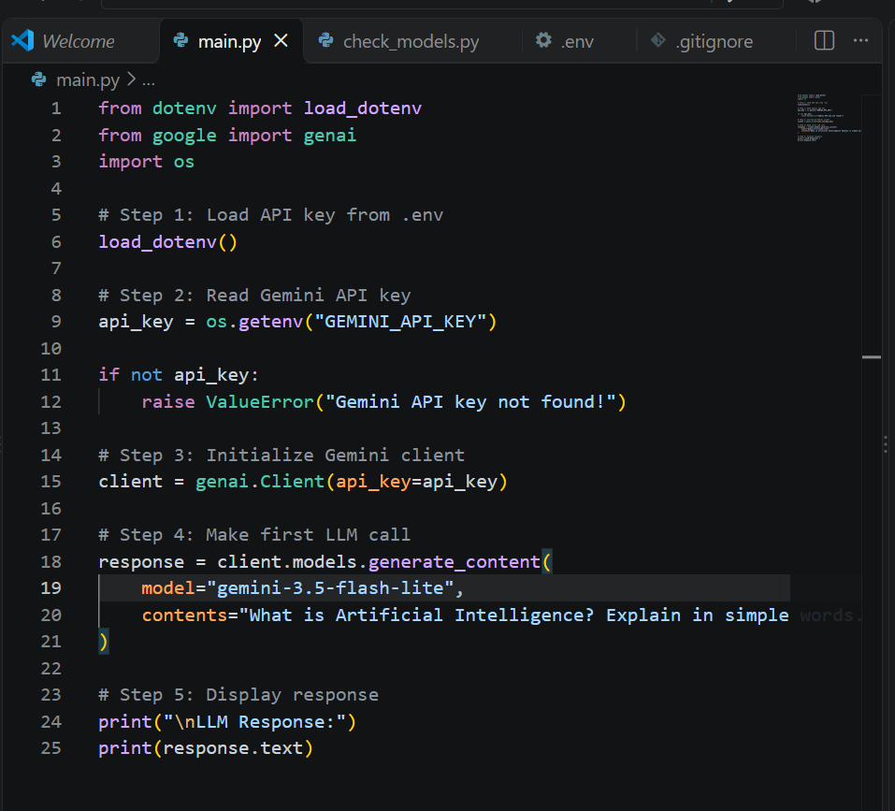
Screenshot 3: Successful terminal execution showing the Gemini response
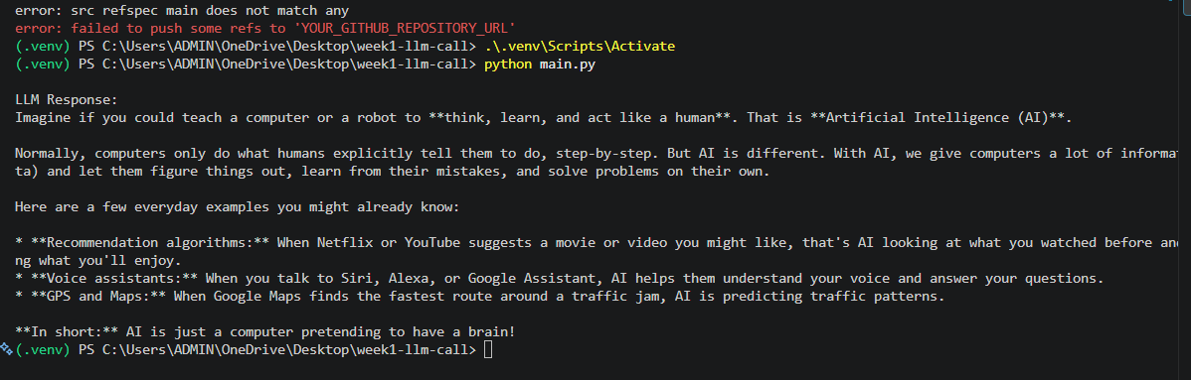

Learning Outcomes
- Understood the basic meaning of a Large Language Model (LLM) and an API.
- Created and activated a Python virtual environment.
- Installed and used the google-genai and python-dotenv packages.
- Stored an API key in a .env file instead of writing it directly in the source code.
- Created a Gemini client using the Python SDK.
- Sent a text prompt to a hosted Gemini model and received a generated response.
- Executed a Python program from the VS Code terminal.

