WINE QUALITY PREDICTION USING MACHINE LEARNING

OBJECTIVE
The objective of this project is to analyze the physicochemical properties of wine and build a machine learning model to predict wine quality. The project aims to identify the important factors affecting wine quality and help wineries improve production quality using data-driven decisions.

Business Understanding
The wine industry is highly competitive, and maintaining consistent product quality is essential for customer satisfaction and brand reputation. Predicting wine quality using machine learning helps wineries monitor important chemical properties and improve production efficiency.

Dataset Description
Dataset Name : Wine Quality Dataset

Total Records : 6498

Total Columns : 14

Target Variable : Quality

Input Variables :

• Fixed Acidity
• Volatile Acidity
• Citric Acid
• Residual Sugar
• Chlorides
• Free Sulfur Dioxide
• Total Sulfur Dioxide
• Density
• pH
• Sulphates
• Alcohol
• Good
• Color

Exploratory Data Analysis
Exploratory Data Analysis was performed to understand the dataset, identify missing values, detect duplicate records, study feature distributions, analyze outliers, and determine the relationship between input variables and wine quality.
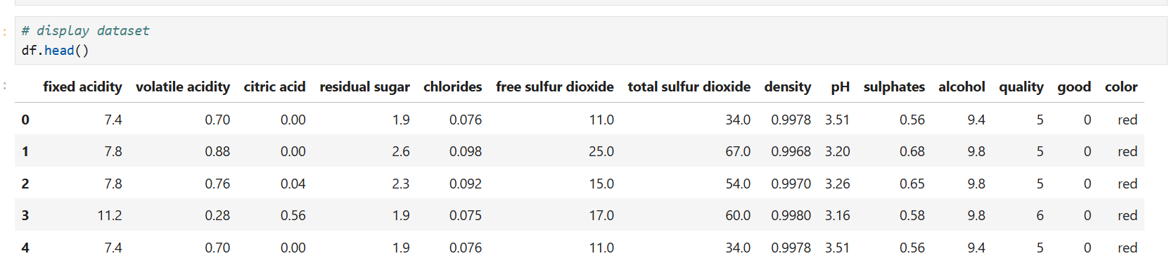
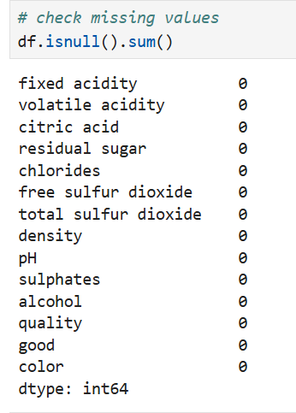
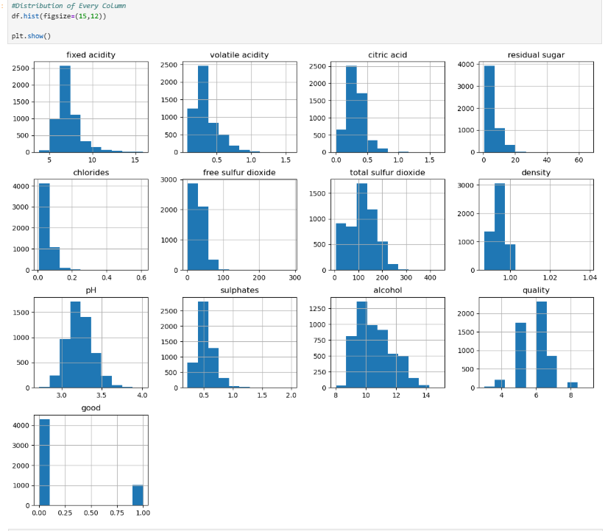

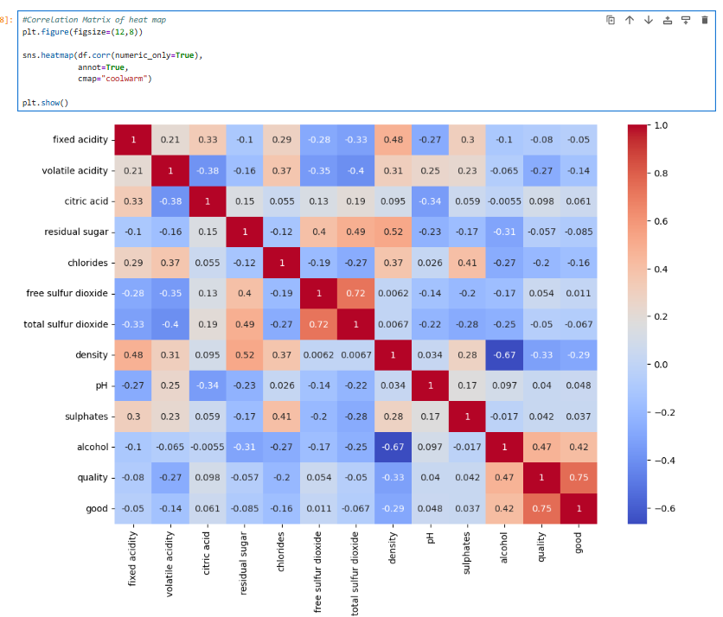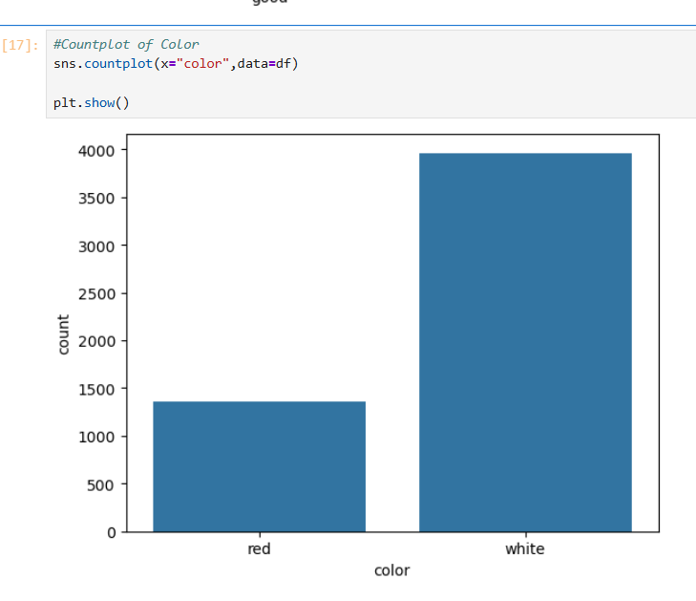
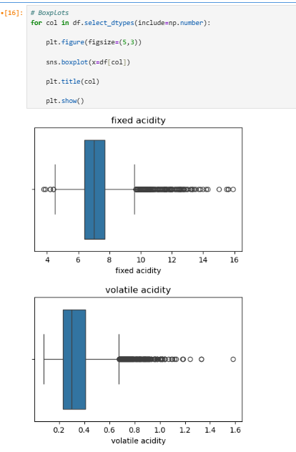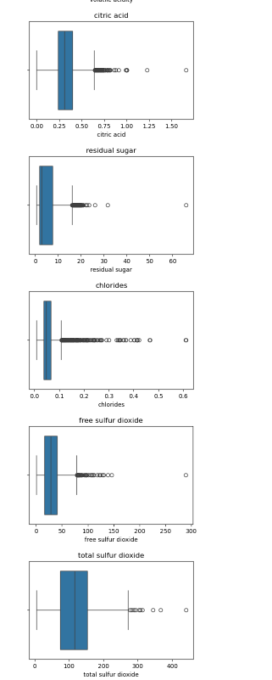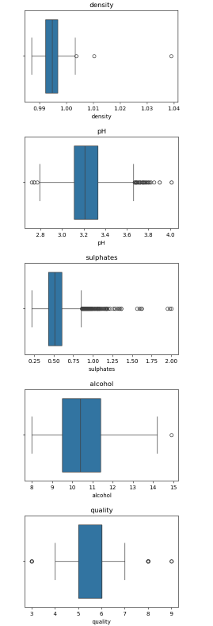

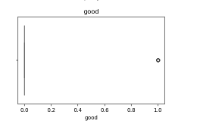

Data Preprocessing
The preprocessing steps included:

• Missing value checking
• Duplicate removal
• Label Encoding of the Color feature
• Standardization of numerical variables
• Splitting the dataset into training and testing sets (75:25)

Machine Learning Algorithms
The following machine learning algorithms were implemented to predict wine quality:
1. K-Nearest Neighbors (KNN)
K-Nearest Neighbors (KNN) is a classification algorithm that predicts the class of a new data point based on the majority class of its nearest neighbors.
2. Logistic Regression
Logistic Regression is a supervised machine learning algorithm used for classification. It predicts the probability of a data point belonging to a particular class.
3. Support Vector Machine (SVM)
Support Vector Machine (SVM) is a classification algorithm that finds the best boundary (hyperplane) to separate different classes.
4. Decision Tree
Decision Tree is a classification algorithm that makes predictions by splitting the data into branches based on feature values.
5. Random Forest
Random Forest is an ensemble algorithm that combines multiple decision trees to improve prediction accuracy and reduce overfitting.

Model Evaluation

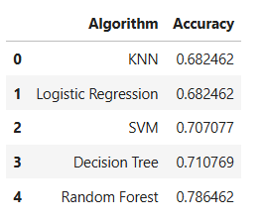

Business Insights
1.Most wines in the dataset have a quality score between 5 and 7, indicating that average-quality wines are more common than very low- or very high-quality wines.
2.Alcohol content has a positive relationship with wine quality. Wines with higher alcohol levels tend to receive higher quality ratings.
3.Volatile acidity has a negative impact on wine quality. Higher volatile acidity is generally associated with lower-quality wines.
4.Sulphates show a positive correlation with quality. Wines with moderate sulphate levels are more likely to have better quality scores.
5.Residual sugar and density have a relatively weak relationship with wine quality, suggesting they are less influential than alcohol or acidity.
6.The dataset contains both red and white wines, and their physicochemical properties differ, which may affect quality prediction.
7.Some features contain outliers, but these may represent real variations in wine production rather than errors.
8.The correlation analysis shows that alcohol, volatile acidity, sulphates, and citric acid are among the most important variables for predicting wine quality.

Business Recommendations
1.Focus on maintaining optimal alcohol levels, as alcohol content has a strong positive influence on wine quality.
2.Reduce volatile acidity during the production process to improve the overall quality of wine.
3.Regularly monitor sulphate levels to ensure product stability while maintaining good taste and quality.
4.Use data-driven quality prediction models to identify potential quality issues before the wine reaches customers.
5.Continuously monitor important chemical properties such as acidity, alcohol, sulphates, and citric acid during wine production.
6.Use predictive analytics to improve quality consistency, reduce production costs, and strengthen customer satisfaction.
7.Develop separate quality control strategies for red and white wines, as their characteristics differ.
8.Continuously analyze production data to optimize the winemaking process and improve overall product quality.

conclusion
This project successfully analyzed the Wine Quality dataset using Exploratory Data Analysis and Machine Learning techniques. Among all the models tested, the model with the highest accuracy was selected as the best-performing model for predicting wine quality. The findings can help wineries improve product quality, optimize production processes, and make better business decisions.

