STUDENT PERFORMANCE ANALYSIS
Submitted By:
Name: Kommichetty Lakshmi Lahari
Course: B. Tech (CSE - Data Science)
College: Sri Venkateshwara College of Engineering, Tirupati
1.Introduction
Student Performance Analysis is a data analysis project developed using Python. The objective of this project is to analyze students' academic performance, identify trends in marks and attendance, and present the results using data visualizations. This project demonstrates how Python libraries such as Pandas and Matplotlib can be used to process and visualize educational data effectively.
2. Objective
The main objectives of this project are:
- Analyze student performance data.
- Identify the highest, lowest, and average marks.
- Study the relationship between attendance and academic performance.
- Generate meaningful insights.
- Visualize the data using charts.

3. Dataset Description
The project uses the Student Performance Dataset in CSV format.
Dataset Details:
- File Format: CSV
- Number of Records: 20
- Number of Columns: 33
- Important Columns:
  - G1 – First Period Marks
  - G2 – Second Period Marks
  - G3 – Final Marks
  - absences – Number of Student Absences
4. Tools and Technologies Used
- Python
- Pandas
- Matplotlib
- Visual Studio Code (VS Code)
5. Data Cleaning
The following preprocessing steps were performed.
- Loaded the CSV dataset using Pandas.
- Checked the dataset information.
- Verified missing values.
- Verified the dataset dimensions.
- Ensured the dataset was ready for analysis.
6. Data Analysis
The following analysis was performed:
- Calculated the average final marks.
- Identified the highest final marks.
- Identified the lowest final marks.
- Calculated average student absences.
- Identified students scoring above 15 marks.
- Analyzed the relationship between attendance and final marks.
7. Data Visualization
The following visualizations were created using Matplotlib:
- Bar Chart – Final Marks of Students
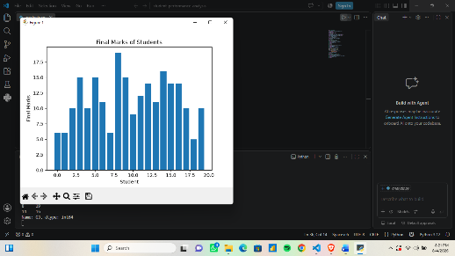
- Histogram – Distribution of Final Marks
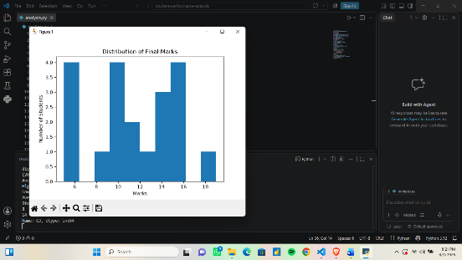
- Pie Chart – Pass vs Fail Percentage
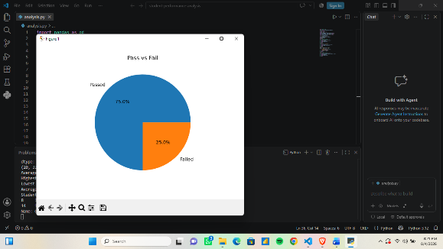
- Scatter Plot – Attendance (Absences) vs Final Marks
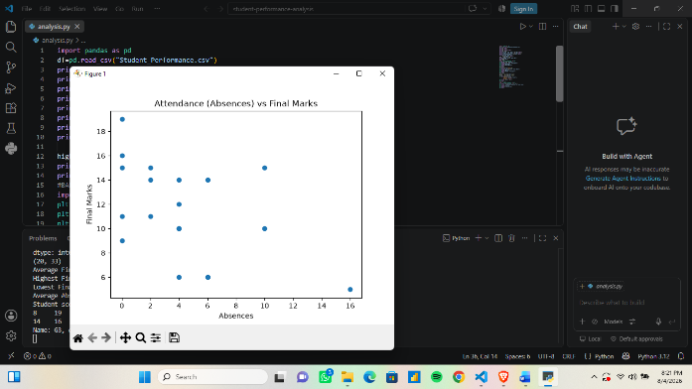
8.Dashboard
A Power BI dashboard was created to present student performance in a visual and interactive format. The dashboard displays key performance indicators such as Total Students, Average Marks, Highest Marks, and Lowest Marks. It also includes Bar Chart, Histogram, Pie Chart, Scatter Plot, and Student Details Table to analyze student performance and attendance effectively. The dashboard helps users quickly understand the overall academic performance and identify important trends.
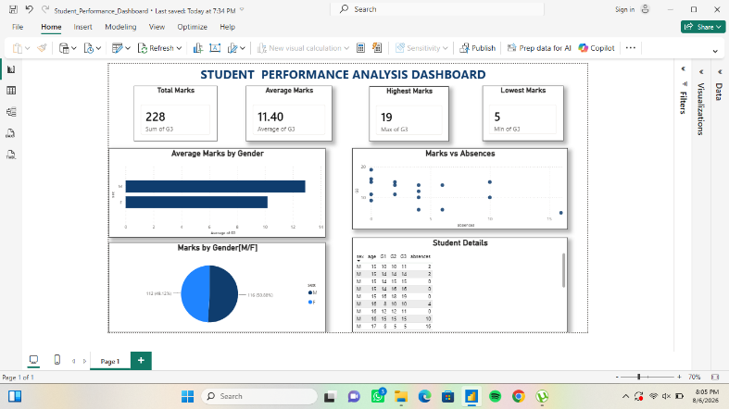

9. Insights
- The average final marks were calculated successfully.
- Students with fewer absences generally achieved better final marks.
- Most students scored within the average performance range.
- The charts helped in understanding the distribution of marks and attendance patterns.
- Data visualization made it easier to compare student performance.
10. Conclusion
This project successfully analyzed student performance using Python, Pandas, and Matplotlib. The dataset was cleaned, analyzed, and visualized to identify meaningful trends in student marks and attendance. The visualizations made it easier to understand the performance of students and the impact of attendance on academic results. This project enhanced practical knowledge of data analysis and data visualization techniques.
11. References
- UCI Machine Learning Repository. Student Performance Dataset.
- Python Software Foundation. Python Documentation.
- Pandas Development Team. Pandas Documentation.
- Matplotlib Development Team. Matplotlib Documentation.

