ID: 27381

ASSIGNMENT 4

Create an infographic illustrating the Test-Driven Development [TDD] process. Highlight steps like writing tests before code, benefits such as bug reduction, and how it fosters software reliability.

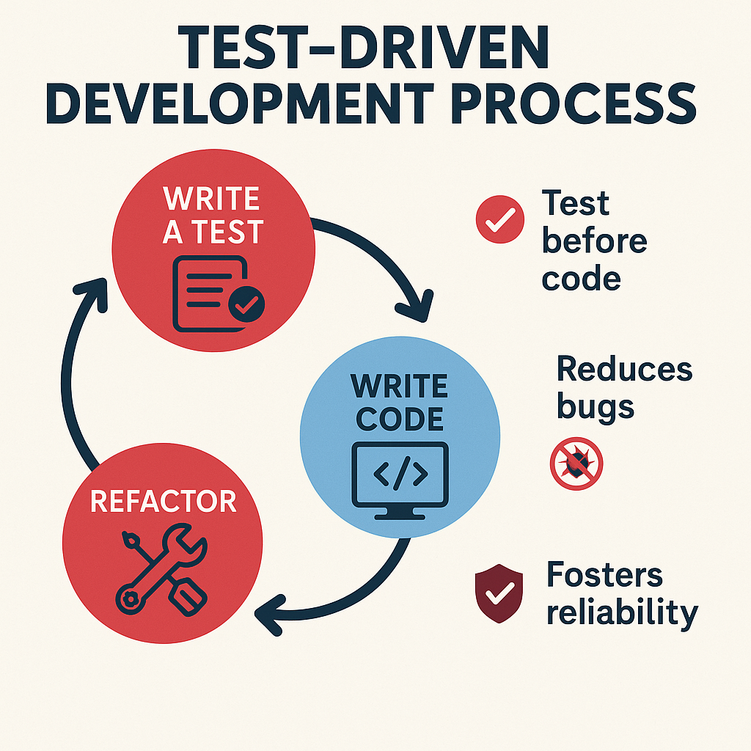

**What is TDD?**

* **Test-Driven Development (TDD)** is a software development process that relies on the repetition of a very short development cycle: **write a test before writing the code that needs to pass**.

**TDD Cycle (The 3 Steps)**

1. **WRITE A TEST**
   * Begin by writing a test for the functionality you want to implement.
   * The test will initially **fail**, since the code doesn’t exist yet.
   * This defines the **expected behaviour**.
2. **WRITE CODE**
   * Write just enough code to **make the test pass**.
   * Focus only on what is necessary for the test — no extras.
3. **REFACTOR**
   * Once the test passes, **clean up the code**.
   * Improve structure and readability without changing behaviour.
   * Ensure all tests still pass after refactoring.

**Key Benefits of TDD**

* **Test Before Code**
  + Forces clarity in requirements and expectations before implementation.
* **Reduces Bugs**
  + Because every piece of functionality is tested upfront, bugs are caught early.
* **Fosters Reliability**
  + The test suite becomes a safety net for future changes, making the codebase more stable and maintainable.

TDD is a powerful approach that promotes **software reliability** and **maintainability**. By prioritizing tests, developers can create more robust applications and reduce the risk of defects over time.

TDD is widely used in Agile and XP (Extreme Programming) practices to ensure robust and high-quality software.