ID: 27381

ASSIGNMENT 5

Write a brief summary on SCRUM Framework.

**SCRUM Framework:**

1. **Agile Methodology**: SCRUM is an Agile approach for managing complex projects.

2. **Iterative Progress**: Projects are broken into smaller tasks and developed in iterations, known as sprints.

3. **Frequent Reviews**: Regular reviews and feedback ensure continuous progress and improvements.

4. **Collaboration**: Focuses on teamwork and collaboration across all stakeholders, including the development team, product owner, and SCRUM master.

5. **Flexibility**: Adapts to changing requirements throughout the project lifecycle.

6. **Continuous Improvement**: SCRUM encourages ongoing learning and process enhancements.

7. **Core Principles**: Based on transparency, inspection, and adaptation to ensure the project remains aligned with its goals.

**Key Roles in SCRUM:**

1. **Product Owner**: The **Product Owner** acts as the voice of the customer, ensuring that the development team works on the most valuable features by managing and prioritizing the product backlog.
2. **Scrum Master**: The SCRUM Master serves as a facilitator, who helps the team follow SCRUM rules, removes any obstacles that slow them down, and makes sure everyone works well together.
3. **Development Team**: The **Development Team** consists of skilled professionals who work together to design, build, and test the product increment, ensuring it meets the requirements defined in the product backlog.

**Key Artifacts:**

1. **Product Backlog**: The **Product Backlog** is a dynamic list of all the features, enhancements, and fixes needed for the product, prioritized based on importance.
2. **Sprint Backlog**: The **Sprint Backlog** is a subset of the product backlog, consisting of the tasks the team commits to completing during the current sprint.
3. **Increment**: The **Increment** is the cumulative set of all completed tasks or features at the end of the sprint, representing the progress made.

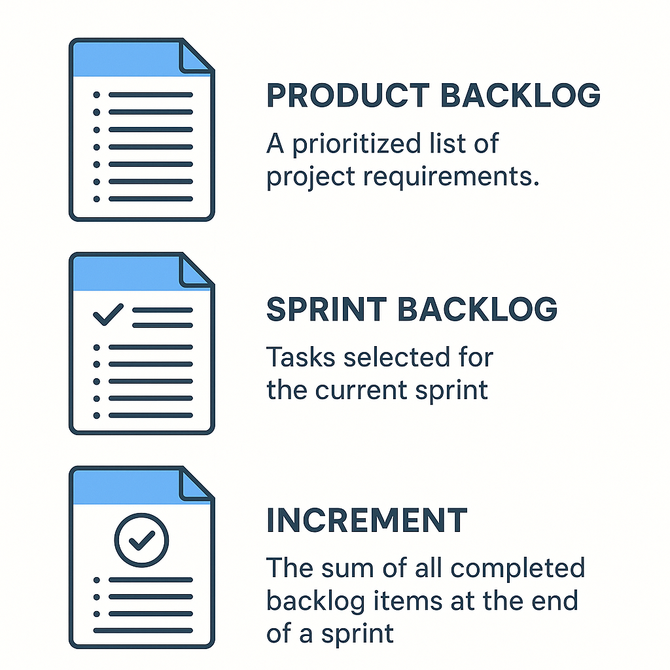

**SCRUM Events:**

1. **Sprint**: A time-boxed iteration, usually 1-4 weeks, to deliver a usable product increment.
2. **Sprint Planning**: A meeting to decide what to accomplish in the sprint.
3. **Daily SCRUM (Standup)**: A brief daily meeting for the team to synchronize their work.
4. **Sprint Review**: A meeting to review the work done and adapt the product backlog.
5. **Sprint Retrospective**: A meeting to reflect on the sprint and improve processes.

