ID: 27381

ASSIGNMENT 1

SCREEN SHOTS OF THE PROCESS OF CREATING A REPOSITORY AND UPLOADING THE FILES INTO GITHUB.

1. Create a Repository

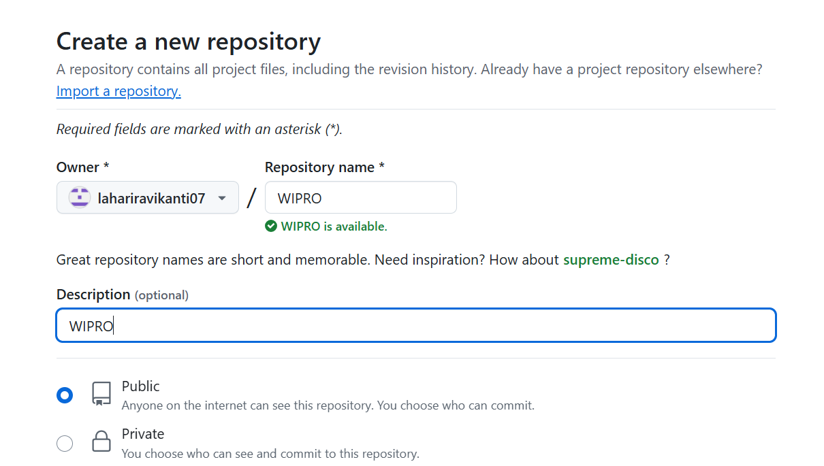

Create a Repository and give a description for the repository.

Then make the repository Public.

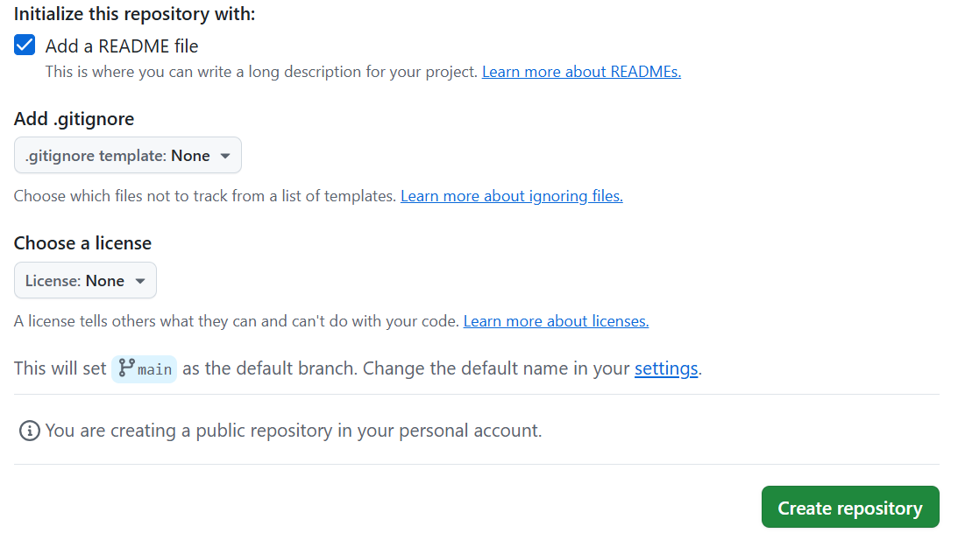

Initialize the repository with Add a Readme file and Create the Repository.

1. Now copy the URL of the created repository and clone the repository to the Local system.

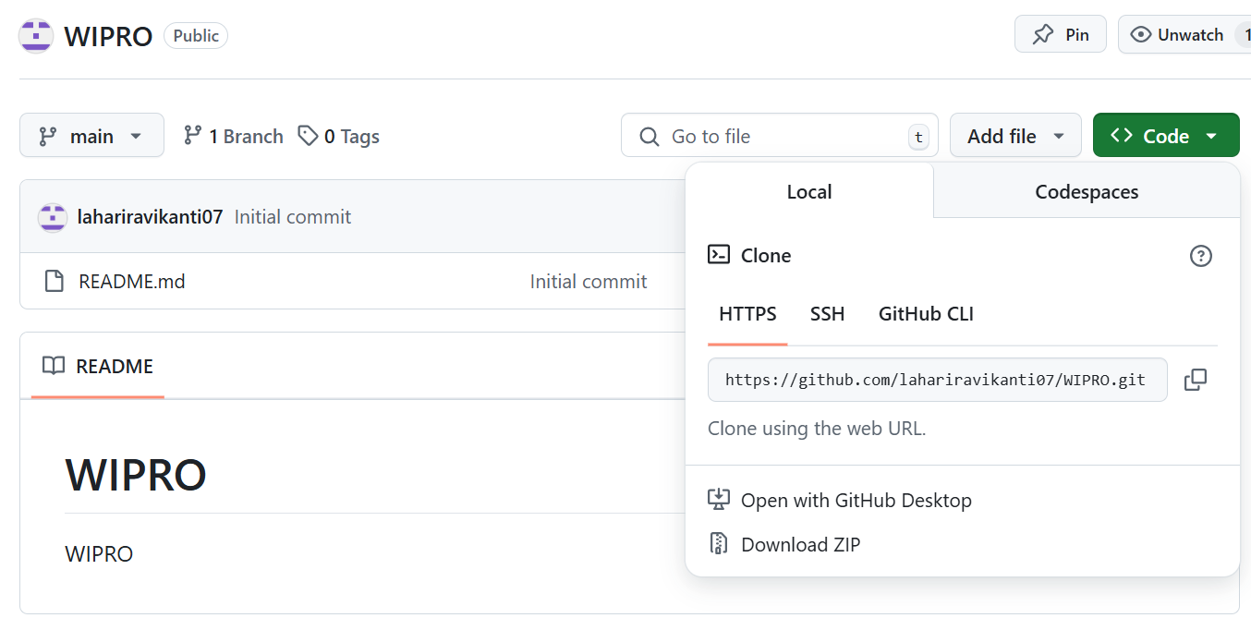

Cloning can be done using the command git clone “url”

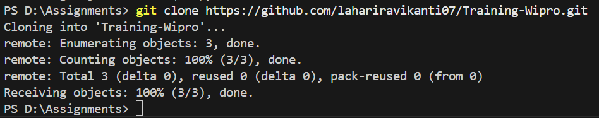

1. Create the Folders after Cloning

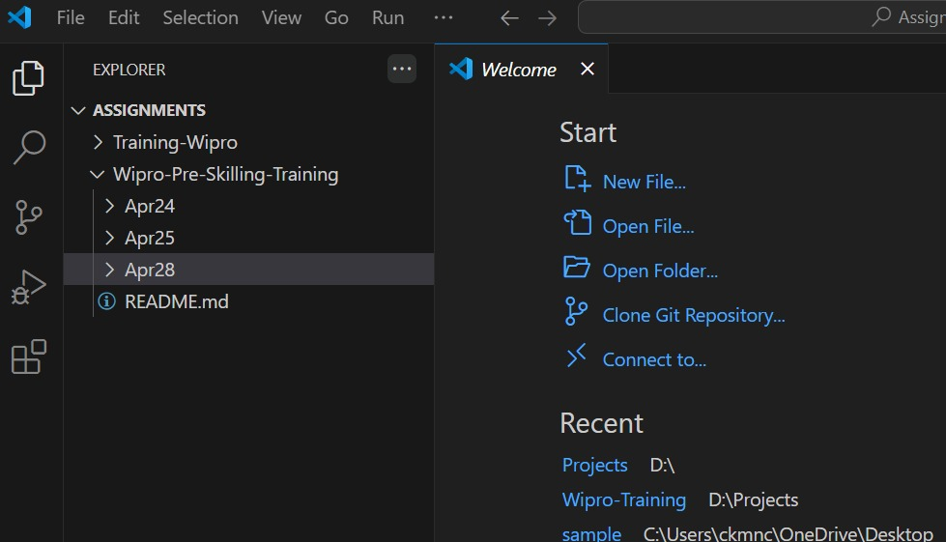

1. Commit and Push the Files

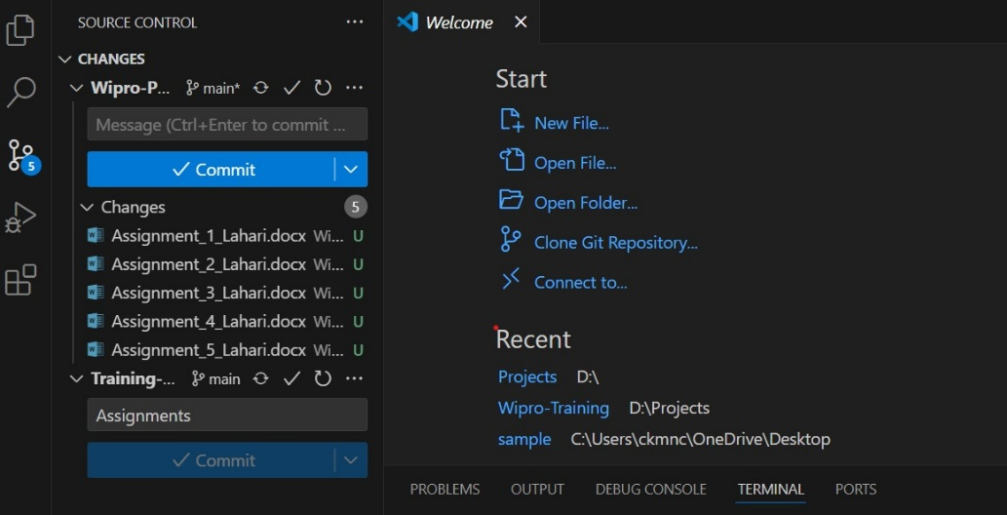

The message should be written before the start of Commit and Push.

1. The files are now committed and pushed into the Github.

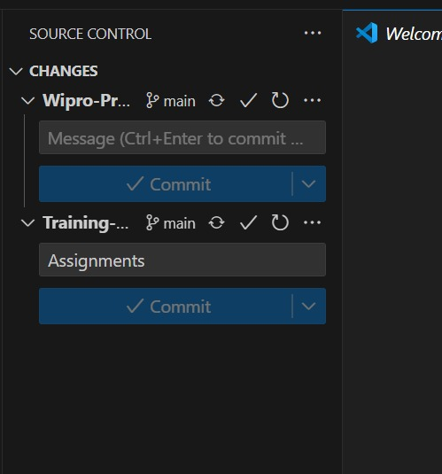

1. The files can now be viewed in Github.

