**Car assignment**

**Back-end**

**Description**

The project is a REST API with spring boot and spring batch to read records from a CVS file table and insert the results into database table. We will use Maven as our build tool, [H2](http://www.mysql.com/) as our database.

**Setting the build tool**

In project directory with plugin java and spring-boot. Also, we will add following dependencies -

1. spring-boot-starter-batch - to pull in spring batch classes.
2. spring-boot-starter-data-jpa - to handle the datasource and pull in spring-jdbc dependencies.

**Dependencies**

* JDK 11
* spring-boot-starter-batch
* spring-boot-starter-web
* Maven - 3.x.x
* H2 Database
* Lombok
* CorsFilter

**Explore Rest APIs**

The app defines following CRUD APIs.

* GET /cars/all
* GET /cars/search/{filter}
* GET /cars/ lowest/{distanceMonth}/{price}
* POST /cars/add

You can test them using postman or any other rest client.

**Front-end**

**Angular Rest**

This project was generated with [Angular CLI](https://github.com/angular/angular-cli) version 1.0.0-rc.2.

**Development server**

cd front-end

npm i --no-save ../angular-crud/*.tgz

# or install the latest released version with: npm install -D angular-crud

npm install

Run ng serve for a dev server. Navigate to http://localhost:4200/. The app will automatically reload if you change any of the source files.

# Screenshots of Demo

* + Dashboard

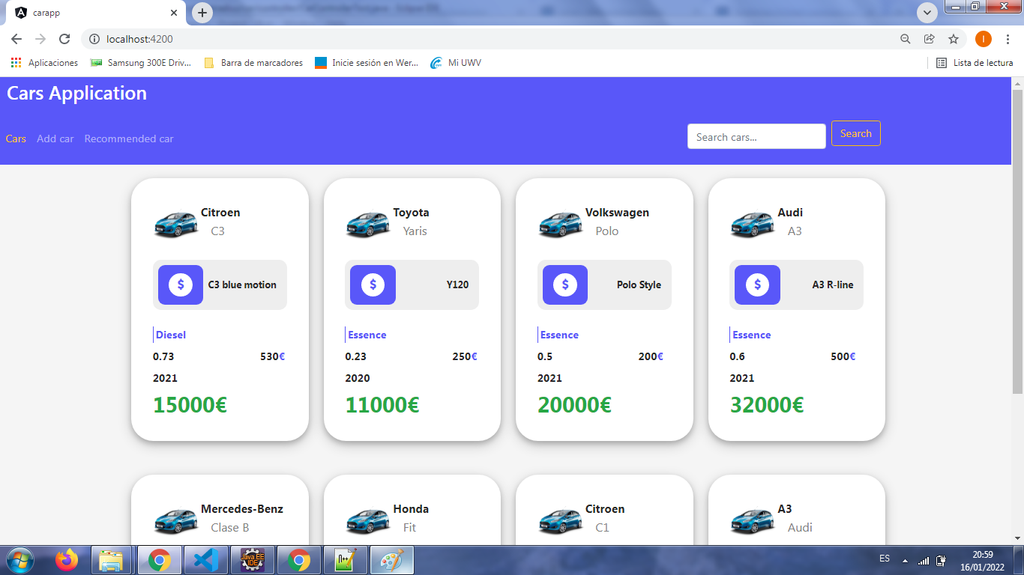

* + Add new car

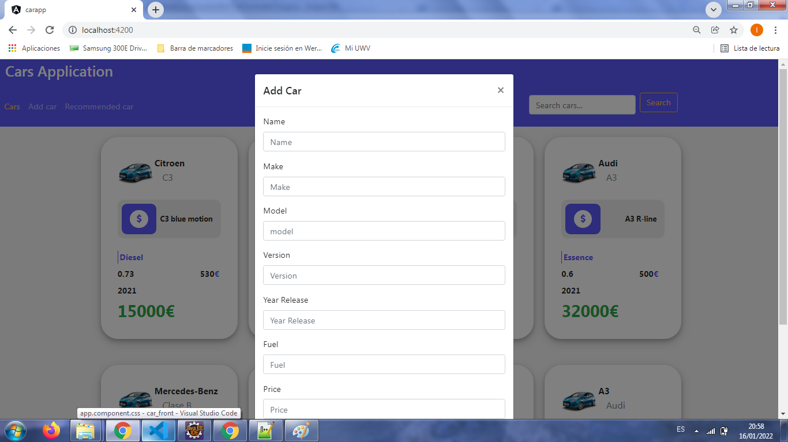

* + Recomended car search

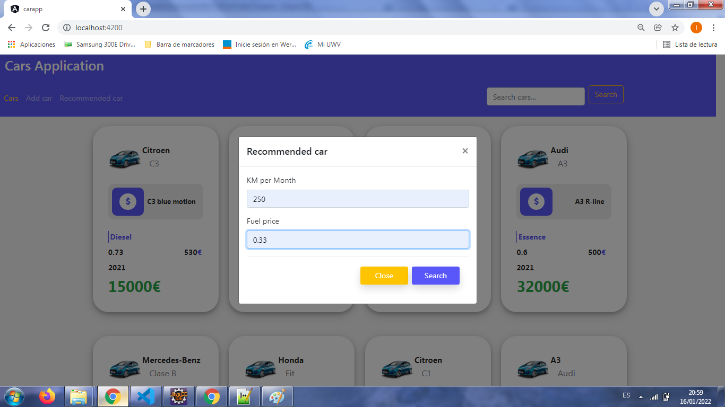

* + Searh car by keyword ( model, year, name, etc…)

