ANALYSIS 1: Customer Revenue Analysis (JOIN + GROUP BY)
1.Which customers generate the highest total revenue?
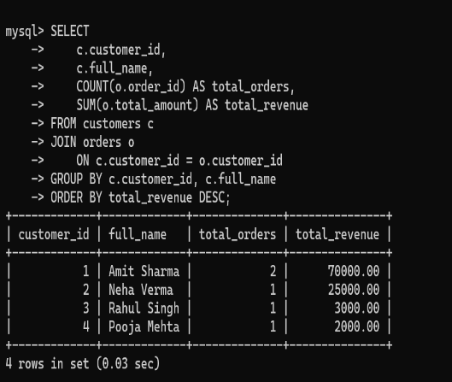

ANALYSIS 2: Product Performance (JOIN + AGGREGATES)
2. Which products sell the most in terms of quantity and revenue?


ANALYSIS 3: City-wise Customer Revenue (multi-table logic)
3. Which cities generate the highest revenue?
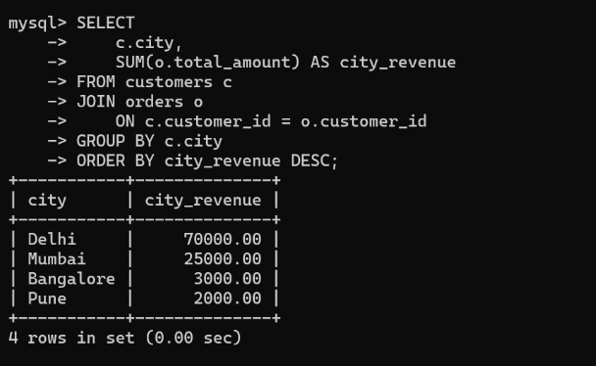

ANALYSIS 4: Customer Lifetime Value (VIEW)
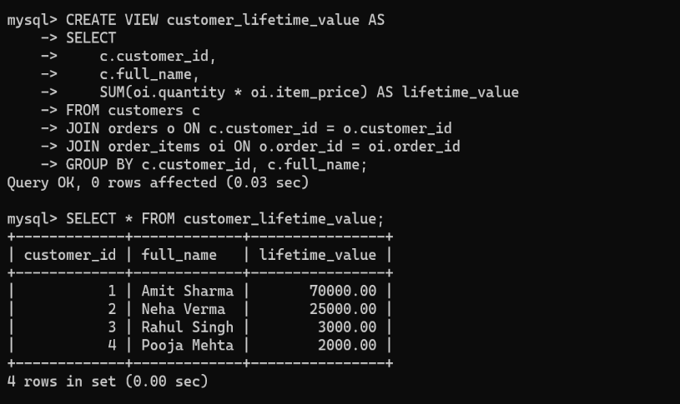

ANALYSIS 5:Advanced Product Revenue Query (with subquery)
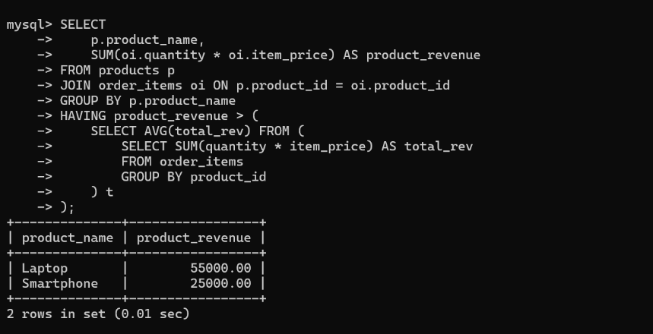

ANALYSIS 6: Data Validation Query
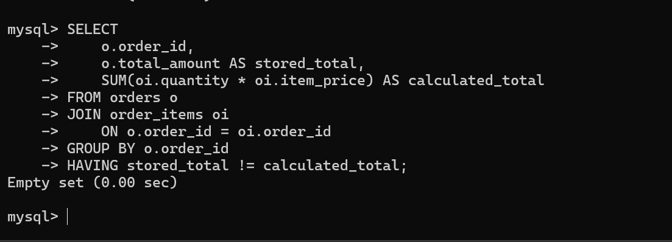

ANALYSIS 7: Optimize queries with indexes
