5Internet Programming

Lab Number: (6)
Subject: PHP Form Handling

Lab Objectives:

This lab will give students practice in using PhpStorm. Students will practice the following:
- Adding Web controls to the web pages using PhpStorm
- Using PHP superglobals $_GET and $_POST to collect form-data.

Lab Work:

Task 1: Ticket.html
Create a webpage called (Ticket.html) and add the following controls:

- Textbox1 for ticket number
- Textbox2 for customer name
- Textbox3 for the age of customer
- ComboBox for destination of ticket (with the following options: Beirut, Cairo and Jeddah)
- Submit Button: "Compute Bill"

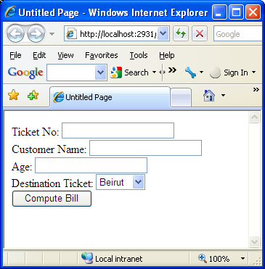

If the user presses on the button the bill amount will be calculated according to the ticket destination and age.

Age | Basic price
>25 | 20 JD
6-25 | 10 JD
<6 | 0 JD

Destination | Price
Beirut | 200 JD
Cairo | 230 JD
Jeddah | 250 JD

Bill amount=Price Of ticket +Basic price

Note: add 0.16 % tax to the price

Task 2: Report.php

Using: $_POST to collect data
Print a full report to the customer including (Ticket Id, Customer name, Age, total price, tax, and net price) as following:

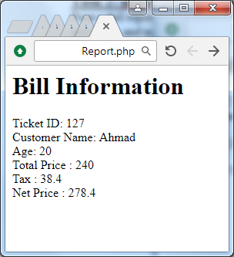
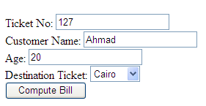
Sample in Ticket.html
Report.php

