5Internet Programming

Lab Number: (7)
Subject: PHP Form Handling And Functions

Lab Objectives:

This lab will give students practice in using PhpStorm. Students will practice the following:
- Adding Web controls to the web pages using PhpStorm
- Using PHP superglobals $_GET and $_POST to collect form-data.

Lab Work:

Task 1: Ticket.html
Create a webpage called (Vowels.html) and add the following controls:

- Textbox1 for Character
- Submit Button: “Vowels Or Not”

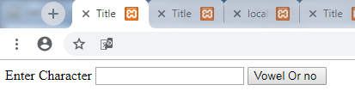

If the user presses on the button call function called vowel and send the character You enterd to check if vowel or not

Task 2: Vowel.php

Using: $_Get to collect data
Print if Vowel or not

