**Internet Programming Lab Sheet 2**

### Question

The new **<canvas>**element is one of the new goodies that comes along with HTML5. The **<canvas>**element allows you to programmatically draw via JavaScript. Write java script code that generate the following bar chart.

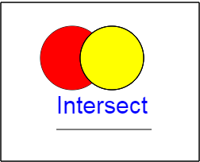

### HW:

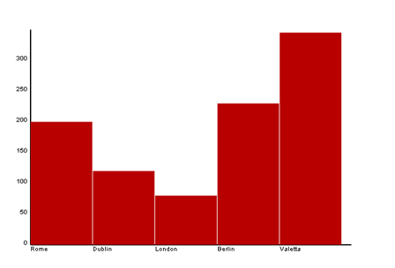The new **<canvas>**element is one of the new goodies that comes along with HTML5. The **<canvas>**element allows you to programmatically draw via JavaScript. Write java script code that generate the following bar chart.