**Internet Programming Lab**

Lab Number: (4)

Subject:

## JQuery

***Lab Objectives:***

This lab will give students practical experience in programming using JQuery.

**Lab Exercise:**

Q1) create a page called Lab4.html, there is a paragraph “Internet Programming” if the user press **mouse down** the paragraph changed to “PHP Language” and the color of this paragraph to “Red”

if the mouse up change paragraph to “JQuery “and the color to “purple”.

Q2)Develop form Contact form system using the new input types included in **HTML5** and **jQuery**. The form should be tested in Chrome or Firefox.

|  |  |
| --- | --- |
| **Field** | **Description** |
| Name | **Text** |
| Email | Confirmation email **Required** |
| Telephone | Input with type number |
| Message | TextArea rows=20 ,cols=20 |
| Button | button |

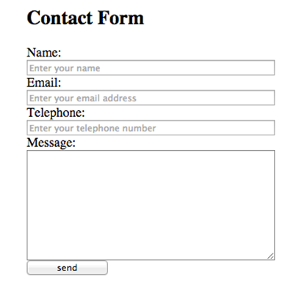

When the user clicks on” Send” button, your program will add the entered data to the second table as the following:

