1. 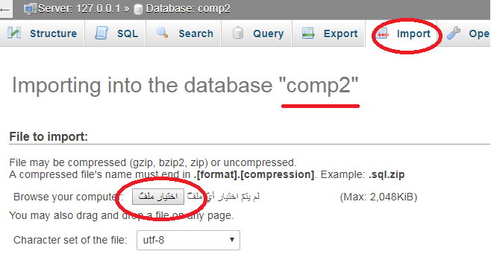Open <https://localhost/phpmyadmin/>
2. Create New Database: comp2
3. Click Import then Choose File “comp2.sql”
4. Click

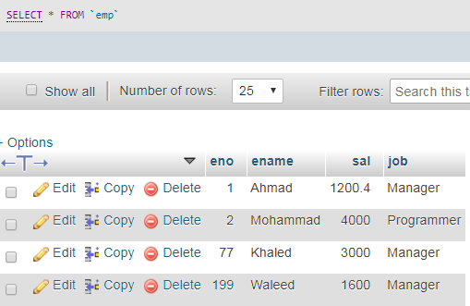

Emp

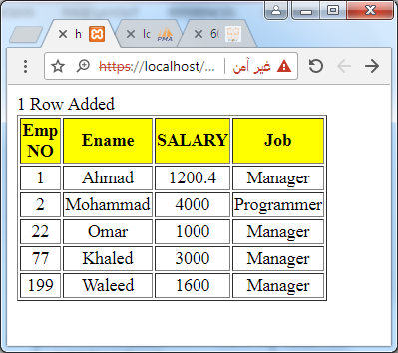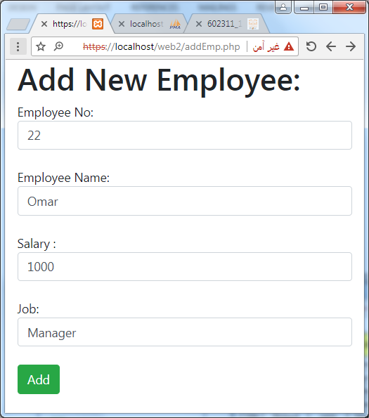

addEmp2.php

addEmp.php