SAIGON UNIVERSITY
FACULTY OF INFORMATION TECHNOLOGY

----- 🙡 🕮 🙣 -----
COURSE: SOFTWARE TESTING

REPORT ON ASSIGNMENT 1
MANUAL TESTING
SUBMISSION DATE: October 23, 2024

SUPERVISOR | : | HANNAH VU
STUDENT NAME | : | LA HIEU PHONG
STUDENT ID | : | 3121411162
CLASS | : | DCT121C5

---------------------------------------------------------------------
Ho Chi Minh City, October 22, 2024

Introduction
During the testing phase of the OpenCart Demo system, our testing team identified several critical issues that impact user experience. Ensuring the accuracy and usability of the system is essential for enhancing customer satisfaction. This report details the logged errors, including error codes, titles, descriptions, severity levels, and priority levels, along with specific reproduction steps.
Each error is analyzed to identify root causes and propose necessary improvements. These recommendations aim not only to address current issues but also to enhance the system's security and performance in the future.
We hope this report will contribute to the system's improvement and provide a better experience for end users.

Table of Contents
1. Test Case Design 1
1.1. Các ca kiểm thử chức năng (Functional Test Cases) 1
Test Case 01: User Registration 1
Test Case 02: User Login 3
Test Case 03: Submit Contact Form 6
Test Case 04: Add Product to Cart 8
Test Case 05: User Logout 11
1.2. Usability Test Cases 13
Test Case 06: Test Product Search Feature 13
Test Case 07: Evaluate the Checkout Process 16
Test Case 08: Test User Experience During Checkout Process 20
Test Case 09: Evaluate the Usability of the Shopping Cart 24
Test Case 10: Test Navigation Feature 31
1.3. Boundary Test Cases 34
Test Case 11: Enter Special Characters in the Email Field 34
Test Case 12: Test Maximum Character Input in Username Field 35
Test Case 13: Test Password Field with Minimum Characters 36
Test Case 14: Test Entering Negative Values in the Product Quantity Field 37
Test Case 15: Test Entering Maximum Values in the Product Quantity Field 39
2. Bug Reporting 40
Error 01: Error When Adding Negative Product Quantity to Cart 40
Error 02: Error When Adding Quantity Exceeding Limit to Cart 42
Error 03: Error in Time Limit for the "Delivery Date" Field 44
Error 04: Error in Product Review 47
Error 05: Error Not Displaying the New Password Entry Page When Password is Forgotten 48
Error 06: Error Entering Special Characters in the Product Name Field 51
Error 07: Error Losing Login Session When Returning from the Order Creation Page 53
3. Test Summary Report 56
3.1. Introduction 56
3.2. Scope 56
3.3. Test Case Summary 56
3.4. Bug Summary 56
3.5. Solutions 56
3.6. Conclusion 57

Test Case Design

Các ca kiểm thử chức năng (Functional Test Cases)

Test Case 01: User Registration

Test Case ID |  |  | TC_001 | Test Case Description |  | Test the registration of a user account with valid information on the OpenCart demo system.
Created By |  |  | La Hieu Phong | Reviewed By |  |  |  |  |  |  |  | Version
QA Tester’s Log
Tester's Name |  |  | La Hieu Phong | Date Tested |  | 22-Oct-2024 |  |  |  |  |  | Test Case (Pass/Fail/Not Executed) |  |  |  |  |  |  | Pass & Fair
S # |  | Prerequisites: |  |  |  |  |  | S # |  |  | Test Data
1 |  | Access to Safari Browser |  |  |  |  |  | 1 |  |  | E-Mail = hieuphong 144@gmail.com
2 |  | XAMPP installed and running on your computer |  |  |  |  |  | 2 |  |  | Pass = 21112003
3 |  | OpenCart installed and configured on XAMPP
4 |  | A stable internet connection to access necessary resources and install extensions for OpenCart
Test Scenario |  | Verify New User Registration Functionality
Prerequisites:
Access the user registration page of the OpenCart demo.

Step # |  | Step Details |  | Expected Results |  | Actual Results |  |  |  |  |  |  |  |  | Pass / Fail / Not executed / Suspended
1 |  | Navigate to the registration page at http://localhost/demo/index.php?route=account/register&language=en-gb |  | The registration page should load successfully |  | As Expected |  |  |  |  |  |  |  |  | Pass
2 |  | Fill in the required information: name, email, password, and confirm password |  | Credential can be entered |  | As Expected |  |  |  |  |  |  |  |  | Pass
3 |  | Click the "Continue" button |  | The system should create the account successfully and redirect to the registration success page.
 |  |  |  | Scenario 1 (Success):  The system redirects to the "Account" page with the URL:  http://localhost/demo/index.php?route=account/account&language=en-gb&customer_token=b093ed2efc5afd905747b1daa6  The page displays the following sections:  - "My Account"  - "My Orders"  - "My Affiliate Account"  - "Newsletter" |  | As Expected |  |  |  |  |  |  |  |  | Pass
 |  |  |  | Scenario 2 (Failure):  A warning dialog appears with one of the following messages:  - "Warning: You must agree to the Privacy Policy!"  - "Warning: E-Mail Address is already registered!" |  | Unexpected |  |  |  |  |  |  |  |  | Fail
Steps to Reproduce
Access the Login page: http://localhost/demo/index.php?route=account/register&language=en-gb
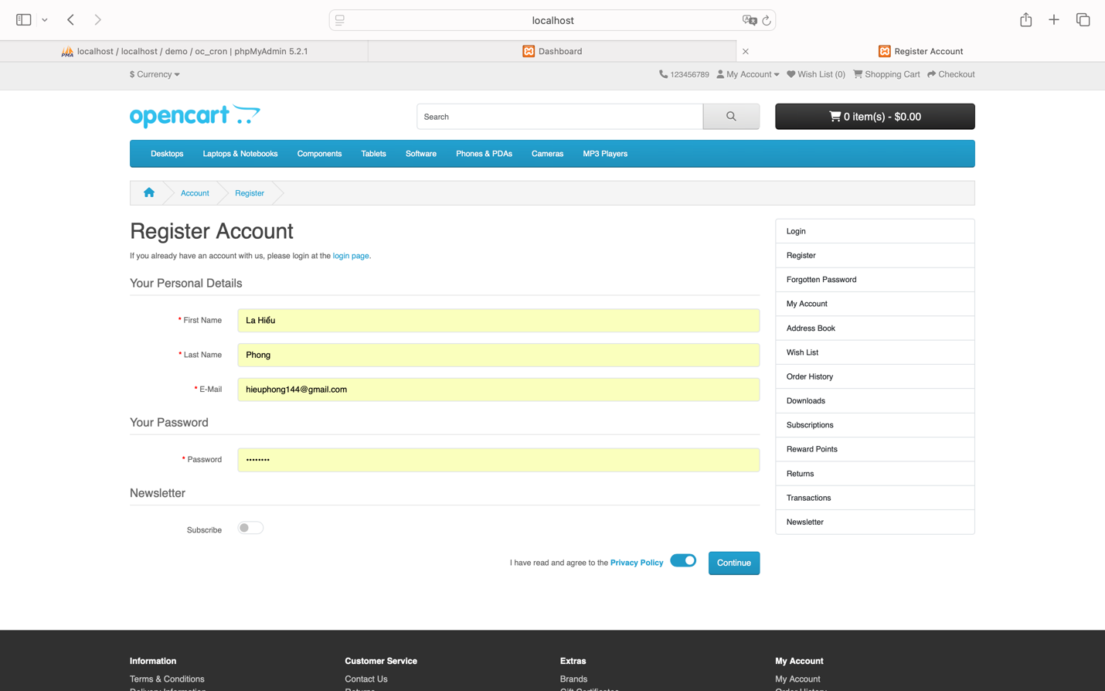
Condition 1 (If successful):
Redirected to the Account page: http://localhost/demo/index.php?route=account/account&language=en-gb&customer_token=b093ed2efc5afd905747b1daa6
The main content area displays four headings: "My Account," "My Orders," "My Affiliate Account," and "Newsletter."
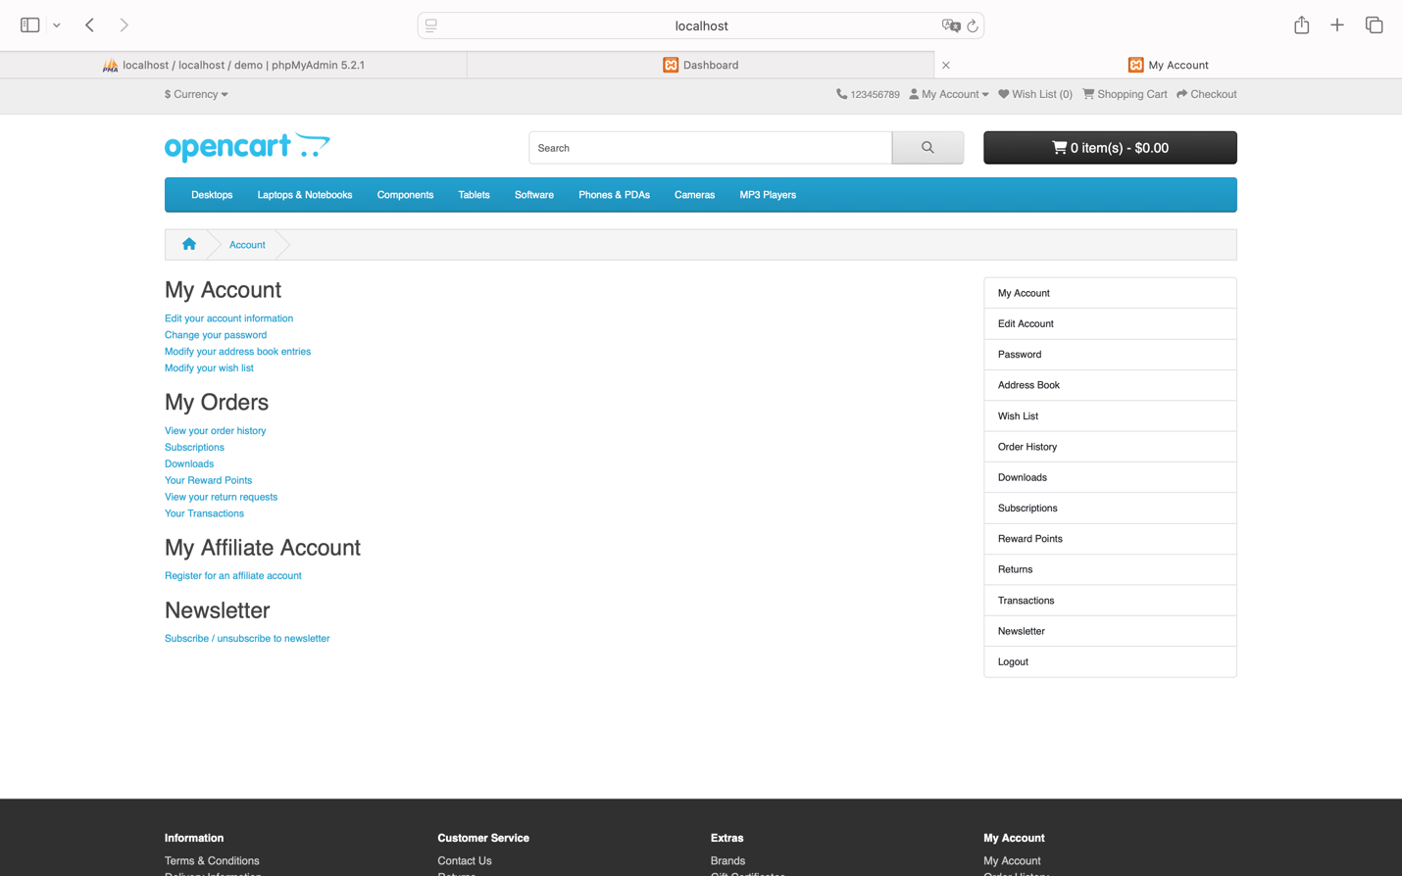
Status: Success
Condition 2 (If failed):
A warning dialog appears with the following message: “Warning: You must agree to the Privacy Policy!”
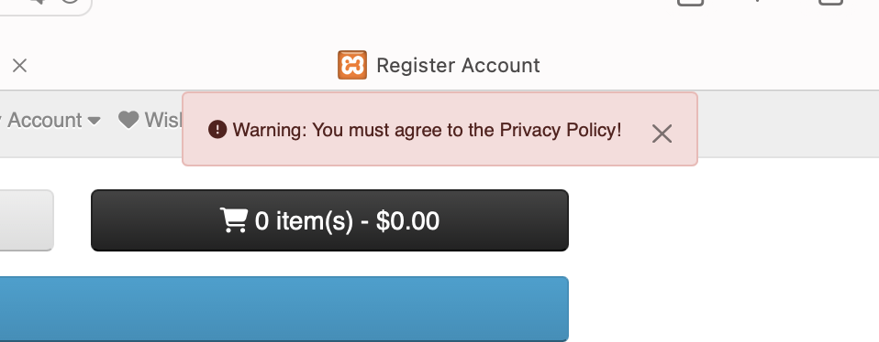
or a warning dialog appears with the following message: “Warning: E-Mail Address is already registered!”
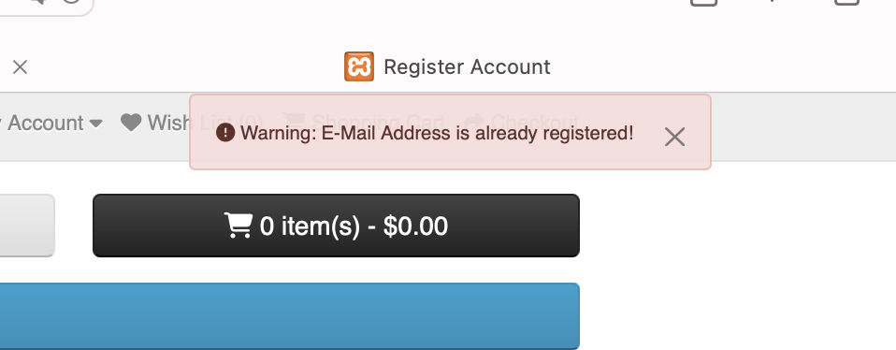
Status: Fail

Test Case 02: User Login

Test Case ID |  | TC_002 | Test Case Description |  | Test the login functionality using a registered account.
Created By |  | La Hieu Phong | Reviewed By |  |  |  |  |  |  |  | Version
QA Tester’s Log
Tester's Name |  | La Hieu Phong | Date Tested |  | 22-Oct-2024 |  |  |  |  |  | Test Case (Pass/Fail/Not Executed) |  |  |  |  |  | Pass & Fair
S # | Prerequisites: |  |  |  |  |  | S # |  |  | Test Data
1 | Access to Safari Browser |  |  |  |  |  | 1 |  |  | E-Mail = hieuphong 144@gmail.com
2 | XAMPP installed and running on your computer |  |  |  |  |  | 2 |  |  | Password = 21112003
3 | OpenCart installed and configured on XAMPP
4 | A stable internet connection to access necessary resources and install extensions for OpenCart
Test Scenario | Verify User Login Functionality
Prerequisites:
The user has a valid registered account.

Step # | Step Details |  | Expected Results |  | Actual Results |  |  |  |  |  |  |  | Pass / Fail / Not executed / Suspended
1 | Navigate to the login page at http://localhost/demo/index.php?route=account/login&language=en-gb |  | The login page should load successfully |  | As Expected |  |  |  |  |  |  |  | Pass
2 | Enter valid email and password into the "E-Mail Address" and "Password" fields |  | Credentials should be entered successfully |  | As Expected |  |  |  |  |  |  |  | Pass
3 | Click the "Continue" button |  | The user should log in successfully and be redirected to their account page.
3 |  |  | Scenario 1 (Success):  The system redirects to:  http://localhost/demo/index.php?route=account/account&language=en-gb&customer_token=58d86053b28cefd68c2cf75f01  The main content area displays the following headings:  - "My Account"  - "My Orders"  - "My Affiliate Account"  - "Newsletter"  Additionally, the user can access the homepage while logged in at:  http://localhost/demo/  To verify, click the "My Account" dropdown, which should display 5 menu items:  - "My Account"  - "Order History"  - "Transactions"  - "Downloads"  - "Logout" |  | As Expected |  |  |  |  |  |  |  | Pass
3 |  |  | Scenario 2 (Failure):  A warning dialog appears with the message:  “Warning: No match for E-Mail Address and/or Password.”  The user is redirected to the homepage in a logged-out state at:  http://localhost/demo/  The "My Account" dropdown only shows 2 menu items:  - "Register"  - "Login" |  | Unexpected |  |  |  |  |  |  |  | Fail

Steps to Reproduce
Access the page: http://localhost/demo/index.php?route=account/login&language=en-gb, fill in the required information for the two fields “E-Mail Address” and “Password,” then click the “Login” button.
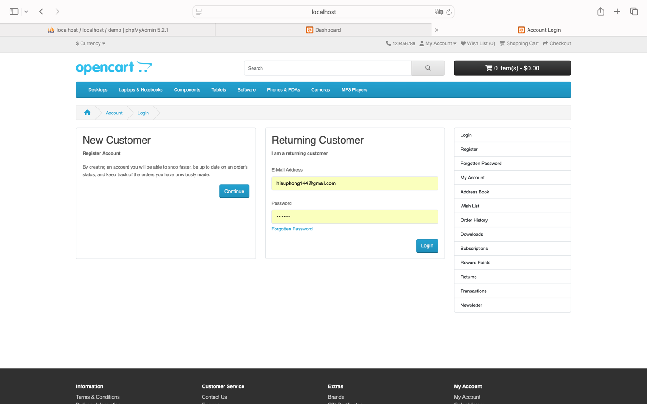
Condition 1 (If successful):
Redirected to the page: http://localhost/demo/index.php?route=account/account&language=en-gb&customer_token=58d86053b28cefd68c2cf75f01
The main content area displays four headings: "My Account," "My Orders," "My Affiliate Account," and "Newsletter" (similar to the “Register” page).
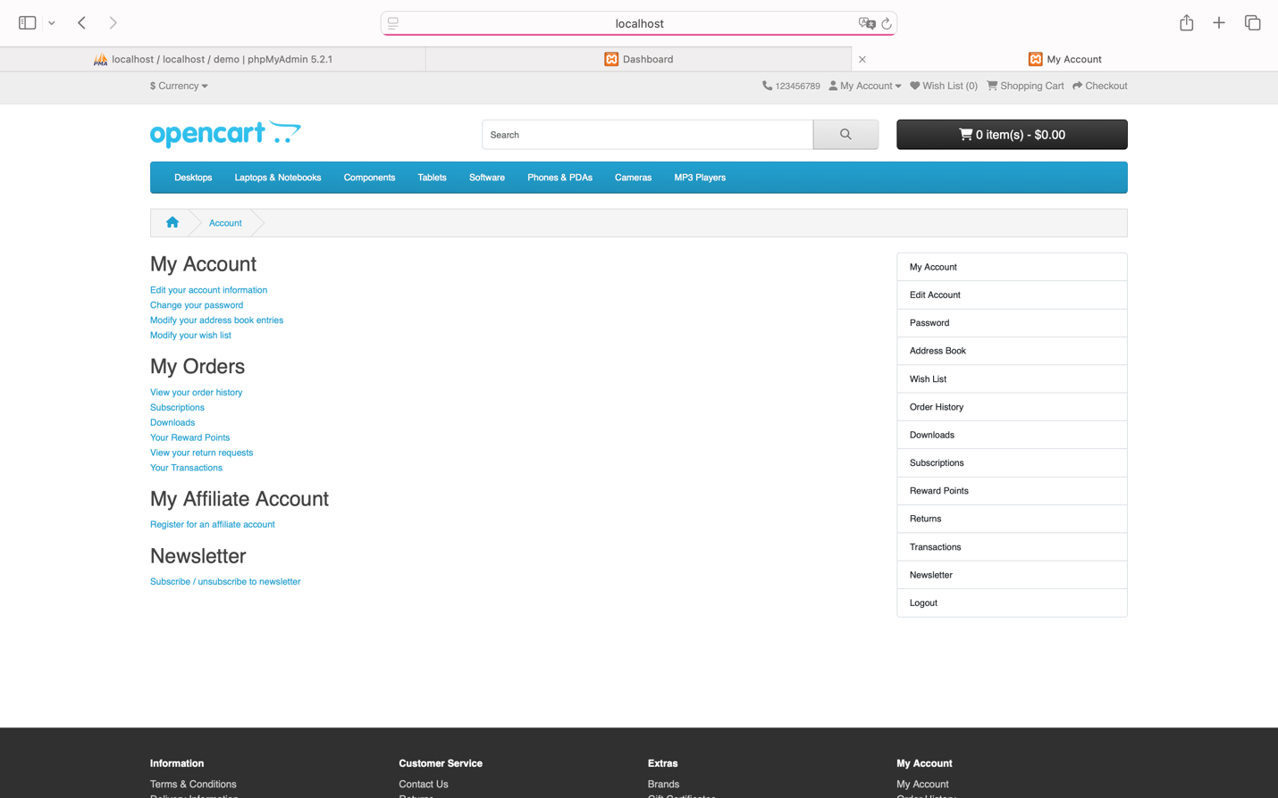
Then access the homepage using the logged-in account: http://localhost/demo/
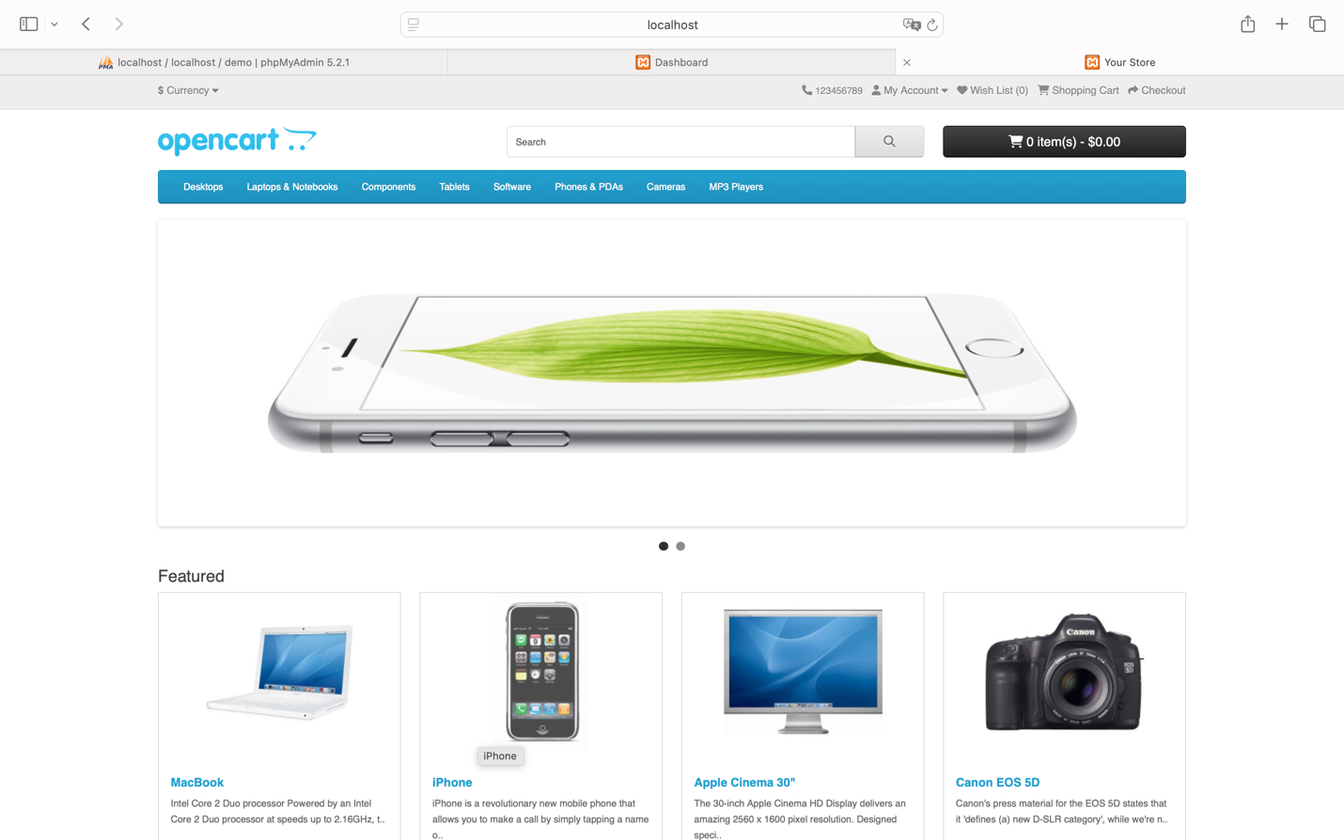

To verify, click on the “My Account” span. A dropdown menu should appear with five menu items: “My Account,” “Order History,” “Transactions,” “Downloads,” and “Logout.”
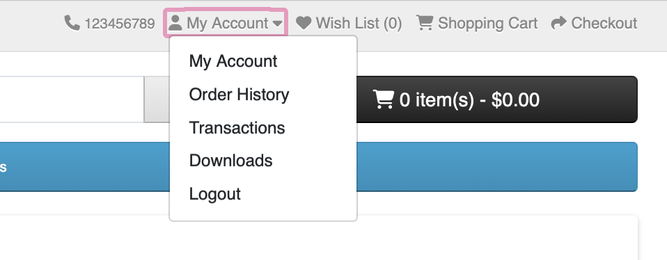
Status: Success
Condition 2 (If failed):
A warning dialog appears with the message: “Warning: No match for E-Mail Address and/or Password.”
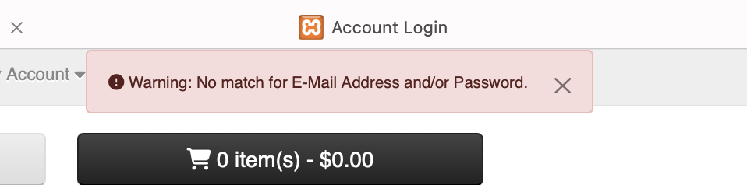

Then access the homepage while in the logged-out state: http://localhost/demo/
Check by clicking on the “My Account” span. The dropdown menu should only display two menu items: “Register” and “Login.”
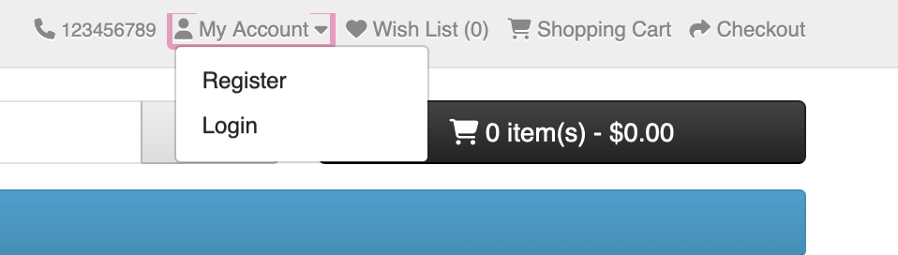

Status: Fail

Test Case 03: Submit Contact Form

Test Case ID |  | TC_003 | Test Case Description |  | Test submitting a contact form with valid information.
Created By |  | La Hieu Phong | Reviewed By |  |  |  |  |  |  |  | Version
QA Tester’s Log
Tester's Name |  | La Hieu Phong | Date Tested |  | 22-Oct-2024 |  |  |  |  |  | Test Case (Pass/Fail/Not Executed) |  |  |  |  |  | Pass
S # | Prerequisites: |  |  |  |  |  | S # |  |  | Test Data
1 | Access to Safari Browser |  |  |  |  |  | 1 |  |  | Your Name “La Hiếu Phong”
2 | XAMPP installed and running on your computer |  |  |  |  |  | 2 |  |  | E-Mail Address “hieuphong144@gmail.com”
3 | OpenCart installed and configured on XAMPP |  |  |  |  |  | 3 |  |  | Enquiry  “ Xin chào đội ngũ hỗ trợ,  Tôi đang quan tâm đến sản phẩm Mac Pro 13.3 inch và muốn biết thêm chi tiết về giá cả và chương trình khuyến mãi hiện tại. Mong nhận được phản hồi sớm từ quý công ty.  Cảm ơn và trân trọng.  La Hiếu Phong”
4 | A stable internet connection to access necessary resources and install extensions for OpenCart
Test Scenario | Verify Contact Form Submission Functionality
Prerequisites:
Access the "Contact Us" page.

Step # | Step Details |  | Expected Results |  | Actual Results |  |  |  |  |  |  |  | Pass / Fail / Not executed / Suspended
1 | Navigate to the "Contact Us" page at http://localhost/demo/index.php?route=information/contact&language=en-gb |  | The contact page should load successfully |  | As Expected |  |  |  |  |  |  |  | Pass
2 | Enter valid name, email and enquiry into the “Your Name”, "E-Mail Address" and " Enquiry" fields |  | Credentials should be entered successfully |  | As Expected |  |  |  |  |  |  |  | Pass
3 | Click the "Continue" button |  | The system should display a success message and send a confirmation email to the user. |  | As Expected |  |  |  |  |  |  |  | Pass
The system redirects to:
http://localhost/demo/index.php?route=information/contact.success&language=en-gb
The page displays the following:
- Heading: "Contact Us"
- Label: "Your enquiry has been successfully sent to the store owner!"

Steps to Reproduce

Access the page: http://localhost/demo/index.php?route=information/contact&language=en-gb
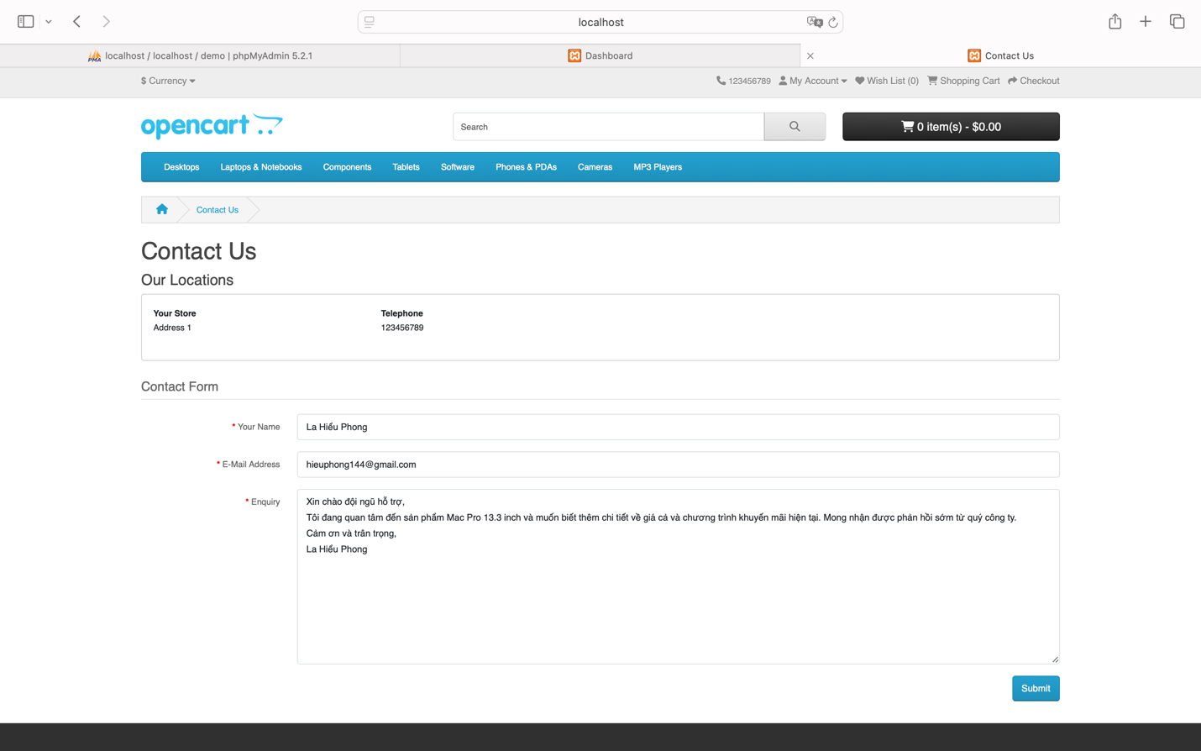
After filling in the three fields “Your Name,” “E-Mail Address,” and “Enquiry,” click the “Submit” button.
You will be redirected to the page: http://localhost/demo/index.php?route=information/contact.success&language=en-gb
The heading “Contact Us” and the label “Your enquiry has been successfully sent to the store owner!” will be displayed.
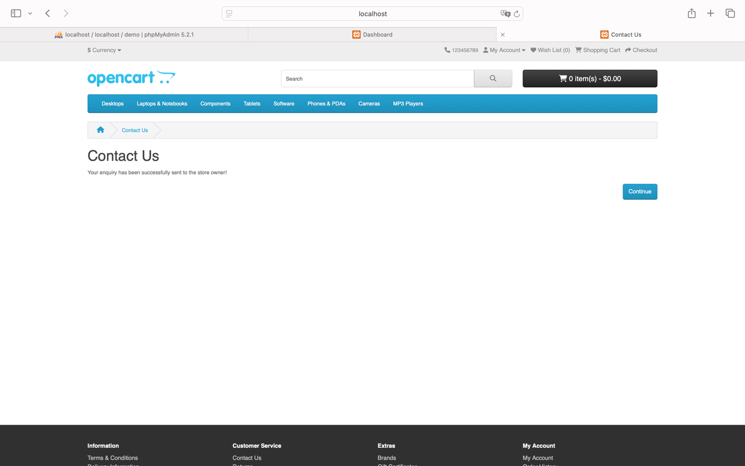
Status: Success

Test Case 04: Add Product to Cart

Test Case ID |  | TC_004 | Test Case Description |  | Add a product to the cart and verify the cart is updated correctly.
Created By |  | La Hieu Phong | Reviewed By |  |  |  |  |  |  |  | Version
QA Tester’s Log
Tester's Name |  | La Hieu Phong | Date Tested |  | 22-Oct-2024 |  |  |  |  |  | Test Case (Pass/Fail/Not Executed) |  |  |  |  |  | Pass & Fair
S # | Prerequisites: |  |  |  |  |  | S # |  |  | Test Data
1 | Access to Safari Browser |  |  |  |  |  | 1 |  |  | Product: MacBook
2 | XAMPP installed and running on your computer |  |  |  |  |  | 2 |  |  | Quantity: 2
3 | OpenCart installed and configured on XAMPP
4 | A stable internet connection to access necessary resources and install extensions for OpenCart
Test Scenario | Verify Add Product to Cart Functionality
Prerequisites:
The user must be logged in.

Step # | Step Details |  | Expected Results |  | Actual Results |  |  |  |  |  |  |  | Pass / Fail / Not executed / Suspended
1 | Search for a product on the homepage |  | The product list should display successfully |  | As Expected |  |  |  |  |  |  |  | Pass
2 | Click the "Add to Cart" button for the selected product |  | The product should be added to the cart successfully |  | As Expected |  |  |  |  |  |  |  | Pass
3 | Check the cart to confirm the product was added |  | The product should appear in the cart with the correct quantity and price.
3 |  |  | A dialog appears with the message:  “Success: You have added MacBook to your shopping cart!”  Click the button showing:  “1 item(s) - $602.00” for a quick view of the added product.  To view the product in detail, click "View Cart", which opens the cart page at:  http://localhost/demo/index.php?route=checkout/cart&language=en-gb  You can modify the quantity (e.g., change it to “2”) and click “Update” to reload the page, reflecting the updated total cost. |  | As Expected |  |  |  |  |  |  |  | Pass
3 |  |  | Scenario 2 (Failure):  A warning dialog appears: “Warning: Product could not be found!”, meaning the product was not added to the cart. |  | Unexpected |  |  |  |  |  |  |  | Fail

Steps to Reproduce

Assume I want to add the product “MacBook” to the shopping cart.
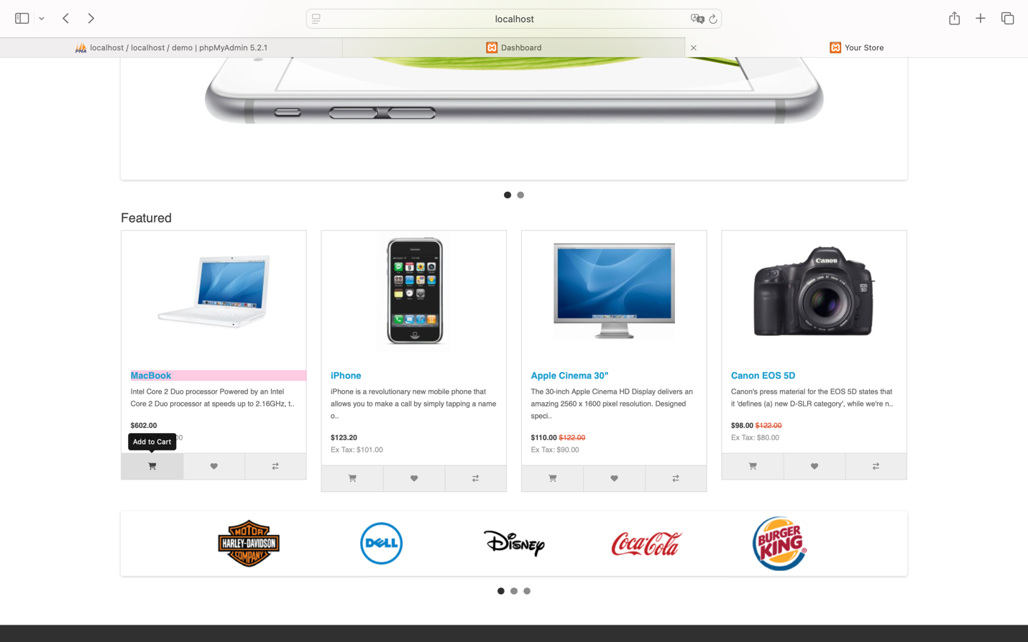
Condition 1 (If successful):
A dialog appears: “Success: You have added MacBook to your shopping cart!”
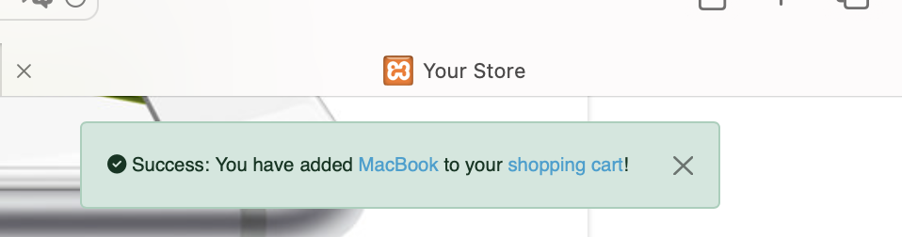
Then click the button “1 item(s) - $602.00” to view the product that was just added.
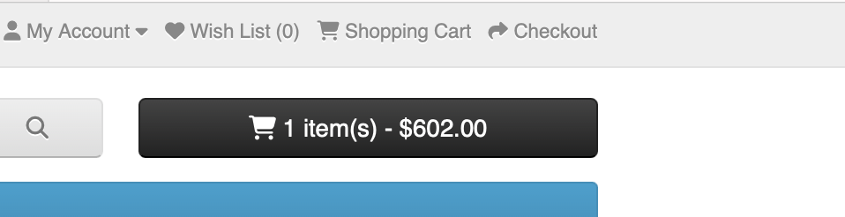
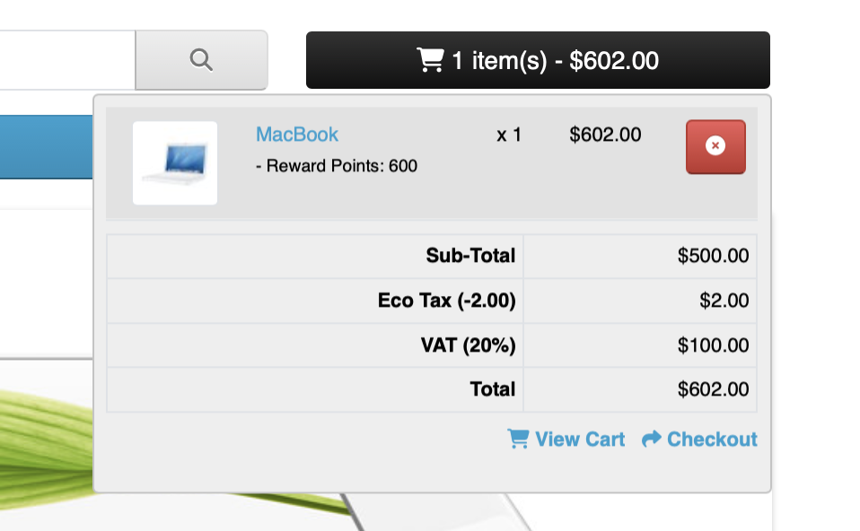
To see the details of the added product, click on “View Cart,” which redirects you to the page: http://localhost/demo/index.php?route=checkout/cart&language=en-gb.
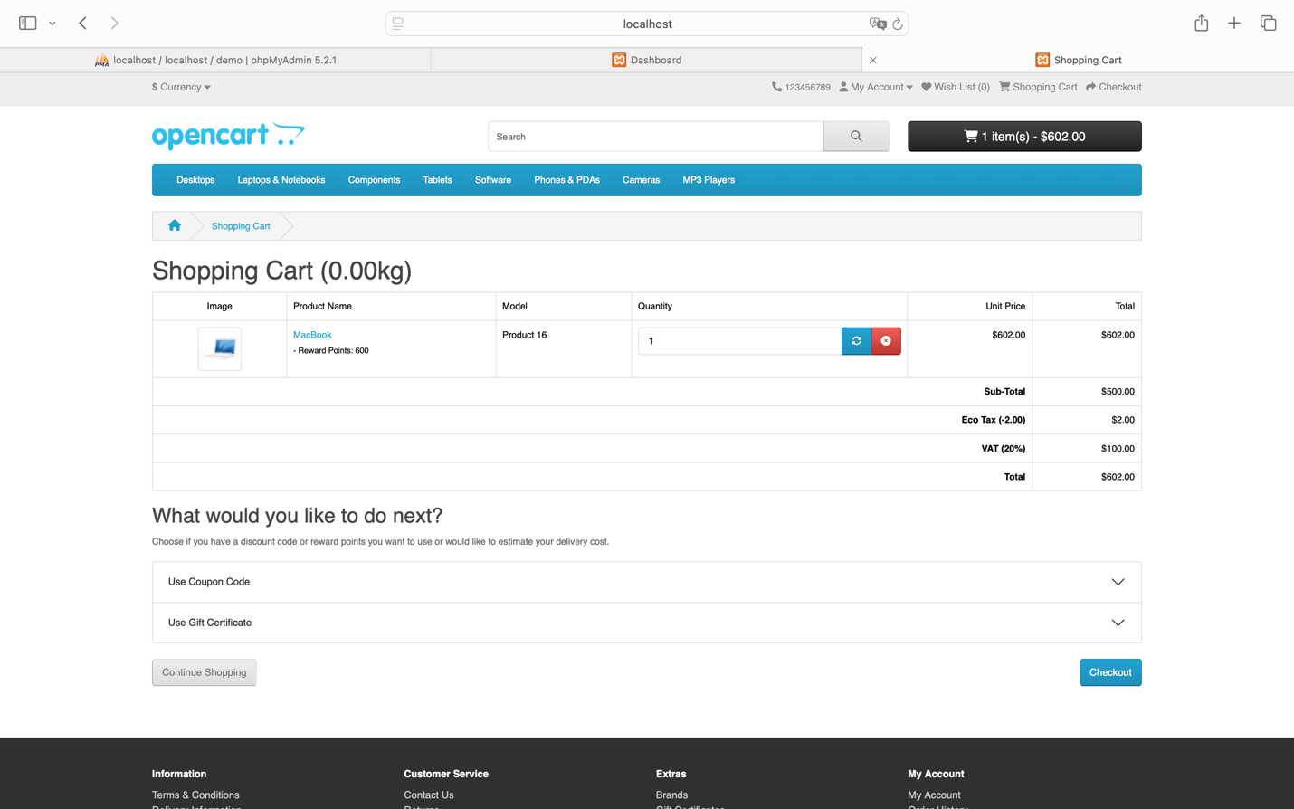
You can change the “Quantity” (for example, update “Quantity” to “2”), then click “Update” to reload, and the order value should change according to the quantity.
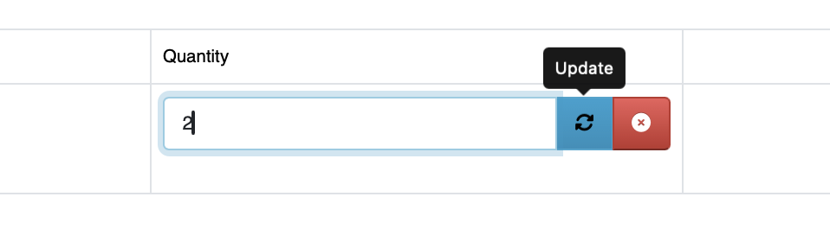
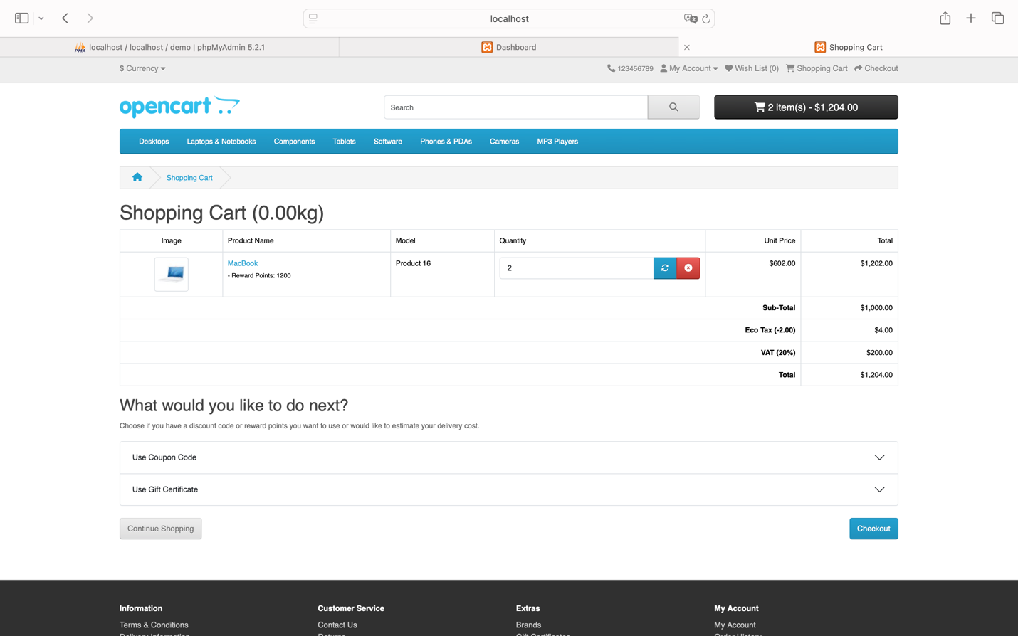
Status: Success
Condition 2 (If failed):
A dialog appears with the message: “Warning: Product could not be found!” (which means: The product was not added to the shopping cart).

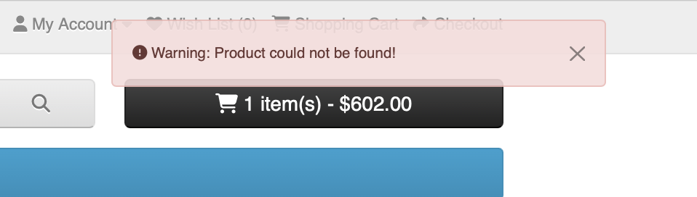

Status: Fail

Test Case 05: User Logout

Test Case ID |  | TC_005 | Test Case Description |  | Test the logout functionality for a logged-in user.
Created By |  | La Hieu Phong | Reviewed By |  |  |  |  |  |  |  | Version
QA Tester’s Log
Tester's Name |  | La Hieu Phong | Date Tested |  | 22-Oct-2024 |  |  |  |  |  | Test Case (Pass/Fail/Not Executed) |  |  |  |  |  | Pass
S # | Prerequisites: |  |  |  |  |  | S # |  |  | Test Data
1 | Access to Safari Browser
2 | XAMPP installed and running on your computer
3 | OpenCart installed and configured on XAMPP
4 | A stable internet connection to access necessary resources and install extensions for OpenCart
Test Scenario | Verify User Logout Functionality
Prerequisites:
The user is currently logged in.

Step # | Step Details |  | Expected Results |  | Actual Results |  |  |  |  |  |  |  | Pass / Fail / Not executed / Suspended
1 | Click the "Logout" button from the user interface |  | The contact page should load successfully |  | As Expected |  |  |  |  |  |  |  | Pass
2 | Verify that the user has been logged out and redirected to the login or homepage |  | The system should return to the logout page at: http://localhost/demo/index.php?route=account/logout&language=en-gb  The page should display the following:  - <h1> tag with: “Account Logout”  - Two <p> tags containing the messages:  - “You have been logged off your account. It is now safe to leave the computer.”  - “Your shopping cart has been saved, the items inside it will be restored whenever you log back into your account.”  To continue, the user can click “Continue” to return to the homepage at: http://localhost/demo/index.php?route=common/home&language=en-gb  in a logged-out state. |  | As Expected |  |  |  |  |  |  |  | Pass

Steps to Reproduce
Click on the span “My Account” to display the dropdown menu with the menu item “Logout.”
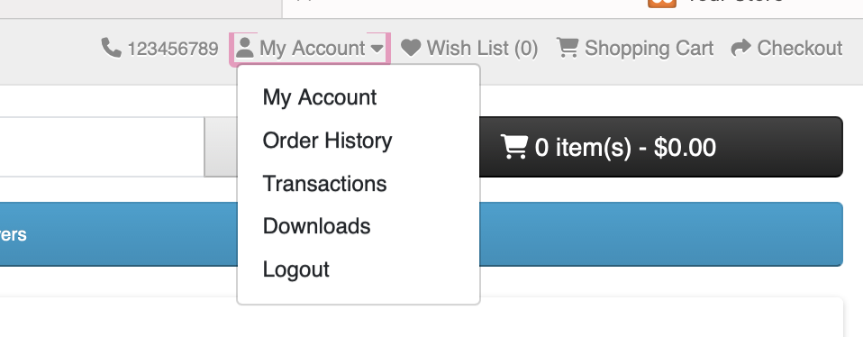
Redirect to the page: http://localhost/demo/index.php?route=account/logout&language=en-gb.
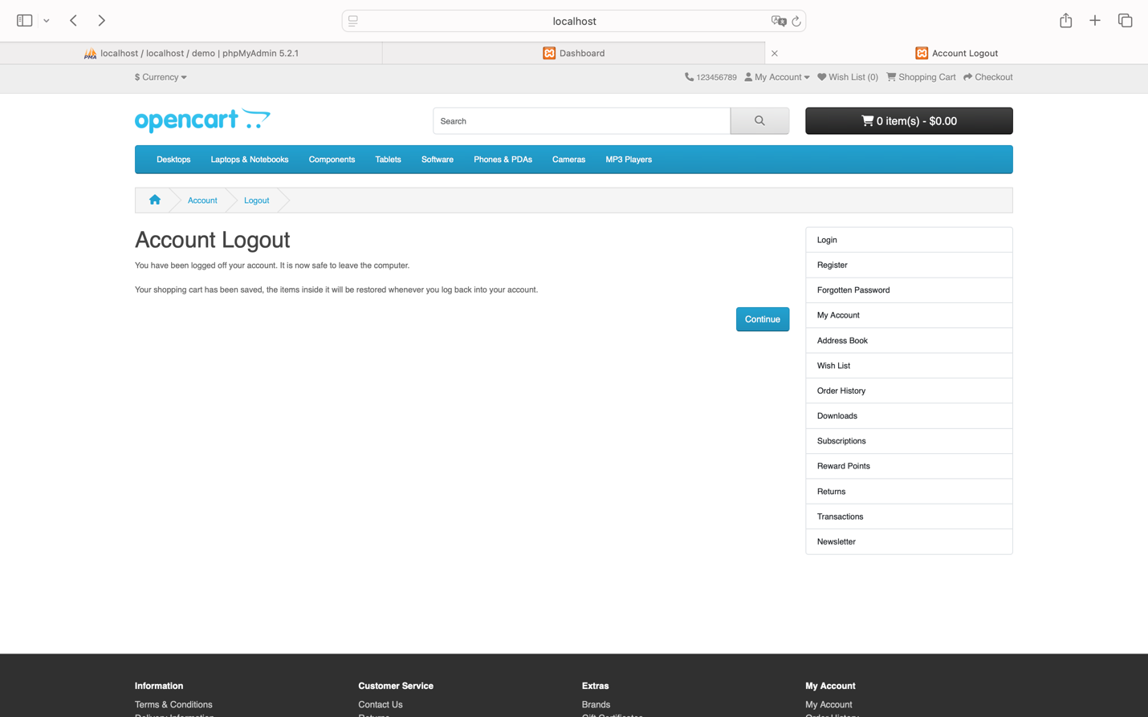

The page displays an <h1> tag with “Account Logout” and two <p> tags containing the text: “You have been logged off your account. It is now safe to leave the computer” and “Your shopping cart has been saved; the items inside it will be restored whenever you log back into your account.” This indicates a successful logout.
You can click the “Continue” button to go back to the homepage: http://localhost/demo/index.php?route=common/home&language=en-gb in the logged-out state.
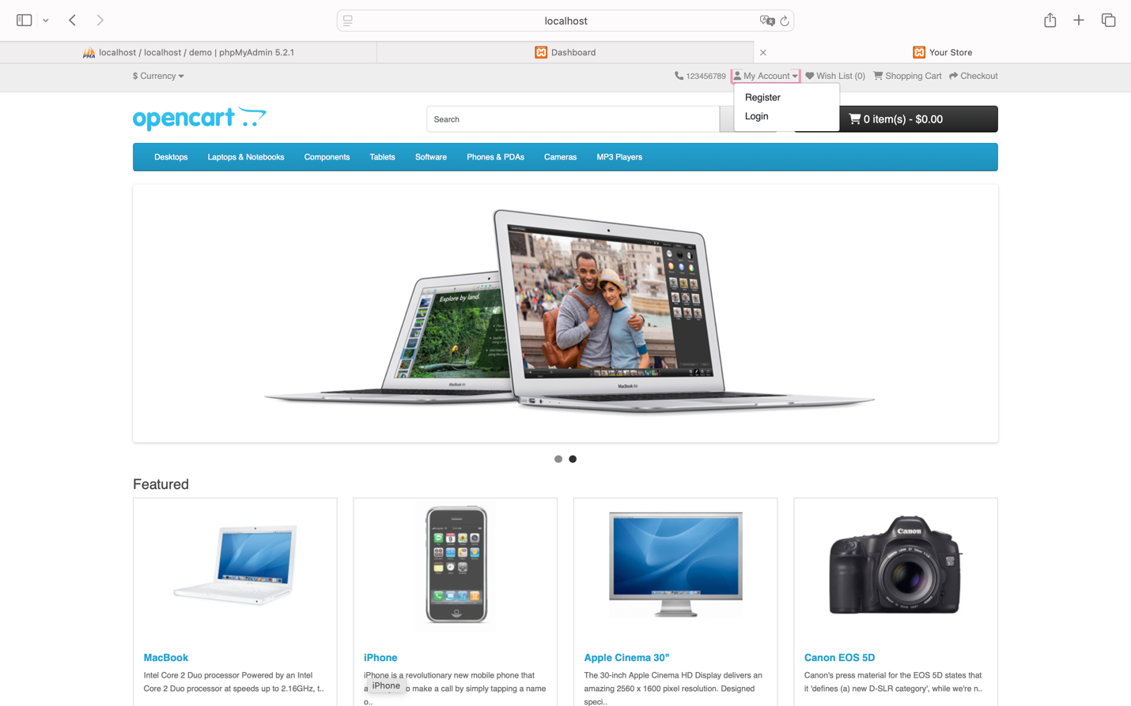
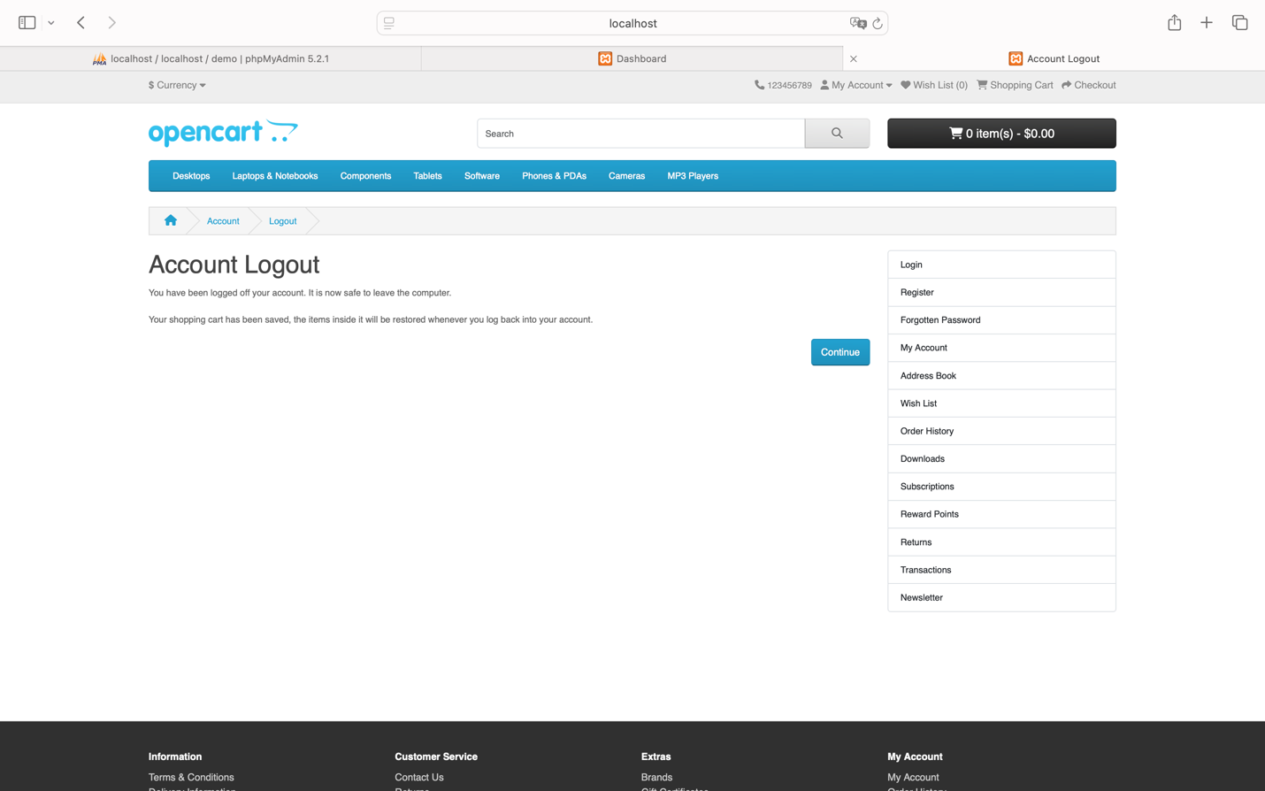
Status: Success

Usability Test Cases

Test Case 06: Test Product Search Feature

Test Case ID |  | TC_006 | Test Case Description |  | Evaluate the ability and accuracy of the product search functionality.
Created By |  | La Hieu Phong | Reviewed By |  |  |  |  |  |  |  | Version
QA Tester’s Log
Tester's Name |  | La Hieu Phong | Date Tested |  | 22-Oct-2024 |  |  |  |  |  | Test Case (Pass/Fail/Not Executed) |  |  |  |  |  | Pass & Fail
S # | Prerequisites: |  |  |  |  |  | S # |  |  | Test Data
1 | Access to Safari Browser |  |  |  |  |  | 1 |  |  | Keyword: MacBook
2 | XAMPP installed and running on your computer |  |  |  |  |  | 2 |  |  | Keyword: macbook
3 | OpenCart installed and configured on XAMPP |  |  |  |  |  | 3 |  |  | Keyword: MacBok
4 | A stable internet connection to access necessary resources and install extensions for OpenCart |  |  |  |  |  | 4 |  |  | Keyword: Banana
Test Scenario | Verify Usability of Product Search Functionality
Prerequisites:
Access the homepage.

Step # | Step Details |  | Expected Results |  | Actual Results |  |  |  |  |  |  |  | Pass / Fail / Not executed / Suspended
1 | Enter a product keyword in the search box |  | The keyword should be entered successfully |  | As Expected |  |  |  |  |  |  |  | Pass
2 | Click the search button or press Enter |  | The search results should load based on the keyword |  | As Expected |  |  |  |  |  |  |  | Pass
3 | Check the search results display |  | Expected Results: Search results should match the entered keyword, be easy to understand, and provide proper navigation.
 |  |  | Scenario 1 (Correct spelling):  The system navigates to:  http://localhost/demo/index.php?route=product/search&language=en-gb&search=Macbook  It displays a product list for the keyword "MacBook".  A product display control bar is shown, including:  - "Product Compare"  - A list of products such as:  - “MacBook”  - “MacBook Air”  - “MacBook Pro” |  | As expected |  |  |  |  |  |  |  | Pass
 |  |  | Scenario 2 (Lowercase keyword):  The same results should be displayed as in Scenario 1.  The system navigates to: http://localhost/demo/index.php?route=product/search&language=en-gb&search=macbook  It shows the same product list and control bar. |  | As expected |  |  |  |  |  |  |  | Pass
 |  |  | Scenario 3 (Misspelled keyword):  The system navigates to: http://localhost/demo/index.php?route=product/search&language=en-gb&search=MacBok  It shows the following message: “There is no product that matches the search criteria.” |  | Unexpected |  |  |  |  |  |  |  | Fail
 |  |  | Scenario 4 (Non-existing product):  The system navigates to: http://localhost/demo/index.php?route=product/search&language=en-gb&search=Banana  It displays the following message: “There is no product that matches the search criteria.” |  | Unexpected |  |  |  |  |  |  |  | Fail

Steps to Reproduce
Search using the entered keyword (Assume the search keyword is: “MacBook”)
Condition 1: Enter the correct spelling.
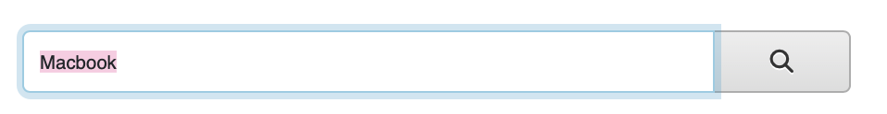
Navigate to the page: http://localhost/demo/index.php?route=product/search&language=en-gb&search=Macbook to display the products that match the search results.
A product display control bar shows “Product Compare” + a list of products (specifically “MacBook,” “MacBook Air,” “MacBook Pro”).
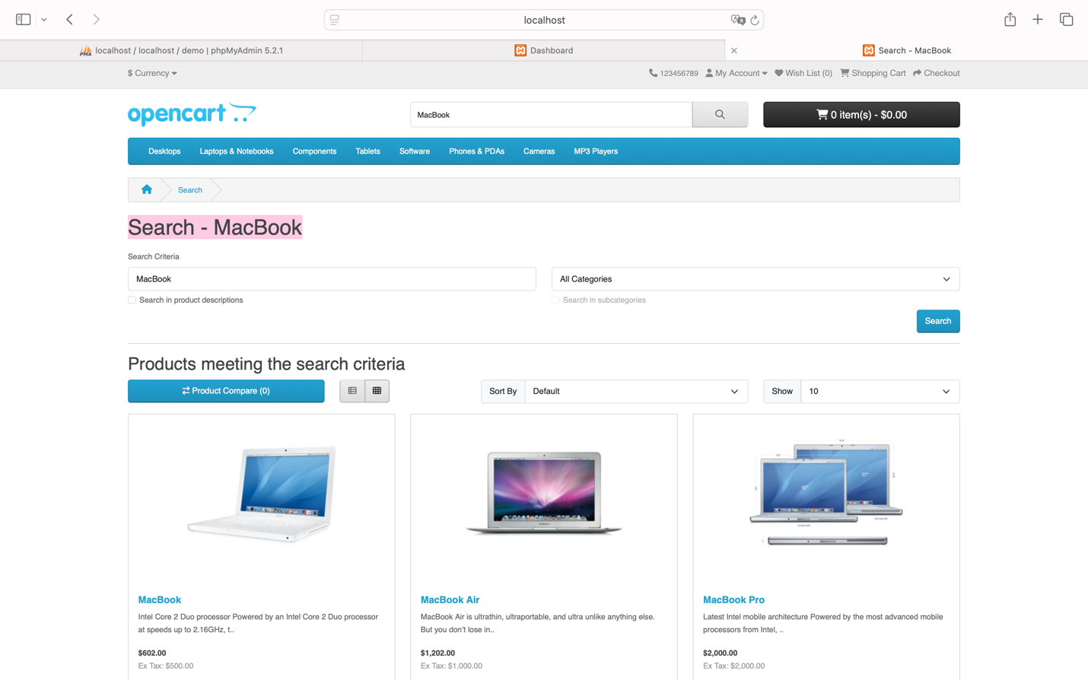
Status: Success
Condition 2: Enter all lowercase letters:

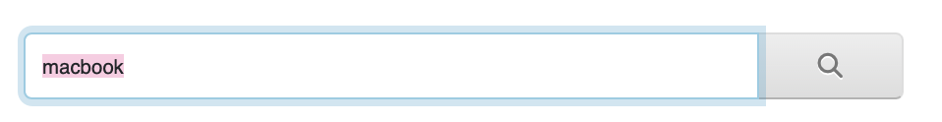

Also navigate to the page: http://localhost/demo/index.php?route=product/search&language=en-gb&search=macbook to display the products that match the search results.
A product display control bar shows “Product Compare” + a list of products (specifically “MacBook,” “MacBook Air,” “MacBook Pro”) (same as Condition 1).

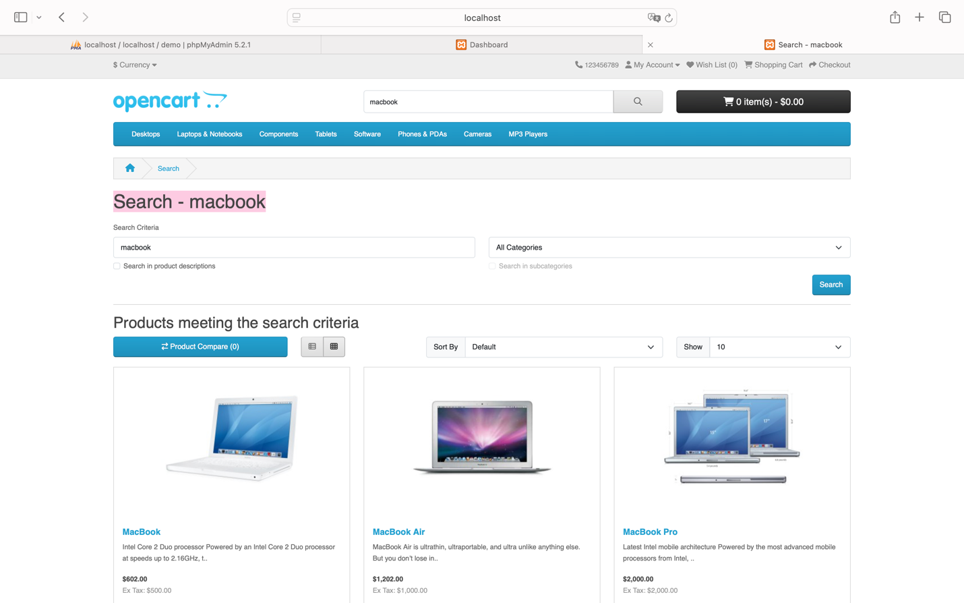

Status: Success

Condition 3: Entering a misspelled word:


Navigate to the page: http://localhost/demo/index.php?route=product/search&language=en-gb&search=MacBok to display the products that match the search results.
Check for the message: “There is no product that matches the search criteria.”
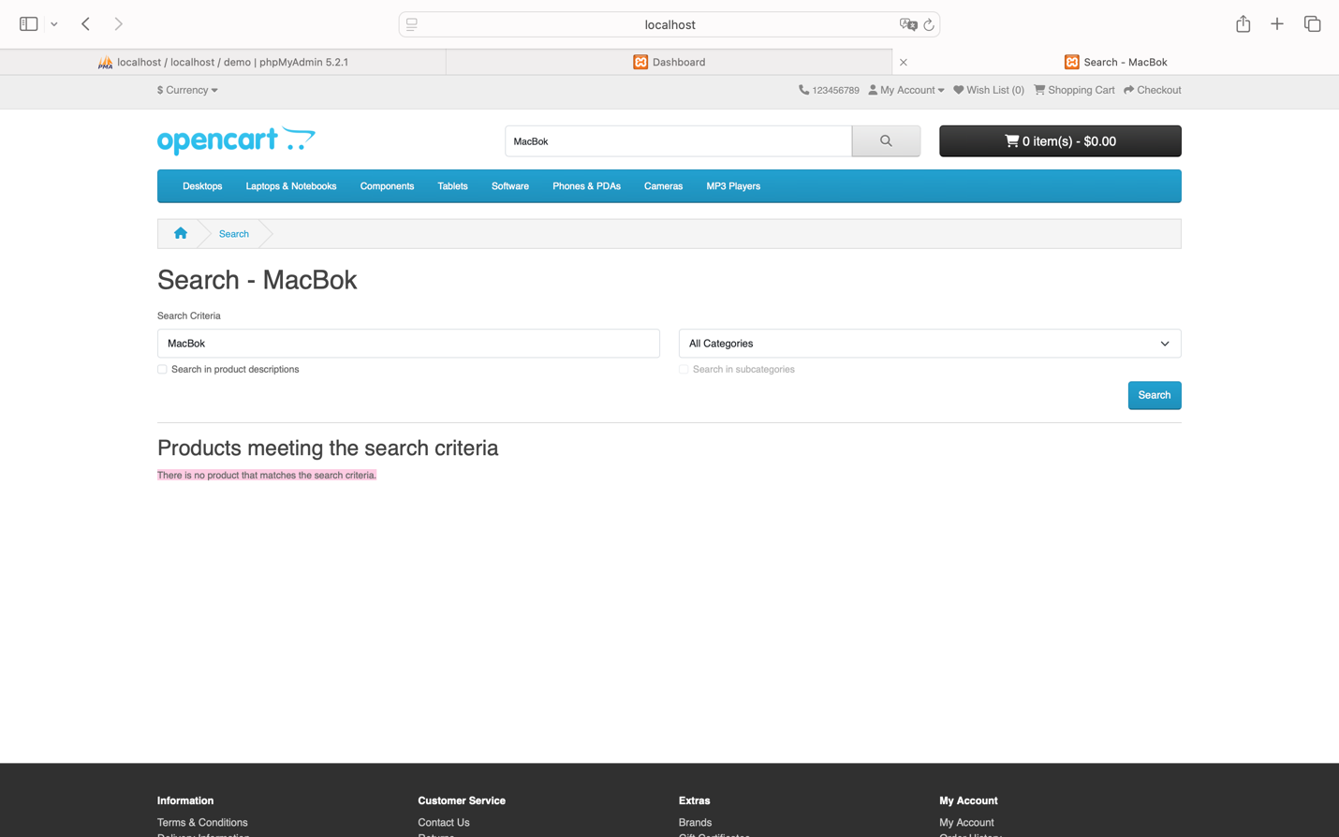

Status: Fail
Condition 4: Entering a product name not found on the homepage:
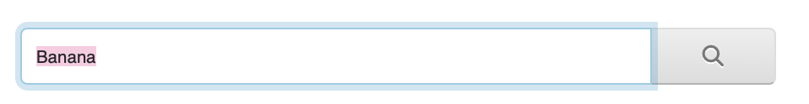
Navigate to the page: http://localhost/demo/index.php?route=product/search&language=en-gb&search=Banana to display the products that match the search results.
Check for the message: “There is no product that matches the search criteria.” (same as Condition 3).
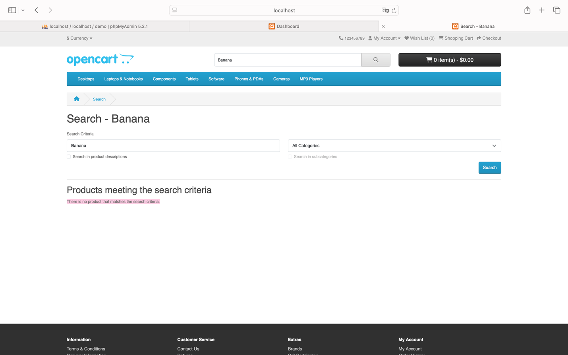

Status: Fail

Conclusion: The search feature works effectively for handling both correct and incorrect keywords, ensuring clarity and ease of use for users.

Test Case 07: Evaluate the Checkout Process

Test Case ID |  | TC_007 | Test Case Description |  | Assess the ease and convenience of the checkout process.
Created By |  | La Hieu Phong | Reviewed By |  |  |  |  |  |  |  | Version
QA Tester’s Log
Tester's Name |  | La Hieu Phong | Date Tested |  | 22-Oct-2024 |  |  |  |  |  | Test Case (Pass/Fail/Not Executed) |  |  |  |  |  | Pass & Fail
S # | Prerequisites: |  |  |  |  |  | S # |  |  | Test Data
1 | Access to Safari Browser |  |  |  |  |  | 1 |  |  | 2 products: "MacBook" and "iPhone"
2 | XAMPP installed and running on your computer
3 | OpenCart installed and configured on XAMPP
4 | A stable internet connection to access necessary resources and install extensions for OpenCart
Test Scenario | Verify Usability of the Checkout Process
Prerequisites:
Products must be added to the cart.

Step # | Step Details |  | Expected Results |  | Actual Results |  |  |  |  |  |  |  | Pass / Fail / Not executed / Suspended
1 | Open the cart and click the “Checkout” button |  | The system should navigate to the checkout page |  | As Expected |  |  |  |  |  |  |  | Pass
2 | Enter shipping and payment information |  |  |  | As Expected |  |  |  |  |  |  |  | Pass
  The system should accept the information without errors
3 | Click the “Confirm Order” button |  | The checkout process should be clear, understandable, and the steps should be well-guided.
 |  |  | Scenario 1 (Successful Checkout):  Assume two products ("MacBook" and "iPhone") have been successfully added to the cart.  Clicking “Checkout” redirects to:  http://localhost/demo/index.php?route=checkout/checkout&language=en-gb  After filling out all the required information, clicking “Confirm Order” leads to:  http://localhost/demo/index.php?route=checkout/success&language=en-gb  The page displays the following:  - Heading: “Your order has been placed!”  - Label: “Your order has been successfully processed!”  The cart should now show 0 products after checkout.  The user can view the order history by:  - Clicking on the "My Account" span in the navigation bar.  - Selecting “Order History”, which navigates to:  http://localhost/demo/index.php?route=account/order&language=en-gb&customer_token=d52ed55e768bb556dfb5608a12  - Clicking “View” to see the order details. |  | As expected |  |  |  |  |  |  |  | Pass
 |  |  | Scenario 2 (Empty Cart):  When clicking “Checkout” with an empty cart, the system should display the following:  - Heading: “Shopping Cart”  - Label: “Your shopping cart is empty!” |  | Unexpected |  |  |  |  |  |  |  | Fail

Steps to Reproduce

Condition 1: Assume two products have been successfully added to the shopping cart (specifically “MacBook” and “iPhone”), then click “Checkout.”
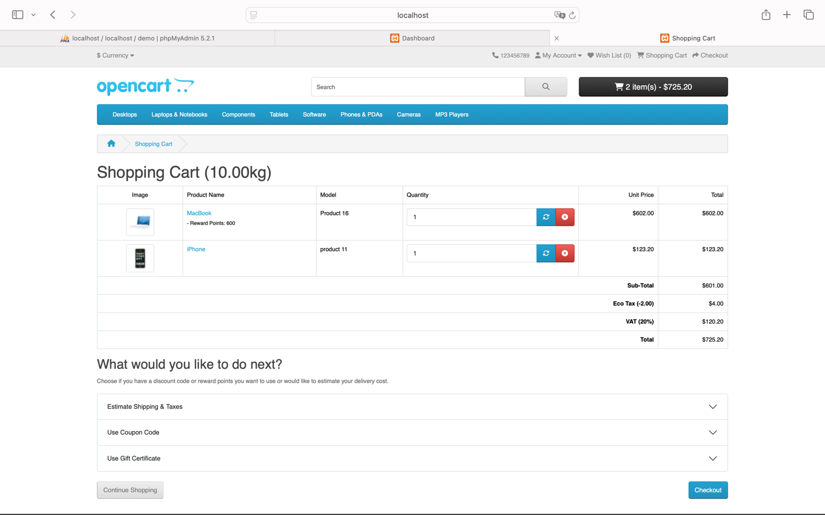
You will be redirected to the page: http://localhost/demo/index.php?route=checkout/checkout&language=en-gb, fill in all the required information, and click the “Confirm Order” button.
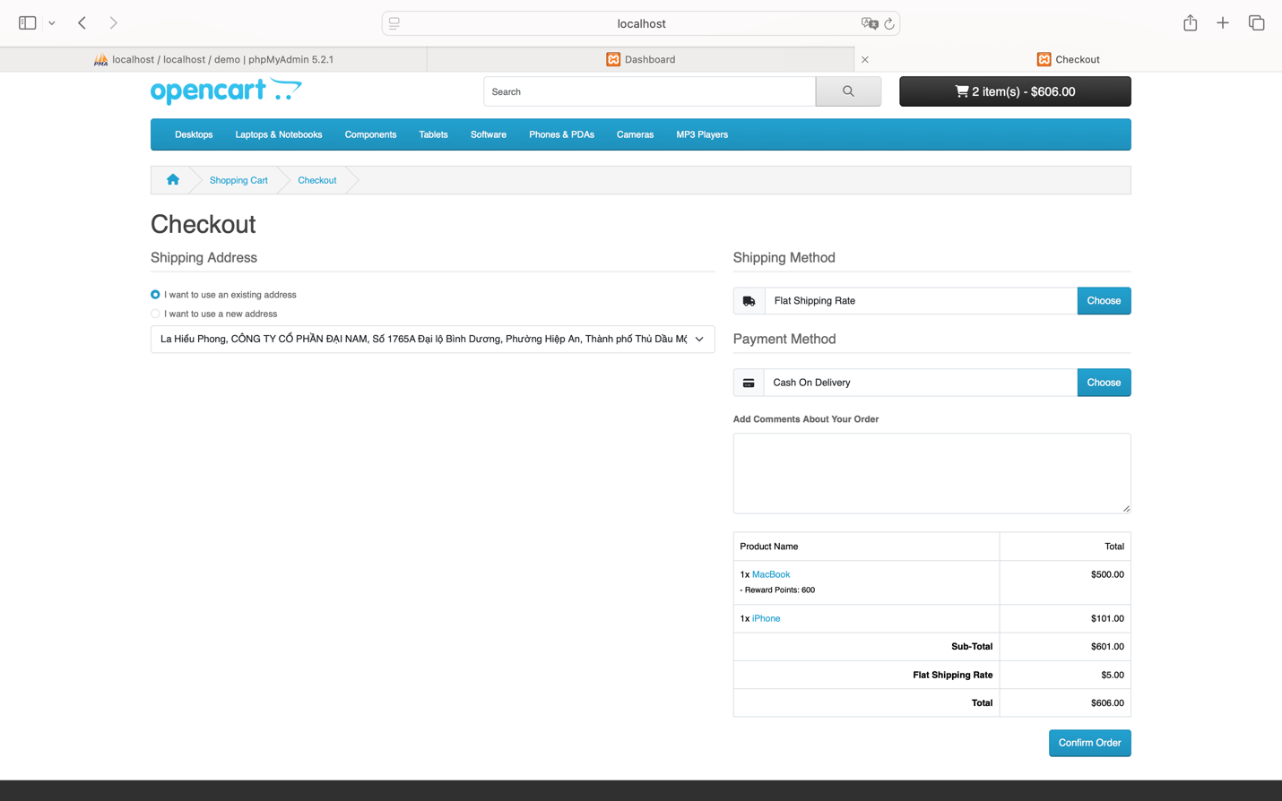
You will see the page: http://localhost/demo/index.php?route=checkout/success&language=en-gb
The heading “Your order has been placed!” and the label “Your order has been successfully processed!” will be displayed, and the shopping cart will be empty (0 products).

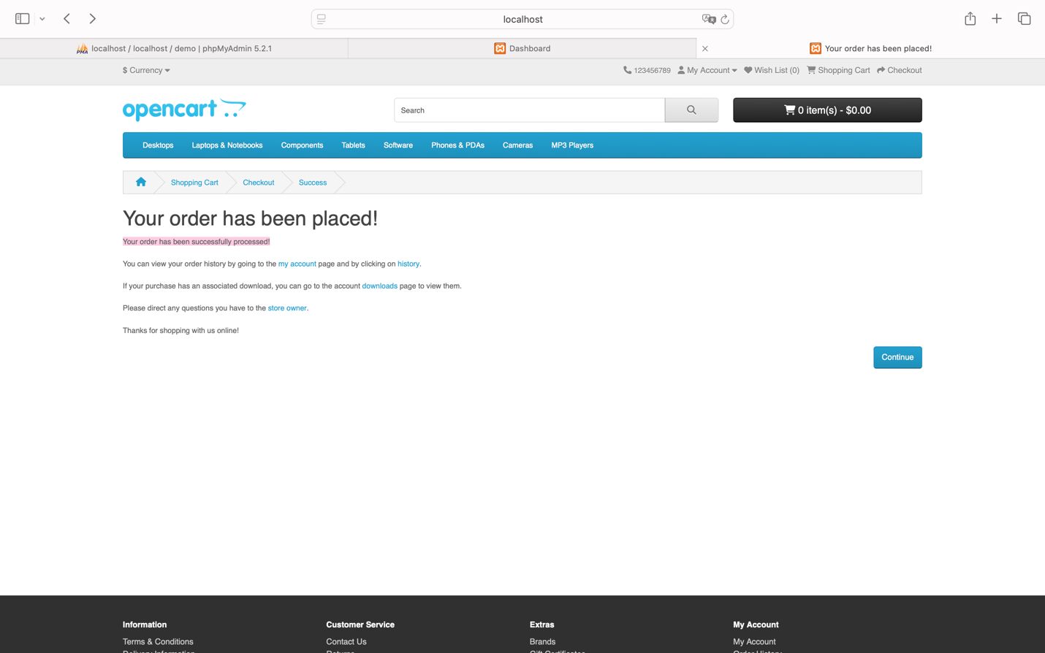
You can also view the order history of the recently placed order by accessing the “My Account” span on the navigation bar and selecting the menu item “Order History.”
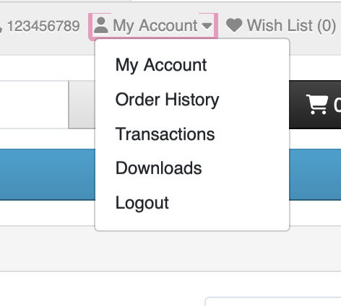
You will be redirected to the page: http://localhost/demo/index.php?route=account/order&language=en-gb&customer_token=d52ed55e768bb556dfb5608a12.
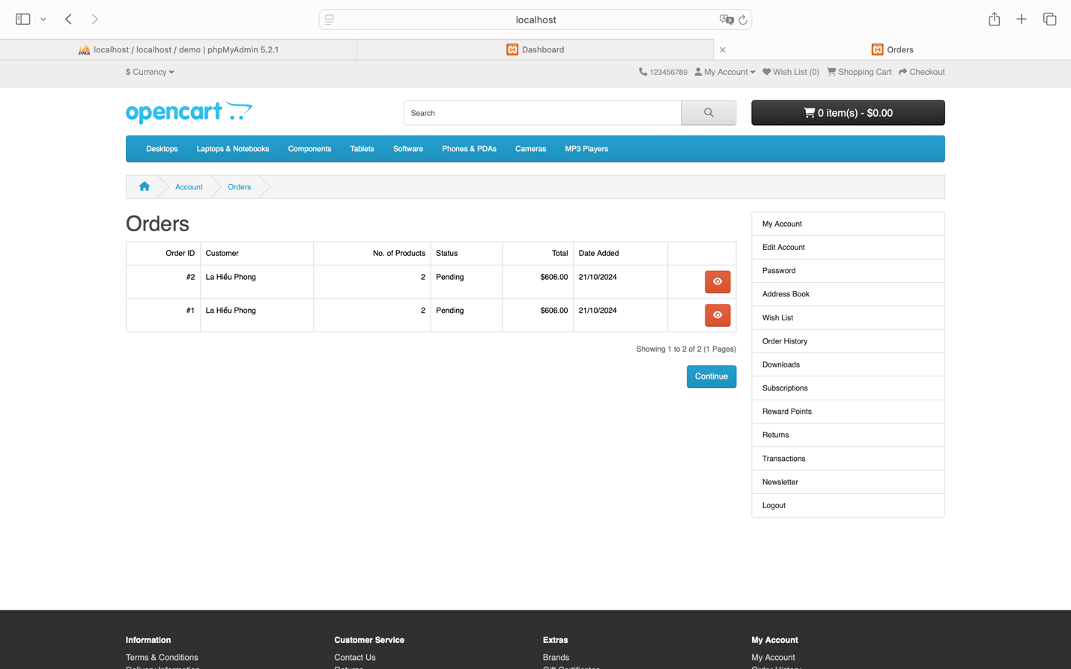
Click the “View” button to see the details of the order you placed and checked out.
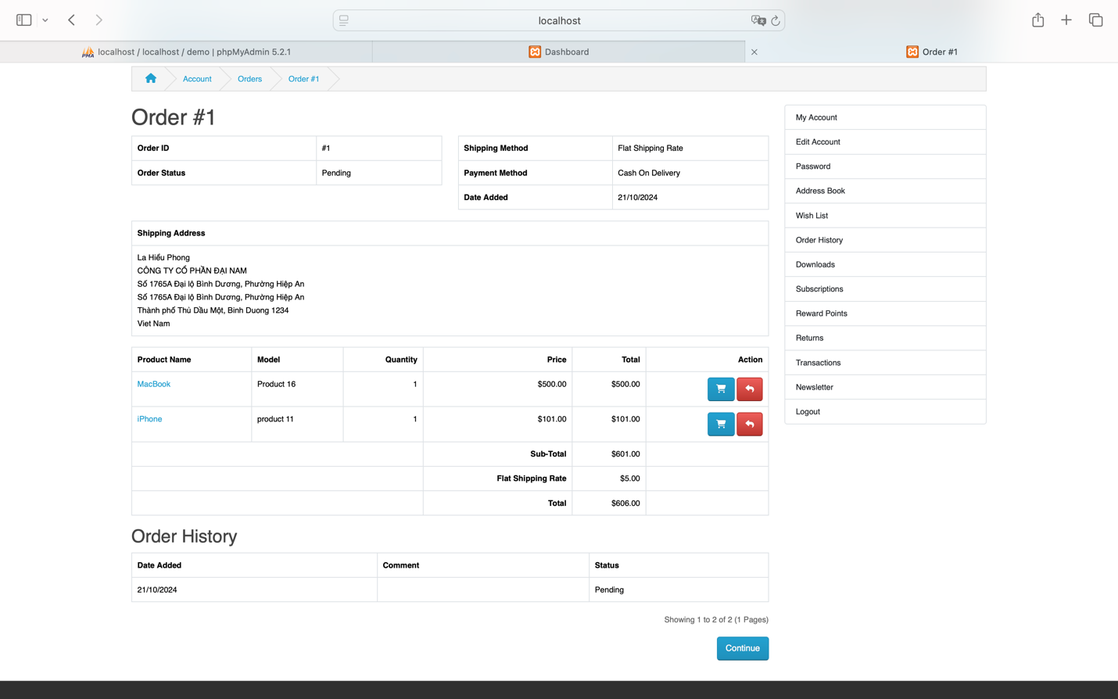
Status: Success
Condition 2: Empty shopping cart

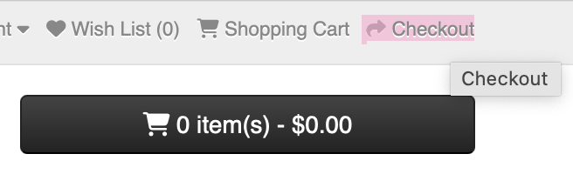

When you click “Checkout,” the heading “Shopping Cart” and the label “Your shopping cart is empty!” will be displayed.

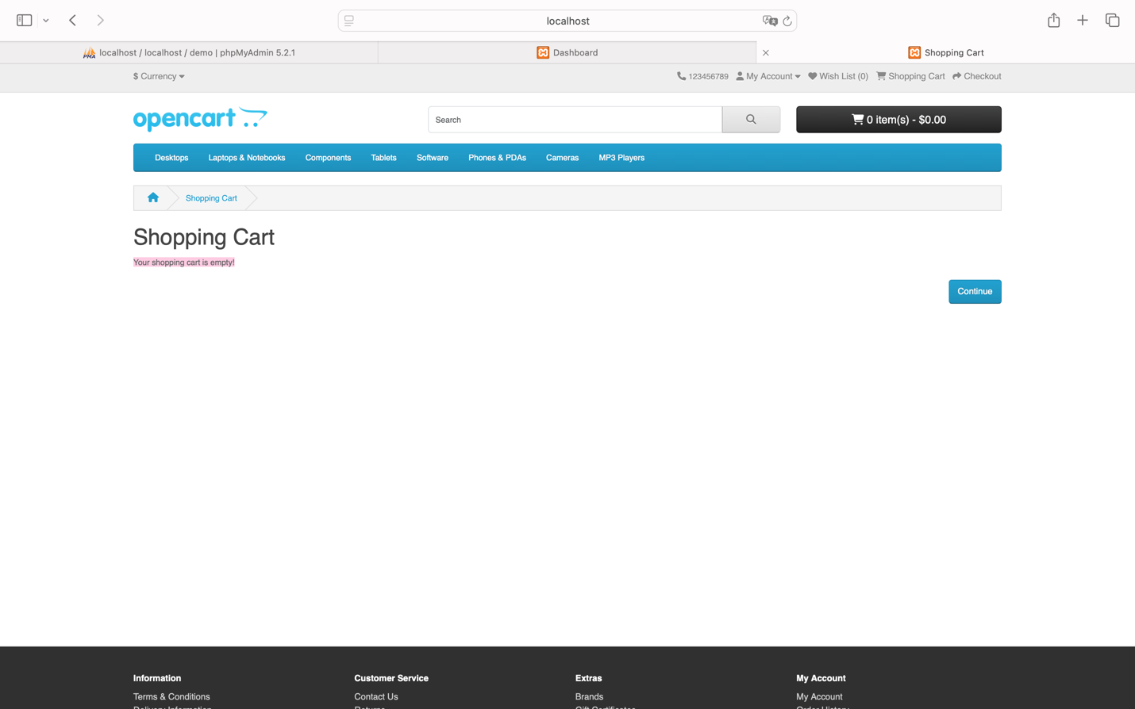

Status: Fail

Conclusion: This test case demonstrates that the checkout system meets requirements in both scenarios: when there are products in the cart and when the cart is empty. The clear process and notifications enhance the user experience.

Test Case 08: Test User Experience During Checkout Process

Test Case ID |  | TC_008 |  | Test Case Description |  | Test the usability and overall experience of the user during the checkout process.
Created By |  | La Hieu Phong |  | Reviewed By |  |  |  |  |  |  | Version
QA Tester’s Log
Tester's Name |  | La Hieu Phong |  | Date Tested |  | 22-Oct-2024 |  |  |  |  | Test Case (Pass/Fail/Not Executed) |  |  |  |  |  |  |  | Pass
S # | Prerequisites: |  |  |  |  |  |  | S # |  |  |  | Test Data
1 | Access to Safari Browser |  |  |  |  |  |  | 1 |  |  |  | 2 products: "MacBook" and "iPhone"
2 | XAMPP installed and running on your computer
3 | OpenCart installed and configured on XAMPP
4 | A stable internet connection to access necessary resources and install extensions for OpenCart
Test Scenario | Assess User Experience in the Checkout Process
Prerequisites:
User must be logged into their account.
At least one product must be added to the cart.

Step # | Step Details |  |  | Expected Results |  | Actual Results |  |  |  |  |  |  |  |  | Pass / Fail / Not executed / Suspended
1 | Access the cart and click the “Checkout” button to start the checkout process |  |  | The system should navigate to the checkout page at http://localhost/demo/index.php?route=checkout/checkout&language=en-gb |  | As Expected |  |  |  |  |  |  |  |  | Pass
2 | Enter shipping information (name, address, etc.) and check if the input fields are clearly labeled |  |  | Input fields should be clearly marked and easy to fill |  | As Expected |  |  |  |  |  |  |  |  | Pass
3 | Select a payment method (e.g., credit card, cash on delivery, PayPal) and check for clear guidance for each method |  |  | Each payment method should have clear instructions provided |  | As expected |  |  |  |  |  |  |  |  | Pass
4 | Confirm the order details (product name, quantity, price) and check if the total amount is displayed clearly |  |  | The total payment amount should be prominently displayed |  | As expected |  |  |  |  |  |  |  |  | Pass
5 | Click the “Confirm Order” button to complete the order |  |  | The checkout process should be intuitive and well-guided at each step.  After confirming the order, the system should navigate to:  http://localhost/demo/index.php?route=checkout/success&language=en-gb  The page will display the following:  - Heading: “Your order has been placed!”  - Label: “Your order has been successfully processed!”  The cart should now show:  “0 item(s) - $0.00”  The user can view their order history by:  - Clicking on the "My Account" span in the navigation bar.  - Selecting “Order History”, which navigates to:  http://localhost/demo/index.php?route=account/order&language=en-gb&customer_token=d52ed55e768bb556dfb5608a12  - Clicking “View” to see the order details.  Finally, the user can click “Continue” to return to the homepage. |  | As expected |  |  |  |  |  |  |  |  | Pass

Steps to Reproduce
Assume the shopping cart has been successfully filled beforehand.
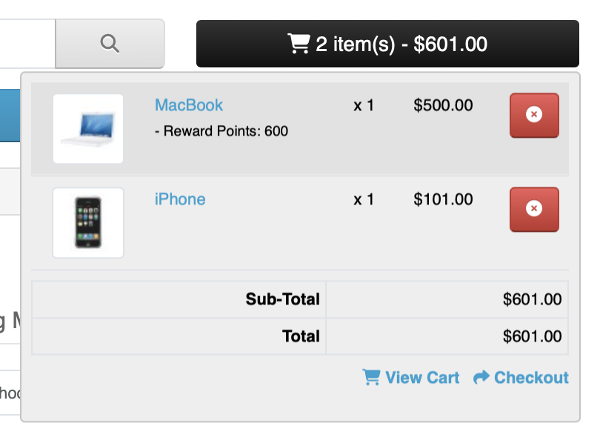
Click the “Checkout” button to be redirected to the page: http://localhost/demo/index.php?route=checkout/checkout&language=en-gb. If we have already entered the information previously, we can select the radio button “I want to use an existing address” and then continue choosing the next options.
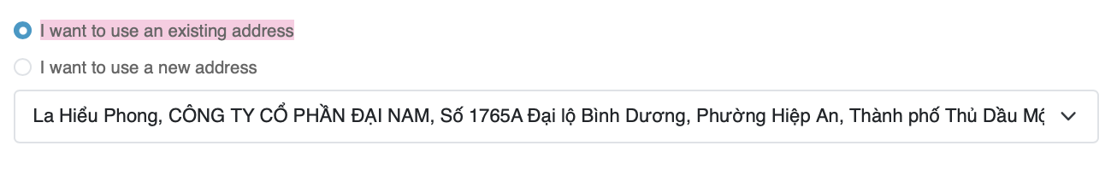
Alternatively, we can select the radio button “I want to use a new address” to enter new information.
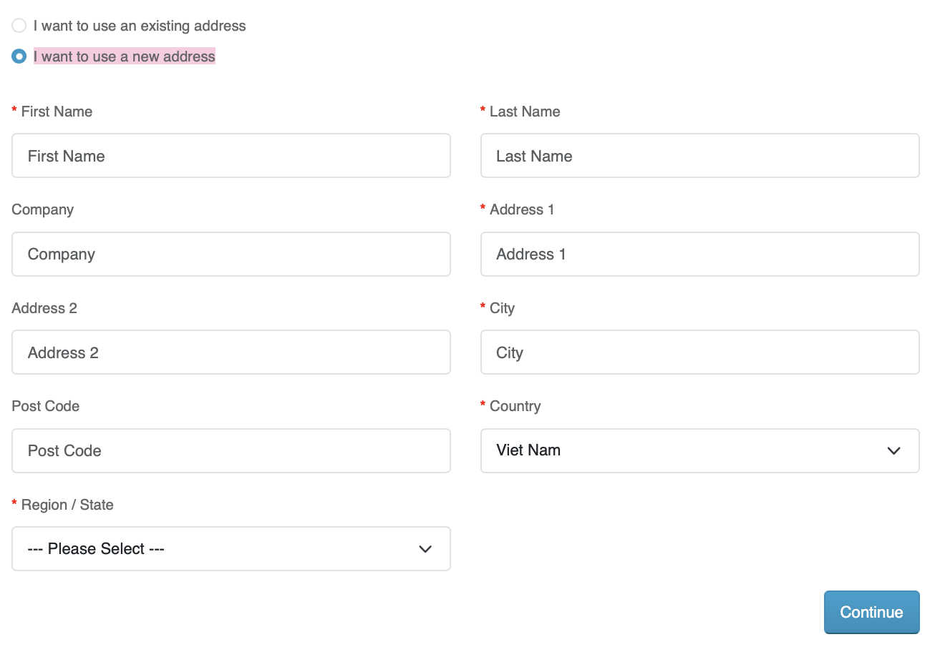
You will notice that the input fields are clearly marked and easy to fill out.
Next steps:
Select the “Shipping method options” and “Payment method options.”
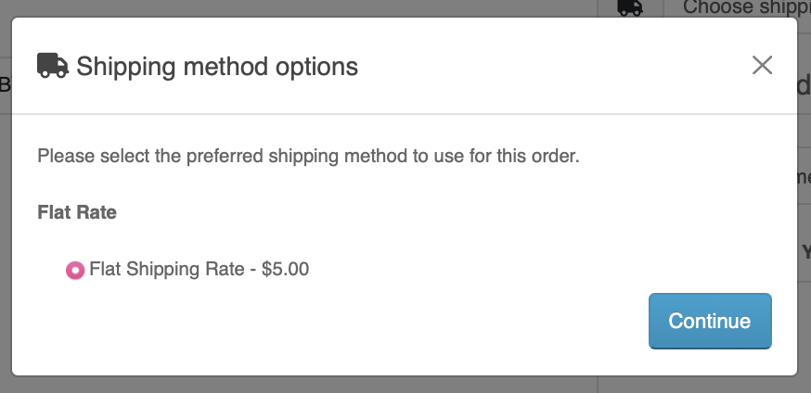

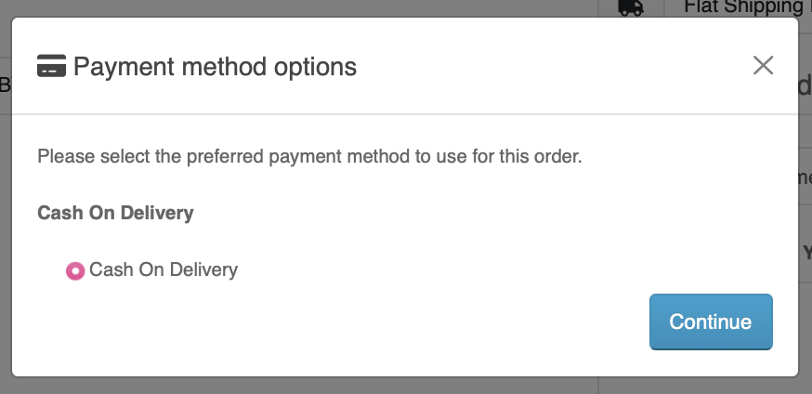

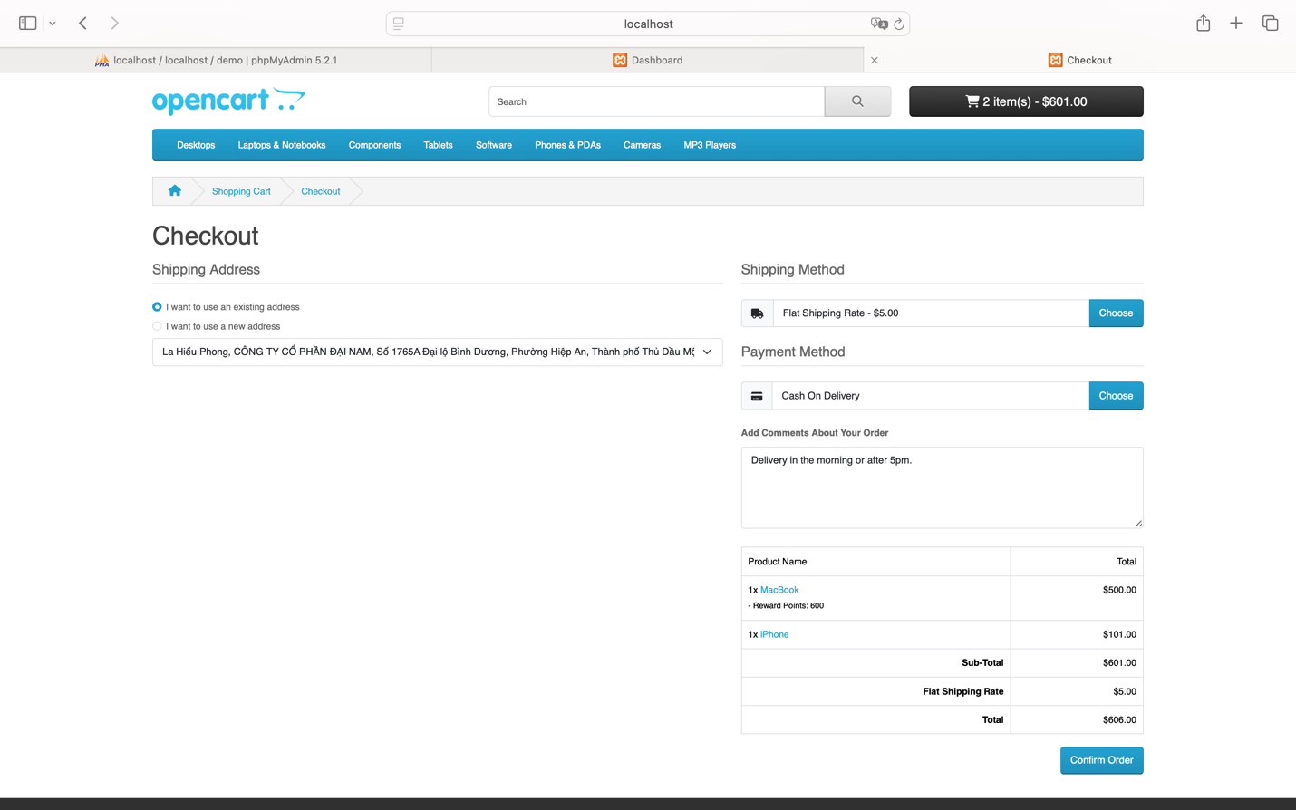
After filling in all the required information and clicking the “Confirm Order” button, you will be redirected to the page: http://localhost/demo/index.php?route=checkout/success&language=en-gb where the heading “Your order has been placed!” and the label “Your order has been successfully processed!” will be displayed. Additionally, the shopping cart will now show as empty with “0 item(s) - $0.00.”
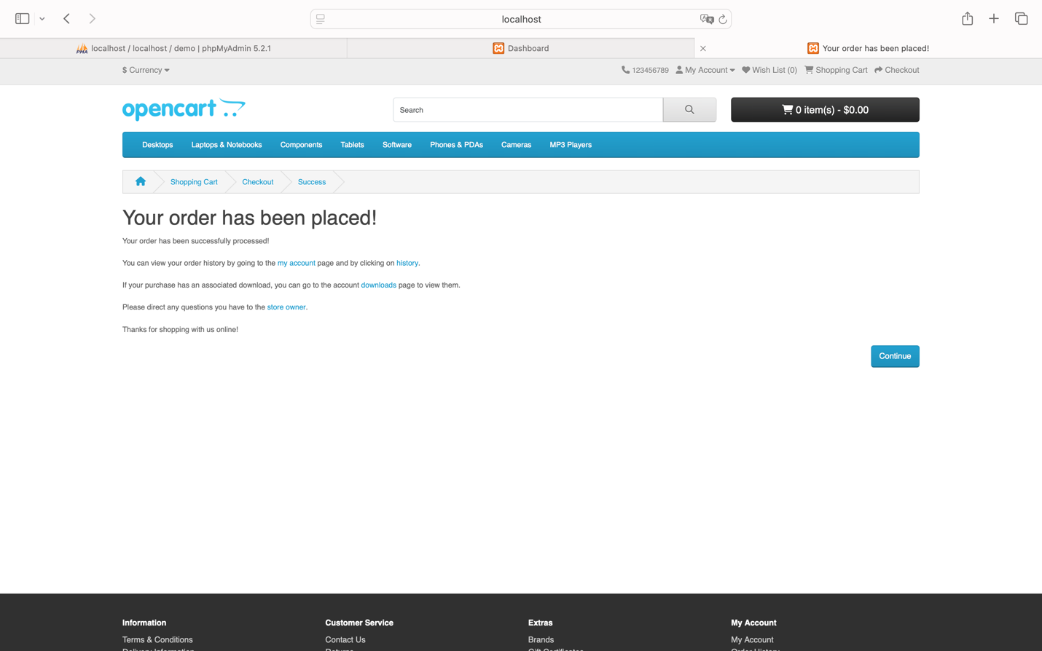
You can also view the order history of the recently placed order by accessing the “My Account” span on the navigation bar and selecting the menu item “Order History.”
You will be redirected to the page: http://localhost/demo/index.php?route=account/order&language=en-gb&customer_token=d52ed55e768bb556dfb5608a12.
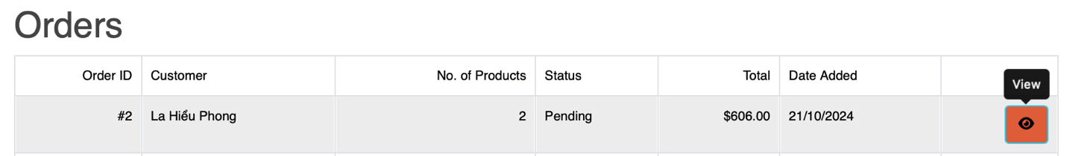
Click the “View” button to see the details of the order you placed and checked out.
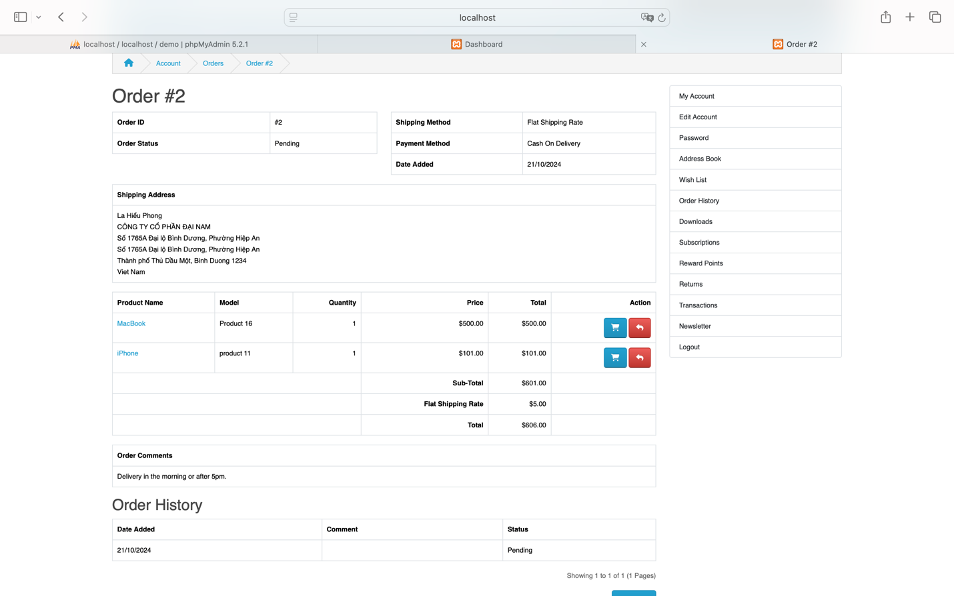
Then click “Continue” to return to the homepage.
Status: Success

Conclusion: This test case focuses on the user experience during the checkout process, ensuring that the checkout is intuitive, user-friendly, and instills confidence in users as they complete their transactions.

Test Case 09: Evaluate the Usability of the Shopping Cart

Test Case ID |  | TC_009 | Test Case Description |  | Test the ease of use and functionality of the shopping cart, ensuring users can easily add, remove, and update products in their cart.
Created By |  | La Hieu Phong | Reviewed By |  |  |  |  |  |  |  | Version
QA Tester’s Log
Tester's Name |  | La Hieu Phong | Date Tested |  | 22-Oct-2024 |  |  |  |  |  | Test Case (Pass/Fail/Not Executed) |  |  |  |  |  | Pass & Fail
S # | Prerequisites: |  |  |  |  |  | S # |  |  | Test Data
1 | Access to Safari Browser |  |  |  |  |  | 1 |  |  | Product: "MacBook"
2 | XAMPP installed and running on your computer
3 | OpenCart installed and configured on XAMPP
4 | A stable internet connection to access necessary resources and install extensions for OpenCart
Test Scenario | Assess User Experience When Using the Shopping Cart
Prerequisites:
User must be logged into their account.
At least one product must be added to the cart.

Step # | Step Details |  | Expected Results |  | Actual Results |  |  |  |  |  |  |  | Pass / Fail / Not executed / Suspended
1 | Access the cart from the homepage or any page on the website. |  | Users can either:  - Click the “Shopping Cart” on the menu bar  - Click the button displaying “0 item(s) - $0.00” to check the cart.  If no product is added:  - The system should navigate to the empty cart page at:  http://localhost/demo/index.php?route=checkout/cart&language=en-gb  - This page should show:  - “Shopping Cart” heading  - The label “Your shopping cart is empty!”  Alternatively, clicking the “0 item(s) - $0.00” button should display:  - A dropdown message: “Your shopping cart is empty.” |  | As Expected |  |  |  |  |  |  |  | Pass
2 | Test adding a product to the cart using the “Add to Cart” button. |  | A success dialog appears: “Success: You have added MacBook to your shopping cart!” |  | As Expected |  |  |  |  |  |  |  | Pass
3 | Add a product to the wishlist using the “Add to Wish List” button, then add it to the cart from the wishlist. |  | A success dialog appears: “Success: You have added MacBook to your wish list!”  Clicking the “Wish List” on the menu bar navigates to:  - The wishlist page, where products are displayed with full details, including:  - Image  - Product Name  - Model  - Stock  - Unit Price  After adding to the cart from the wishlist, the cart is updated with the message:  “Success: You have added MacBook to your shopping cart!” |  | As expected |  |  |  |  |  |  |  | Pass
4 | View specific product details, update the quantity, and add to the cart. |  | The cart is updated with a success message: “Success: You have added MacBook to your shopping cart!” |  | As expected |  |  |  |  |  |  |  | Pass
5 | Check the cart by clicking “Shopping Cart” or “2 item(s) - $1,000.00.” |  | The system navigates to: http://localhost/demo/index.php?route=checkout/cart&language=en-gb  This page displays a table with product information, including:  - Image  - Product Name  - Model  - Quantity  - Unit Price  - Total  - Sub-Total  - Total |  | As expected |  |  |  |  |  |  |  | Pass
6 | Change the quantity of products in the cart and click “Update Cart.” |  | The cart is updated with a success dialog: “Success: You have modified your shopping cart!”  The cart updates to show “100 item(s) - $50,000.00.” |  | As expected |  |  |  |  |  |  |  | Pass
7 | Test removing a product by clicking the “X” button next to the product in the cart. |  | The product should be removed, and the total updated accordingly. |  | Product not removed; still appears in the cart.  - Unexpected |  |  |  |  |  |  |  | Fail

Steps to Reproduce
Access the shopping cart.
You can click on the menu bar “Shopping Cart” or the button “0 item(s) - $0.00” to check the cart.
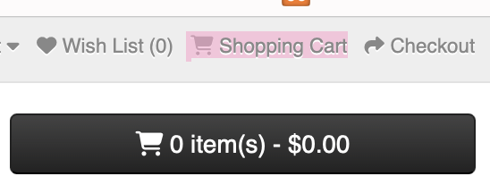
If no products have been added, clicking the menu bar “Shopping Cart” will redirect you to the empty cart page: http://localhost/demo/index.php?route=checkout/cart&language=en-gb.
The heading will display “Shopping Cart” and the label “Your shopping cart is empty!”
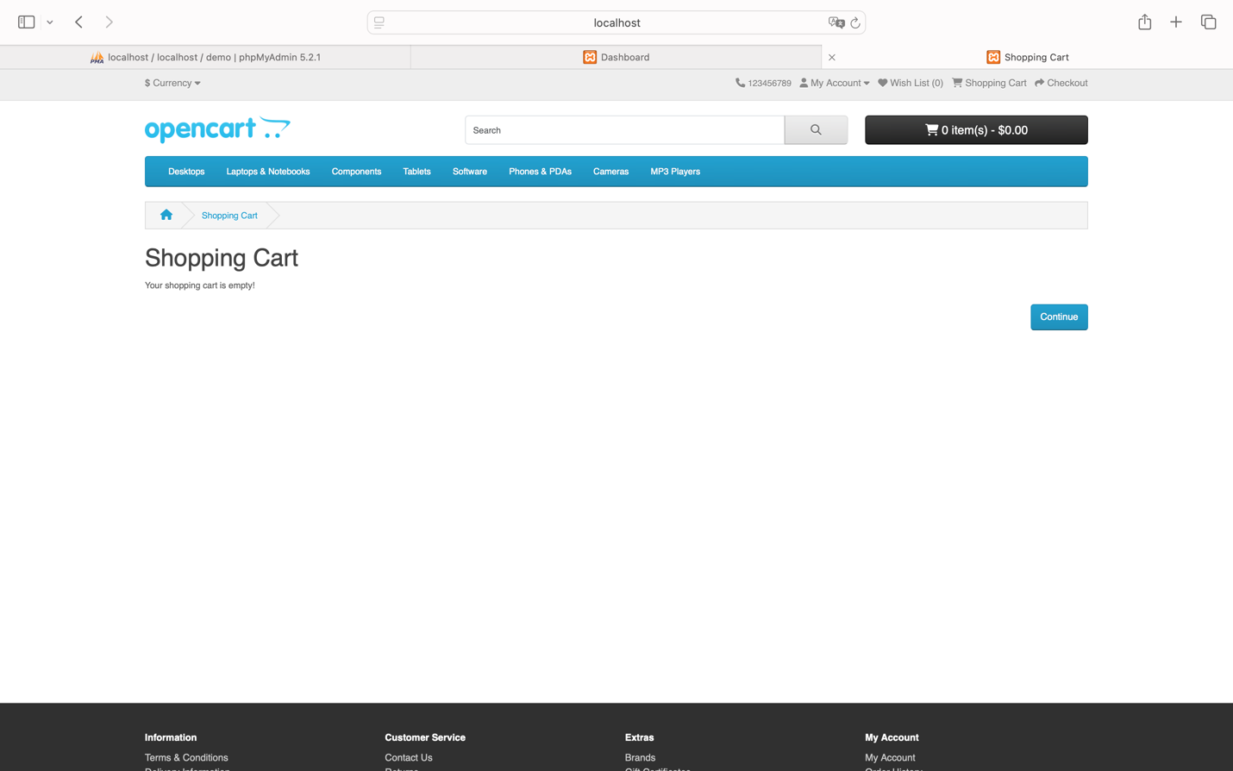
Alternatively, clicking the button “0 item(s) - $0.00” will show a dropdown menu saying “Your shopping cart is empty.”
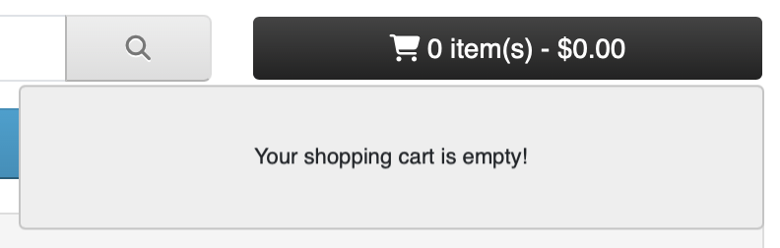
Status: Fail
- Add products to the shopping cart
Method 1: Click the “Add to Cart” button.

A dialog will appear saying “Success: You have added MacBook to your shopping cart!”

Status: Success

Method 2: Add the product to the wish list by clicking “Add to Wish List.”

A dialog will appear saying “Success: You have added MacBook to your wish list!”

When clicking on the menu bar “Wish List,”
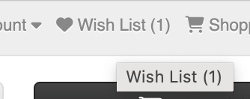
You will be redirected to the Wish List page: http://localhost/demo/index.php?route=account/wishlist&language=en-gb&customer_token=d52ed55e768bb556dfb5608a12.
The list of products in the wish list will clearly display the image, product name, model, stock, and unit price for each product.
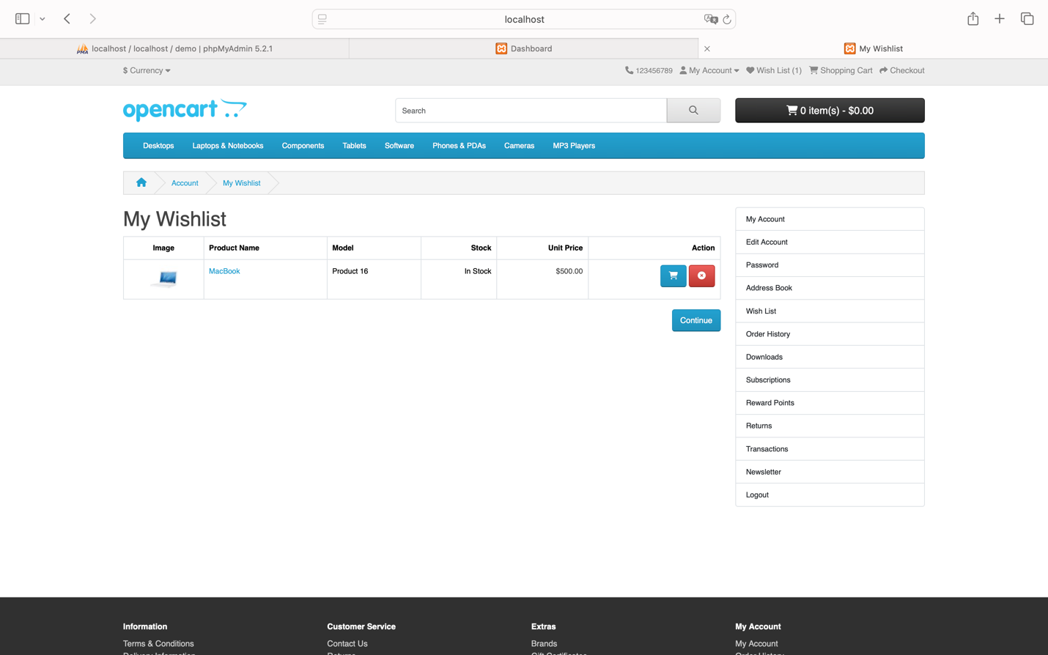
You can then click “Add to Cart”
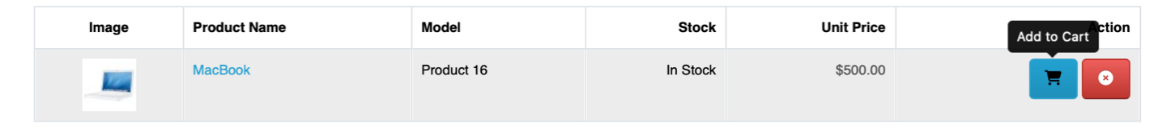
Which will update the cart and display a dialog saying “Success: You have added MacBook to your shopping cart!”
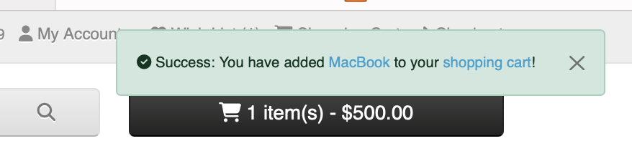
Status: Success
Method 3: Click on each specific product to view detailed information, update the quantity, and rate the product.
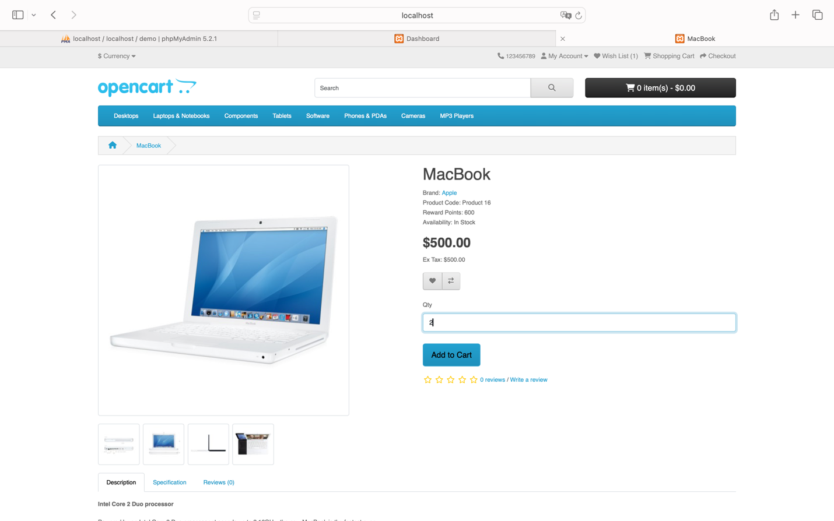
When you click the “Add to Cart” button, the cart will update, and a dialog will appear saying “Success: You have added MacBook to your shopping cart!”

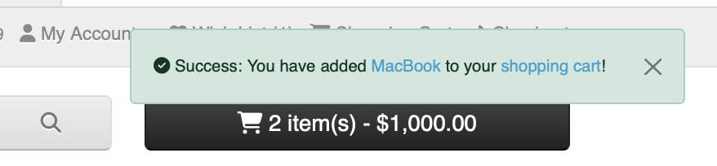
Status: Success
After that, you can confirm that the product has been successfully added by accessing the menu bar “Shopping Cart” or the button “2 item(s) - $1,000.00,” and clicking “View Cart” will direct you to the View Cart page: http://localhost/demo/index.php?route=checkout/cart&language=en-gb.
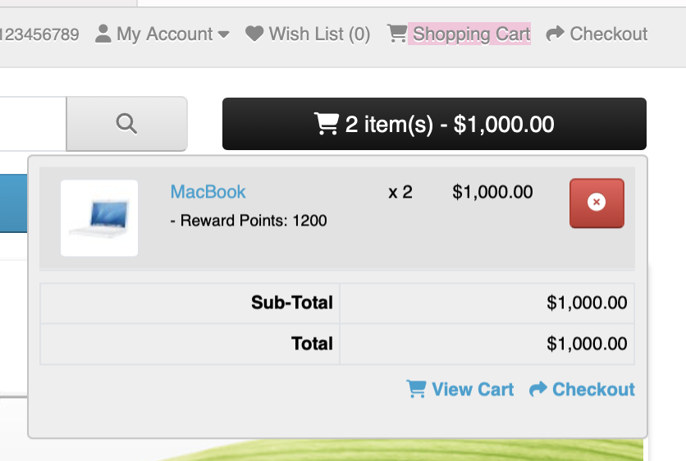
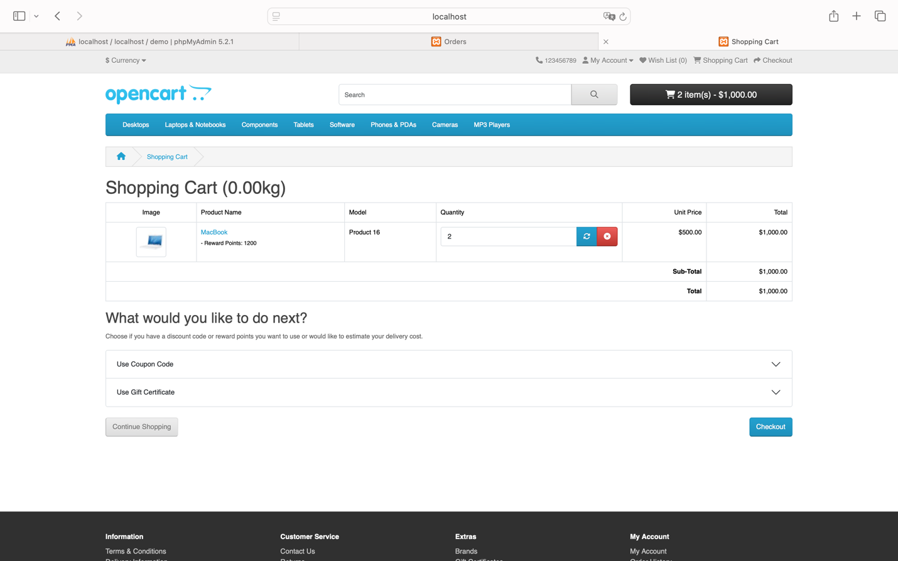
The interface will show a table with complete information including “Image,” “Product Name,” “Model,” “Quantity,” “Unit Price,” “Total,” “Sub-Total,” and “Total.”
Method 4: Change the product quantity to update the cart.
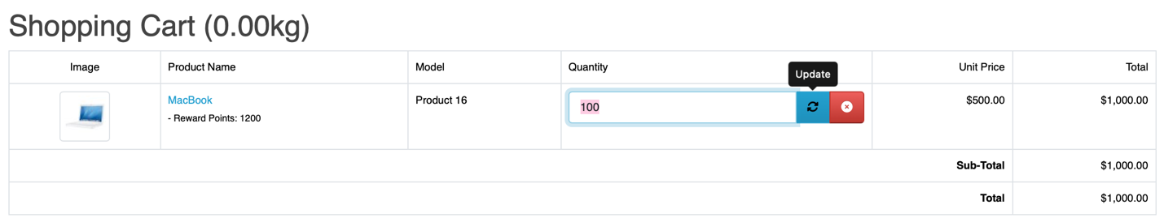
The cart will be updated with a dialog notification saying “Success: You have modified your shopping cart!” and the button will change to “100 item(s) - $50,000.00.”
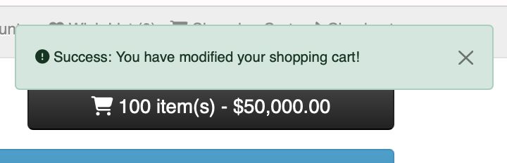
Status: Success
Exception Case:
Assume I successfully added a product to the cart, but when I want to remove that product by clicking the “X” button, it fails to remove it.
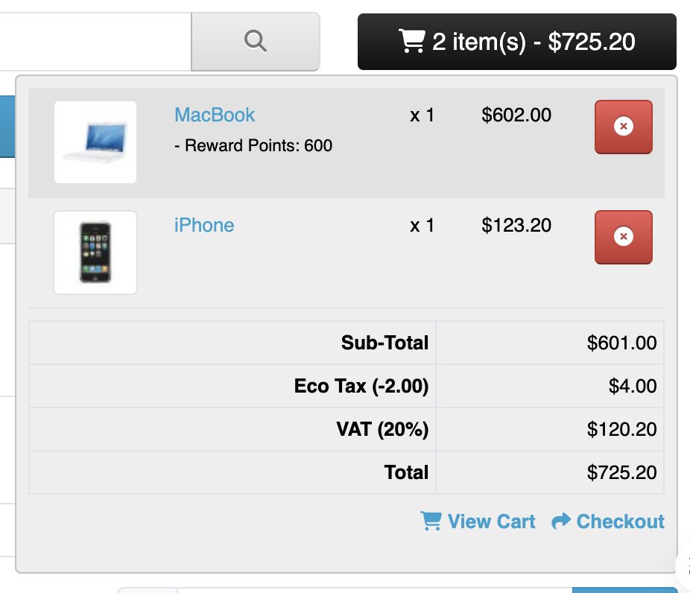
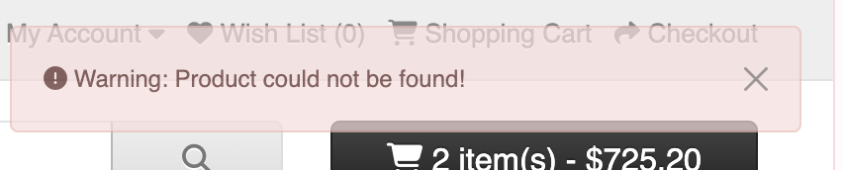

There are still products remaining in the cart.

Status: Fail

Conclusion: This test case ensures that the shopping cart features in OpenCart work smoothly, from adding products to updating and displaying product information, enhancing the shopping experience for users. However, there is an issue with the product removal functionality that needs improvement to complete the experience more effectively.

Test Case 10: Test Navigation Feature

Test Case ID |  | TC_010 | Test Case Description |  | Test the ease of navigation and coherence between different pages of the website.
Created By |  | La Hieu Phong | Reviewed By |  |  |  |  |  |  |  | Version
QA Tester’s Log
Tester's Name |  | La Hieu Phong | Date Tested |  | 22-Oct-2024 |  |  |  |  |  | Test Case (Pass/Fail/Not Executed) |  |  |  |  |  | Pass & Fail
S # | Prerequisites: |  |  |  |  |  | S # |  |  | Test Data
1 | Access to Safari Browser |  |  |  |  |  | 1 |  |  | Link to the “Product
2 | XAMPP installed and running on your computer |  |  |  |  |  | 2 |  |  | Link to the “Contact”
3 | OpenCart installed and configured on XAMPP |  |  |  |  |  | 3 |  |  | Link to the “Checkout”
4 | A stable internet connection to access necessary resources and install extensions for OpenCart |  |  |  |  |  | 4 |  |  | Link to the homepage
Test Scenario | Evaluate Navigation Features Between Pages
Prerequisites:
Access the homepage.

Step # | Step Details |  | Expected Results |  | Actual Results |  |  |  |  |  |  |  | Pass / Fail / Not executed / Suspended
1 | Click on main navigation links (e.g., “Product,” “Contact,” “Checkout,” etc.). |  | Users should be able to navigate to other pages easily. |  | Clicking the "Product" link resulted in a page load time of 1.24s.  - As Expected |  |  |  |  |  |  |  | Pass
2 | Click on the “Contact” link to navigate to the Contact page. |  | The page loads successfully with relevant content displayed. |  | The "Contact" page loaded in 1.24s.  - As Expected |  |  |  |  |  |  |  | Pass
3 | Click on the “Checkout” link. |  | The checkout page should load, allowing users to proceed with the purchase. |  | The "Checkout" page loaded in 1.25s.  - As expected |  |  |  |  |  |  |  | Pass
4 | Test navigating back to the homepage from any other page. |  | Users should easily return to the homepage with a load time within the expected range (1-3 seconds). |  | The homepage loaded in 1.37s after navigating back from other pages.  - As expected |  |  |  |  |  |  |  | Pass
5 | Evaluate page load speed across different pages. |  | All pages should load within an ideal range of 1-3 seconds to ensure a smooth user experience. |  | Load times for all pages were within the ideal range (1.24s - 1.37s)  - As expected |  |  |  |  |  |  |  | Pass

Steps to Reproduce

- Navigation Links and Page Load Times:
Link to the “Product” page: Load time: 1.24 seconds
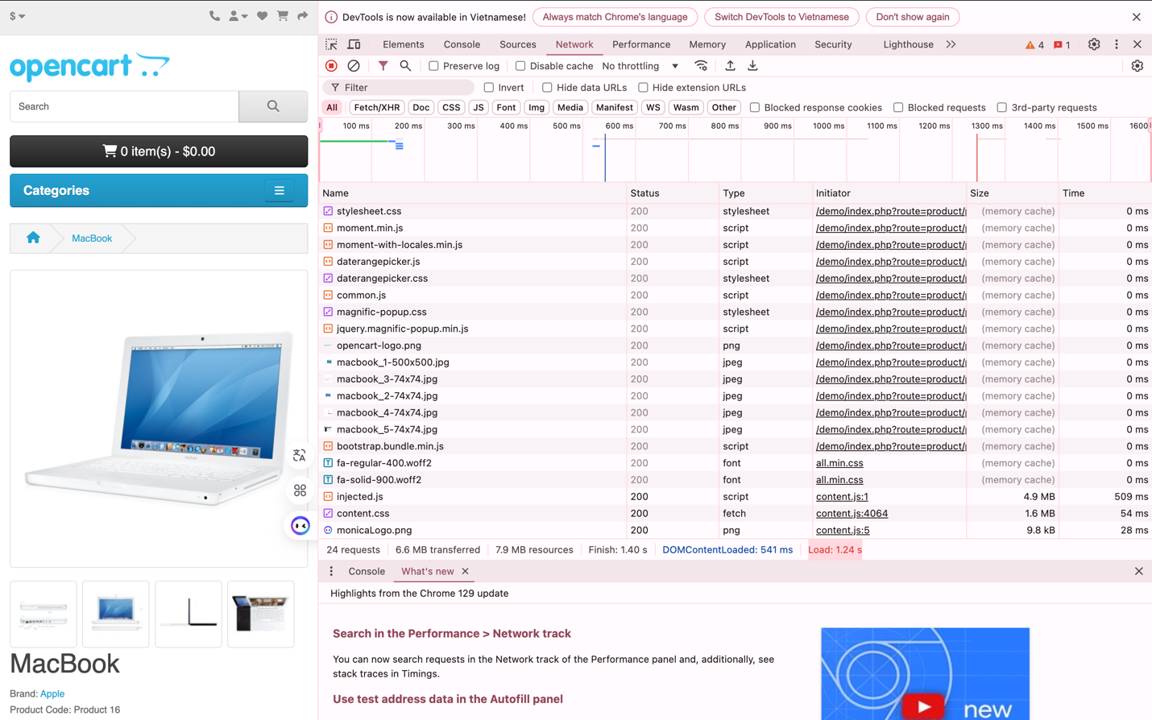
Link to the “Contact” page: Load time: 1.24 seconds
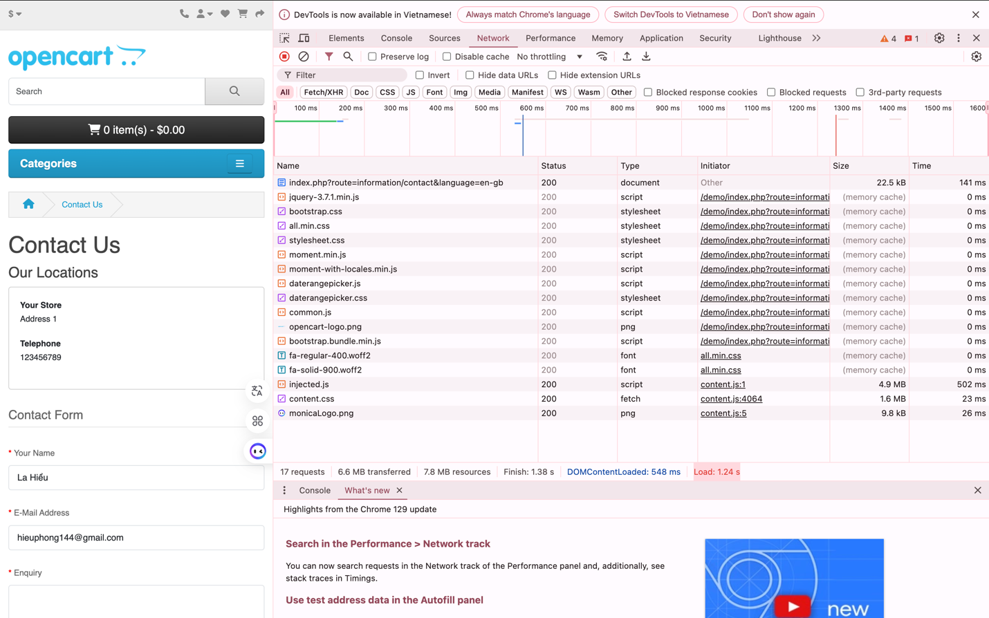
Link to the “Checkout” page: Load time: 1.25 seconds
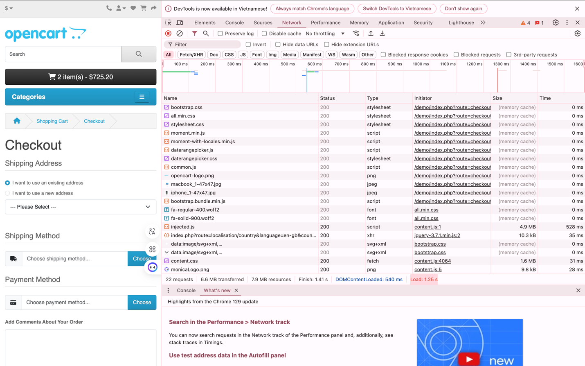
Link to the homepage: Current load time and returning to the homepage: 1.37 seconds
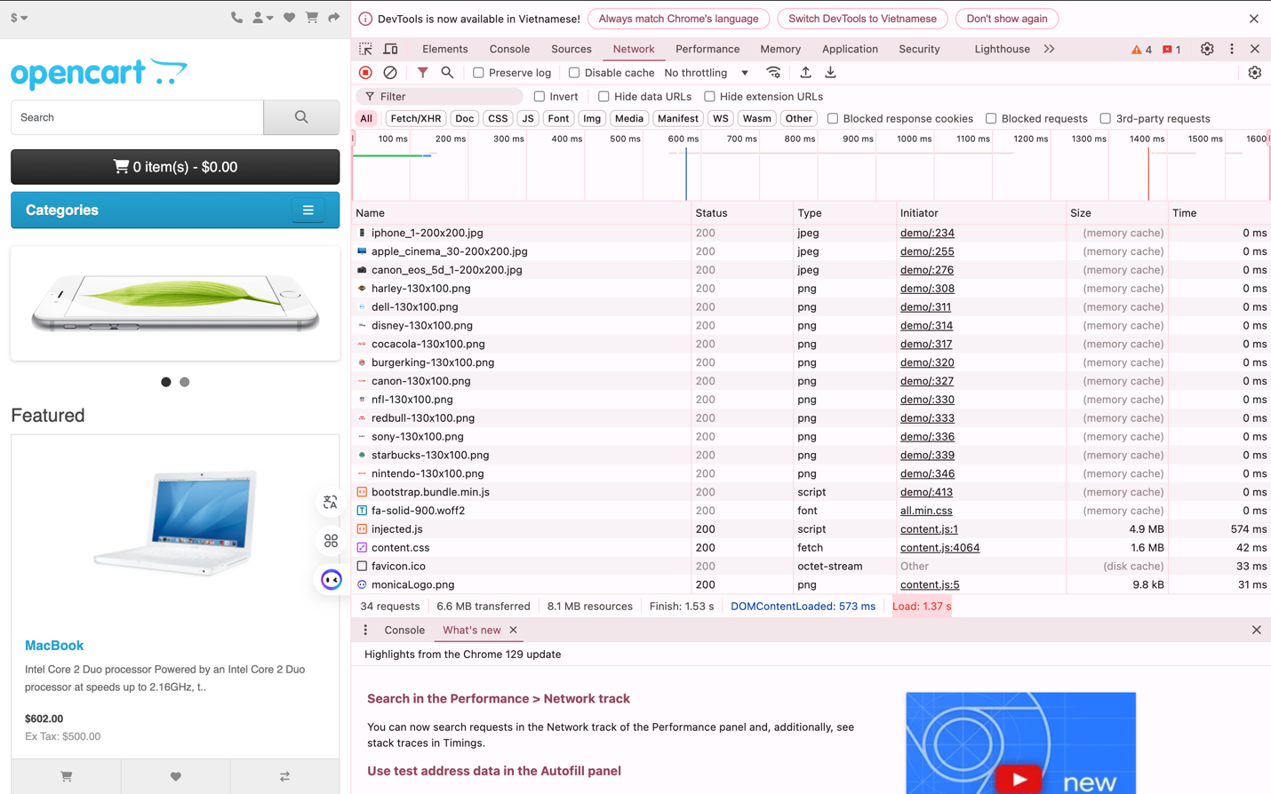

Status: Success

Conclusion: This test case confirms that the navigation between different pages of the website is efficient and user-friendly. The page load times were well within the acceptable range, ensuring a smooth and responsive user experience when navigating between the homepage, product, contact, and checkout pages.

Boundary Test Cases

Test Case 11: Enter Special Characters in the Email Field

Test Case ID |  | TC_011 | Test Case Description |  | Test entering special characters in the email field
Created By |  | La Hieu Phong | Reviewed By |  |  |  |  |  |  |  | Version
QA Tester’s Log
Tester's Name |  | La Hieu Phong | Date Tested |  | 22-Oct-2024 |  |  |  |  |  | Test Case (Pass/Fail/Not Executed) |  |  |  |  |  | Pass
S # | Prerequisites: |  |  |  |  |  | S # |  |  | Test Data
1 | Access to Safari Browser |  |  |  |  |  | 1 |  |  | Email: 1@@@lhp@gmail.com
2 | XAMPP installed and running on your computer
3 | OpenCart installed and configured on XAMPP
4 | A stable internet connection to access necessary resources and install extensions for OpenCart
Test Scenario | Verify that entering an email address with special characters displays an appropriate error message
Prerequisites:
Access the registration page.

Step # | Step Details |  | Expected Results |  | Actual Results |  |  |  |  |  |  |  | Pass / Fail / Not executed / Suspended
1 | Go to the registration page: http://localhost/demo/index.php?route=account/register&language=en-gb. |  | The registration form should be displayed. |  | Registration form loaded successfully.  - As Expected |  |  |  |  |  |  |  | Pass
2 | Enter valid information for “First Name,” “Last Name,” “Password” fields. |  | All fields should accept valid input without errors. |  | Valid inputs were accepted for these fields.  - As Expected |  |  |  |  |  |  |  | Pass
3 | Enter the email: 1@@@lhp@gmail.com in the “E-Mail” field. |  | The system should detect the invalid email format. |  | The system detected the invalid email format.  - As expected |  |  |  |  |  |  |  | Pass
4 | Click “Continue.” |  | The system should display a clear and understandable error message. |  | Error message displayed: “Phần đứng sau ‘@’ không được chứa biểu tượng ‘@’.”  - As expected |  |  |  |  |  |  |  | Pass

Steps to Reproduce
Access the Register page: http://localhost/demo/index.php?route=account/register&language=en-gb.
Enter the information in the correct format and complete the fields “First Name,” “Last Name,” and “Password.”
For the “E-Mail” field, enter: 1@@@lhp@gmail.com.
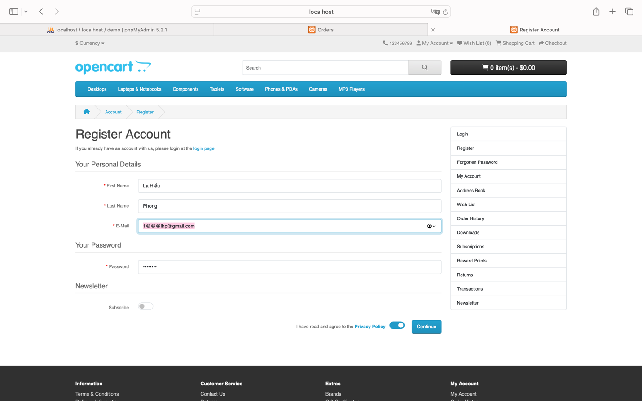

The system displays an error message for the “E-Mail” field: “The part after ‘@’ must not contain the symbol ‘@.’”
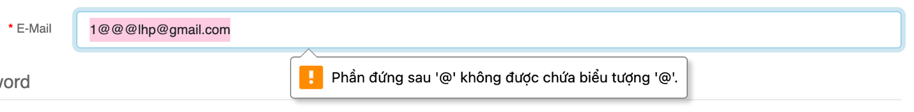
Status: Success

Conclusion: This test case confirmed that the system correctly identifies and rejects email addresses with multiple @ symbols. However, the error message could be improved for better user understanding, enhancing the user experience when filling out the registration form.

Test Case 12: Test Maximum Character Input in Username Field

Test Case ID |  | TC_012 | Test Case Description |  | Test the system's response when users enter a username exceeding the allowed character limit.
Created By |  | La Hieu Phong | Reviewed By |  |  |  |  |  |  | Version
QA Tester’s Log
Tester's Name |  | La Hieu Phong | Date Tested |  | 22-Oct-2024 |  |  |  |  | Test Case (Pass/Fail/Not Executed) |  |  |  |  |  |  | Pass
S # | Prerequisites: |  |  |  |  |  | S # |  |  |  | Test Data
1 | Access to Safari Browser |  |  |  |  |  | 1 |  |  |  | First Name: 11111111111111111111111111111111111111111111111111111111111111111111 (over 32 characters)
2 | XAMPP installed and running on your computer |  |  |  |  |  | 2 |  |  |  | Last Name: 11111111111111111111111111111111111111111111111111111111111111111111 (over 32 characters)
3 | OpenCart installed and configured on XAMPP
4 | A stable internet connection to access necessary resources and install extensions for OpenCart
Test Scenario | Verify that entering a username exceeding the maximum character limit displays appropriate error messages
Prerequisites:
Access the registration page.

Step # | Step Details |  | Expected Results |  | Actual Results |  |  |  |  |  |  |  | Pass / Fail / Not executed / Suspended
1 | Go to the registration page: http://localhost/demo/index.php?route=account/register&language=en-gb. |  | The registration form should be displayed. |  | Registration form loaded successfully.  - As Expected |  |  |  |  |  |  |  | Pass
2 | Enter a string exceeding 32 characters in the “First Name” field. Example: 111111111111111111111111111111111111. |  | The system should recognize the character limit and prevent further input. |  | User can input more than 32 characters. |  |  |  |  |  |  |  | Fail (No limit on input length)
3 | Enter a string exceeding 32 characters in the “Last Name” field. Example: 111111111111111111111111111111111111. |  | The system should recognize the character limit and prevent further input. |  | User can input more than 32 characters. |  |  |  |  |  |  |  | Fail (No limit on input length)
4 | Click “Continue.” |  | The system should display an error message for both fields. |  | Error messages displayed: “First Name must be between 1 and 32 characters!” and “Last Name must be between 1 and 32 characters!”  - As expected |  |  |  |  |  |  |  | Pass

Steps to Reproduce
Access the registration page: http://localhost/demo/index.php?route=account/register&language=en-gb.
Assume you enter the following in the fields "First Name" and "Last Name":
First Name: 11111111111111111111111111111111111111111111111111111111111111111111
Last Name: 11111111111111111111111111111111111111111111111111111111111111111111
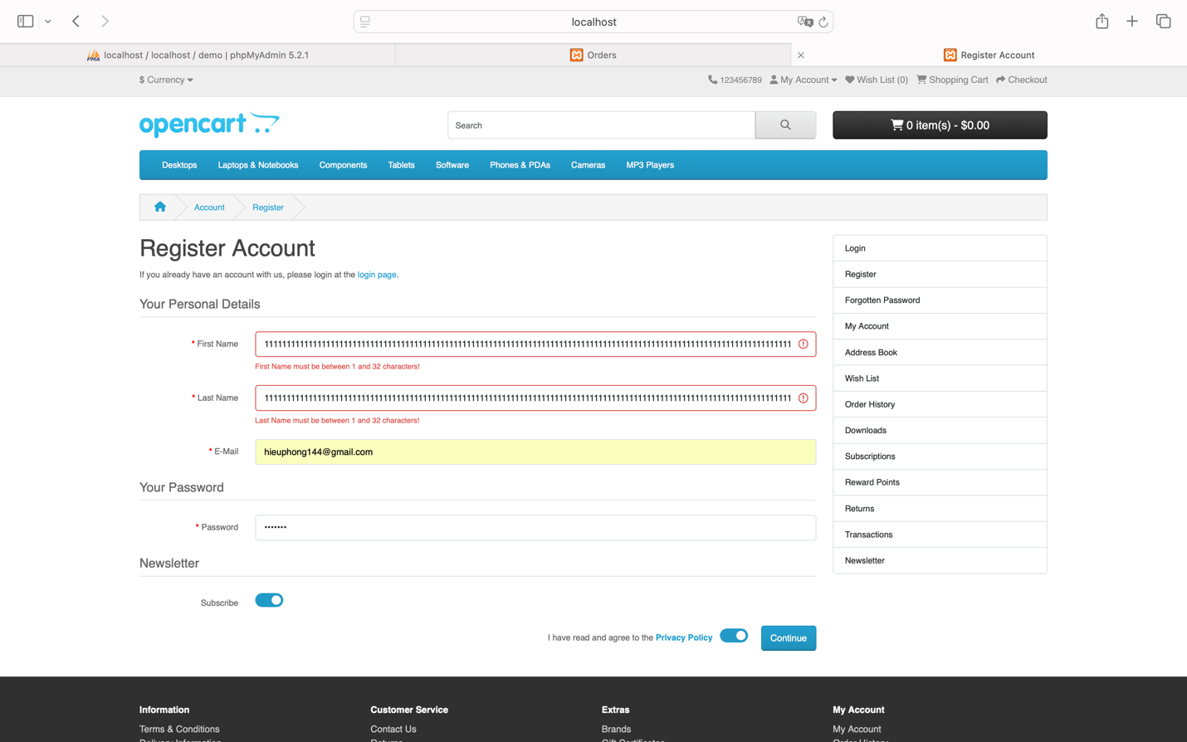
Two error messages are displayed:
- For the “First Name” field: “First Name must be between 1 and 32 characters!”
- For the “Last Name” field: “Last Name must be between 1 and 32 characters!”
Status: Success

Conclusion: The system functions as expected and provides clear error messages that enhance user experience. However, it would be beneficial to implement real-time validation to alert users immediately when they exceed the character limit, rather than waiting until they click "Continue."

Test Case 13: Test Password Field with Minimum Characters

Test Case ID |  | TC_013 | Test Case Description |  | Test the password field with the minimum number of characters
Created By |  | La Hieu Phong | Reviewed By |  |  |  |  |  |  |  | Version
QA Tester’s Log
Tester's Name |  | La Hieu Phong | Date Tested |  | 22-Oct-2024 |  |  |  |  |  | Test Case (Pass/Fail/Not Executed) |  |  |  |  |  | Pass
S # | Prerequisites: |  |  |  |  |  | S # |  |  | Test Data
1 | Access to Safari Browser |  |  |  |  |  | 1 |  |  | Password: 123 (less than the minimum required characters)
2 | XAMPP installed and running on your computer
3 | OpenCart installed and configured on XAMPP
4 | A stable internet connection to access necessary resources and install extensions for OpenCart
Test Scenario | Verify Maximum Character Limit in Username Fields
Prerequisites:
Access the registration page.

Step # | Step Details |  | Expected Results |  | Actual Results |  |  |  |  |  |  |  | Pass / Fail / Not executed / Suspended
1 | Navigate to http://localhost/demo/index.php?route=account/register&language=en-gb |  | The registration page should open |  | As Expected |  |  |  |  |  |  |  | Pass
2 | Enter a password with only 3 characters in the "Password" field (e.g., 123) |  | Password can be entered |  | As Expected |  |  |  |  |  |  |  | Pass
3 | Click on the "Continue" button |  | An error message should be displayed stating "Password must be between 4 and 20 characters!" |  | As Expected |  |  |  |  |  |  |  | Pass

Steps to Reproduce
Access the registration page: http://localhost/demo/index.php?route=account/register&language=en-gb.
Assume you enter the following in the "Password" field: 123
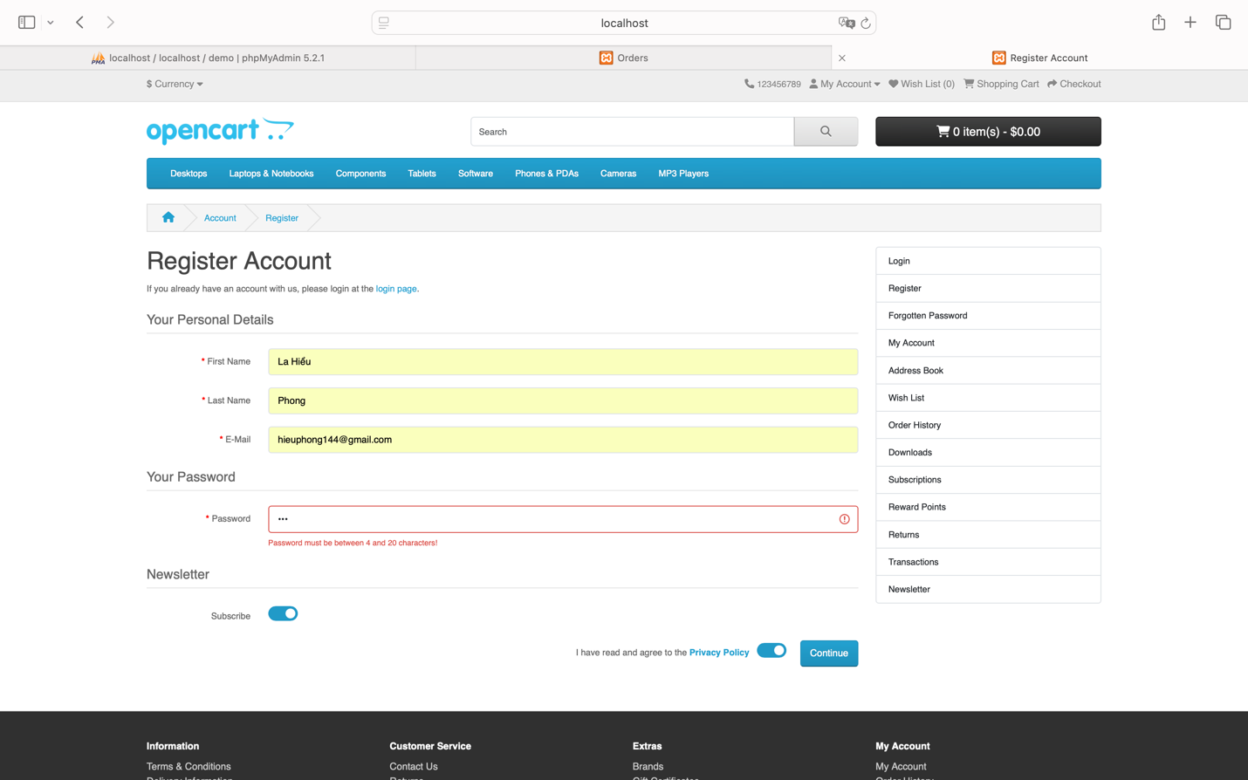
An error message is displayed for the “Password” field: “Password must be between 4 and 20 characters!”
Status: Success

Conclusion: The system displayed the correct error message as expected, ensuring that the password policy is enforced and improves data security by preventing too-short passwords.

Test Case 14: Test Entering Negative Values in the Product Quantity Field

Test Case ID |  | TC_014 | Test Case Description |  | Test entering negative values in the product quantity field.
Created By |  | La Hieu Phong | Reviewed By |  |  |  |  |  |  |  | Version
QA Tester’s Log
Tester's Name |  | La Hieu Phong | Date Tested |  | 22-Oct-2024 |  |  |  |  |  | Test Case (Pass/Fail/Not Executed) |  |  |  |  |  | Fail
S # | Prerequisites: |  |  |  |  |  | S # |  |  | Test Data
1 | Access to Safari Browser |  |  |  |  |  | 1 |  |  | Quantity: -1 (negative value)
2 | XAMPP installed and running on your computer
3 | OpenCart installed and configured on XAMPP
4 | A stable internet connection to access necessary resources and install extensions for OpenCart
Test Scenario | Verify that entering a negative quantity value for a product shows an error message or prevents the action.
Prerequisites:
Access to the product detail page.

Step # | Step Details |  | Expected Results |  | Actual Results |  |  |  |  |  |  |  | Pass / Fail / Not executed / Suspended
1 | Navigate to the product detail page (e.g., MacBook) http://localhost/demo/index.php?route=product/product&language=en-gb&product_id=43 |  | The product detail page should open |  | As Expected |  |  |  |  |  |  |  | Pass
2 | Enter a negative quantity (e.g., -1) in the "Qty" field |  | Negative value should be entered |  | As Expected |  |  |  |  |  |  |  | Pass
3 | Click the "Add to Cart" button |  | The system should either display an error message or prevent adding a negative quantity |  | Unexpectedly, the system shows a success dialog: "Success: You have added MacBook to your shopping cart!", but the cart remains empty |  |  |  |  |  |  |  | Fail

Steps to Reproduce
Assume you access the product detail page for “MacBook”: http://localhost/demo/index.php?route=product/product&language=en-gb&product_id=43.
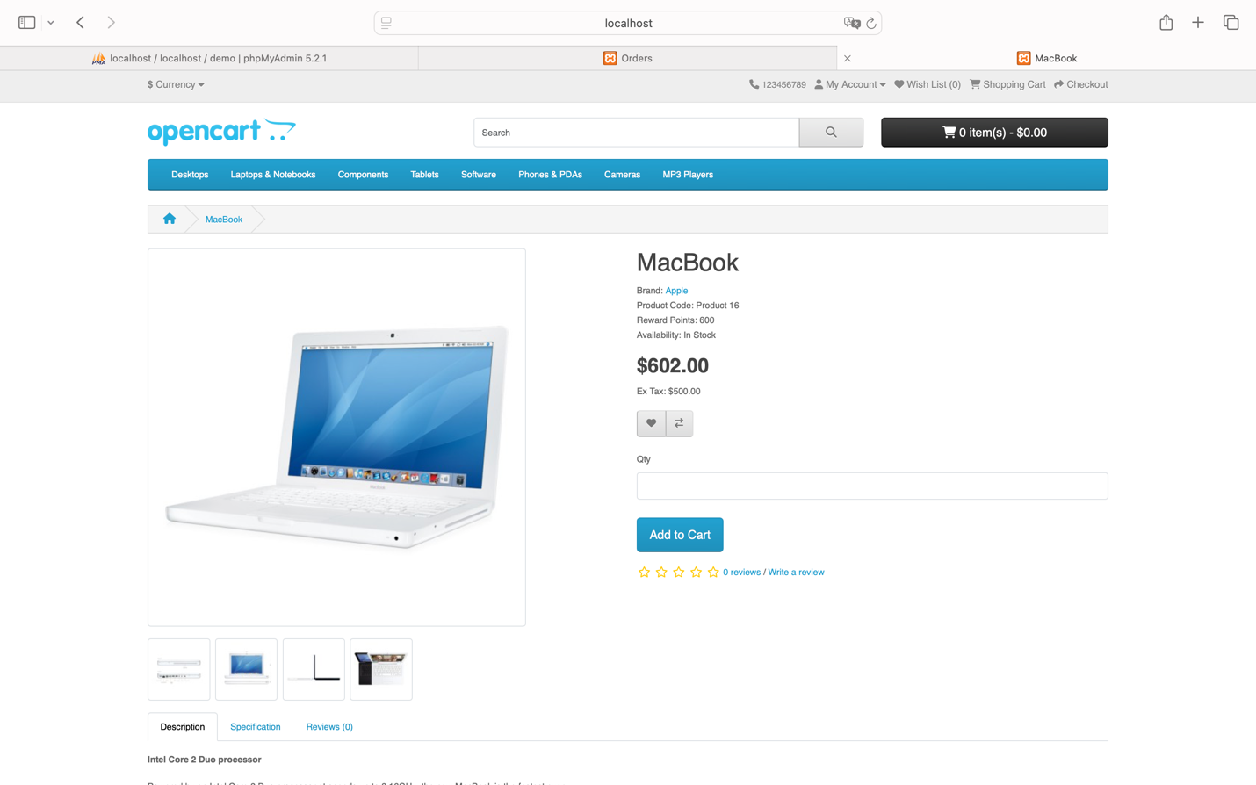
I enter “Qty” as -1 and click the “Add to Cart” button.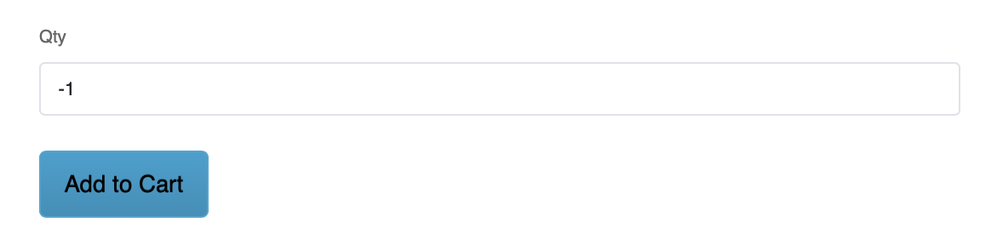
A dialog message appears: “Success: You have added MacBook to your shopping cart!”
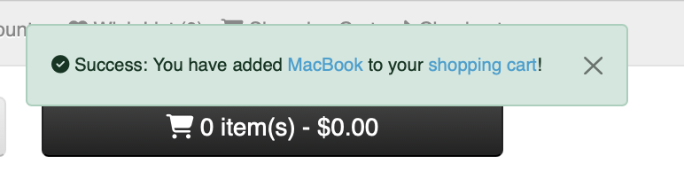
However, the shopping cart does not update, and it remains empty (specifically, it still shows “0 item(s) - $0.00”).
Status: Fail

Conclusion: This is a system bug as it should not accept a negative quantity value. The system needs to be updated to reject negative values and provide appropriate feedback to the user.

Test Case 15: Test Entering Maximum Values in the Product Quantity Field

Test Case ID |  | TC_015 | Test Case Description |  | Test entering a maximum value in the product quantity field
Created By |  | La Hieu Phong | Reviewed By |  |  |  |  |  |  |  | Version
QA Tester’s Log
Tester's Name |  | La Hieu Phong | Date Tested |  | 22-Oct-2024 |  |  |  |  |  | Test Case (Pass/Fail/Not Executed) |  |  |  |  |  | Fail
S # | Prerequisites: |  |  |  |  |  | S # |  |  | Test Data
1 | Access to Safari Browser |  |  |  |  |  | 1 |  |  | Quantity: 2147483648 (exceeds the maximum allowed value of 2147483647)
2 | XAMPP installed and running on your computer
3 | OpenCart installed and configured on XAMPP
4 | A stable internet connection to access necessary resources and install extensions for OpenCart
Test Scenario | Verify that entering a quantity greater than the allowed limit displays an error message or prevents the action.
Prerequisites:
Access to the product detail page.

Step # | Step Details |  | Expected Results |  | Actual Results |  |  |  |  |  |  |  | Pass / Fail / Not executed / Suspended
1 | Navigate to the product detail page (e.g., MacBook) http://localhost/demo/index.php?route=product/product&language=en-gb&product_id=43 |  | The product detail page should open |  | As Expected |  |  |  |  |  |  |  | Pass
2 | Enter a quantity greater than the maximum limit (e.g., 2147483648) in the "Qty" field |  | Value should be entered |  | As Expected |  |  |  |  |  |  |  | Pass
3 | Click the "Add to Cart" button |  | The system should display an error message or prevent the addition of a quantity that exceeds the limit |  | Unexpectedly, the system shows a success dialog: "Success: You have added MacBook to your shopping cart!", and only updates the cart with the maximum allowed quantity of "2147483647 item(s)" |  |  |  |  |  |  |  | Fail

Steps to Reproduce

Assume you access the product detail page for “MacBook”: http://localhost/demo/index.php?route=product/product&language=en-gb&product_id=43.
I enter “Qty” as 2147483648 and click the “Add to Cart” button.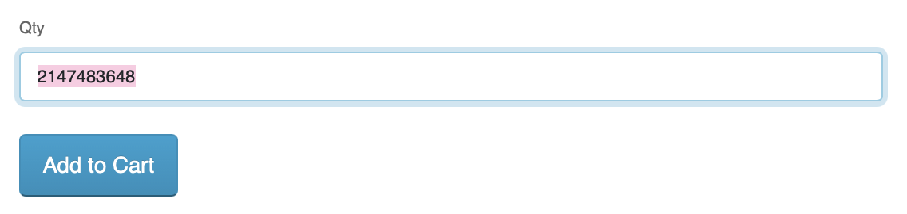
A dialog message appears: “Success: You have added MacBook to your shopping cart!” However, the shopping cart only updates with the maximum quantity of “2147483647 item(s).”
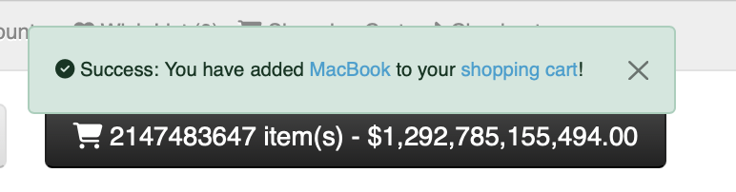
Status: Fail

Conclusion: This is a system bug because it does not display an error message when an out-of-bounds value is entered. The behavior does not align with the original test requirement, indicating a need for correction in the system to enforce quantity limits accurately.

Bug Reporting

Error 01: Error When Adding Negative Product Quantity to Cart

Error ID |  | ERR_001 | Bug Description |  | Allow negative product quantity input but do not update the shopping cart
Created By |  | La Hieu Phong | Reviewed By |  |  |  |  |  |  |  | Version
QA Tester’s Log |  | Initial report of the issue regarding negative product quantity entry.
Bug Reporter |  | La Hieu Phong | Bug Report Date |  | 22-Oct-2024 |  |  |  |  |  | Error (Pass/Fail/Not Executed) |  |  |  |  |  | Fair
S # | Prerequisites: |  |  |  |  |  | S # |  |  | Test Data
1 | Access to Safari Browser |  |  |  |  |  | 1 |  |  | Access to product detail page "MacBook"
2 | XAMPP installed and running on your computer |  |  |  |  |  | 2 |  |  | Quantity = -1
3 | OpenCart installed and configured on XAMPP
4 | A stable internet connection to access necessary resources and install extensions for OpenCart
Test Scenario | Verify that the system does not allow entering a negative quantity and does not update the shopping cart accordingly.
Step # | Step Details |  | Expected Results |  | Actual Results |  |  |  |  |  |  |  | Pass / Fail / Not executed / Suspended
1 | Access any product detail page (specifically "MacBook") |  | Page should open successfully |  | As Expected |  |  |  |  |  |  |  | Pass
2 | Enter a negative quantity ("Qty") as -1 |  | System should not allow negative input |  | Unexpected |  |  |  |  |  |  |  | Fail
3 | Click "Add to Cart" |  | An error message should appear, preventing addition |  | Unexpected |  |  |  |  |  |  |  | Fail
4 | Check the shopping cart icon in the top corner |  | Cart should show items added |  | Unexpected |  |  |  |  |  |  |  | Fail

Issue Details
- Error Code: ERR_001
- Title: Allowing negative product quantity input but not updating the shopping cart
- Description: When the user accesses the product detail page and enters a negative quantity, the system displays a success message when attempting to add the product to the cart, but the cart remains empty.
- Severity Level: High
- Priority Level: Medium
- Environment: Safari, macOS, OpenCart Demo Version.
Steps to Reproduce:
Assume you access the product detail page for “MacBook”: http://localhost/demo/index.php?route=product/product&language=en- gb&product_id=43.
I enter “Qty” as -1 and click the “Add to Cart” button.
A dialog message appears: “Success: You have added MacBook to your shopping cart!”
However, the shopping cart does not update, and it remains empty (specifically, it still shows “0 item(s) - $0.00”).

Status: Fail

Expected Behavior:
The system should validate the input and prevent the entry of negative quantity values. An error message should be displayed if the user attempts to input a negative quantity, and the product should not be added to the cart.
Actual Behavior:
The system allows the user to enter a negative quantity and displays a success message stating, “Success: You have added MacBook to your shopping cart!” However, the product is not added to the cart, and the cart remains empty (specifically displaying “0 item(s) - $0.00”).
Comments:
This is a critical bug as the system should not allow the user to input negative quantities. Displaying a success message without executing any action is misleading and confusing for the user. The system needs to validate input and prevent invalid quantity values (e.g., negative numbers) before allowing products to be added to the cart.
Suggested Improvements:
- Input Validation: Implement input validation to check the quantity value as the user enters it. If the value is negative or zero, the system should display an error message and prevent the addition of the product to the cart.
- Clear Error Messaging: Instead of showing a “Success” message, the system should display an error message such as, “Product quantity must be a positive number greater than 0,” to clarify the issue for the user.
- Cart Interface Update: The cart interface should be updated immediately when the user enters a valid quantity and clicks “Add to Cart,” allowing the user to see that the product was successfully added, and the cart is accurately updated.

Error 02: Error When Adding Quantity Exceeding Limit to Cart

Error ID |  | ERR_002 | Bug Description |  |  |  |  |  |  |  |  | Allowing quantity input beyond the limit but not handling it correctly
Created By |  | La Hieu Phong | Reviewed By |  |  |  |  |  |  |  |  |  |  |  |  |  |  |  | Version
QA Tester’s Log |  | Initial report of the issue regarding exceeding product quantity entry.
Bug Reporter |  | La Hieu Phong | Bug Report Date |  |  |  |  |  |  |  |  | 22-Oct-2024 |  |  |  |  |  |  | Error (Pass/Fail/Not Executed) |  |  |  |  |  | Fair
S # | Prerequisites: |  |  |  |  |  |  |  |  |  |  |  |  |  | S # |  |  | Test Data
1 | Access to Safari Browser |  |  |  |  |  |  |  |  |  |  |  |  |  | 1 |  |  | Access to product detail page "MacBook"
2 | XAMPP installed and running on your computer |  |  |  |  |  |  |  |  |  |  |  |  |  | 2 |  |  | Quantity = 2147483648
3 | OpenCart installed and configured on XAMPP
4 | A stable internet connection to access necessary resources and install extensions for OpenCart
Test Scenario | Verify that the system does not allow entering a quantity beyond the allowable limit and provides appropriate feedback.
Step # | Step Details |  | Expected Results |  |  |  |  |  |  |  |  | Actual Results |  |  |  |  |  |  |  |  | Pass / Fail / Not executed / Suspended
1 | Access any product detail page (specifically "MacBook") |  | Page should open successfully |  |  |  |  |  |  |  |  | As Expected |  |  |  |  |  |  |  |  | Pass
2 | Enter a quantity ("Qty") of 2147483648 |  | System should not allow exceeding the maximum limit |  |  |  |  |  |  |  |  | Unexpected |  |  |  |  |  |  |  |  | Fail
3 | Click "Add to Cart" |  | An error message should indicate the quantity limit |  |  |  |  |  |  |  |  | Unexpected |  |  |  |  |  |  |  |  | Fail
4 | Check the shopping cart icon in the top corner |  | Cart should reflect the allowed maximum quantity |  |  |  |  |  |  |  |  | Unexpected |  |  |  |  |  |  |  |  | Fail

Issue Details
- Error Code: ERR_002
- Title: Allowing product quantity input beyond the limit but not handling it correctly
- Description: When the user inputs a quantity exceeding the allowable limit, the system still displays a success message and automatically adjusts the quantity to the maximum storable limit, but fails to alert the user.
- Severity Level: Medium
- Priority Level: Medium
- Environment: Safari, macOS, OpenCart Demo Version.
Steps to Reproduce:

Assume you access the product detail page for “MacBook”: http://localhost/demo/index.php?route=product/product&language=en-gb&product_id=43.
I enter “Qty” as 2147483648 and click the “Add to Cart” button.
A dialog message appears: “Success: You have added MacBook to your shopping cart!” However, the shopping cart only updates with the maximum quantity of “2147483647 item(s).”

Expected Behavior:
The system should restrict the input quantity to a reasonable limit and display a warning when the user attempts to enter a value beyond the allowed limit. Instead of automatically adjusting without notification, the system should inform the user about the product quantity limit.
Actual Behavior:
The system allows the user to input a quantity that exceeds the maximum allowed for the product ("Qty"). Although the system adjusts the quantity to the maximum (2147483647), it does not inform the user of this change, leading to confusion.
Comments:
This is another significant issue related to improper handling of values that exceed the data type limit. The system needs to validate input to ensure that product quantities do not exceed the limits that the data type can handle.
Suggested Improvements:
- Handle Excess Quantity Input:
  - Limit Input Values: The system should enforce a maximum value for product quantities, such as not allowing users to input quantities greater than 2147483647 (or another limit as per system requirements).
  - Error Message for Exceeding Limits: If the user inputs a value beyond the limit, the system should display a message such as, “The maximum product quantity is 2147483647,” and prevent the product from being added to the cart.
- Improve Shopping Cart Interface:
  - The system should immediately update the shopping cart interface when the user enters a valid quantity and clicks “Add to Cart,” allowing users to clearly see that the product has been successfully added, and the cart is updated correctly.

Error 03: Error in Time Limit for the "Delivery Date" Field

Error ID |  | ERR_003 | Bug Description |  |  |  |  |  |  |  |  | No validation on the "Delivery Date" field allows past dates.
Created By |  | La Hieu Phong | Reviewed By |  |  |  |  |  |  |  |  |  |  |  |  |  |  |  | Version
QA Tester’s Log |  | Initial report of the issue regarding exceeding product quantity entry.
Bug Reporter |  | La Hieu Phong | Bug Report Date |  |  |  |  |  |  |  |  | 22-Oct-2024 |  |  |  |  |  |  | Error (Pass/Fail/Not Executed) |  |  |  |  |  | Fair
S # | Prerequisites: |  |  |  |  |  |  |  |  |  |  |  |  |  | S # |  |  | Test Data
1 | Access to Safari Browser |  |  |  |  |  |  |  |  |  |  |  |  |  | 1 |  |  | Access to any product detail page
2 | XAMPP installed and running on your computer |  |  |  |  |  |  |  |  |  |  |  |  |  | 2 |  |  | Delivery Date = Past date (e.g., 2023)
3 | OpenCart installed and configured on XAMPP
4 | A stable internet connection to access necessary resources and install extensions for OpenCart
Test Scenario | Verify that the system does not allow entering a delivery date in the past.
Step # | Step Details |  | Expected Results |  |  |  |  |  |  |  |  | Actual Results |  |  |  |  |  |  |  |  | Pass / Fail / Not executed / Suspended
1 | Access any product detail page |  | Page should open successfully |  |  |  |  |  |  |  |  | As Expected |  |  |  |  |  |  |  |  | Pass
2 | Enter a past date (e.g., 2023) in the "Delivery Date" field |  | System should prevent entry of past dates |  |  |  |  |  |  |  |  | Unexpected |  |  |  |  |  |  |  |  | Fail
3 | Click "Add to Cart" |  | System should not allow addition and show error message |  |  |  |  |  |  |  |  | Unexpected |  |  |  |  |  |  |  |  | Fail
4 | Proceed to "Checkout" |  | Checkout should not allow completion with past delivery date |  |  |  |  |  |  |  |  | Unexpected |  |  |  |  |  |  |  |  | Fail

Issue Details
- Error Code: ERR_003
- Title: No validation on the "Delivery Date" field
- Description: The system allows users to enter a delivery date in the past. After entering an invalid date, users can still add products to the cart and complete the checkout with the incorrect delivery date.
- Severity Level: Major
- Priority Level: High
- Environment: Safari, macOS, OpenCart Demo Version.
Steps to Reproduce:
Assume you access the product detail page for “HP LP3065”: http://localhost/demo/index.php?route=product/product&language=en-gb&product_id=47&search=hp.
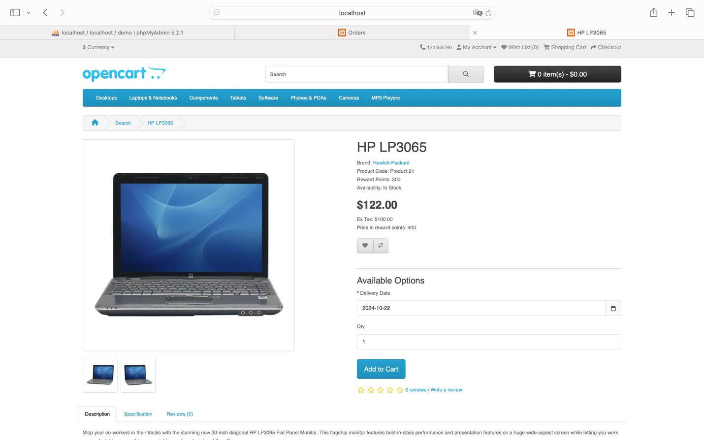
The “Delivery Date” field does not restrict past dates.
Currently, the year is 2024, but when entering a previous year like 2023
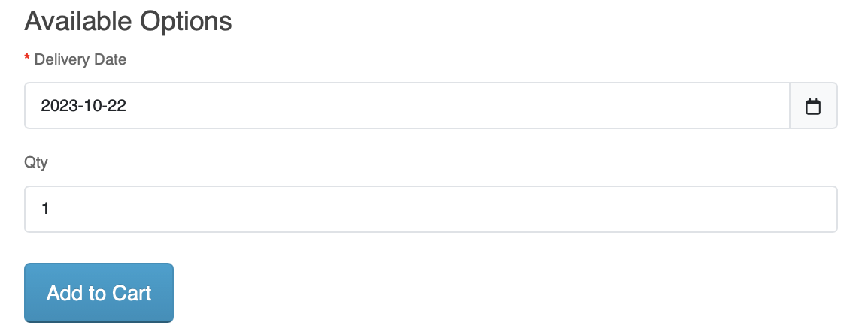
And clicking “Add to Cart,” the product is still added to the cart with a dialog message: “Success: You have added HP LP3065 to your shopping cart!” The cart button is also updated to “1 item(s) - $122.00.”
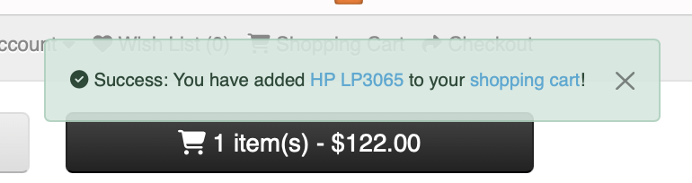
The quick order information for the item just added to the cart still displays the year 2023.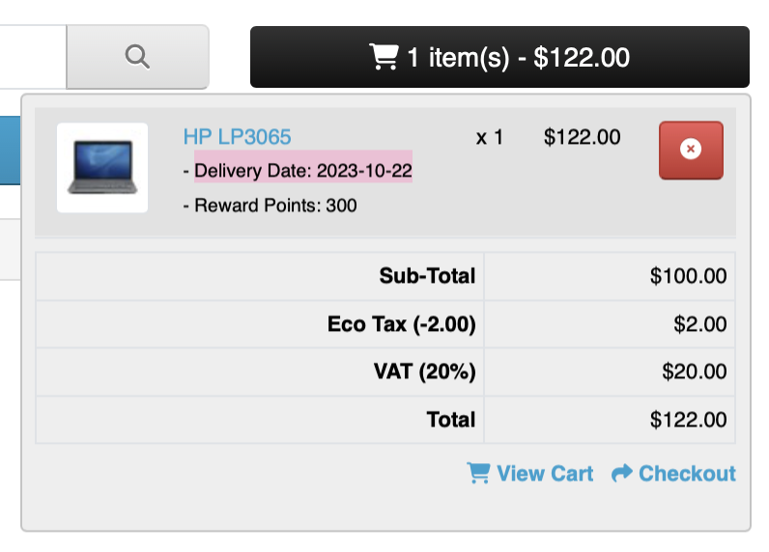
The “Checkout” page also shows 2023.
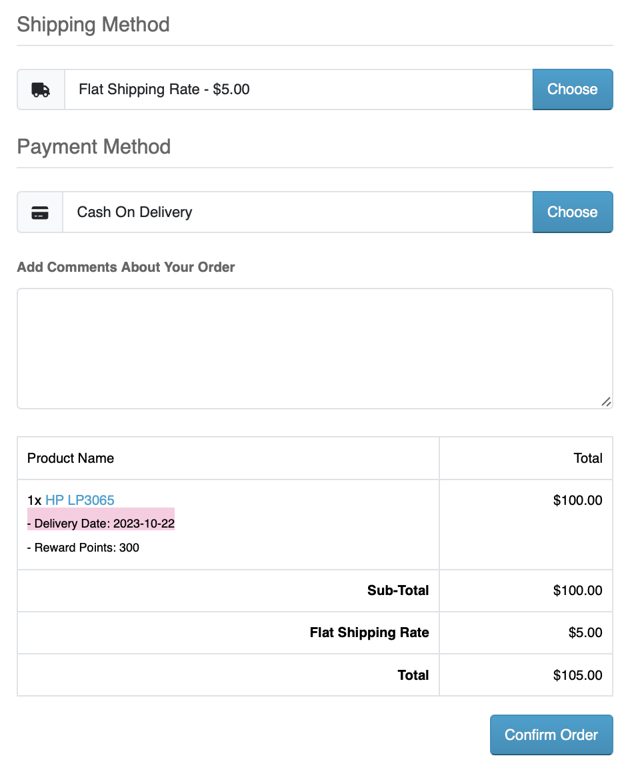
When the checkout is successful, the order still reflects the year 2023.
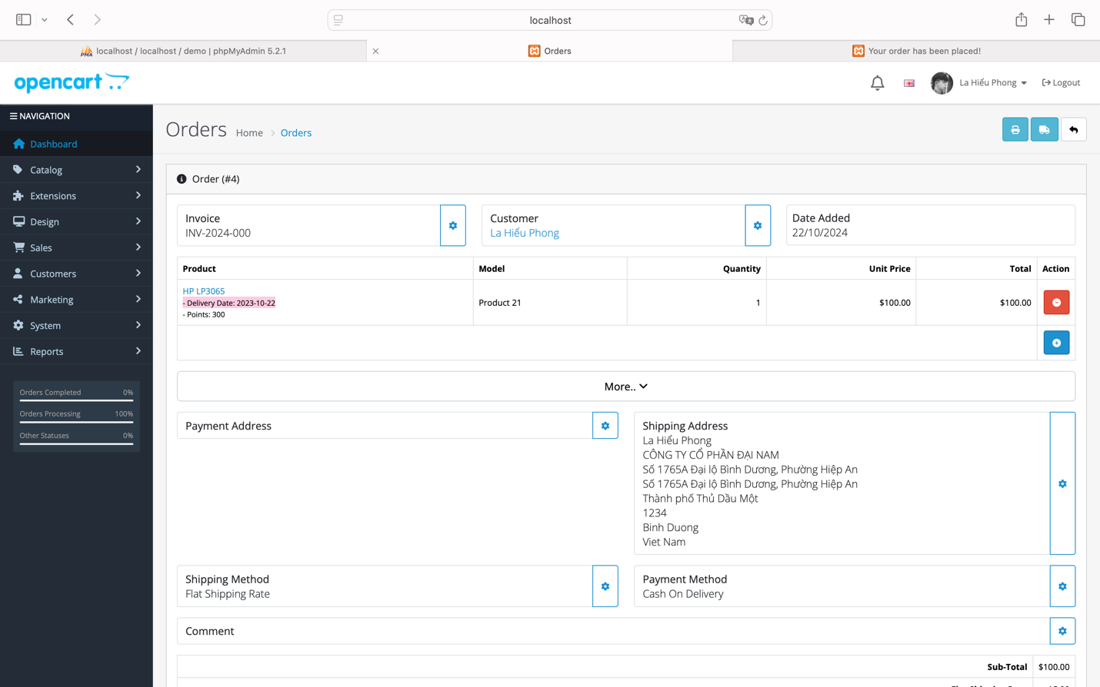

Expected Behavior:
The system must validate the delivery date and not allow users to enter a past date. If an invalid date is entered (before the current date), the system should display an error message and prompt for correction.
Actual Behavior:
The system does not limit the entry of past dates. When entering a date like 2023 and clicking "Add to Cart," the product is still added with a success message, and the cart displays “1 item(s) - $122.00.” The order summary still reflects the year 2023 during checkout, and the order is completed with the incorrect date.
Comments:
The system overlooks a critical check regarding date validation, allowing users to place orders with delivery dates in the past. This could lead to issues related to order accuracy and feasibility in fulfilling orders.
Suggested Improvements:
- Input Date Validation:
  - The system should validate the input immediately as the user enters a value in the "Delivery Date" field. If the date is earlier than the current date, an error message should be displayed: “The delivery date cannot be in the past. Please select a valid future date.”
- Prevent Adding to Cart and Checkout:
  - If the delivery date is invalid, the system should prevent users from adding products to the cart and completing the checkout. Users should only be able to proceed once a valid future date is entered.
- Clear Error Messaging:
  - Provide specific error messages to inform users of the issue with the entered date and how to correct it.
- Automatic Date Check:
  - Consider implementing an automatic date check feature, such as disabling past dates in the delivery date picker, preventing users from selecting invalid dates.

Error 04: Error in Product Review

Error ID |  | ERR_004 | Bug Description |  |  |  |  |  |  |  |  | Unable to load the product review page
Created By |  | La Hieu Phong | Reviewed By |  |  |  |  |  |  |  |  |  |  |  |  |  |  |  | Version
QA Tester’s Log |  | Initial report regarding the inability to load the product review page.
Bug Reporter |  | La Hieu Phong | Bug Report Date |  |  |  |  |  |  |  |  | 22-Oct-2024 |  |  |  |  |  |  | Error (Pass/Fail/Not Executed) |  |  |  |  |  | Fair
S # | Prerequisites: |  |  |  |  |  |  |  |  |  |  |  |  |  | S # |  |  | Test Data
1 | Access to Safari Browser |  |  |  |  |  |  |  |  |  |  |  |  |  | 1 |  |  | Access to any product detail page
2 | XAMPP installed and running on your computer |  |  |  |  |  |  |  |  |  |  |  |  |  | 2 |  |  | Product for review (e.g., "MacBook")
3 | OpenCart installed and configured on XAMPP
4 | A stable internet connection to access necessary resources and install extensions for OpenCart
Test Scenario | Verify that the system loads the product review page correctly when a user attempts to submit a review.
Step # | Step Details |  | Expected Results |  |  |  |  |  |  |  |  | Actual Results |  |  |  |  |  |  |  |  | Pass / Fail / Not executed / Suspended
1 | Access any product detail page (specifically "MacBook") |  | Page should open successfully |  |  |  |  |  |  |  |  | As Expected |  |  |  |  |  |  |  |  | Pass
2 | Click the "Write a review" button |  | Review form should open for input |  |  |  |  |  |  |  |  | As Expected |  |  |  |  |  |  |  |  | Pass
3 | Enter review content and click “Continue” |  | Review should be submitted, and confirmation message displayed |  |  |  |  |  |  |  |  | Unexpectedly, review page does not load, and no confirmation is shown |  |  |  |  |  |  |  |  | Fail

Issue Details
- Error Code: ERR_004
- Title: Unable to load the product review page
- Description: When clicking the product review button on the product detail page, the review page fails to load, preventing users from submitting their reviews.
- Severity Level: Medium
- Priority Level: High
- Environment: Safari, macOS, OpenCart Demo Version.
Steps to Reproduce:
Assume you access the product detail page for “MacBook”: http://localhost/demo/index.php?route=product/product&language=en-gb&product_id=43.

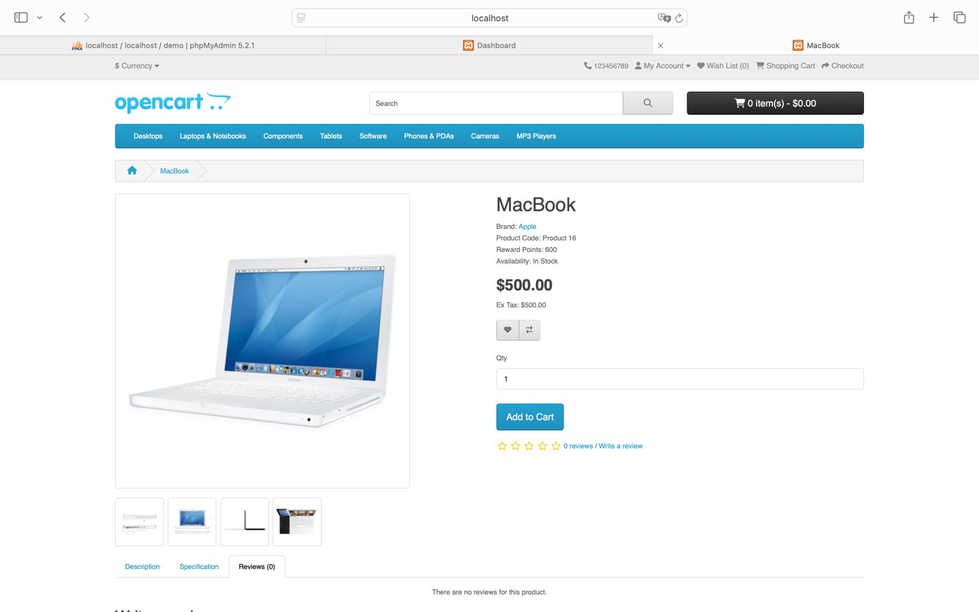
When you click on the product rating
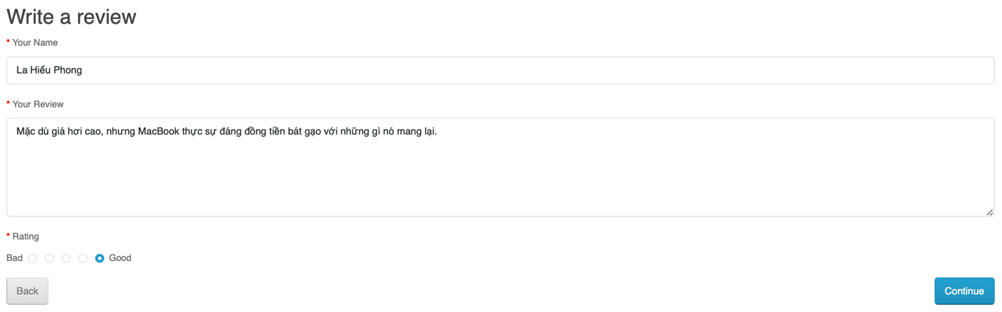
And then click “Continue,” the rating page does not load.
Expected Behavior:
After clicking "Continue," the review page should load, and the user’s review should be submitted successfully or display a success notification.
Actual Behavior:
When attempting to write a review, clicking "Continue" does not load the review page, preventing any further action.
Comments:
This issue negatively impacts the user experience and diminishes interaction with the system, particularly the product review functionality, which is crucial for enhancing the shopping experience.
Suggested Improvements:
- Check Connection and Review Page Load:
  - Ensure that the product review page loads correctly and that users can complete the review process without encountering errors.
- Improve Error Notifications:
  - If the review page fails to load, the system should display a clear error message to inform users about the issue and allow them to try again later.
- Quickly Address Page Load Errors:
  - Review the code related to the review feature to ensure there are no errors affecting the loading of the product review page.
- Enhance User Interaction:
  - Improve loading speed and user experience during the review process to ensure the submission is smooth and uninterrupted.

Error 05: Error Not Displaying the New Password Entry Page When Password is Forgotten

Error ID |  | ERR_005 |  | Bug Description |  |  |  |  |  |  |  |  | Password Reset Page Not Displayed When Password is Forgotten
Created By |  | La Hieu Phong |  | Reviewed By |  |  |  |  |  |  |  |  |  |  |  |  |  |  |  | Version
QA Tester’s Log |  | Initial report regarding the inability to display the new password input page after requesting a password reset.
Bug Reporter |  | La Hieu Phong |  | Bug Report Date |  |  |  |  |  |  |  |  | 22-Oct-2024 |  |  |  |  |  |  | Error (Pass/Fail/Not Executed) |  |  |  |  |  |  | Fair
S # | Prerequisites: |  |  |  |  |  |  |  |  |  |  |  |  |  |  | S # |  |  | Test Data
1 | Access to Safari Browser |  |  |  |  |  |  |  |  |  |  |  |  |  |  | 1 |  |  | Login Page URL
2 | XAMPP installed and running on your computer |  |  |  |  |  |  |  |  |  |  |  |  |  |  | 2 |  |  | Registered Email: hieuphong144@gmail.com
3 | OpenCart installed and configured on XAMPP
4 | A stable internet connection to access necessary resources and install extensions for OpenCart
Test Scenario | Verify the behavior when a user requests a password reset.
Step # | Step Details |  |  | Expected Results |  |  |  |  |  |  |  |  | Actual Results |  |  |  |  |  |  |  |  |  | Pass / Fail / Not executed / Suspended
1 | Navigate to the login page |  |  | Page should open successfully |  |  |  |  |  |  |  |  | As Expected |  |  |  |  |  |  |  |  |  | Pass
2 | Click on the "Forgotten Password" link |  |  | User should be redirected to the Forgotten Password page |  |  |  |  |  |  |  |  | As Expected |  |  |  |  |  |  |  |  |  | Pass
3 | Enter review content and click “Continue” |  |  | The system should send a confirmation email and display a password reset page |  |  |  |  |  |  |  |  | Unexpectedly |  |  |  |  |  |  |  |  |  | Fail

Issue Details
- Error Code: ERR_005
- Title: Password reset page not displayed after forgotten password request
- Description: The system navigates back to the login page without displaying the new password entry page after a user requests a password reset.
- Severity Level: Major
- Priority Level: High
- Environment: OpenCart Demo Version.
Steps to Reproduce:
Access the Login page: http://localhost/demo/index.php?route=account/login&language=en-gb.
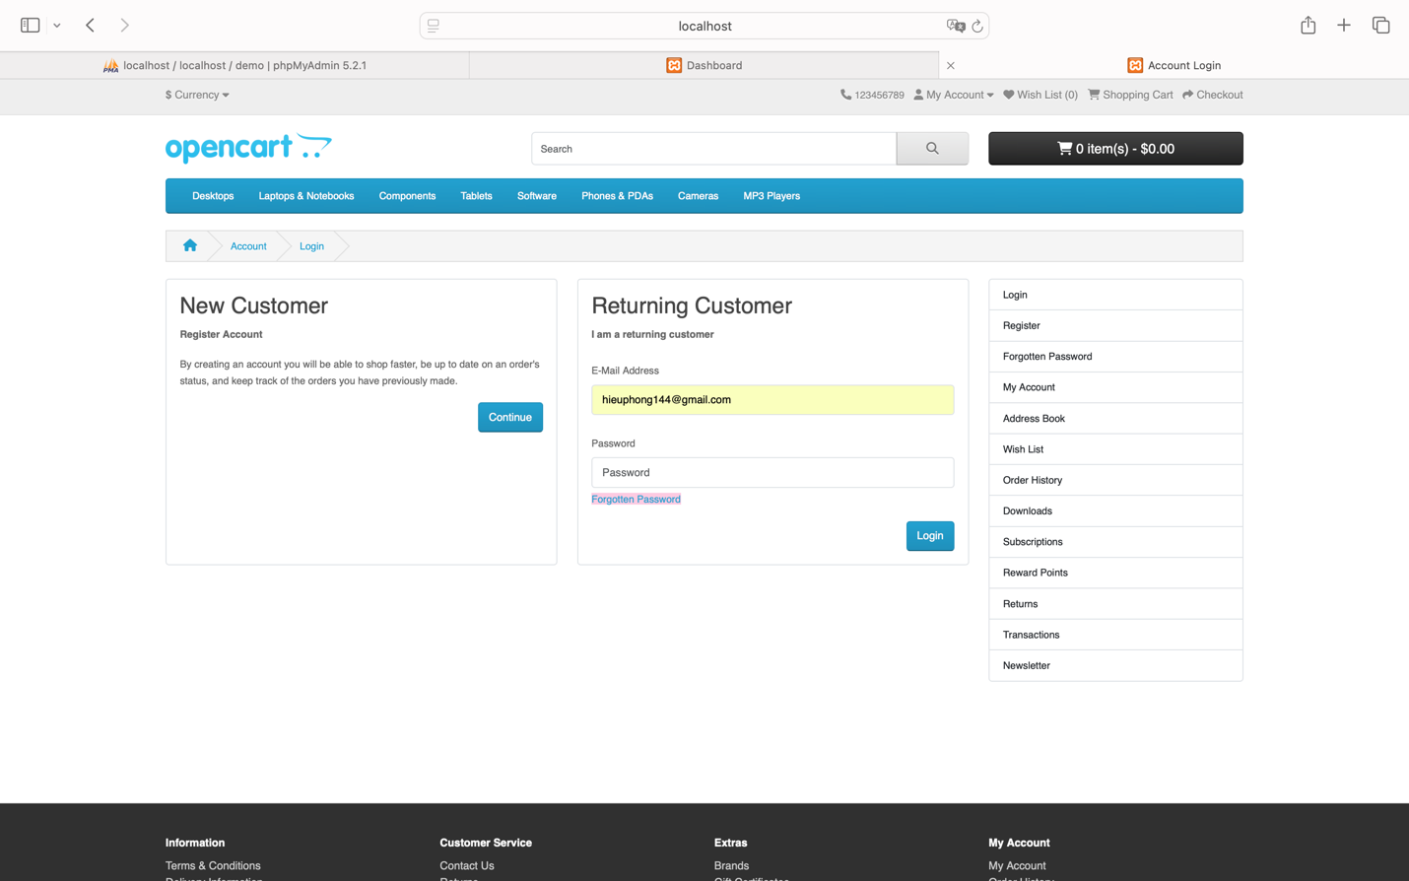
Click on the “Forgotten Password” link, which redirects you to the page: http://localhost/demo/index.php?route=account/forgotten&language=en-gb.
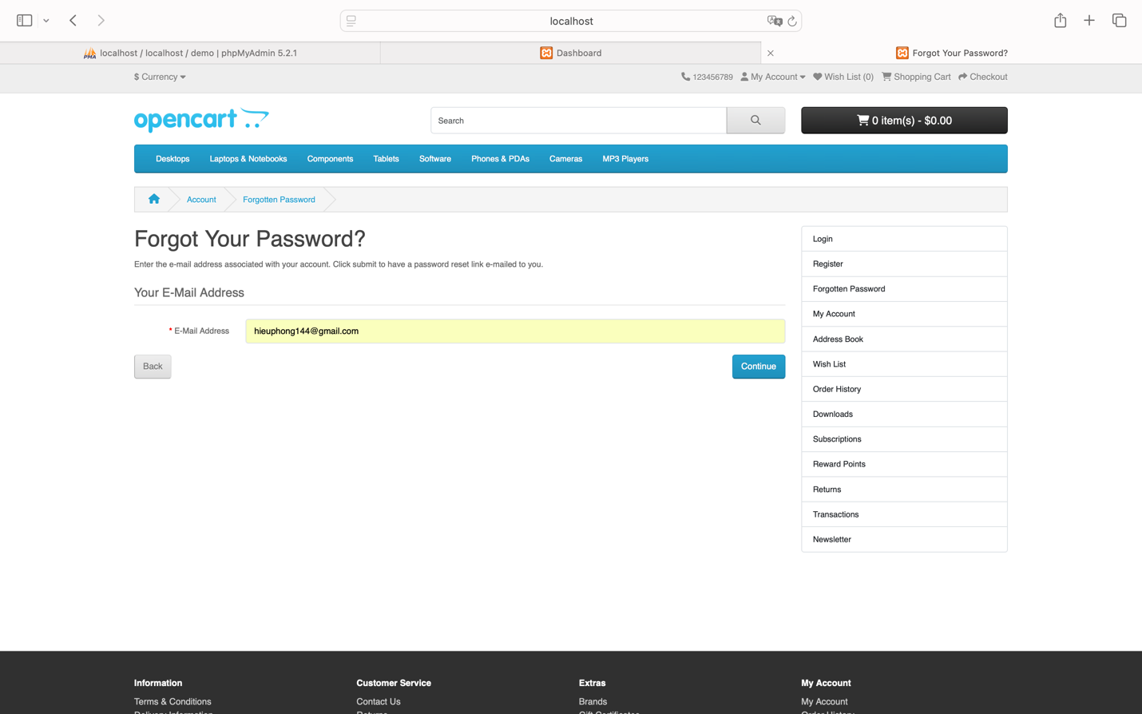
When you re-enter the registered “E-Mail Address” and click “Continue,” you are redirected to the login page: http://localhost/demo/index.php?route=account/login&language=en-gb without any page to input a new password for changing the password. However, an alert message appears stating, “Success: Your password has been successfully updated.”
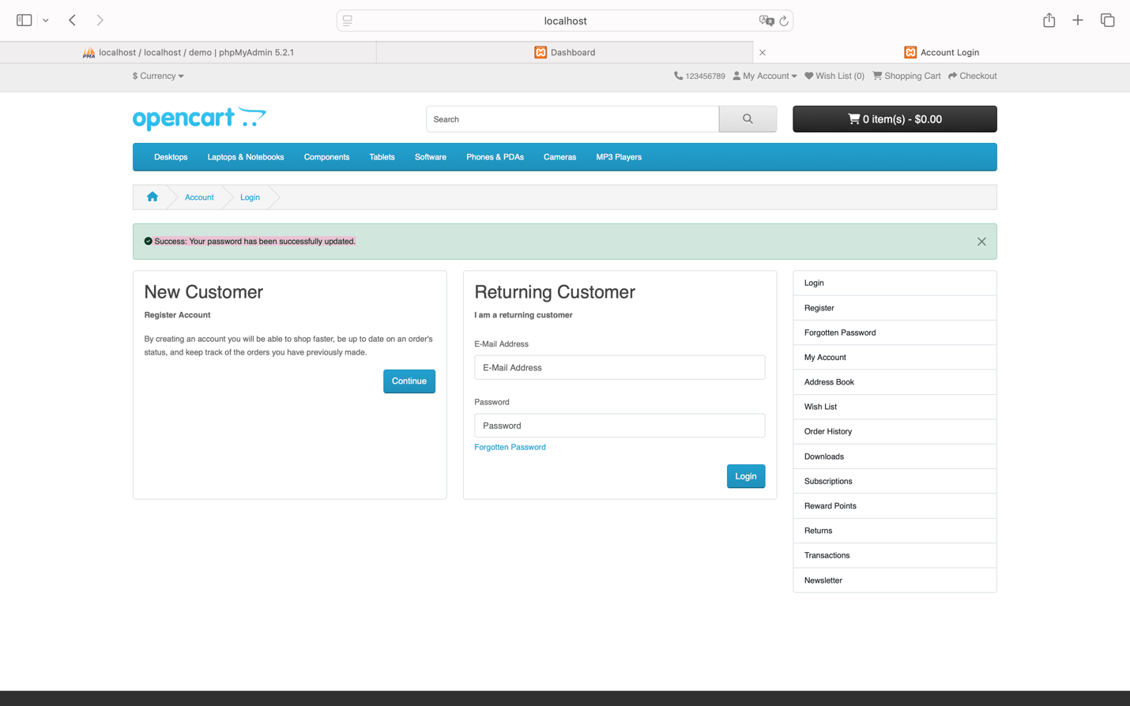
Expected Behavior:
After entering the email to reset the password, the system should send a confirmation email to the user and provide a page to enter a new password, or navigate to a password reset page via a link in the email.
Actual Behavior:
After submitting the email address, the user is redirected back to the login page and does not see the password entry field for changing the password. Instead, an alert message appears: "Success: Your password has been successfully updated."
Comments:
This issue significantly affects the password recovery feature, preventing users from changing their passwords when forgotten. It disrupts the login process and may cause considerable inconvenience for users.
Suggested Improvements:
- Fix Navigation Flow:
  - When a user clicks "Continue" after entering their email, the system should send a confirmation email containing a link for the user to reset their password.
  - The system should then display a new password entry page for the user to make the change.
- Adjust System Notifications:
  - If no password change occurs, the system should not display a "Success" message. Instead, it should accurately communicate: “A link to reset your password has been sent to your email.”
- Check and Fix Email Flow:
  - Ensure that the password recovery email is sent correctly and that users can securely access the link to reset their passwords.
- Enhance Security Measures:
  - Ensure that only users with access to the registered email can change their password through the secure link, to mitigate any security risks associated with account access.

Error 06: Error Entering Special Characters in the Product Name Field

Error ID |  | ERR_006 | Bug Description |  |  |  |  |  |  |  |  | Password Reset Page Not Displayed When Password is Forgotten
Created By |  | La Hieu Phong | Reviewed By |  |  |  |  |  |  |  |  |  |  |  |  |  |  |  | Version
QA Tester’s Log |  | Initial report concerning the system’s acceptance of special characters in the product name during registration.
Bug Reporter |  | La Hieu Phong | Bug Report Date |  |  |  |  |  |  |  |  | 22-Oct-2024 |  |  |  |  |  |  | Error (Pass/Fail/Not Executed) |  |  |  |  |  | Fair
S # | Prerequisites: |  |  |  |  |  |  |  |  |  |  |  |  |  | S # |  |  | Test Data
1 | Access to Safari Browser |  |  |  |  |  |  |  |  |  |  |  |  |  | 1 |  |  | First Name: @La Hiểu
2 | XAMPP installed and running on your computer |  |  |  |  |  |  |  |  |  |  |  |  |  | 2 |  |  | Last Name: Phong@
3 | OpenCart installed and configured on XAMPP |  |  |  |  |  |  |  |  |  |  |  |  |  | 3 |  |  | E-Mail: 1!!!lhp@gmail.com
4 | A stable internet connection to access necessary resources and install extensions for OpenCart |  |  |  |  |  |  |  |  |  |  |  |  |  | 4 |  |  | Password: 21112003
Test Scenario | Verify that the system does not allow special characters in the "First Name," "Last Name," and "E-Mail" fields during registration.
Step # | Step Details |  | Expected Results |  |  |  |  |  |  |  |  | Actual Results |  |  |  |  |  |  |  |  | Pass / Fail / Not executed / Suspended
1 | Access the registration page |  | Page should open successfully |  |  |  |  |  |  |  |  | As Expected |  |  |  |  |  |  |  |  | Pass
2 | Enter invalid data in the fields: First Name, Last Name, and Email |  | System should validate input and reject any special characters |  |  |  |  |  |  |  |  | Unexpectedly, user is registered successfully and redirected to the success page with the message: "Your Account Has Been Created!" |  |  |  |  |  |  |  |  | Fail

Issue Details
- Error Code: ERR_006
- Title: Allowing special characters in product name
- Description: The system allows special characters to be entered in the product name field when adding a new product.
- Severity Level: Medium
- Priority Level: High
- Environment: OpenCart Demo Version.
Steps to Reproduce:
Access the Register page: http://localhost/demo/index.php?route=account/register&language=en-gb.
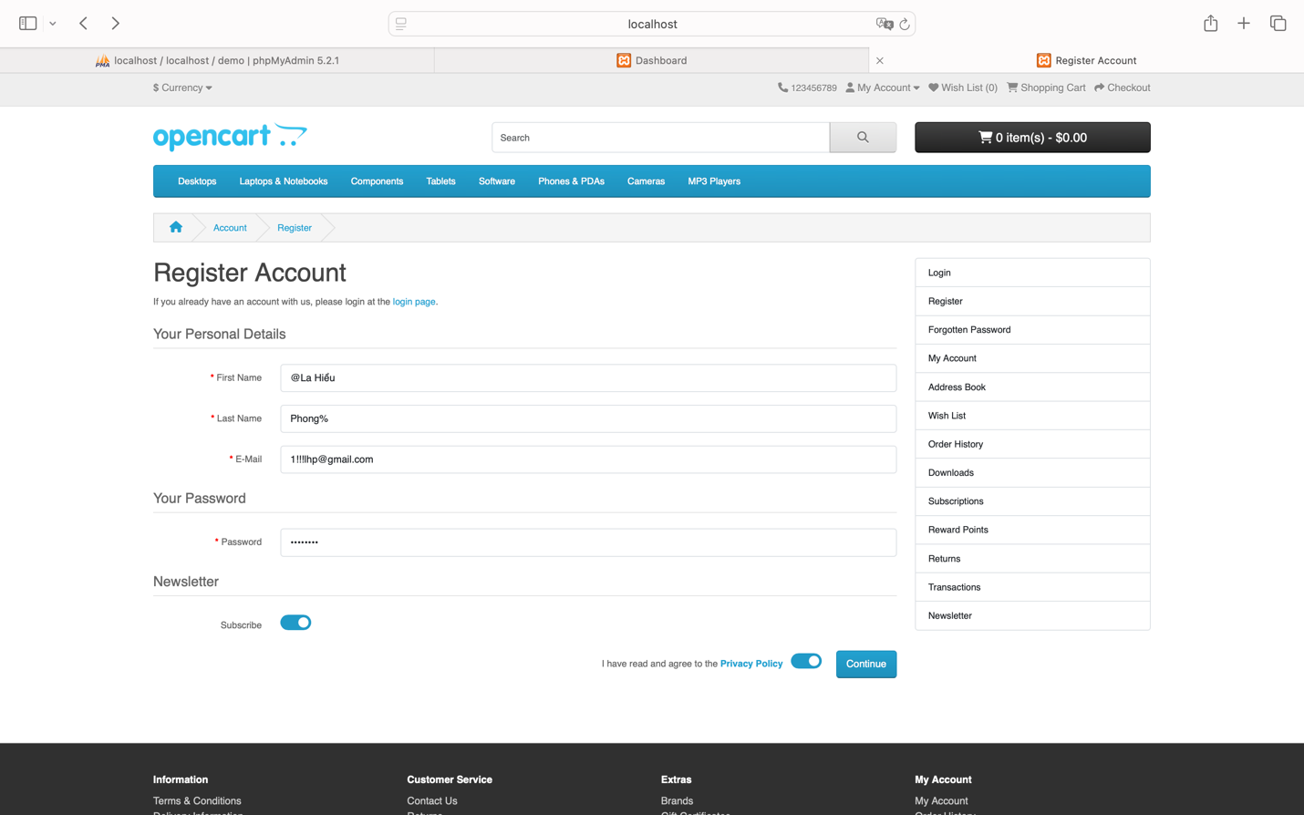
Enter the fields containing special characters:
“First Name”: @La Hiểu
“Last Name”: Phong@
“E-Mail”: 1!!!lhp@gmail.com
“Password”: 21112003
When you click “Continue,” the account is still registered successfully and redirects to the page: http://localhost/demo/index.php?route=account/success&language=en-gb&customer_token=a2fe1fb8c88d57cfa27f125fe9, and the heading appears as “Your Account Has Been Created!”
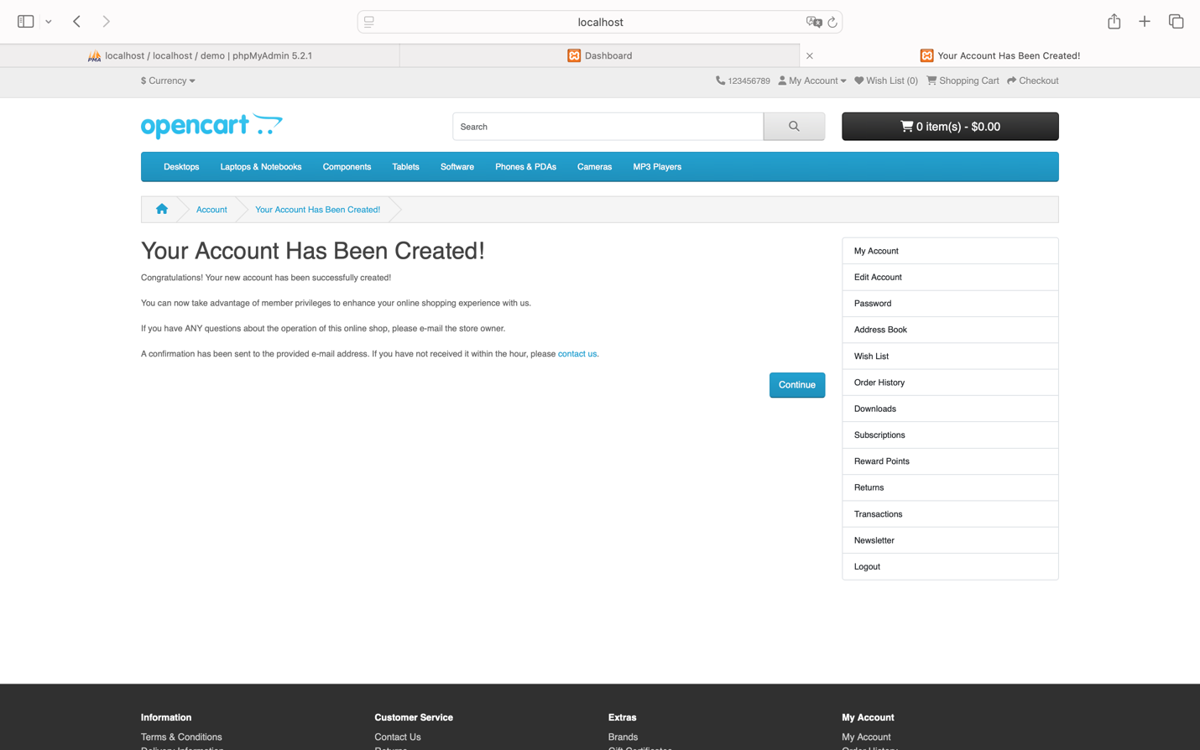

Expected Behavior:
The system should validate the input for the "First Name," "Last Name," and "E-Mail" fields, rejecting invalid special characters. If invalid characters are entered, the system should display an error message indicating which fields need correction.
Actual Behavior:
Upon submitting the registration form with special characters, the account is registered successfully, redirecting to: http://localhost/demo/index.php?route=account/success&language=en-gb&customer_token=a2fe1fb8c88d57cfa27f125fe9 with the heading "Your Account Has Been Created!"
Comments:
This issue leads to inaccurate data being stored in the system, potentially complicating customer information management and email notifications. Additionally, using special characters in name fields can result in display issues within the system.
Suggested Improvements:
- Tighten Input Validation:
  - Update validation rules for the "First Name," "Last Name," and "E-Mail" fields to exclude invalid special characters.
  - Ensure names consist only of letters, spaces, and valid diacritics (if applicable).
- Provide Clear Error Messages:
  - When users input invalid characters, the system should display specific error messages indicating which fields need correction and the required format.
- Enhance User Experience:
  - Ensure the registration process runs smoothly while maintaining strict control over user input to uphold data accuracy and consistency.
- System-Wide Validation Check:
  - Conduct validation checks across all user data fields in the system to ensure no invalid characters are stored, improving security and system stability.

Error 07: Error Losing Login Session When Returning from the Order Creation Page

Error ID |  | ERR_007 |  | Bug Description |  |  |  |  |  |  |  |  | Session Loss When Navigating Back from Return Order Page
Created By |  | La Hieu Phong |  | Reviewed By |  |  |  |  |  |  |  |  |  |  |  |  |  |  |  | Version
QA Tester’s Log |  | Initial report regarding the automatic logout issue when navigating back from the return order creation page in the OpenCart Demo environment.
Bug Reporter |  | La Hieu Phong |  | Bug Report Date |  |  |  |  |  |  |  |  | 22-Oct-2024 |  |  |  |  |  |  | Error (Pass/Fail/Not Executed) |  |  |  |  |  |  | Fair
S # | Prerequisites: |  |  |  |  |  |  |  |  |  |  |  |  |  |  | S # |  |  | Test Data
1 | Access to Safari Browser |  |  |  |  |  |  |  |  |  |  |  |  |  |  | 1 |  |  | User credentials for successful login
2 | XAMPP installed and running on your computer
3 | OpenCart installed and configured on XAMPP
4 | A stable internet connection to access necessary resources and install extensions for OpenCart
Test Scenario | Verify that the user does not lose their session when clicking the "Back" button from the return order page.
Step # | Step Details |  |  | Expected Results |  |  |  |  |  |  |  |  | Actual Results |  |  |  |  |  |  |  |  |  | Pass / Fail / Not executed / Suspended
1 | Log in successfully to the OpenCart Demo |  |  | User should be logged in without issues |  |  |  |  |  |  |  |  | As Expected |  |  |  |  |  |  |  |  |  | Pass
2 | Navigate to the order history page |  |  | Order history page should load successfully |  |  |  |  |  |  |  |  | As Expected |  |  |  |  |  |  |  |  |  | Pass
3 | Select any order and click "View" |  |  | Order details page should be displayed |  |  |  |  |  |  |  |  | As Expected |  |  |  |  |  |  |  |  |  | Pass
4 | Click on the "Return" button to create a return order |  |  | Return order creation page should load |  |  |  |  |  |  |  |  | As Expected |  |  |  |  |  |  |  |  |  | Pass
3 | Click the "Back" button to return to the order details page |  |  | User should return to the order details page without losing the session |  |  |  |  |  |  |  |  | Unexpectedly, user is logged out and redirected to the login page with a warning: “Warning: Invalid token session. Please login again!” |  |  |  |  |  |  |  |  |  | Fail

Issue Details
- Error Code: ERR_007
- Title: Session Lost When Navigating Back from Return Order Page
- Description: The user is automatically logged out when pressing the "Back" button from the return order creation page after successfully logging into the OpenCart Demo system.
- Severity Level: Medium
- Priority Level: High
- Environment: OpenCart Demo, Chrome, macOS.
Steps to Reproduce:
Assuming a successful login
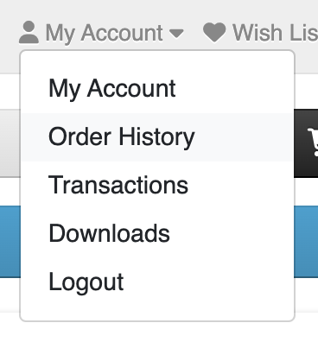
When I want to view my “Order History,” I click to navigate to the page: http://localhost/demo/index.php?route=account/order&language=en-gb&customer_token=b7dea137184f4974233fb74f37.
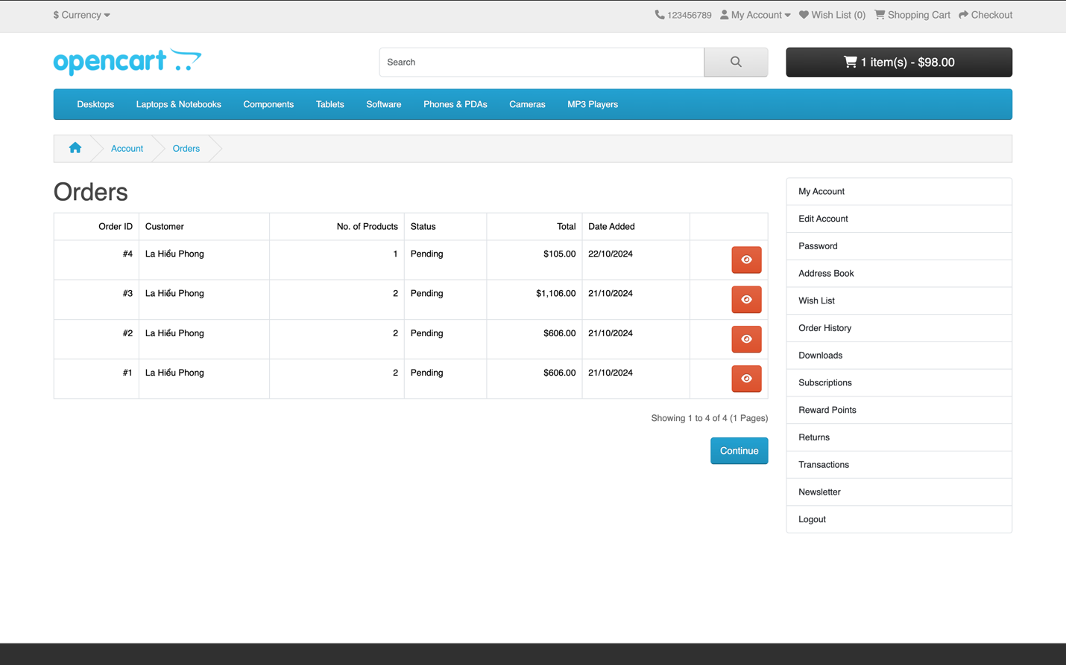
I select any order and click the “View” button.
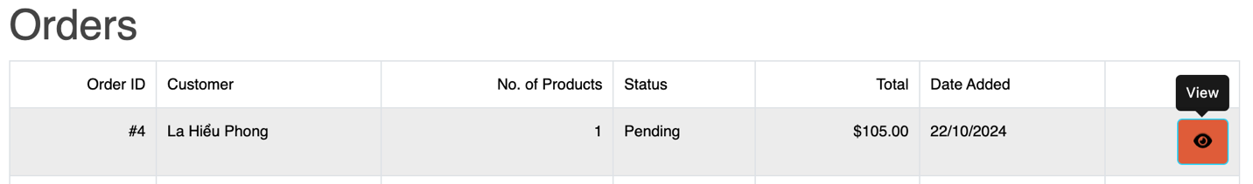
This navigates to the Order page: http://localhost/demo/index.php?route=account/order.info&language=en-gb&customer_token=b7dea137184f4974233fb74f37&order_id=4.

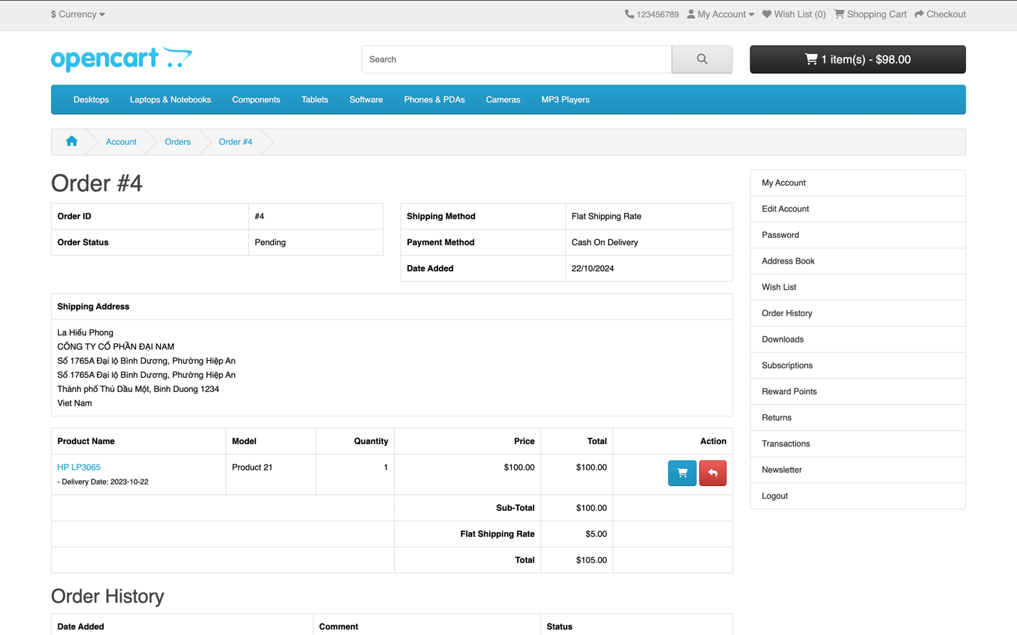
I want to perform the “Return” action to create a new order and repurchase that product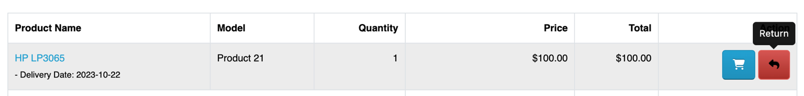
Which navigates me to the Return page: http://localhost/demo/index.php?route=account/returns.add&language=en-gb&order_id=4&product_id=47.
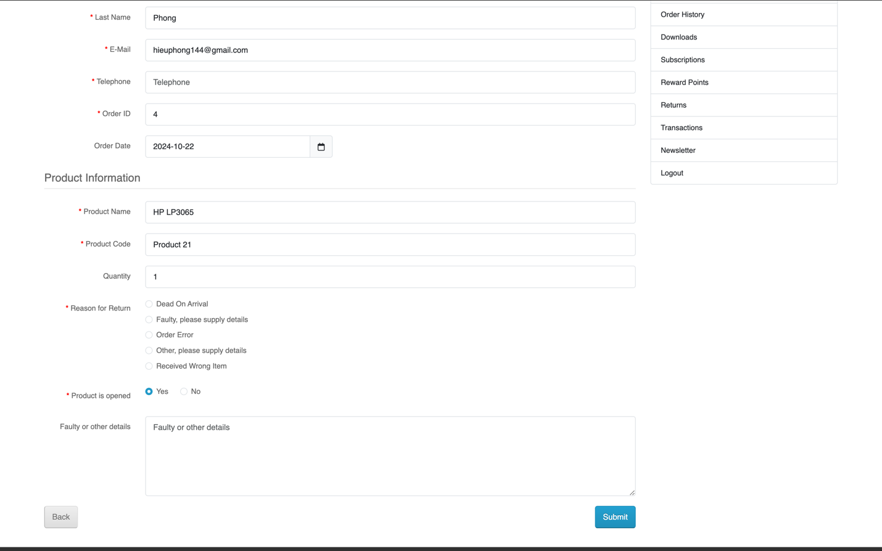
However, I do not want to proceed further, so I click the “Back” button to return to the Order page.

But when I click “Back,” it automatically logs me out and redirects to the Login page: http://localhost/demo/index.php?route=account/login&language=en-gb, and a warning message appears: “Warning: Invalid token session. Please login again!”
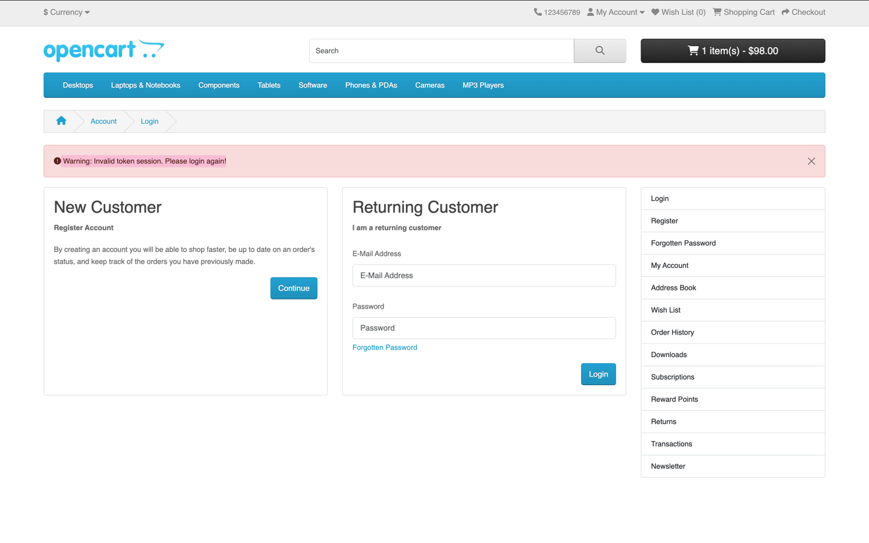
Expected Behavior:
When the user clicks the "Back" button, the system should navigate back to the order details page without invalidating the session. The user should remain logged in.
Actual Behavior:
After clicking "Back," the user is automatically logged out and redirected to the login page: http://localhost/demo/index.php?route=account/login&language=en-gb, with an alert stating, “Warning: Invalid token session. Please login again!”
Comments:
This issue seems related to the management of session tokens. The system should maintain the user’s session while navigating between different pages.
Suggested Improvements:
- Review Token Management:
  - Investigate and resolve issues related to session token management to prevent session loss during navigation.
- Check Navigation Workflow:
  - Review the navigation processes between pages to ensure continuity and security of the login session.
- Enhance Back Button Functionality:
  - Ensure the "Back" button functions as expected, maintaining the user’s session and not causing automatic logout

Test Summary Report

Introduction
OpenCart is an open-source e-commerce platform that allows users to easily set up and manage an online store. The objective of this testing is to evaluate the functionality, usability, and stability of the OpenCart Demo application, ensuring that all features work as expected and that no critical errors affect the user experience.

Scope
The features tested include:
- User Registration
- User Login/Logout
- Contact Form Submission
- Adding Products to Cart
- Payment Process
- Product Search Functionality
- Navigation within the Application

Test Case Summary

Test Case | Result
Test Case 01: User Registration | Passed
Test Case 02: User Login | Passed
Test Case 03: Contact Form Submission | Passed
Test Case 04: Adding Products to Cart | Failed
Test Case 05: User Logout | Passed
Test Case 06: Product Search Functionality | Passed
Test Case 07: Payment Process Evaluation | Passed
Test Case 08: User Experience during Payment | Passed
Test Case 09: Usability of Cart | Passed
Test Case 10: Navigation Functionality | Passed
Test Case 11: Special Character in Email Field | Failed
Test Case 12: Maximum Character Input in Username Field | Passed
Test Case 13: Minimum Character in Password Field | Passed
Test Case 14: Negative Value in Quantity Field | Failed
Test Case 15: Maximum Value in Quantity Field | Passed
Success Rate: 10/15 (66.67%)
Failure Rate: 5/15 (33.33%)

Bug Summary

Error ID | Description | Severity | Priority
Error 01 | Error when adding a negative quantity of products to cart | High | Medium
Error 02 | Error when adding more than the available quantity of products | Medium | Medium
Error 03 | Error in time limit for "Delivery Date" field | Major | High
Error 04 | Error in product rating | Medium | High
Error 05 | Error not displaying the new password input page when forgetting password | Major | High
Error 06 | Error entering special characters in product name field | Medium | High
Error 07 | Session lost when returning from the create return order page | Medium | High

Solutions
- For Error 01 (Negative Quantity in Cart):
  - Implement input validation to restrict users from entering negative values in the quantity field.
  - Provide a user-friendly error message that clearly indicates the issue.
- For Error 02 (Exceeding Available Quantity):
  - Introduce checks on the backend to prevent users from adding more items than are available in stock.
  - Display a notification to users when they attempt to exceed the available quantity.
- For Error 03 (Delivery Date Time Limit):
  - Ensure the system has appropriate constraints on date input, including a maximum allowable date.
  - Display a clear message when users select an invalid delivery date.
- For Error 04 (Product Rating Error):
  - Review the rating system implementation to identify any potential bugs in the logic.
  - Conduct additional testing to ensure ratings can be submitted and displayed correctly.
- For Error 05 (Forgot Password Issue):
  - Fix the link to the new password input page in the "Forgot Password" process.
  - Test the entire password recovery flow to ensure it functions as intended.
- For Error 06 (Special Characters in Product Name):
  - Validate input fields for special characters and provide guidelines on acceptable input.
  - Include error handling to notify users when they enter invalid characters.
- For Error 07 (Session Loss Issue):
  - Investigate session management settings to prevent session loss during navigation.
  - Implement mechanisms to preserve user session data during transitions between pages.

Conclusion
The overall quality of the OpenCart application is quite good, with a success rate of 66.67% in the executed test cases. However, some critical errors, such as being unable to add a product with a negative quantity and not displaying the new password input page when forgetting the password, need immediate attention. Suggested improvements include conducting additional testing to ensure all features function correctly and updating error messages to enhance user experience.

