SAIGON UNIVERSITY
FACULTY OF INFORMATION TECHNOLOGY

----- 🙡 🕮 🙣 -----
COURSE: SOFTWARE TESTING

REPORT ON ASSIGNMENT 2
SUBMISSION DATE: November 07, 2024

SUPERVISOR | : | HANNAH VU
STUDENT NAME | : | LA HIEU PHONG
STUDENT ID | : | 3121411162
CLASS | : | DCT121C5

Ho Chi Minh City, November 7, 2024

Table of Contents
I. Objective and Purpose 1
II. Application Overview 1
III. Testing Scope 2
1. Environment Setup: 2
2. Key Functionalities to Automate: 2
3. Test Execution - Test Case 3
test_login_success_chrome 3
test_login_failure_invalid_username_chrome 4
test_login_failure_invalid_password_chrome 5
test_logout_success_chrome 7
test_lost_session_when_navigating_back_from_order_creation 8
test_contact_form_submission_success_chrome 14
test_contact_form_submission_failure_chrome 15
test_submission_of_contact_form_with_special_characters_in_message 17
test_contact_form_submission_with_special_characters_in_email 20
test_contact_form_submission_with_special_characters_in_name 21
test_navigate_to_random_product_detail_chrome 24
test_navigate_to_empty_cart_chrome 25
test_navigate_to_shopping_cart 26
test_navigate_to_checkout 27
test_navigate_to_sitemap_page 28
test_dashboard_product_info 29
test_compare_product_info 30
test_contact_us_invalid_fields 31
test_registration_invalid_fields 32
test_error_page_displayed_when_adding_product_to_cart_fails 33
test_error_page_displayed_when_adding_product_with_negative_quantity 36
test_search_macbook (random: “MacBook”) 39
test_search_macbook (random: “macbook”) 40
test_search_macbook_fail 41
test_open_home_page_chrome 42
test_open_home_page_firefox 43
test_check_text_on_widgets 44
test_check_ui_on_large_screen 50
4. Report Generation: 53
Test Case Summary: 53
Type of Testing Performed 53
5. Code Review: 57

Objective and Purpose

Objective
The primary objective of this project is to design, develop, and execute automated test scripts using Selenium to thoroughly validate the core functionalities of the web application. These test scripts will be crafted to assess key user journeys and interactions across the site. After executing the scripts, comprehensive test reports will be generated, providing a detailed analysis of the system's performance, potential issues, and any deviations from the expected behavior. This approach ensures that the web application is rigorously tested, providing both developers and stakeholders with valuable insights to optimize the overall user experience.

Purpose
The purpose of this testing initiative is to ensure that all critical aspects of the e-commerce website, including its functionality, usability, performance, and security, align with predefined business and technical requirements. By conducting thorough testing, we aim to identify and resolve any issues before the website is live, thereby ensuring that users enjoy a smooth, intuitive, and secure shopping experience. Specifically, the goal is to validate that the core features of the website—such as product browsing, user registration, login/logout processes, shopping cart functionality, and payment processing—work seamlessly and efficiently, providing users with a reliable platform for purchasing clothing and household items.

Application Overview

The e-commerce website, built on the OpenCart platform, is designed to provide a comprehensive online shopping experience for customers interested in exploring and purchasing a wide range of clothing and household products. OpenCart's flexible and user-friendly interface empowers customers to browse an extensive product catalog, search for specific items, and complete their purchases with ease. This robust platform incorporates a variety of features that enhance the shopping experience and streamline both the customer journey and back-end management. Key features of the website include:

- User Registration & Account Management: Customers can create personal accounts, update their profiles, and access order histories. OpenCart allows users to manage their shipping addresses, track the status of orders, and save their preferred payment methods for future purchases.
- Login/Logout Functionality: OpenCart offers secure login and logout features, enabling users to access their accounts and enjoy a personalized shopping experience. Customers can quickly log in using their credentials and easily log out once their shopping session is completed. This functionality ensures that user data is protected and that customers can manage their shopping experience more efficiently.
- Shopping Cart: OpenCart provides an intuitive shopping cart feature, allowing users to easily add products to their cart, view detailed item descriptions, and review their selections before proceeding to checkout. Users can modify quantities, remove items, or save products for later purchase, offering full flexibility in managing their cart. The cart is also updated in real-time, reflecting changes instantly.
- Payment Processing: OpenCart integrates with various secure payment gateways to ensure users can complete their transactions with confidence. The website supports multiple payment options, including credit and debit cards, PayPal, and other secure methods. This flexibility allows customers to choose the payment option that suits them best while ensuring that their sensitive information remains protected.
- Order Management: OpenCart's backend allows both administrators and customers to easily manage orders. Administrators can process orders, manage stock levels, and track sales, while customers can view order statuses, request refunds, or initiate product returns directly from their accounts.

By focusing on these essential features, the website is designed to provide a seamless and efficient shopping experience. The OpenCart platform’s built-in capabilities not only streamline the user journey but also ensure scalability, security, and ease of maintenance. This makes it possible for the website to handle high traffic and large volumes of transactions while maintaining a smooth and intuitive interface. As a result, the site encourages user engagement, repeat visits, and ultimately, successful transactions, establishing a trusted online marketplace for both clothing and household goods.

Testing Scope

Environment Setup:

- IDE: Set up an Integrated Development Environment (IDE) such as PyCharm.
- Selenium WebDriver: Install and configure Selenium WebDriver.
- Browser: Choose a browser Chrome and ensure the correct WebDriver is installed for it.
- Version Control: Use a version control system (e.g., Git) to manage your code.

Key Functionalities to Automate:

- Login/Logout Automation
Automate the process of logging into and out of the application. Verify that the login is successful and that logout properly clears the session or redirects as intended.

- Form Submission
Automate the process of filling out and submitting forms, ensuring that the form handles various types of input correctly and that the expected actions (e.g., error messages, confirmation) occur based on the input.

- Navigation Flow
Automate navigation between various pages and sections of the application, confirming that links, buttons, and menus lead to the correct destinations without errors.

- Data Validation
Automate the validation of data displayed on dashboards, tables, or other data-rich components, ensuring the information is accurate, formatted correctly, and updated as expected.

- Error Handling and Validation
Test the application's response to invalid inputs (e.g., incorrect data, missing fields, or erroneous values), ensuring the system provides appropriate feedback and handles errors gracefully.

- Search Functionality
Automate testing of the search feature to ensure that it returns accurate, relevant results based on various query inputs and handles edge cases like no results or partial matches.

- Responsive Design Testing
Automate the verification that the application’s UI and functionality adapt properly across different screen sizes and devices (e.g., mobile, tablet, desktop).

Test Execution - Test Case

Login/Logout Automation
chrome_1_login_logout.py

test_login_success_chrome

TC ID | Description | Steps | Expected Result | Actual Results | Status
TC_001 | Verify successful login functionality in Chrome browser. | 1. Navigate to the login page using Chrome.  2. Enter email in the "input-email" field.  3. Enter password in the "input-password" field.  4. Click the login button.  5. Verify no error alert (alert-danger) is displayed.  6. Assert that the current URL contains "route=account/account".  7. Check for customer_token in the URL.  8. Click the logo to navigate back to the home page.  9. Assert that the current page is the home page with logged-in status.  10. Verify the number of items in the "My Account" dropdown menu. | 1. The login page opens successfully.  2. Email and password are entered correctly.  3. Login is successful without any error alerts.  4. URL redirects to the account page (route=account/account)  5. URL contains the customer_token.  6. Successfully returns to the home page with logged-in status.  7. The "My Account" dropdown contains 5 items. | Login is successful with the correct email and password. The page redirects to the user account page and contains the customer_token. Successfully navigated back to the home page with logged-in status, and the "My Account" dropdown contains 5 items. | Pass

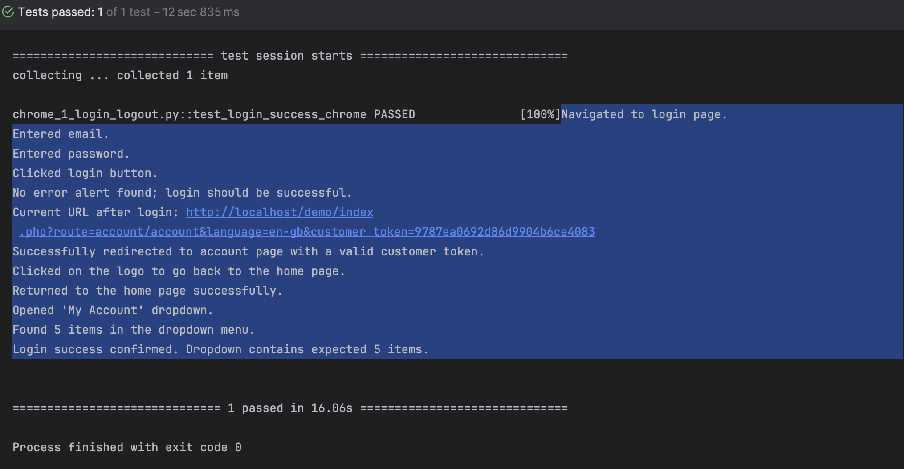

test_login_failure_invalid_username_chrome

TC ID | Description | Steps | Expected Result | Actual Results | Status
TC_002 | Verify that login fails when an invalid username (email) is provided in Chrome browser. | 1. Navigate to the login page using Chrome.  2. Enter an incorrect email in the "input-email" field.  3. Enter a valid password in the "input-password" field.  4. Click the login button.  5. Verify that an error alert (alert-danger) is displayed.  6. Check that the error alert contains the message "Warning: No match for E-Mail Address and/or Password.".  7. Click the logo to navigate back to the home page.  8. Verify that the "My Account" dropdown contains 2 items (Register and Login). | 1. The login page opens successfully.  2. The incorrect email is entered.  3. The password is entered.  4. The login button is clicked.  5. An error alert is displayed.  6. The alert contains the correct warning message about incorrect login.  7. Clicking on the logo redirects back to the home page.  8. The "My Account" dropdown contains only 2 items (Register and Login). | Login fails as expected with the correct error message. The page redirects back to the home page, and the "My Account" dropdown contains 2 items. | Pass

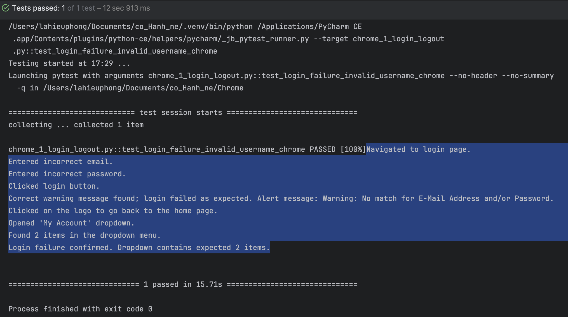

test_login_failure_invalid_password_chrome

TC ID | Description | Steps | Expected Result | Actual Results | Status
TC_003 | Verify that login fails when an invalid password is provided in Chrome browser. | 1. Navigate to the login page using Chrome.  2. Enter a valid email in the "input-email" field.  3. Enter an incorrect password in the "input-password" field.  4. Click the login button.  5. Verify that an error alert (alert-danger) is displayed.  6. Check that the error alert contains the message "Warning: No match for E-Mail Address and/or Password.".  7. Click the logo to navigate back to the home page.  8. Verify that the "My Account" dropdown contains 2 items (Register and Login). | 1. The login page opens successfully.  2. The valid email is entered.  3. The incorrect password is entered.  4. The login button is clicked.  5. An error alert is displayed.  6. The alert contains the correct warning message for incorrect login.  7. Clicking on the logo redirects back to the home page.  8. The "My Account" dropdown contains only 2 items (Register and Login). | Login fails as expected with the correct error message. The page redirects back to the home page, and the "My Account" dropdown contains 2 items. | Pass

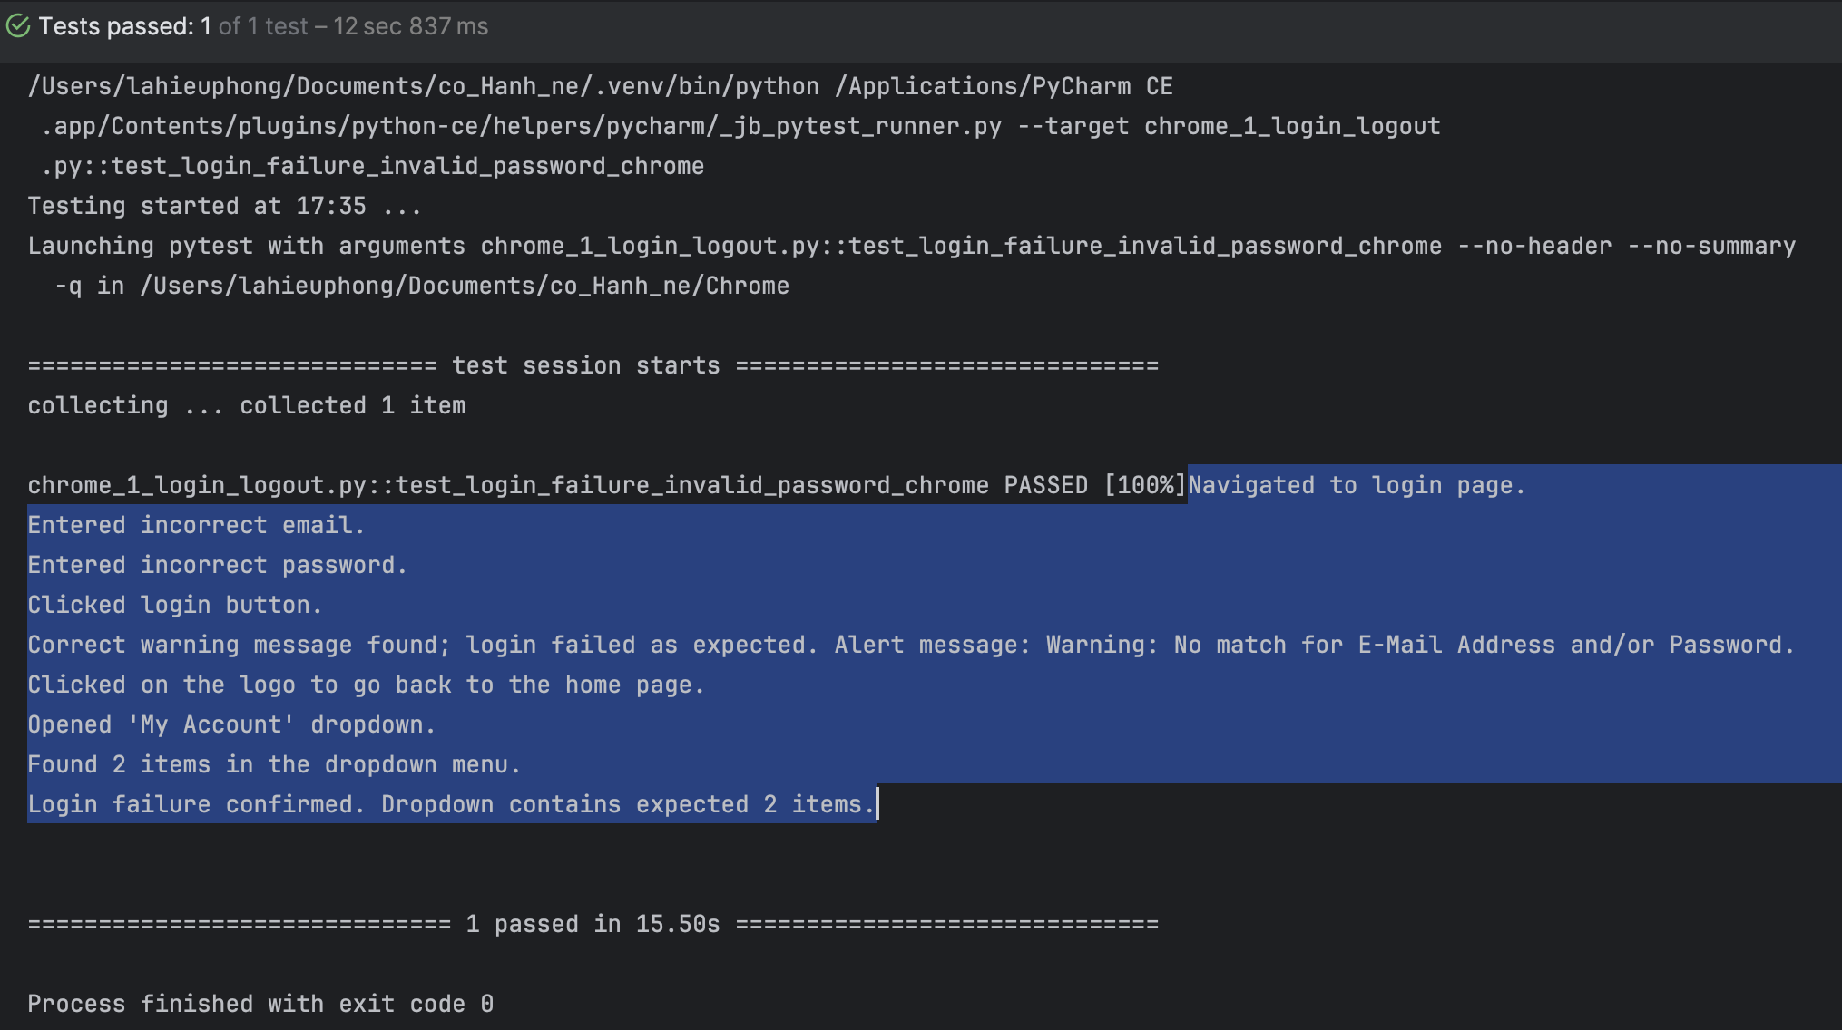

test_logout_success_chrome

TC ID | Description | Steps | Expected Result | Actual Results | Status
TC_004 | Verify that the user can successfully log out from the application in Chrome browser. | 1. Call the test_login_success_chrome function to ensure the user is logged in.  2. Click on the logout link.  3. Verify that the user is redirected to the logout confirmation page.  4. Check that the logout confirmation page displays the expected header and message.  5. Click the 'Continue' button to return to the home page.  6. Verify redirection to the home page.  7. Open the "My Account" dropdown and verify that it contains 2 items (Register and Login). | 1. The login function is called successfully, ensuring the user is logged in.  2. The logout link is clicked.  3. The user is redirected to the logout confirmation page.  4. The logout confirmation page contains the correct header ("Account Logout") and message ("You have been logged off your account.").  5. The 'Continue' button is clicked and the user is redirected to the home page.  6. The "My Account" dropdown contains only 2 items (Register and Login). | The user successfully logs out and is redirected to the logout confirmation page. The confirmation message is displayed. The user returns to the home page and the "My Account" dropdown shows only 2 items. | Pass

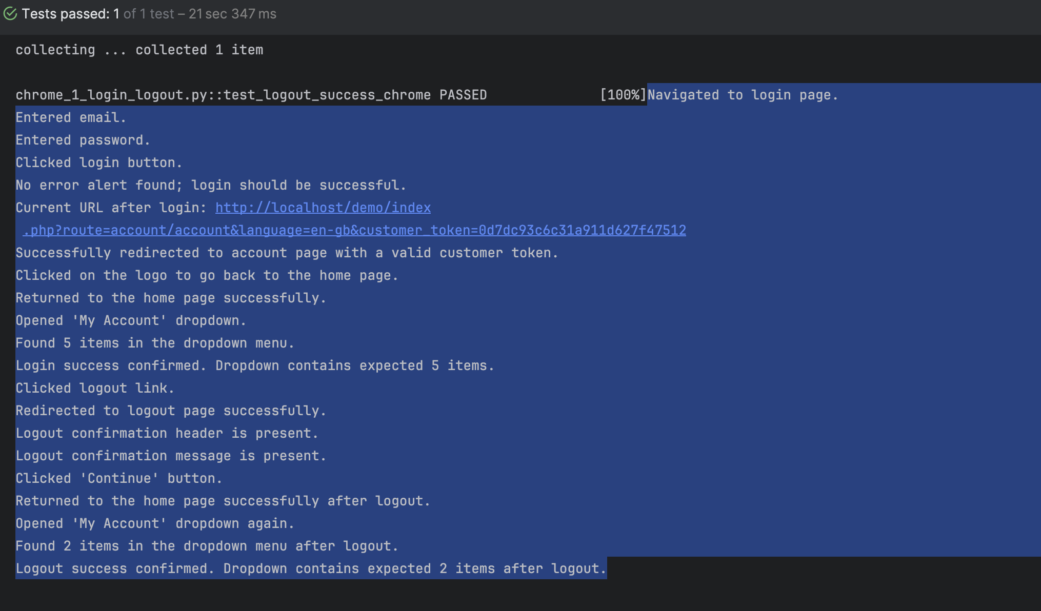

test_lost_session_when_navigating_back_from_order_creation

TC ID | Description | Steps | Expected Result | Actual Results | Status
TC_005 | Verify that the session is lost and the user is redirected to the login page after navigating back from the order creation process in Chrome browser. | 1. Log in successfully using test_login_success_chrome.  2. Navigate to the 'Order History' page by clicking the link.  3. Verify the navigation to the 'Order History' page.  4. Click on the 'View' button to view order details.  5. Verify the navigation to the 'Order Details' page.  6. Scroll down to ensure the 'Return' button is visible.  7. Click on the 'Return' button to initiate a return request.  8. Verify the navigation to the 'Return' page.  9. Scroll down again to ensure the 'Back' button is visible.  10. Click on the 'Back' button to go back to the previous page.  11. Verify that the user is redirected to the login page. | 1. The user logs in successfully.  2. The 'Order History' page is displayed.  3. The user navigates to the 'Order Details' page.  4. The 'Return' button is visible and clickable.  5. The user is redirected to the 'Return' page.  6. The 'Back' button is visible and clickable.  7. After clicking the 'Back' button, the session should be lost and the user should be redirected to the login page. | The session is lost when clicking the 'Back' button after the return process, and the user is redirected to the login page. | Fail

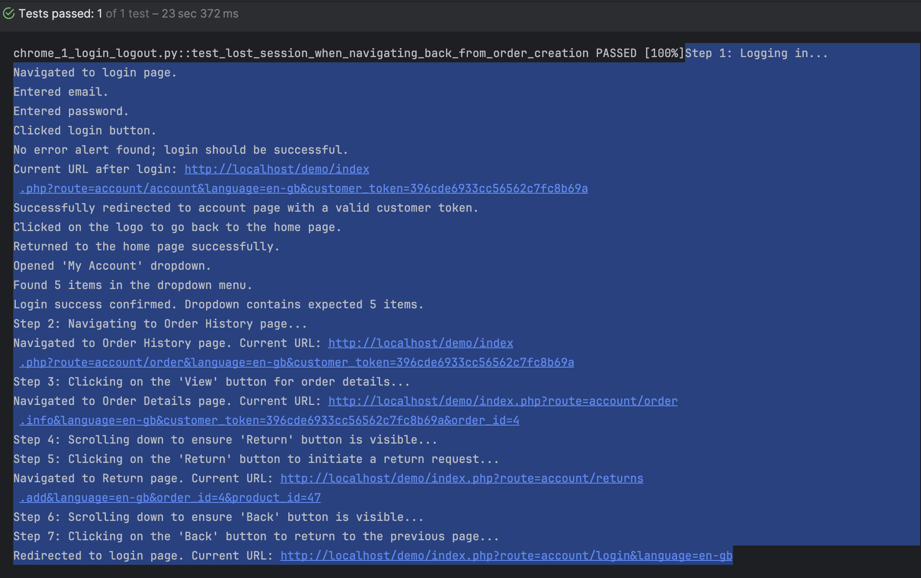

Actual behavior: Lost login session when navigating back from the return order creation page
Assuming login is successful
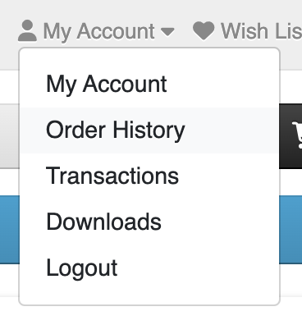
When I want to view “Order History,” I click to navigate to the page http://localhost/demo/index.php?route=account/order&language=en-gb&customer_token=b7dea137184f4974233fb74f37.
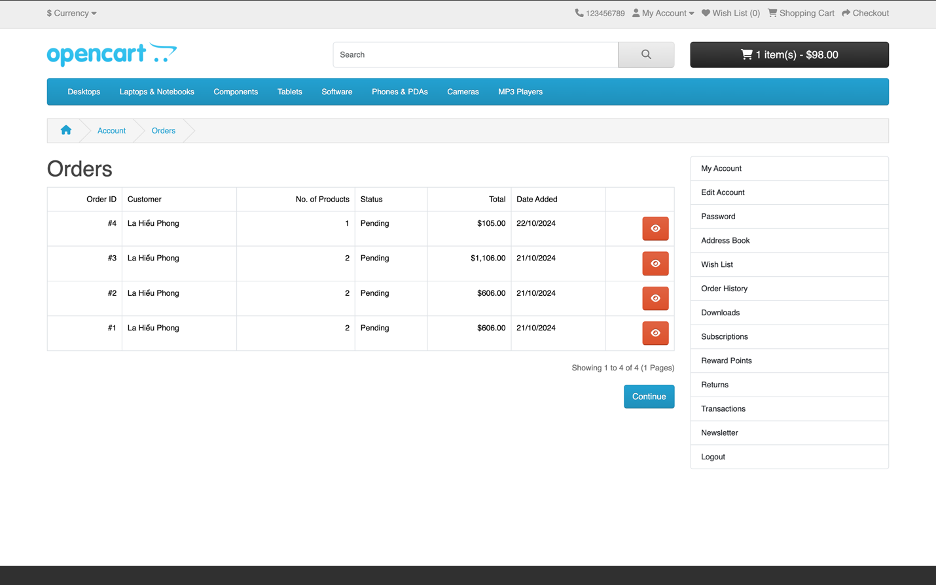
I select any order and click the “View” button.
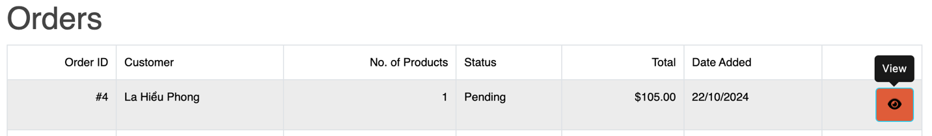
This redirects to the order page http://localhost/demo/index.php?route=account/order.info&language=en-gb&customer_token=b7dea137184f4974233fb74f37&order_id=4.
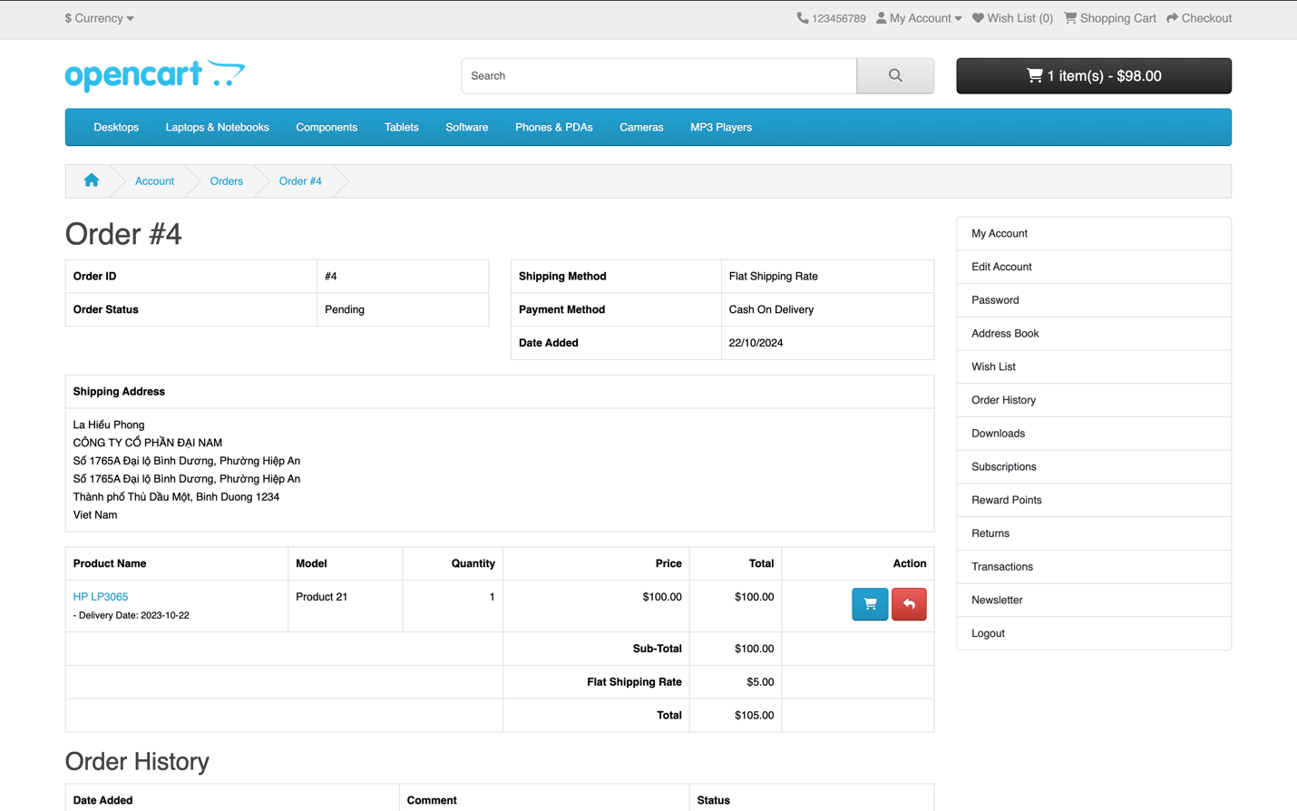
I want to perform the “Return” action to create a new order and repurchase the product 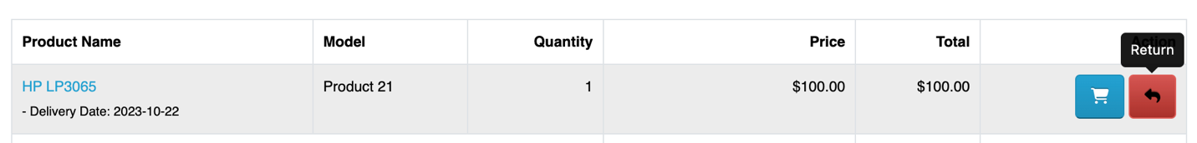
So I am redirected to http://localhost/demo/index.php?route=account/returns.add&language=en-gb&order_id=4&product_id=47.
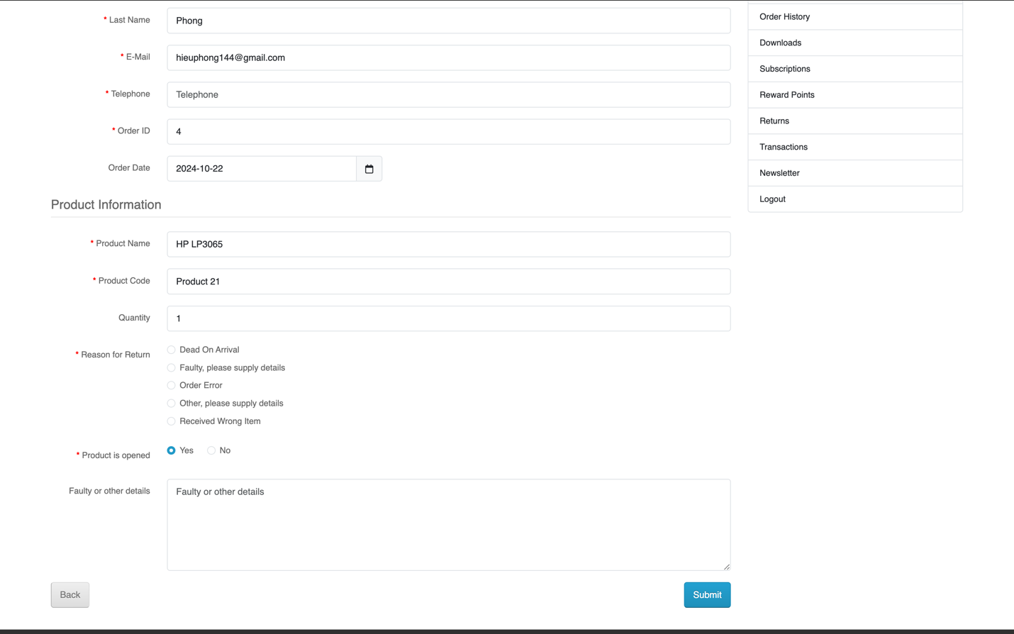
Since I don’t want to continue, I click the “Back” button to return to the order page.
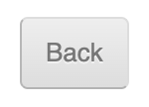
However, when I click "Back," I am automatically logged out and redirected to the login page http://localhost/demo/index.php?route=account/login&language=en-gb, with the warning: "Warning: Invalid token session. Please login again!"
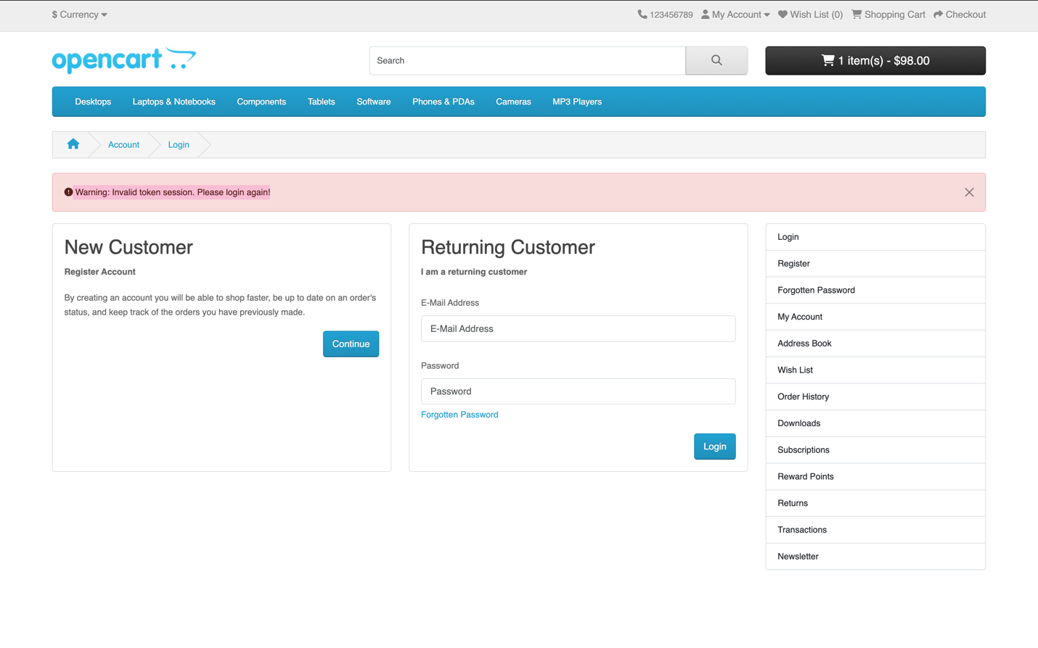
Remarks: This issue seems to be related to session token management. The system needs to maintain the user’s session when navigating between different pages.

Suggested improvements:
Review and fix the issues related to session token management during login sessions.
Check the page navigation process to ensure continuity and security of the login session.
Ensure that the "Back" button works as expected, without causing the login session to be lost

Form Submission
chrome_2_form_submission.py

test_contact_form_submission_success_chrome

TC ID | Description | Steps | Expected Result | Actual Results | Status
TC_006 | Verify that the contact form is successfully submitted and the user is redirected to the success page in Chrome browser. | 1. Navigate to the contact page using the URL: http://localhost/demo/index.php?route=information/contact&language=en-gb.  2. Fill out the contact form with a valid name, email, and enquiry message.  3. Scroll to the submit button and ensure it is in view.  4. Click the submit button to submit the form.  5. Verify that the user is redirected to the contact success page.  6. Verify that the success page displays the correct success header and message.  7. Click the 'Continue' button to return to the home page.  8. Verify that the user is redirected back to the home page. | 1. The contact form page loads successfully.  2. The contact form is filled out with the correct details.  3. The submit button is clicked.  4. The user is redirected to the contact success page.  5. The success header "Contact Us" and success message are displayed.  6. Clicking 'Continue' returns the user to the home page.  7. The user is redirected to the home page successfully. | The contact form is successfully submitted, and the user is redirected to the success page. The success message is displayed, and the user is returned to the home page. | Pass

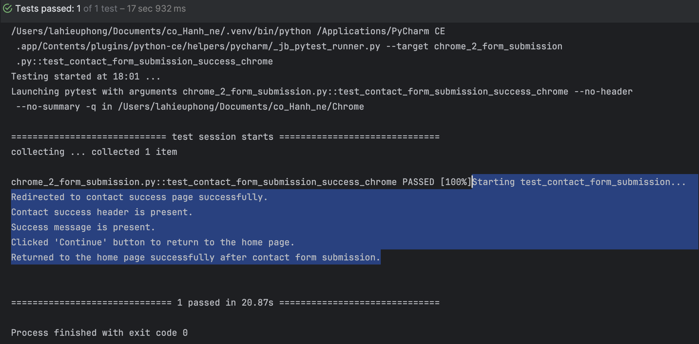

test_contact_form_submission_failure_chrome

TC ID | Description | Steps | Expected Result | Actual Results | Status
TC_007 | Verify that the contact form is successfully submitted and the user is redirected to the success page in Chrome browser. | 1. Navigate to the contact page using the URL: http://localhost/demo/index.php?route=information/contact&language=en-gb.  2. Fill out the contact form with a valid name, email, and enquiry message.  3. Scroll to the submit button and ensure it is in view.  4. Click the submit button to submit the form.  5. Verify that the user is redirected to the contact success page.  6. Verify that the success page displays the correct success header and message.  7. Click the 'Continue' button to return to the home page.  8. Verify that the user is redirected back to the home page. | 1. The contact form page loads successfully.  2. The contact form is filled out with the correct details.  3. The submit button is clicked.  4. The user is redirected to the contact success page.  5. The success header "Contact Us" and success message are displayed.  6. Clicking 'Continue' returns the user to the home page.  7. The user is redirected to the home page successfully. | The contact form is successfully submitted, and the user is redirected to the success page. The success message is displayed, and the user is returned to the home page. | Pass
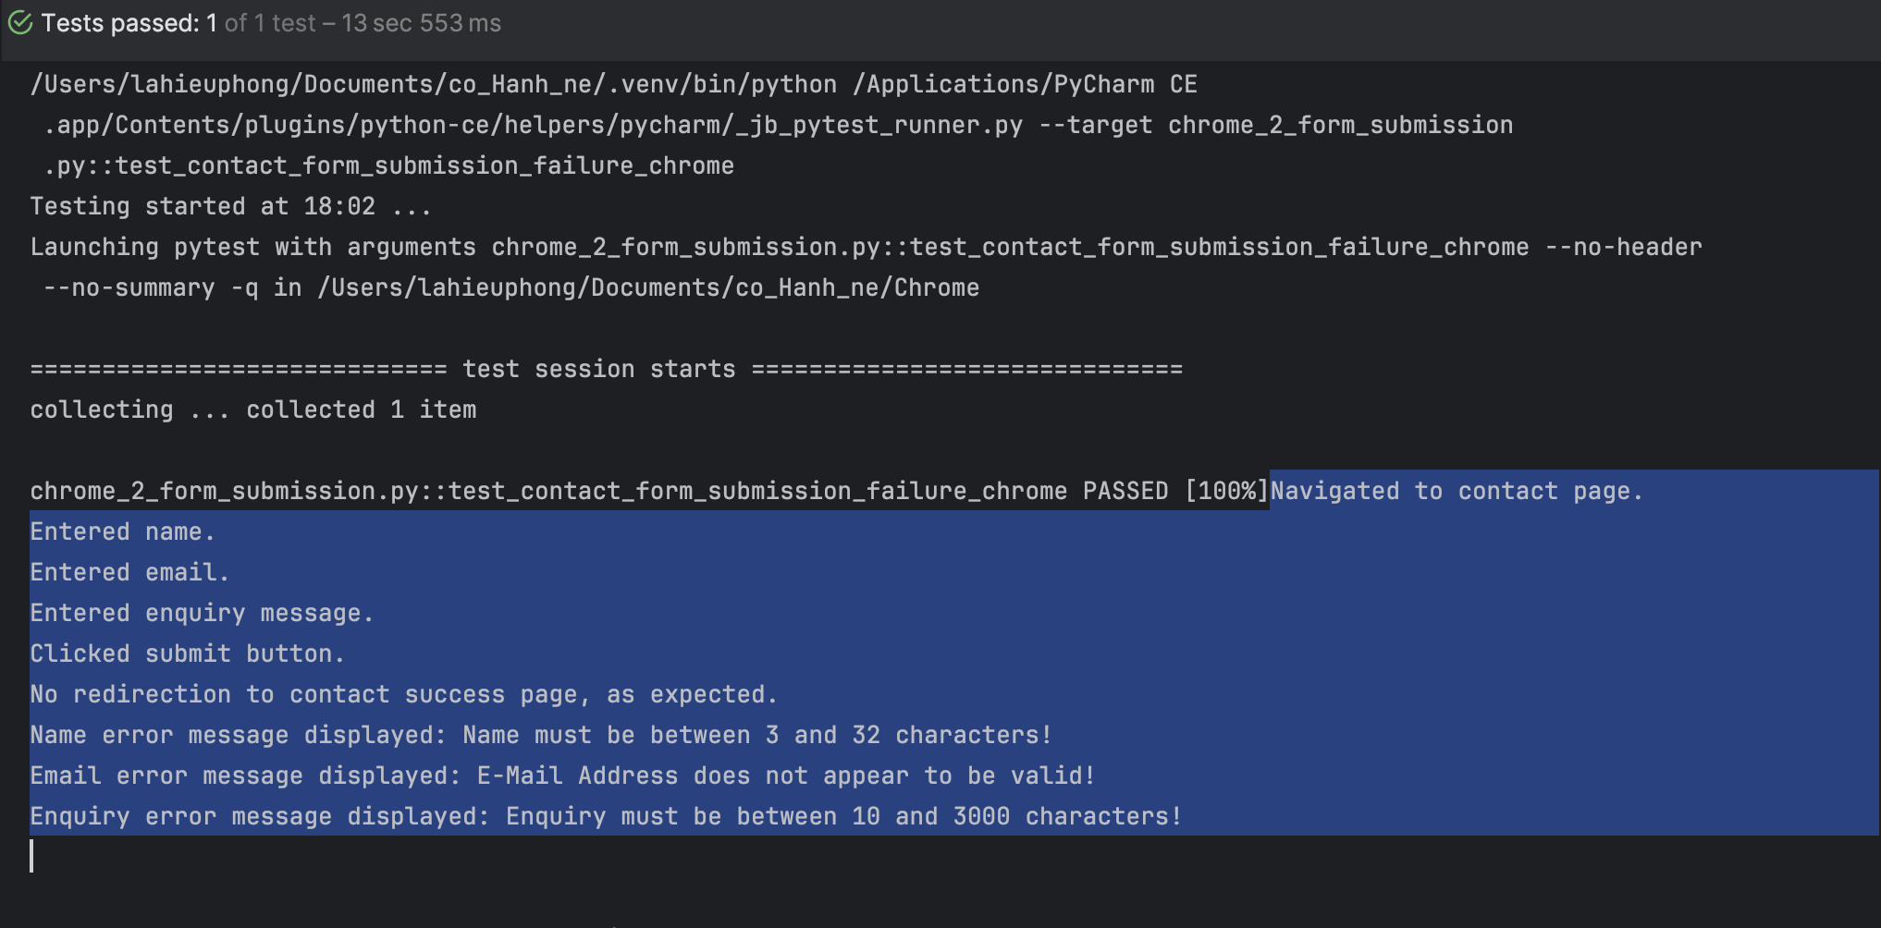

test_submission_of_contact_form_with_special_characters_in_message

TC ID | Description | Steps | Expected Result | Actual Results | Status
TC_008 | Verify that the contact form can be submitted successfully with special characters in the message field and the user is redirected to the success page. | 1. Navigate to the contact page using the URL: http://localhost/demo/index.php?route=information/contact&language=en-gb.  2. Fill out the contact form with a valid name, email, and special characters in the message.  3. Ensure the submit button is in view by scrolling.  4. Click the submit button to submit the form.  5. Verify that the user is redirected to the contact success page.  6. Verify that the success page displays the correct success header and message.  7. Click the 'Continue' button to return to the home page.  8. Verify that the user is redirected back to the home page. | 1. The contact form page loads successfully.  2. The contact form is filled out with the correct details, including special characters.  3. The submit button is clicked.  4. The user is redirected to the contact success page.  5. The success header "Contact Us" and success message are displayed.  6. Clicking 'Continue' returns the user to the home page.  7. The user is redirected to the home page successfully. | The contact form is successfully submitted with special characters, and the user is redirected to the success page. The success message is displayed, and the user is returned to the home page. | Fail

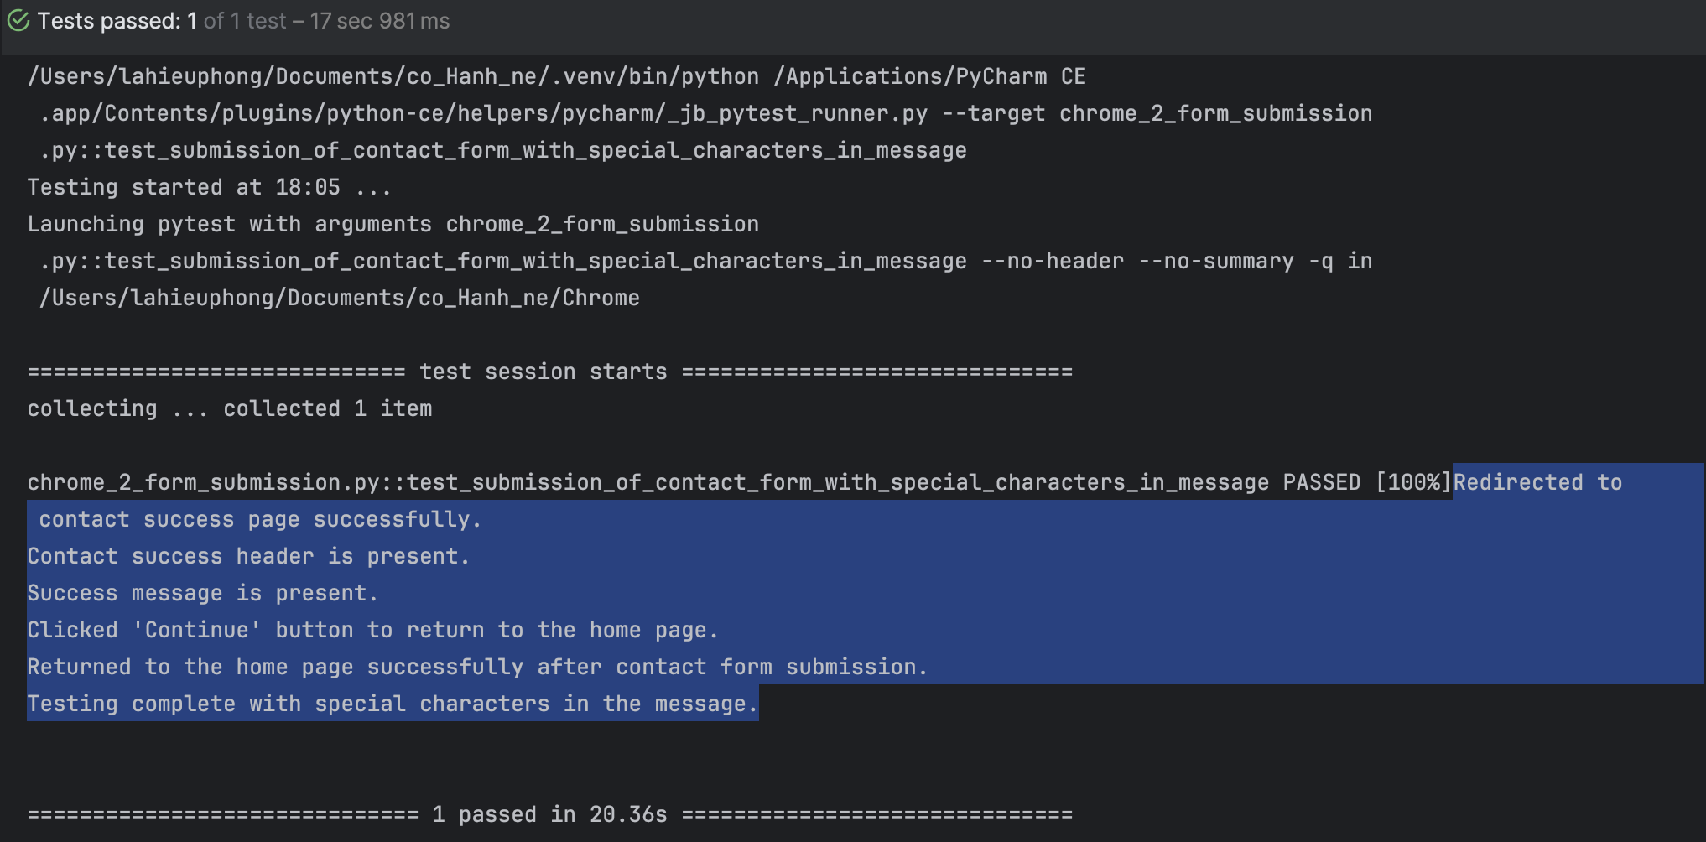

Actual behavior:There is no restriction on special characters in the Enquiry field, and the form can be submitted with only special characters (e.g., <>!@#$%^&).

Access the Contact Us page at http://localhost/demo/index.php?route=information/contact&language=en-gb, enter the corresponding data fields:
Your Name: La Hieu Phong
E-Mail Address: hieuphong144@gmail.com
Enquiry: <>!@#$%^&
and click the “Submit” button.

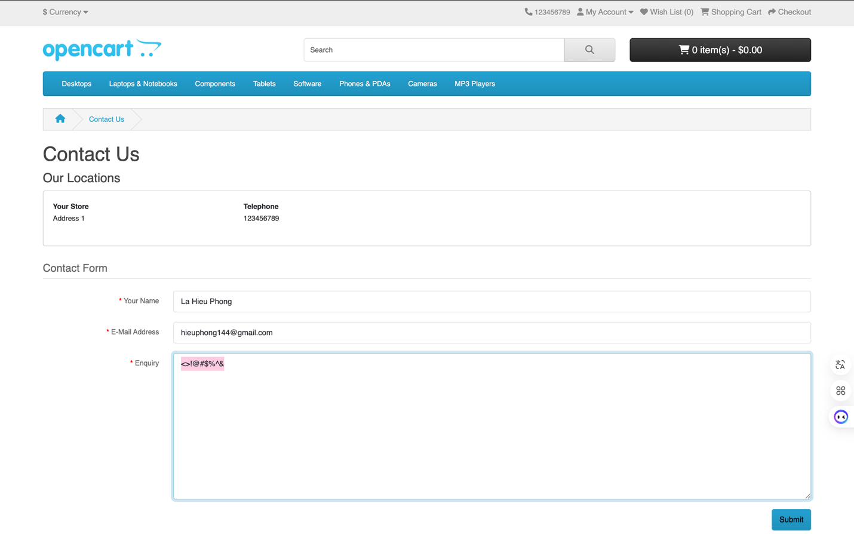

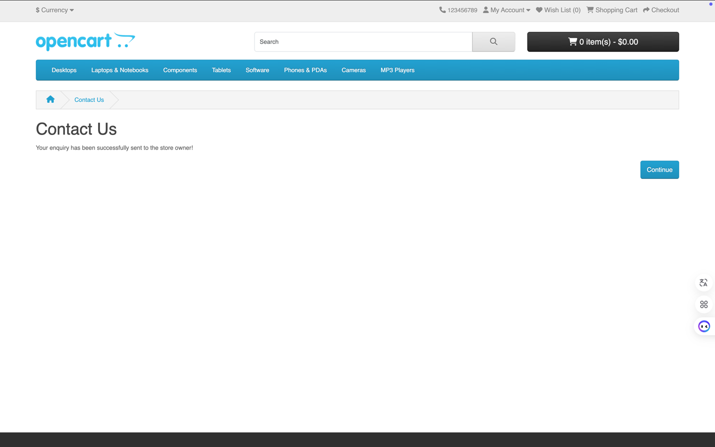

Remarks: This issue indicates that the system does not validate or sanitize the input properly for the Enquiry field, allowing special characters to be submitted without any restrictions. This could lead to potential security vulnerabilities such as SQL injection or cross-site scripting (XSS).

Suggested improvements:
Implement input validation for the Enquiry field to restrict special characters or sanitize the input before submission.
Use regular expressions or other validation methods to ensure that the input meets the required format.
Implement error handling or a warning message when invalid characters are detected in the Enquiry field.

test_contact_form_submission_with_special_characters_in_email

TC ID | Description | Steps | Expected Result | Actual Results | Status
TC_009 | Verify that submitting the contact form with an invalid email containing special characters triggers the appropriate error message. | 1. Navigate to the contact form page using the URL: http://localhost/demo/index.php?route=information/contact&language=en-gb.  2. Enter a valid name in the "Name" field.  3. Enter an invalid email address with special characters (@@@gmail.com) in the "Email" field.  4. Enter a valid message in the "Enquiry" field.  5. Scroll to the submit button and click it.  6. Verify that the user is not redirected to the success page due to invalid email.  7. Check if the error message for the email field is displayed correctly, with the expected error text. | 1. The form is loaded successfully.  2. The name, email, and enquiry fields are filled out.  3. The submit button is clicked.  4. The page should not redirect to the success page due to invalid email.  5. The error message for the email field is displayed.  6. The error message should be: "E-Mail Address does not appear to be valid!" | The form is submitted with an invalid email address. The error message is displayed correctly, and the user is not redirected to the success page. | Pass

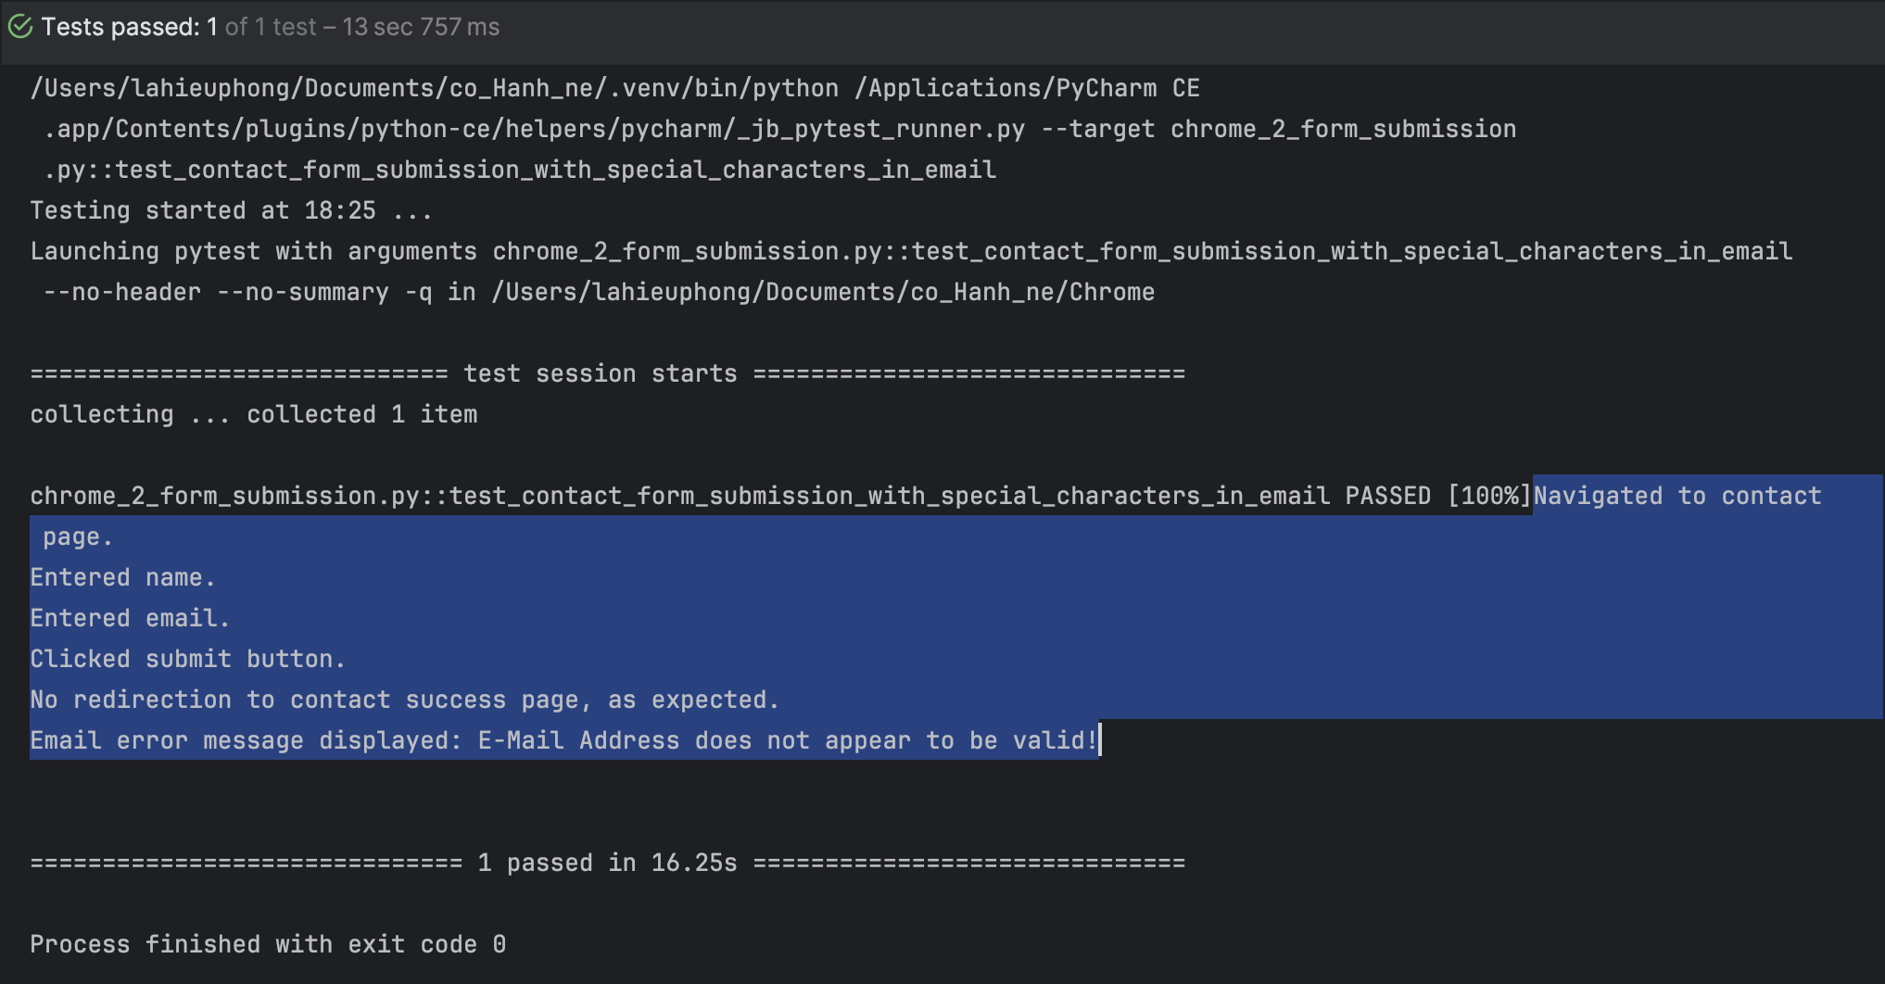

test_contact_form_submission_with_special_characters_in_name

TC ID | Description | Steps | Expected Result | Actual Results | Status
TC_010 | Verify that submitting the contact form with special characters in the name field doesn't cause errors and successfully submits the form. | 1. Navigate to the contact form page at http://localhost/demo/index.php?route=information/contact&language=en-gb.  2. Enter special characters in the "Name" field, such as < >!@#$%^&*.  3. Enter a valid email address in the "Email" field (hieuphong144@gmail.com).  4. Enter a valid enquiry message in the "Enquiry" field.  5. Scroll down to the submit button and click it.  6. Verify the page redirects to the success page after form submission.  7. Verify the success message appears and the user is redirected to the home page. | 1. The form is loaded successfully.  2. The name, email, and enquiry fields are filled out with special characters in the name.  3. The submit button is clicked.  4. The page is redirected to the success page.  5. The success message is displayed: "Your enquiry has been successfully sent to the store owner!"  6. The user is redirected to the home page after submission. | The form is submitted with special characters in the name, and the success page is displayed correctly. The user is redirected to the home page after submission. | Fail

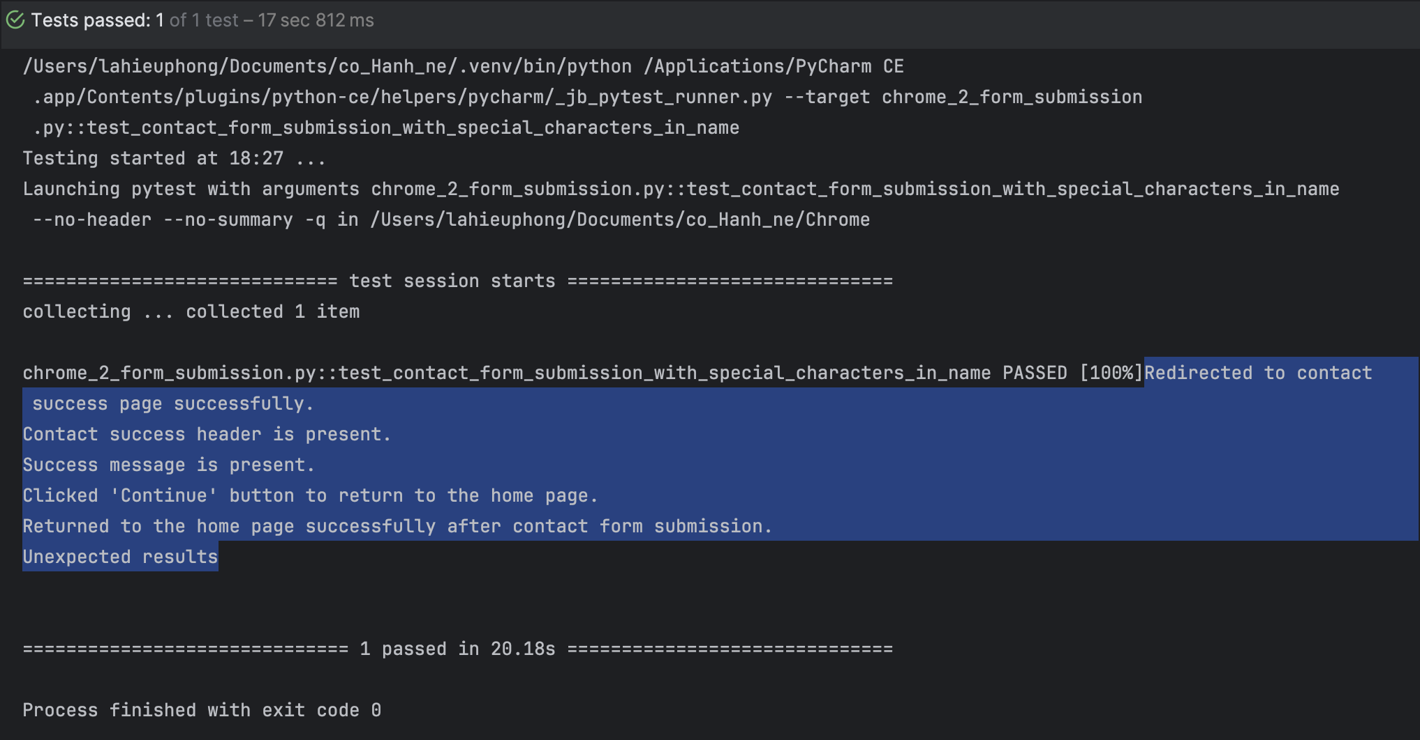

Actual behavior: There is no restriction on special characters in the Your Name field, and the form can be submitted with only special characters (e.g., < >!@#$%^&*).

Access the Contact Us page at http://localhost/demo/index.php?route=information/contact&language=en-gb, enter the corresponding data fields:
Your Name: < >!@#$%^&*
E-Mail Address: hieuphong144@gmail.com
Enquiry:
Hello,
My name is La Hieu Phong, and I am very interested in your store's products.
I have a few questions regarding your shipping policies and warranty. I would greatly appreciate it if you could provide me with more detailed information.
Thank you very much!"

and click the “Submit” button.

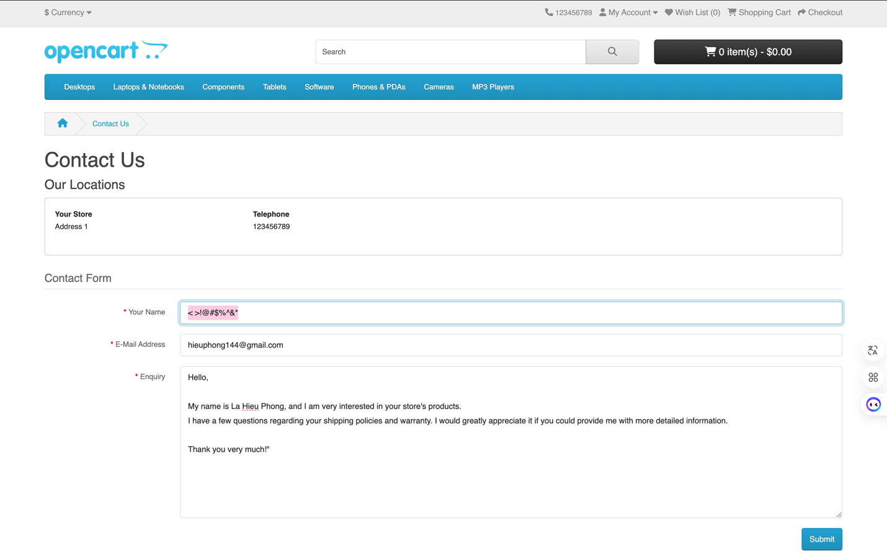

Remarks: This issue indicates that the system does not validate or sanitize the input properly for the Your Name field, allowing special characters to be submitted without any restrictions. This could lead to potential security vulnerabilities such as SQL injection or cross-site scripting (XSS).

Suggested improvements:
Implement input validation for the Your Name field to restrict special characters or sanitize the input before submission.
Use regular expressions or other validation methods to ensure that the input meets the required format.
Implement error handling or a warning message when invalid characters are detected in the Your Name field.

Navigation
chrome_3_navigation.py

test_navigate_to_random_product_detail_chrome

TC ID | Description | Steps | Expected Result | Actual Results | Status
TC_011 | Test navigating to a random product detail page from the homepage by clicking on one of the products and verifying the URL. | 1. Navigate to the homepage at http://localhost/demo/index.php?route=common/home&language=en-gb.  2. Wait for the homepage to load.  3. Define a list of product selectors (iPhone, MacBook, Apple Cinema, Canon EOS 5D).  4. Randomly select one of the products.  5. Scroll to the selected product.  6. Click on the selected product.  7. Verify that the URL is correct for the selected product. | 1. Successfully navigate to the homepage.  2. A random product is selected and clicked.  3. The product detail page is loaded correctly.  4. The URL matches one of the expected product detail URLs. | The test selects a random product, navigates to the product detail page, and confirms that the correct URL is loaded. | Pass

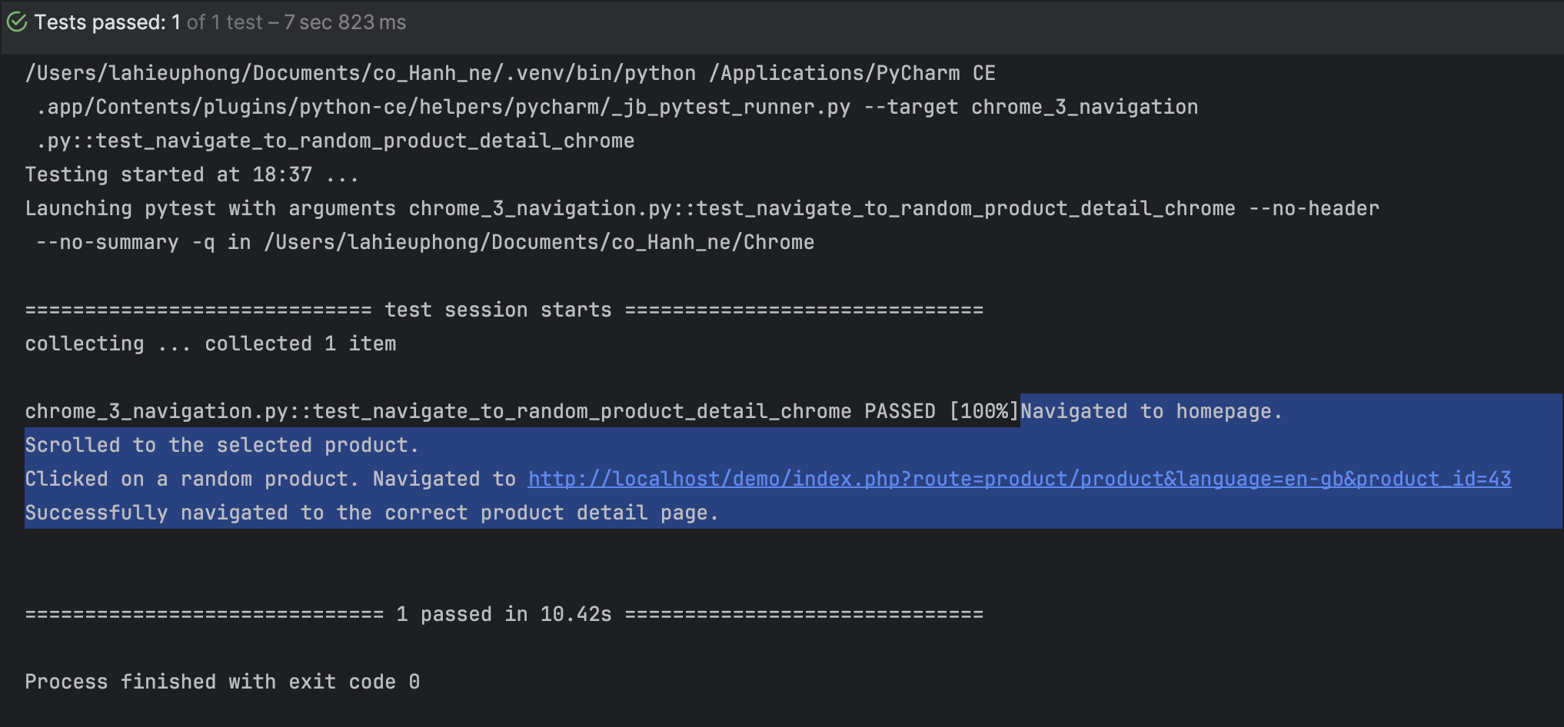

test_navigate_to_empty_cart_chrome

TC ID | Description | Steps | Expected Result | Actual Results | Status
TC_012 | Test navigating to the cart page with an empty cart and verifying the cart details, including empty cart message and item count. | 1. Navigate to the homepage at http://localhost/demo/index.php?route=common/home&language=en-gb.  2. Wait for the homepage to load.  3. Click the shopping cart icon.  4. Verify that the page navigates to the cart page.  5. Verify that the cart page displays "Your shopping cart is empty!".  6. Verify that the cart button shows 0 items and $0.00.  7. Verify the dropdown message when clicking the cart button. | 1. The homepage loads successfully.  2. Clicking the shopping cart icon navigates to the cart page.  3. The cart page shows the "Your shopping cart is empty!" message.  4. The cart button correctly displays "0 item(s) - $0.00".  5. The dropdown message correctly states "Your shopping cart is empty!". | The test navigates to the cart, verifies that the cart is empty, and confirms that the button and dropdown message display the correct empty cart information. | Pass

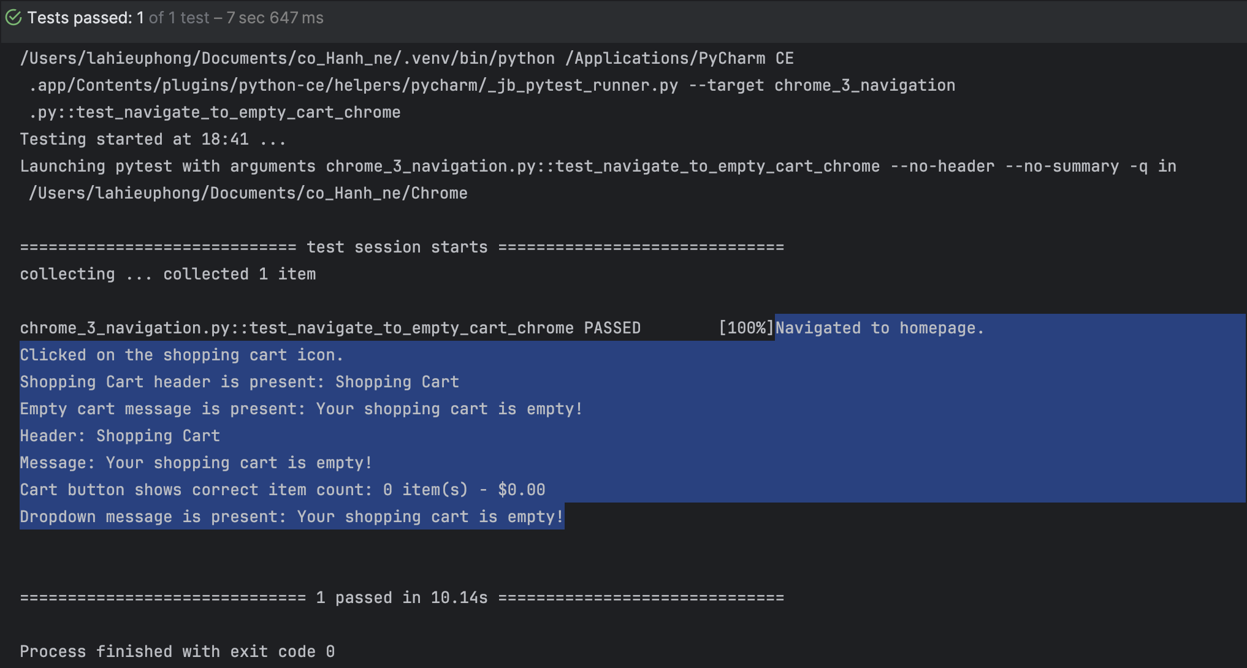

test_navigate_to_shopping_cart

TC ID | Description | Steps | Expected Result | Actual Results | Status
TC_013 | Test navigating to the shopping cart after adding random products to the cart, then viewing and proceeding to checkout. | 1. Add a random quantity of products (iPhone, MacBook, Canon EOS 5D) to the cart.  2. Click on the shopping cart icon to view the cart.  3. Click the "View Cart" option.  4. Verify the user is redirected to the shopping cart page.  5. Verify the presence of the shopping cart header.  6. Scroll to the checkout button and click it to proceed to the checkout page. | 1. The products are successfully added to the cart with random quantities.  2. Clicking on the cart icon redirects to the cart page.  3. The shopping cart page loads with the header "Shopping Cart".  4. Clicking the checkout button redirects to the checkout page. | The products are added to the cart, and the user is successfully redirected to the shopping cart page with the correct header and checkout button. | Pass

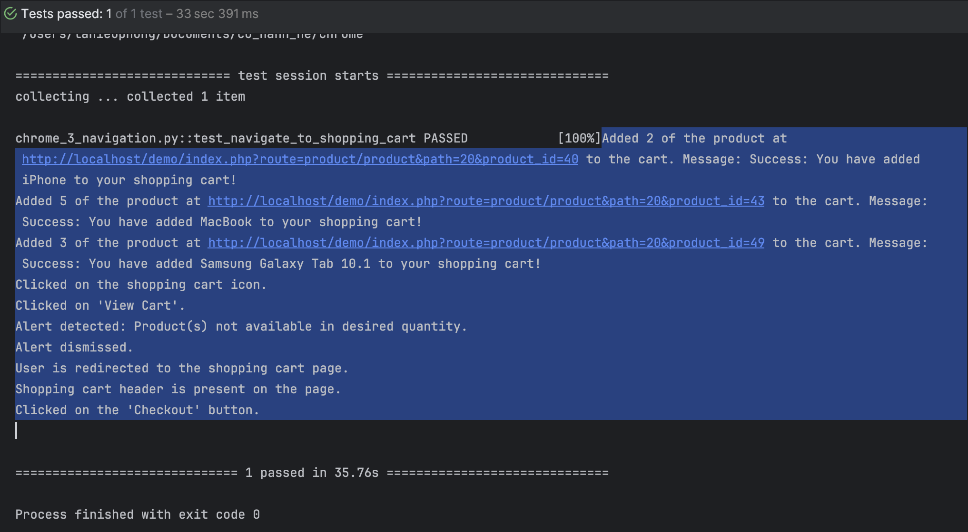

test_navigate_to_checkout

TC ID | Description | Steps | Expected Result | Actual Results | Status
TC_014 | Test navigating from a product page (Canon EOS 5D) to the checkout page by selecting a random color, quantity, and proceeding to checkout. | 1. Navigate to the product page for Canon EOS 5D.  2. Randomly select a color (Red or Blue) from the dropdown.  3. Select a random quantity (between 1 and 5).  4. Click the "Add to Cart" button.  5. Verify success message after adding the product to the cart.  6. Scroll to the top and click the "Checkout" button.  7. Verify the user is redirected to the checkout page. | 1. The product is successfully added to the cart with a selected color and quantity.  2. A success message confirming the addition of the product is shown.  3. The user is redirected to the checkout page after clicking the "Checkout" button. | The color and quantity are selected successfully. The "Add to Cart" button functions correctly, and the user is redirected to the checkout page after confirming the product in the cart. | Pass

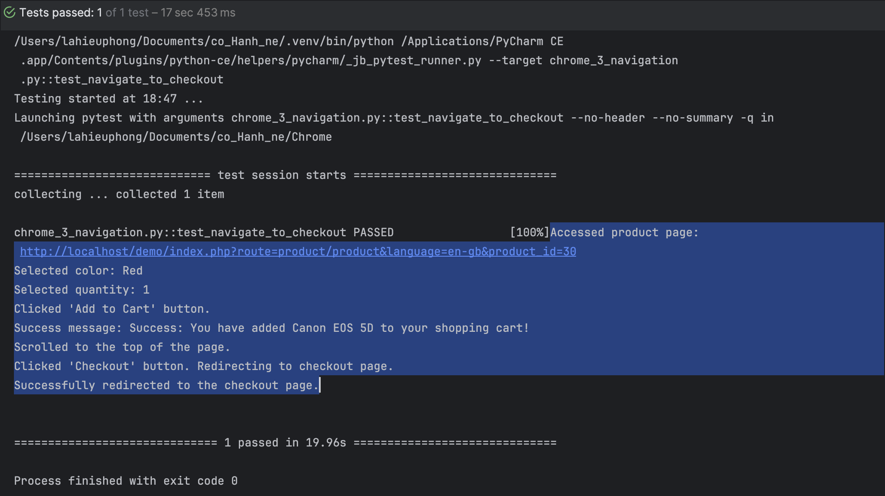

test_navigate_to_sitemap_page

TC ID | Description | Steps | Expected Result | Actual Results | Status
TC_015 | Verify Navigation to Sitemap Page | 1. Navigate to homepage http://localhost/demo/index.php?route=common/home&language=en-gb.  2. Scroll down to the bottom of the page.  3. Find and click the "Site Map" link.  4. Verify URL change.  5. Verify page title contains "Site Map".  6. Optionally scroll halfway down. | 1. Homepage should load.  2. Page should scroll to the bottom.  3. "Site Map" link should be clickable and navigated.  4. URL should change to the sitemap page.  5. Page title should contain "Site Map".  6. Page should scroll halfway down. | Homepage loaded.  Page scrolled to the bottom.  "Site Map" link clicked.  URL changed to sitemap page.  Title contains "Site Map".  Page scrolled halfway down. | Pass

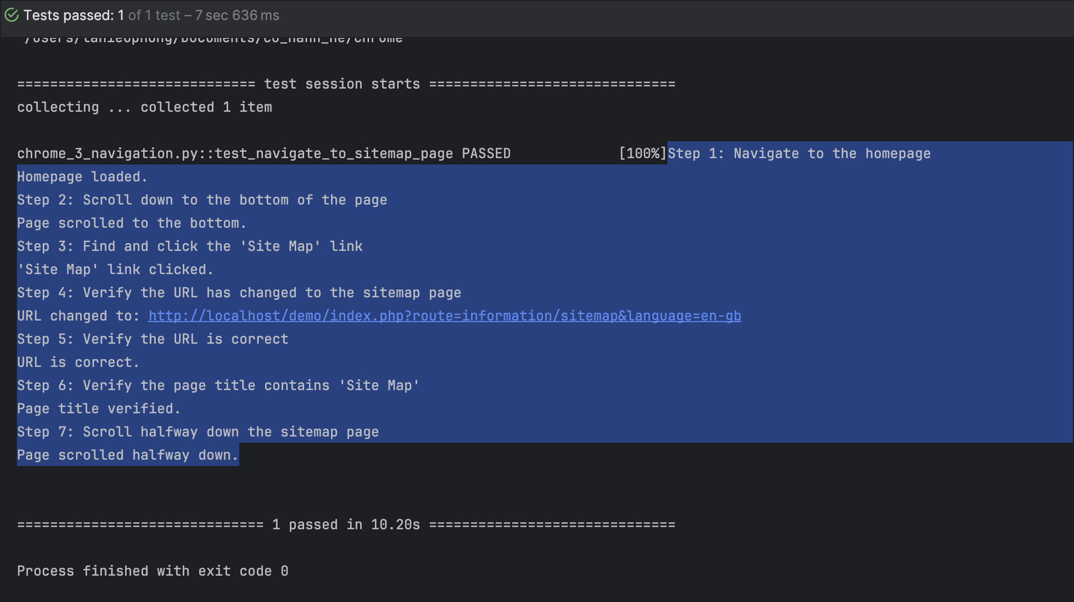

Data Validation
chrome_4_data_validation.py

test_dashboard_product_info

TC ID | Description | Steps | Expected Result | Actual Results | Status
TC_016 | Verify Dashboard Product Info and Recent Activity | 1. Navigate to the dashboard page http://localhost/demo/admin/index.php?route=common/dashboard&user_token=....  2. Close the alert popup (if it exists).  3. Login with admin credentials.  4. Close modal (if it exists).  5. Scroll to the bottom of the page.  6. Check Recent Activity.  7. Verify Latest Orders. | 1. Dashboard page should load.  2. Alert should close (if present).  3. Login should be successful, redirected to the dashboard.  4. Modal should close (if present).  5. Page should scroll to the bottom.  6. Recent Activity should be displayed with no results or valid activity.  7. Latest Orders should display valid order data. | Dashboard loaded.  Alert closed.  Logged in successfully and redirected to the dashboard.  Modal closed.  Page scrolled to the bottom.  Recent Activity: Data found.  Order details printed. | Pass

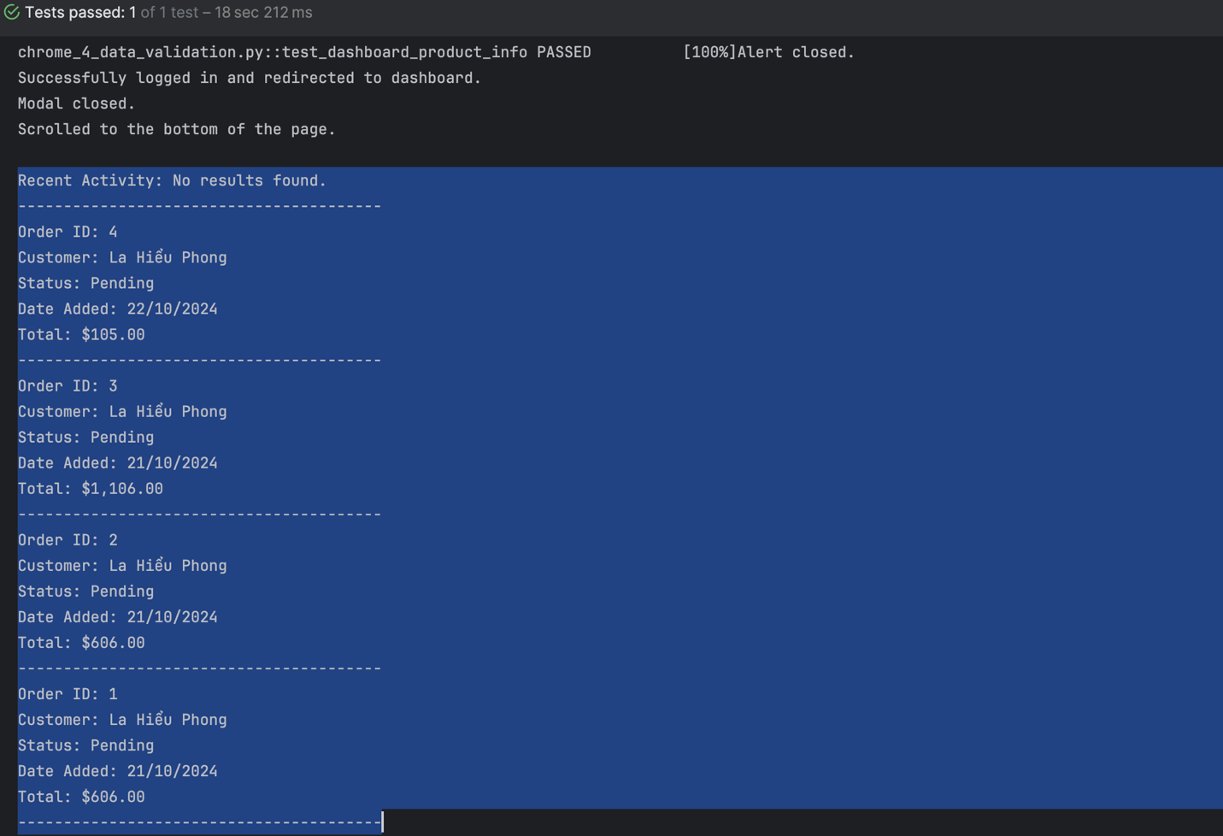

test_compare_product_info

TC ID | Description | Steps | Expected Result | Actual Results | Status
TC_017 | Verify Product Information Comparison Between Product Page and Shopping Cart | 1. Navigate to the product details page.  2. Retrieve product information (name, price, brand, code, availability).  3. Add a random quantity of the product to the cart.  4. Navigate to the cart page.  5. Print product details.  6. Compare product details between the product page and cart.  7. Verify cart total. | 1. Product details (name, price, etc.) should be correctly retrieved.  2. Product should be added to the cart with the selected quantity.  3. Cart page should show the correct item details.  4. Product information should match between the product page and the cart.  5. Cart total should be displayed correctly. | Product information retrieved.  Item added to the cart.  Product details printed.  Comparison results shown.  Cart total verified. | Pass

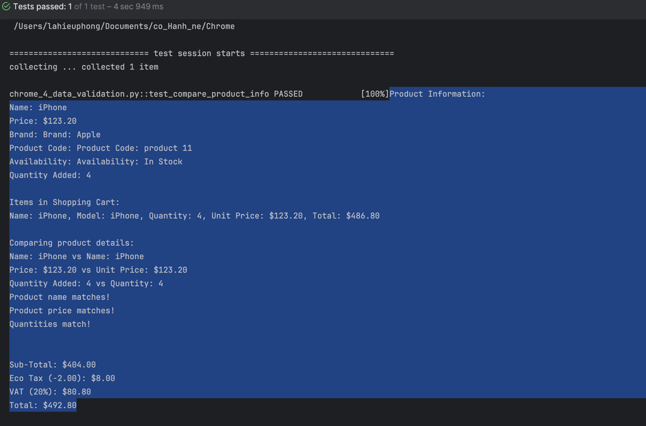

Error Handling
chrome_5_error_handing

test_contact_us_invalid_fields

TC ID | Description | Steps | Expected Result | Actual Results | Status
TC_018 | Verify Validation for Invalid Fields in "Contact Us" Form | 1. Navigate to the "Contact Us" page.  2. Scroll halfway down the page.  3. Fill in the "Name" field with an invalid value.  4. Fill in the "Email" field with an invalid value.  5. Fill in the "Enquiry" field with an invalid value.  6. Click the "Submit" button.  7. Check for error messages for each field. | 1. The page should load successfully.  2. Scrolling should work as expected.  3. Invalid data should trigger error messages for each field (Name, Email, Enquiry).  4. The error messages should be correctly displayed and match the expected text. | Page loaded successfully.  Scrolling halfway completed.  Errors displayed for Name, Email, and Enquiry fields.  Correct error messages shown. | Pass

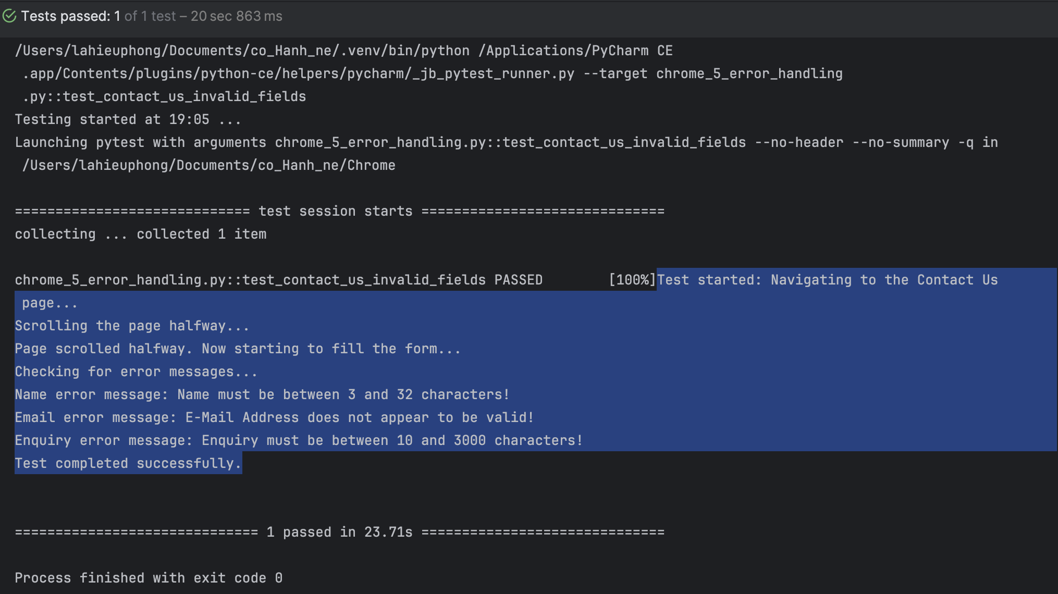

test_registration_invalid_fields

TC ID | Description | Steps | Expected Result | Actual Results | Status
TC_019 | Verify Validation for Invalid Fields in Registration Form | 1. Navigate to the "Registration" page.  2. Scroll halfway down the page.  3. Fill in the "First Name" field with an invalid value (too long).  4. Fill in the "Last Name" field with an invalid value (too long).  5. Fill in the "Email" field with an invalid email.  6. Fill in the "Password" field with an invalid password (too short).  7. Check the "Newsletter" and "Agree to terms" checkboxes.  8. Submit the form.  9. Check for error messages for each field.messages for each field. | 1. The page should load successfully.  2. Scrolling should work as expected.  3. Error messages should be displayed for each invalid field:  - First Name: "First Name must be between 1 and 32 characters!"  - Last Name: "Last Name must be between 1 and 32 characters!"  - Email: "E-Mail Address does not appear to be valid!"  - Password: "Password must be between 4 and 20 characters!"  4. Error messages should match the expected text for each field. | Page loaded successfully.  Scrolling halfway completed.  Errors displayed for First Name, Last Name, Email, and Password fields.  Correct error messages shown. | Pass

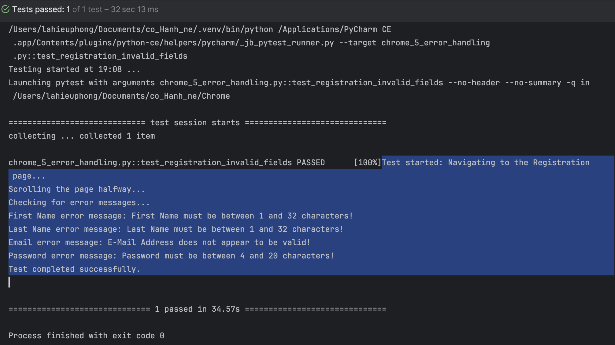

test_error_page_displayed_when_adding_product_to_cart_fails

TC ID | Description | Steps | Expected Result | Actual Results | Status
TC_020 | Verify error or failure when adding a product with an invalid quantity to the cart | 1. Navigate to the product page.  2. Enter an extremely large quantity (2147483648) into the quantity input field.  3. Click on the "Add to Cart" button.  4. Wait for a moment for the response to show up.  5. Check for a success message.  6. Verify the cart button text.  7. Check that the cart text displays the expected item count (2147483647). | 1. The product page should load successfully.  2. The quantity input should accept an extremely large value.  3. The "Add to Cart" button should be clickable.  4. No success message should be displayed (since the quantity is invalid).  5. The cart button should show the correct quantity ("2147483647 item(s)").  6. No additional errors or unexpected behavior should occur. | Product page loaded.  Quantity field set to 2147483648.  Cart button shows "2147483647 item(s)" (as expected).  No unexpected errors or behavior observed. | Fail

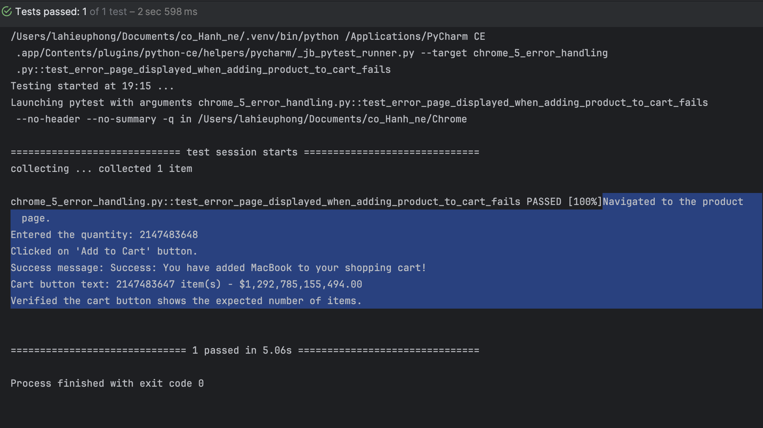

Actual Behavior: The system allows users to enter a value that exceeds the allowed limit for the "Qty" (quantity) field. Although the system automatically adjusts the quantity to the maximum limit (2147483647), it does not notify the user about this change, leading to confusion.

Navigate to the product detail page for “MacBook” at http://localhost/demo/index.php?route=product/product&language=en-gb&product_id=43.
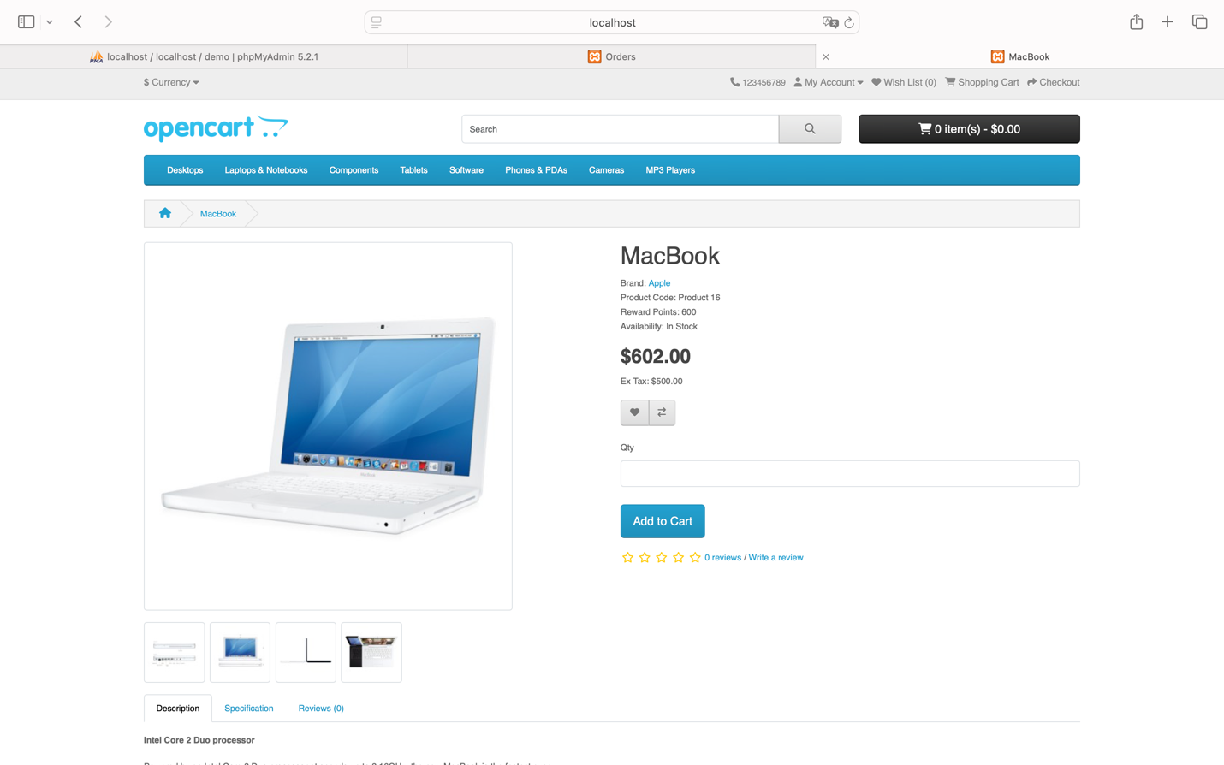
Enter the quantity as "2147483648" and click the "Add to Cart" button.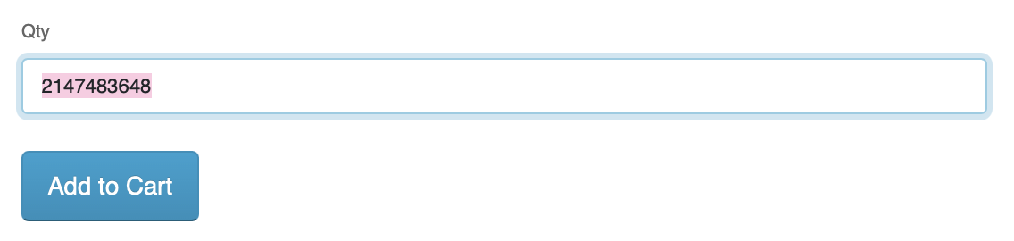
A dialog appears with the message: “Success: You have added MacBook to your shopping cart!”
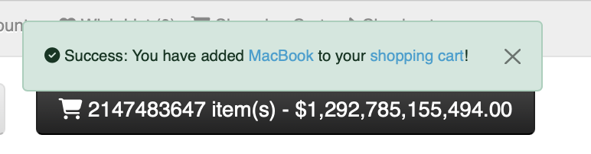
However, the cart is updated with the maximum quantity of “2147483647 item(s)” instead.
Remarks: This is a flaw related to incorrect handling of values that exceed the limits of data types. The system needs to validate input values to ensure that the product quantity does not exceed the limits that the data type can handle.

Suggested Improvements:
Handle quantity values exceeding the limit:
Limit the input value: The system should enforce a maximum limit for the product quantity, such as not allowing users to enter a quantity greater than 2147483647 (or a limit set by the system's requirements).
Display an error message when exceeding the limit: If a user enters a value exceeding the limit, the system should display a message like: “The maximum product quantity is 2147483647” and prevent the product from being added to the cart.

Improve cart interface display:
The system should immediately update the cart interface when a user enters a valid quantity and clicks “Add to Cart,” helping the user clearly understand that the product has been successfully added and the cart is updated correctly.
Notify the user about quantity adjustments: If the system adjusts the quantity automatically (due to a value exceeding the limit), it should display a message informing the user that the quantity has been changed to the maximum allowed value.
Conclusion: The system needs to restrict the product quantity input and display appropriate messages when values exceed the allowed limit.

test_error_page_displayed_when_adding_product_with_negative_quantity

TC ID | Description | Steps | Expected Result | Actual Results | Status
TC_022 | Verify error message and cart behavior when adding negative quantity with explicit wait | 1. Navigate to the product page.  2. Enter a negative quantity (-1) in the quantity input field.  3. Click on 'Add to Cart' button.  4. Wait for the error message to appear.  5. Check the cart contents.  6. Verify cart button text shows '0 item(s) - $0.00'. | 1. An error message should appear indicating an invalid quantity.  2. The cart button should display "0 item(s) - $0.00" after attempting to add a negative quantity. | 1. Error message is successfully found and displays the expected error text.  2. Cart button text correctly shows '0 item(s) - $0.00' after trying to add a negative quantity. | Fail

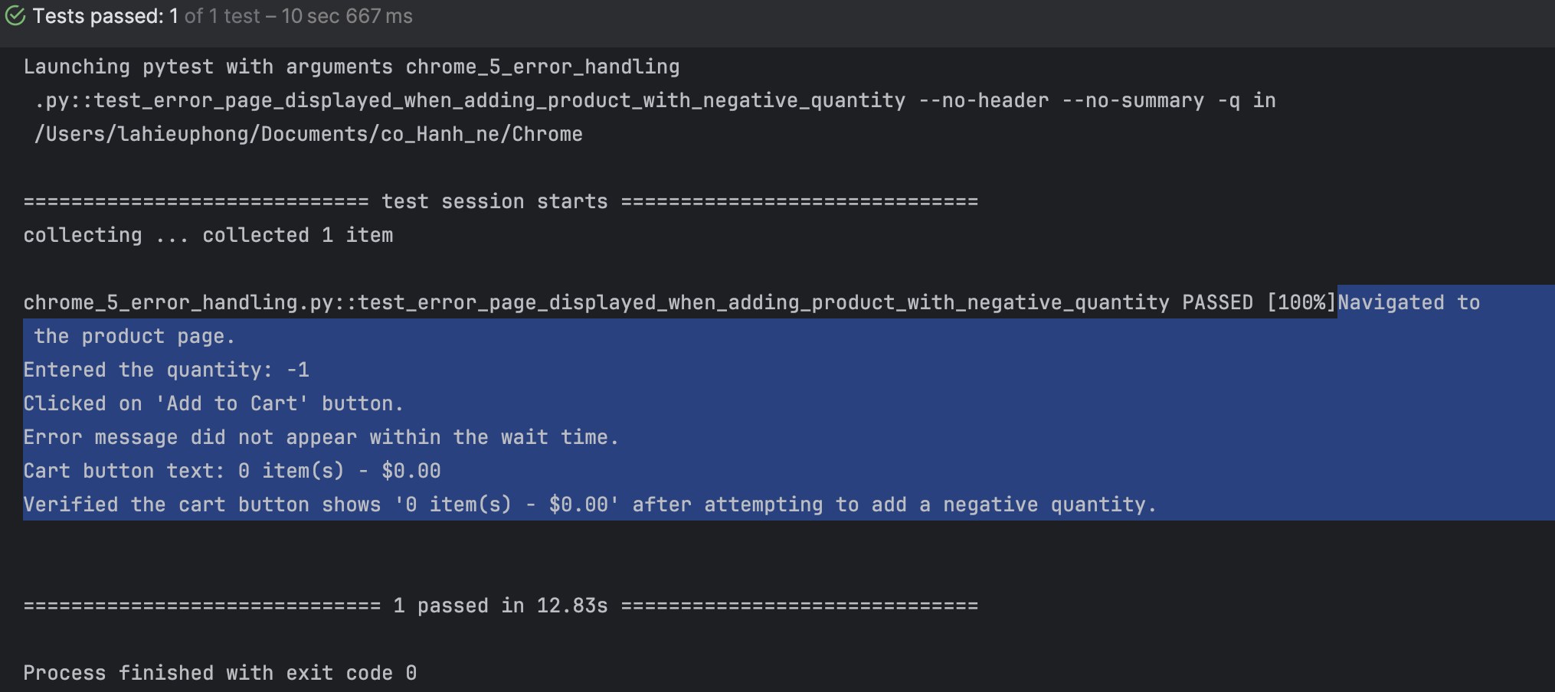

Actual Behavior:
The system allows the user to enter a negative value in the "Qty" (quantity) field and displays a success message when the product is added to the cart. However, the product is not actually added to the cart, and the cart remains empty.

Navigate to the product detail page for "MacBook" at http://localhost/demo/index.php?route=product/product&language=en-gb&product_id=43.

Enter a quantity of -1 and click the "Add to Cart" button.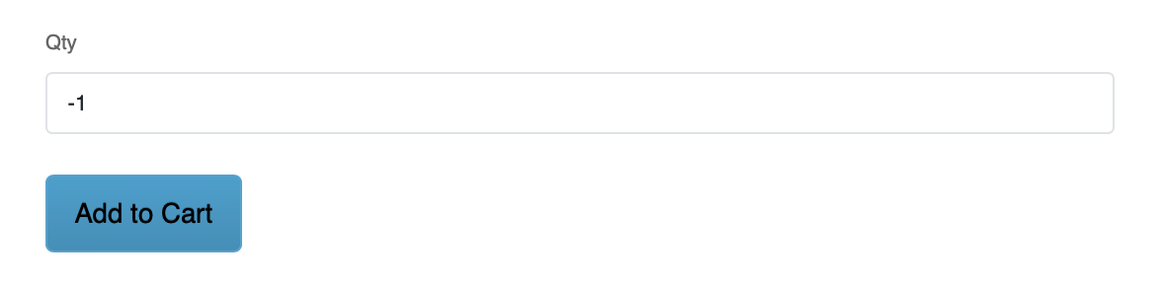
A dialog appears with the message: “Success: You have added MacBook to your shopping cart!”

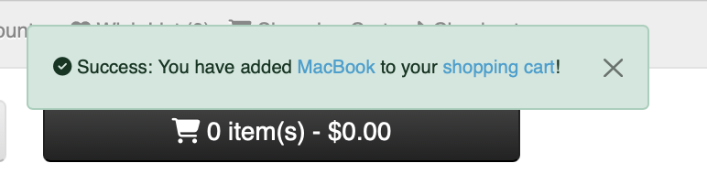
However, the cart does not update, and it still shows “0 item(s) - $0.00” (indicating that no items have been added).

Remarks: This is a critical issue because the system should not allow users to enter negative quantities. Displaying a success message without actually performing any action is misleading and causes confusion for the user. The system must validate the quantity input to prevent invalid values (e.g., negative numbers) before allowing the product to be added to the cart.

Suggested Improvements:
Input validation before adding to cart:
  - The system should validate the quantity value immediately when the user enters it in the "Qty" field. If the value is negative or zero, the system should display an error message and prevent the product from being added to the cart.
Clear error message:
  - Instead of showing a "Success" message, the system should display an error message like: “Product quantity must be a positive number greater than 0” to inform the user of the problem clearly.
Improvement to the cart interface:
  - The system should immediately update the cart interface when a valid quantity is entered and the “Add to Cart” button is clicked, so the user can clearly see that the product has been added successfully and the cart has been updated correctly.
Conclusion: The system must check for negative quantities and display an appropriate error message. It should not allow invalid quantities to be added to the cart, and users should receive clear feedback about the issue.

Search Functionality
chrome_6_search_functionality.py

test_search_macbook (random: “MacBook”)

TC ID | Description | Steps | Expected Result | Actual Results | Status
TC_023.1 | Verify search functionality for "MacBook" only | 1. Navigate to the homepage.  2. Enter "MacBook" into the search box.  3. Click the search button.  4. Verify the search results page URL.  5. Verify the heading contains "Search - MacBook".  6. Verify the presence of product listings for "MacBook".  7. Verify each product title contains "MacBook". | 1. The search should return the results for the term "MacBook".  2. The URL should be correctly formatted with the search term.  3. The heading should display "Search - MacBook".  4. The products listed should contain "MacBook" in their title. | 1. The URL correctly matches the search URL with "MacBook".  2. The heading is correct and displays "Search - MacBook".  3. At least one product appears in the results and contains "MacBook" in the title. | Pass

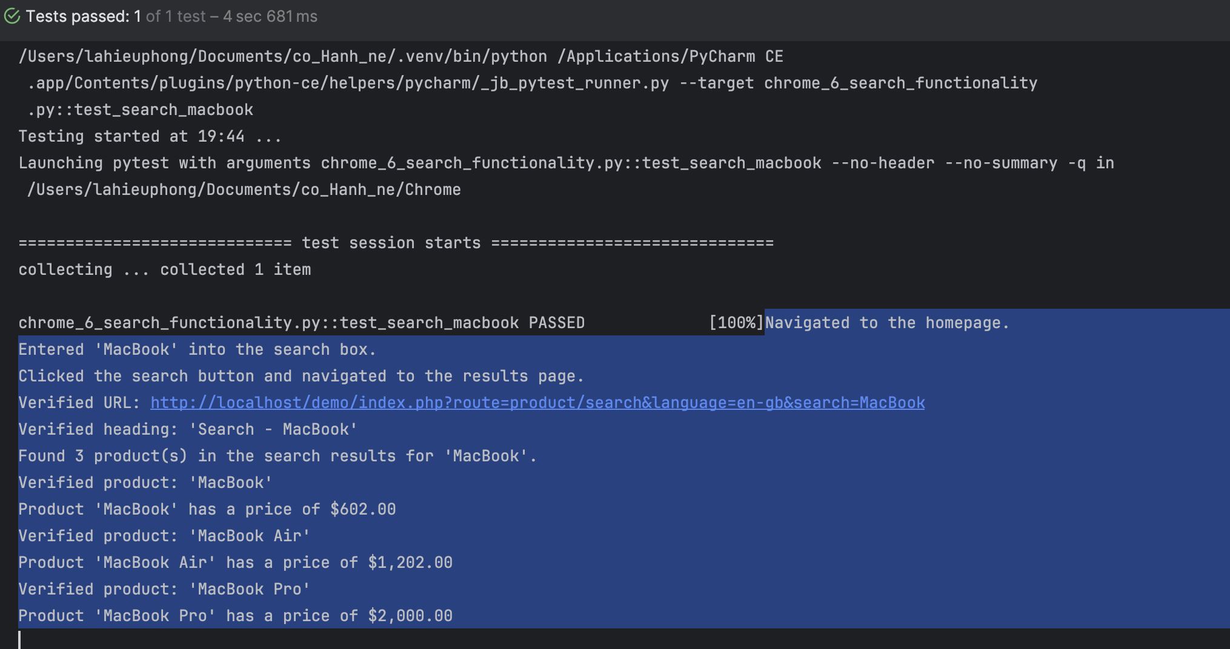

test_search_macbook (random: “macbook”)

TC ID | Description | Steps | Expected Result | Actual Results | Status
TC_023.2 | Verify search functionality for "macbook" only | 1. Navigate to the homepage.  2. Enter "macbook" into the search box.  3. Click the search button.  4. Verify the search results page URL.  5. Verify the heading contains "Search - macbook".  6. Verify the presence of product listings for " macbook".  7. Verify each product title contains " macbook". | 1. The search should return the results for the term "macbook".  2. The URL should be correctly formatted with the search term.  3. The heading should display "Search - macbook".  4. The products listed should contain "macbook" in their title. | 1. The URL correctly matches the search URL with "macbook".  2. The heading is correct and displays "Search - macbook".  3. At least one product appears in the results and contains "macbook" in the title. | Pass
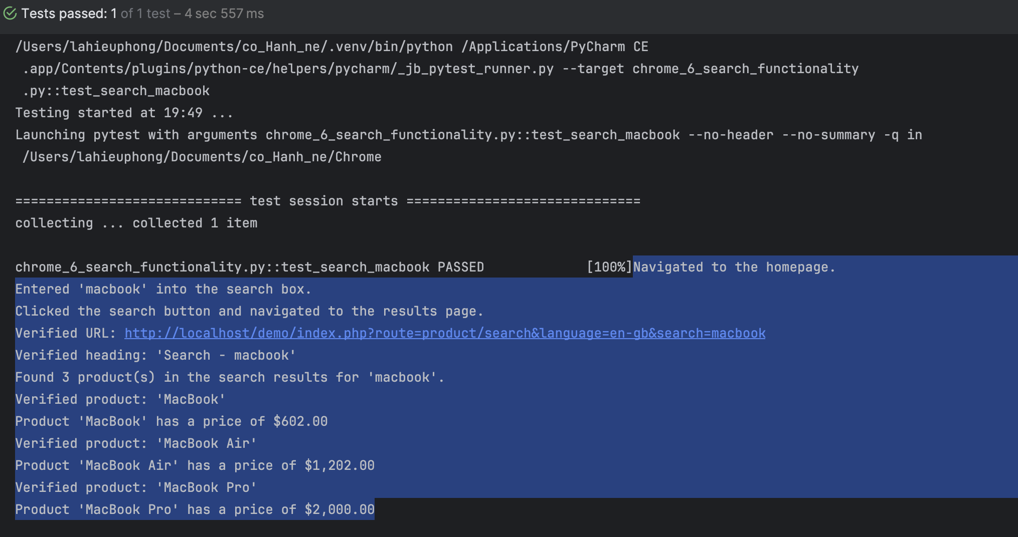

test_search_macbook_fail

TC ID | Description | Steps | Expected Result | Actual Results | Status
TC_024 | Verify search functionality with an incorrect search term (misspelled) | 1. Navigate to the homepage.  2. Enter a misspelled search term such as "MacBok" or "macbok".  3. Click the search button.  4. Verify the URL of the results page.  5. Verify the search result heading is displayed with the misspelled term.  6. Verify that a "no product matches" message is displayed. | 1. The search should return no products for the misspelled term.  2. The URL should correctly reflect the search term.  3. The heading should contain the misspelled term.  4. A "no product matches" message should be displayed. | 1. The URL contains the misspelled search term.  2. The heading shows "Search - MacBok" or "Search - macbok".  3. The "no product matches" message appears. | Pass
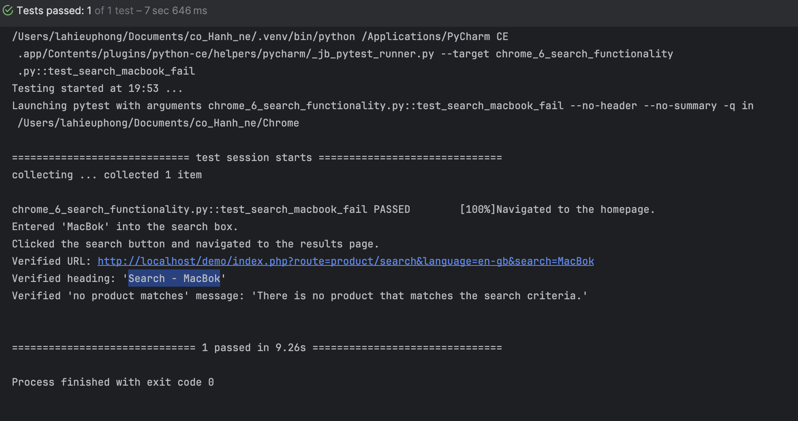
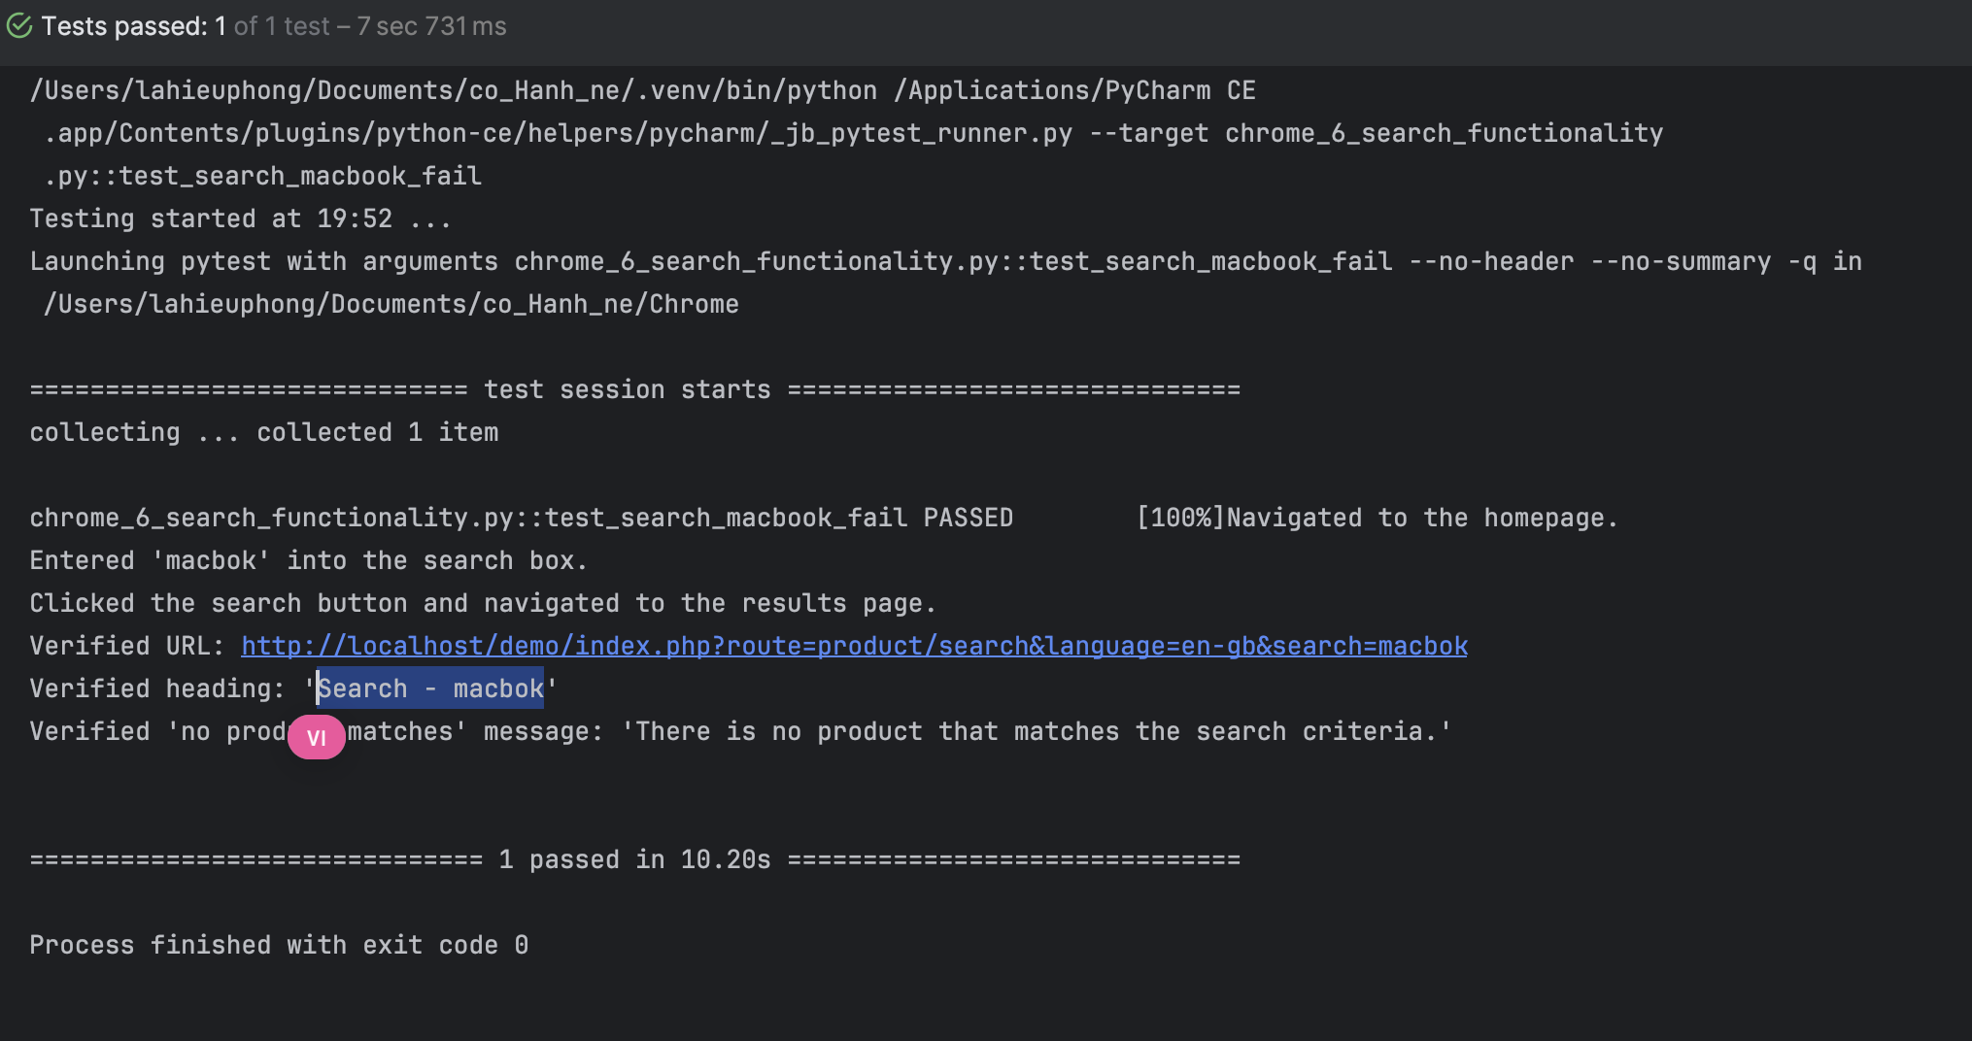

Responsive Design
chrome_7_responsive_design.py

test_open_home_page_chrome

TC ID | Description | Steps | Expected Result | Actual Results | Status
TC_025 | Verify the homepage loads correctly and elements are displayed | 1. Open the homepage URL.  2. Verify the page title is "Your Store".  3. Verify the image with alt text "Your Store" exists.  4. Verify the image source is correct.  5. Scroll down the page. | 1. The homepage should load successfully.  2. The page title should be "Your Store".  3. The image with alt text "Your Store" should be visible.  4. The image source should match the expected URL.  5. The page should scroll down smoothly. | 1. The homepage loads with title "Your Store".  2. The image with alt text "Your Store" is found.  3. The image source is correct.  4. The page scrolls down as expected. | Pass
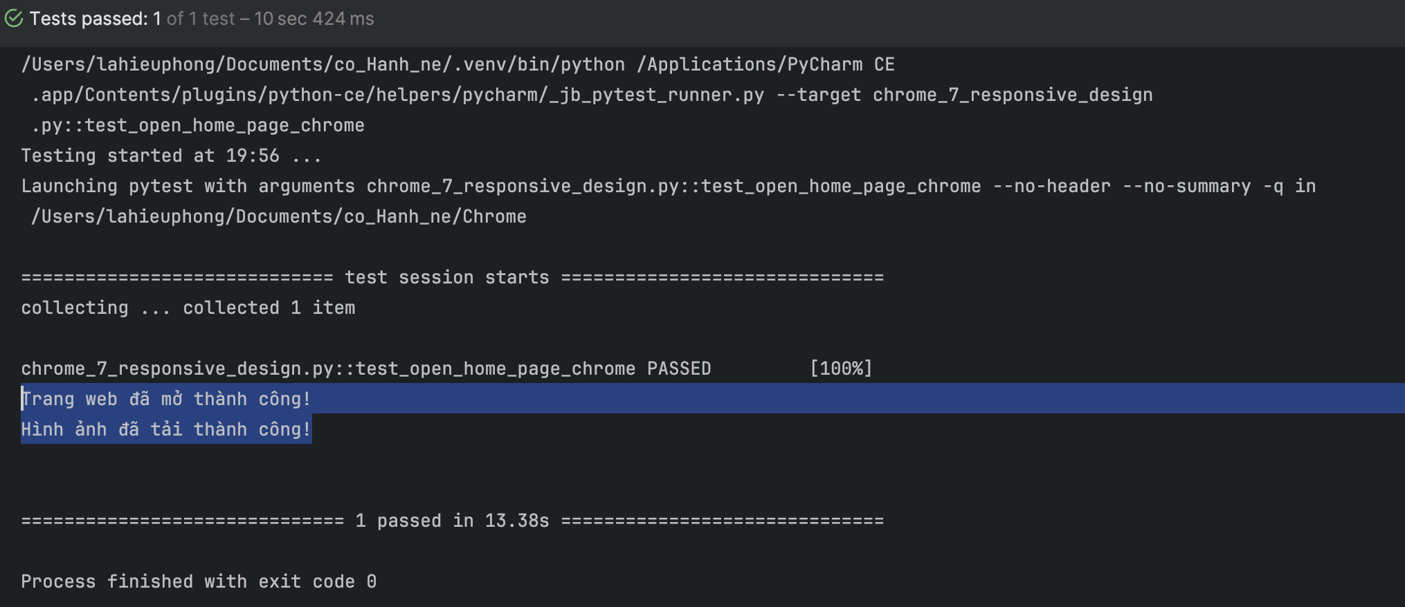

test_open_home_page_firefox

TC ID | Description | Steps | Expected Result | Actual Results | Status
TC_026 | Verify the homepage loads correctly and elements are displayed in Firefox | 1. Open the homepage URL in Firefox.  2. Wait for the image with alt="Your Store" to appear (timeout 10 seconds).  3. Check the image source.  4. Verify the page title is "Your Store".  5. Scroll down the page. | 1. The homepage should load successfully.  2. The image with alt="Your Store" should be visible.  3. The image source should match the expected URL.  4. The page title should be "Your Store".  5. The page should scroll down smoothly. | 1. The homepage loads with title "Your Store".  2. The image with alt="Your Store" appears.  3. The image source is correct.  4. The page scrolls down as expected. | Pass
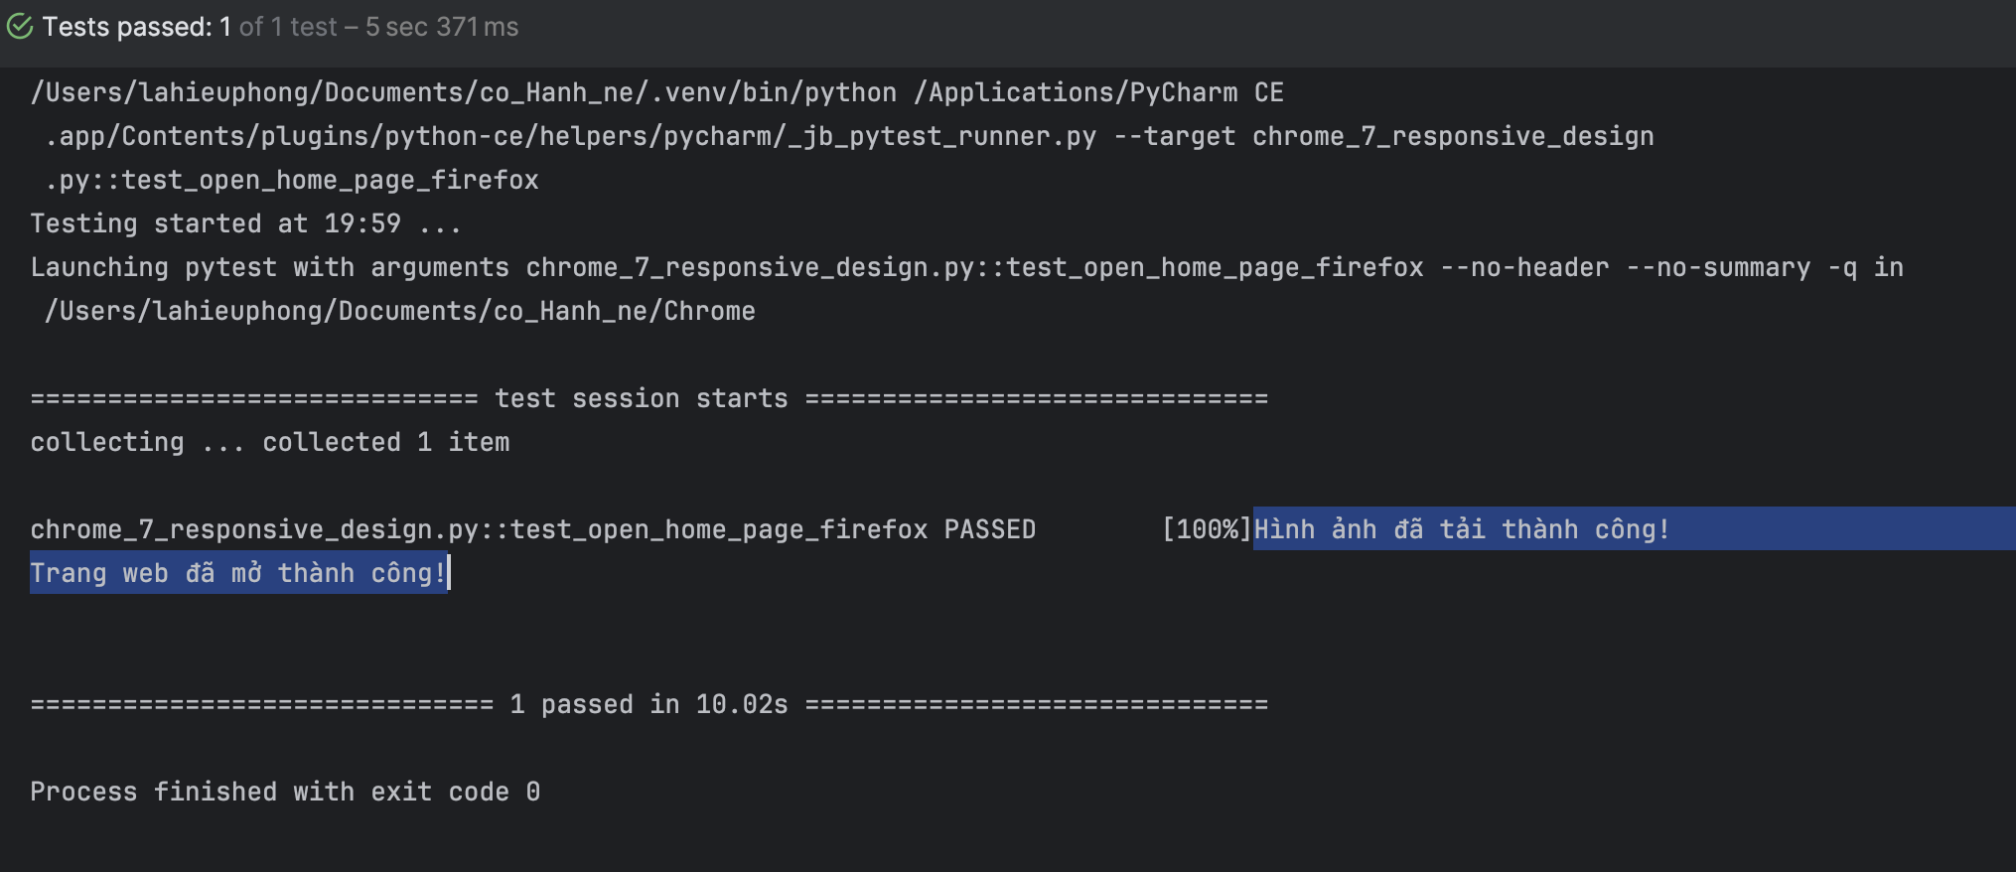

test_check_text_on_widgets

TC ID | Description | Steps | Expected Result | Actual Results | Status
TC_027 | Verify the visibility and text content of various widgets on the homepage | 1. Open the homepage URL in Chrome.  2. Scroll down the page to ensure all widgets are loaded.  3. For each widget selector (button, div, span, p, .widget-class), check if it contains text.  4. Ensure the element is displayed.  5. Print the widget text and display results. | 1. The page should load successfully.  2. For each element matching the widget selectors, the text should be visible.  3. All visible elements should be displayed. | 1. The homepage loads and scrolls to the bottom.  2. The widgets with text are identified and their text is printed.  3. Each widget with text is displayed. | Pass
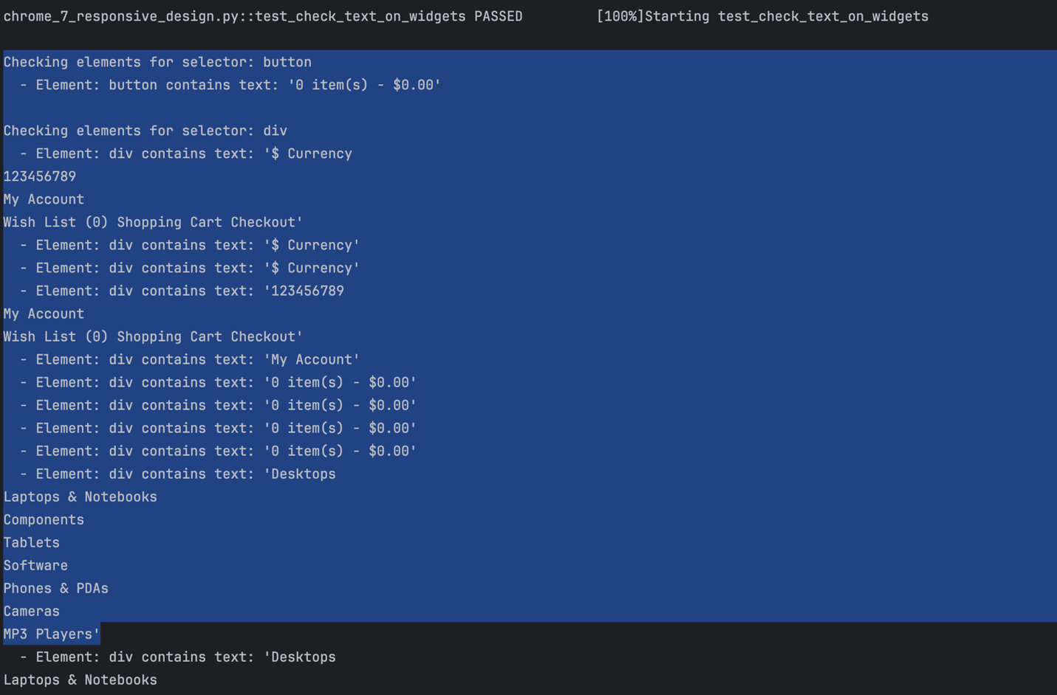
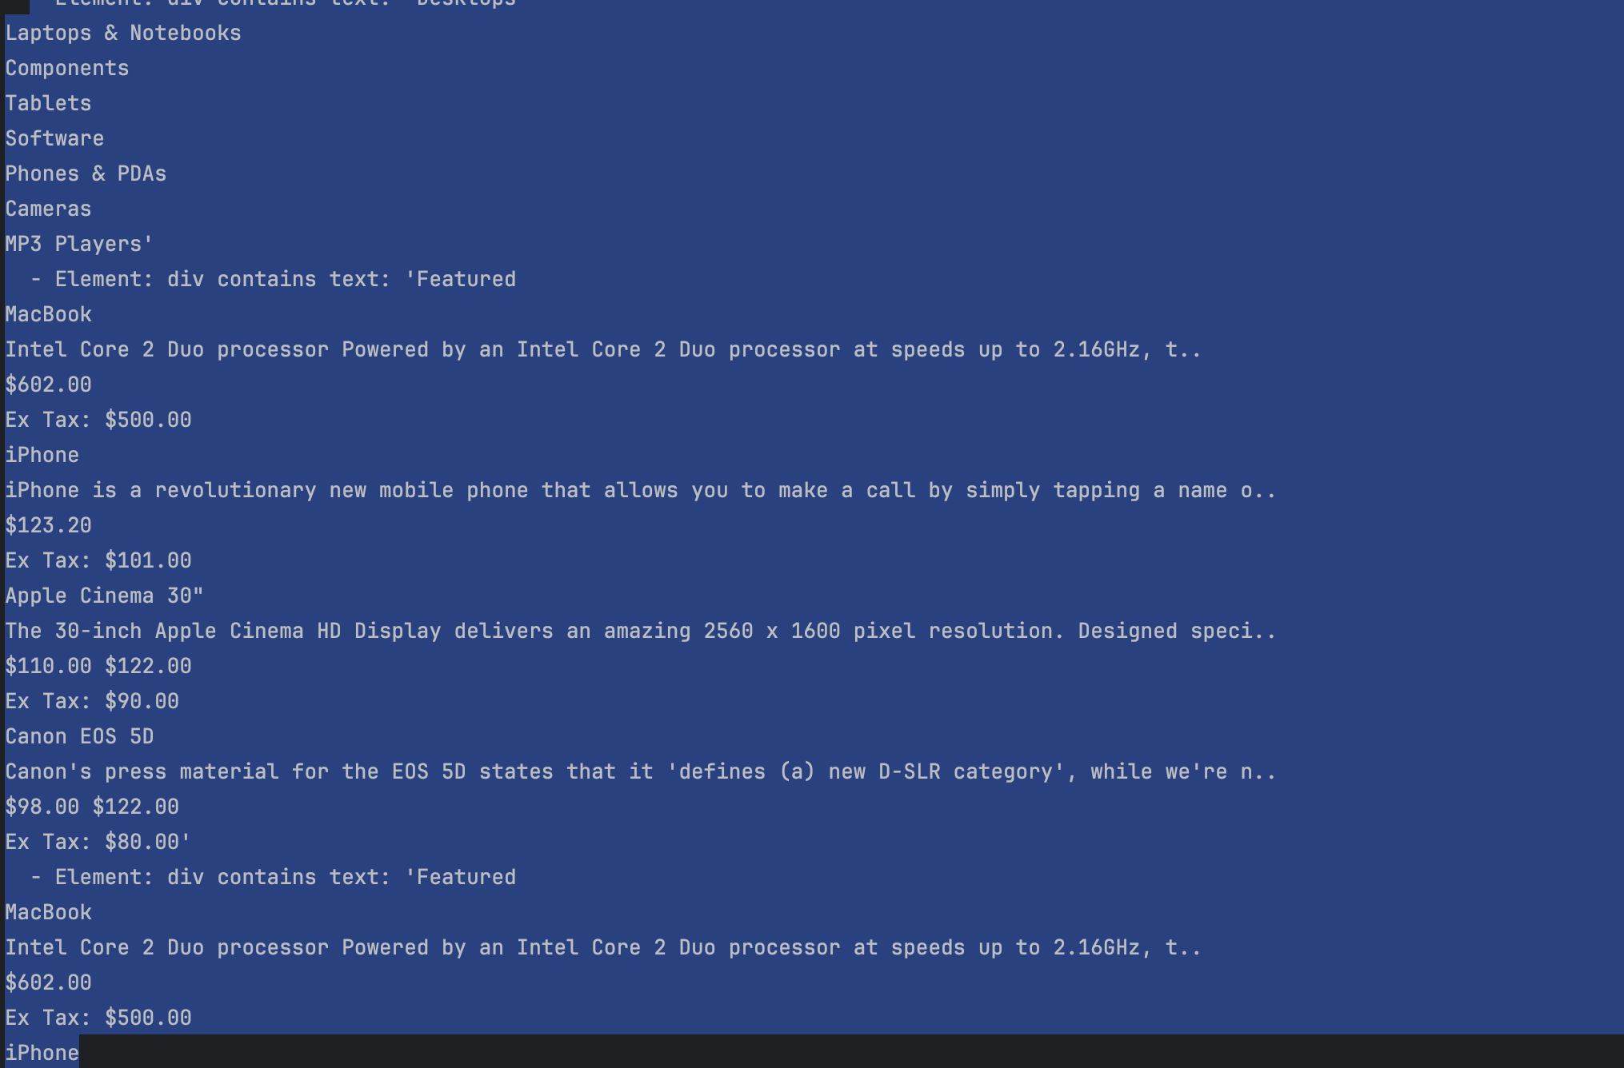
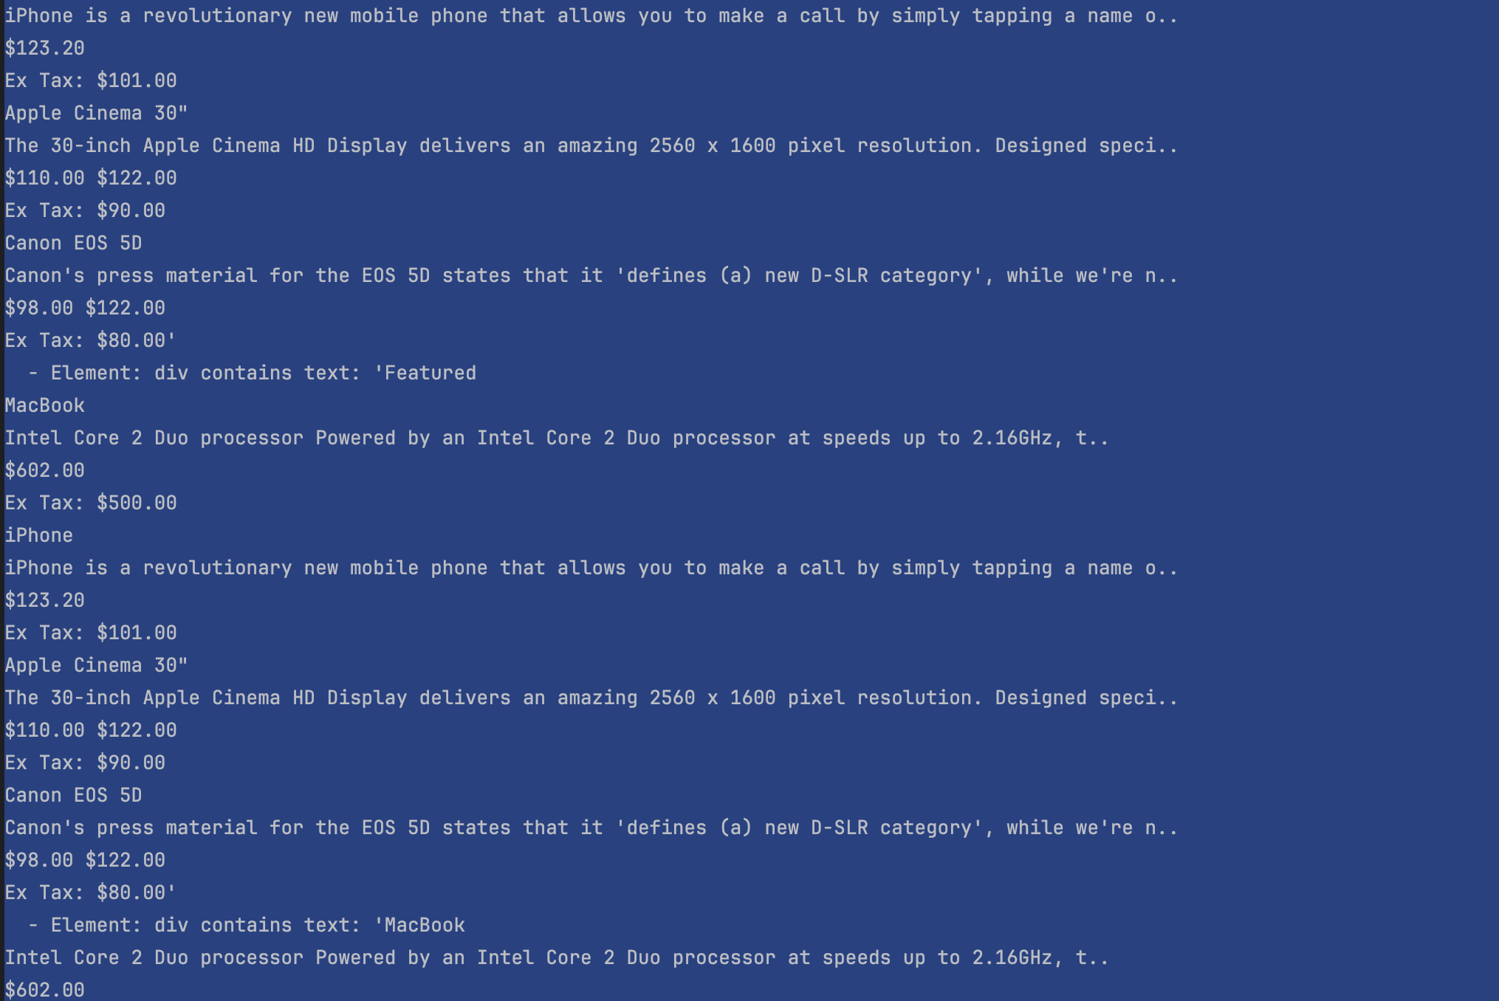
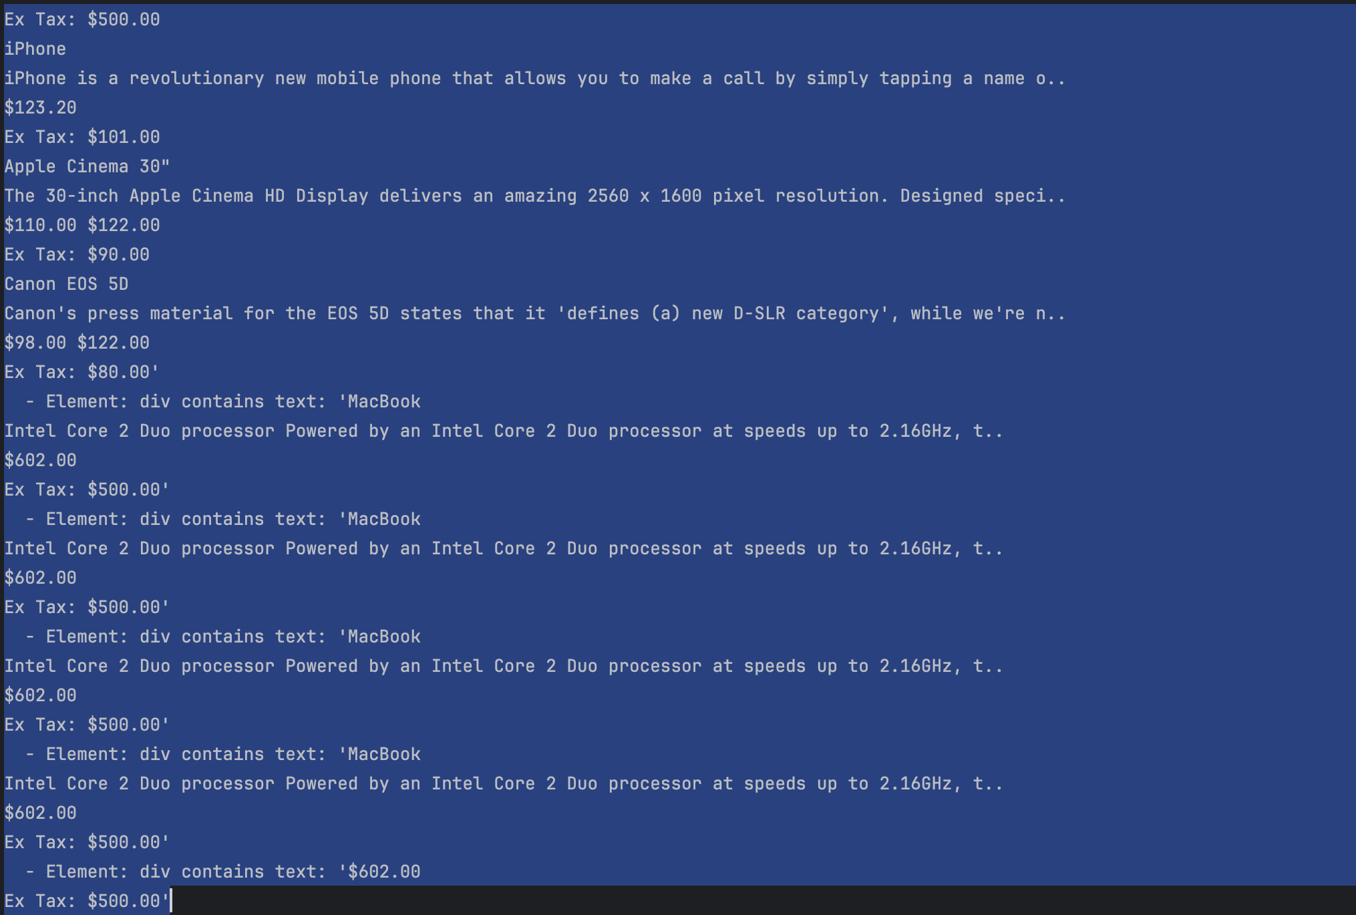
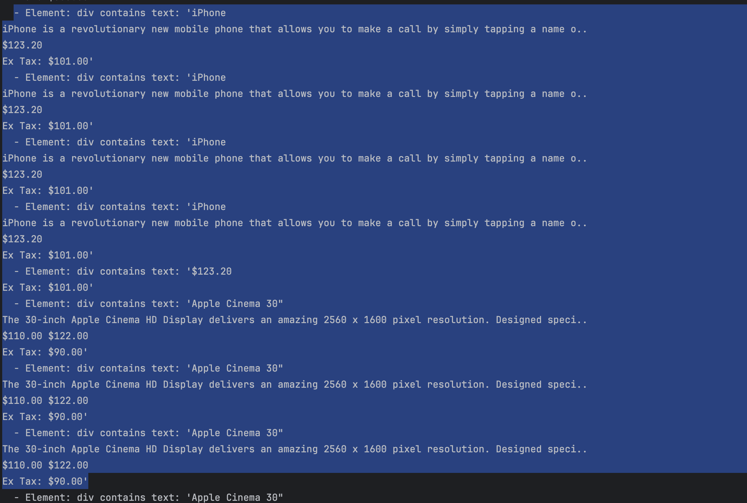
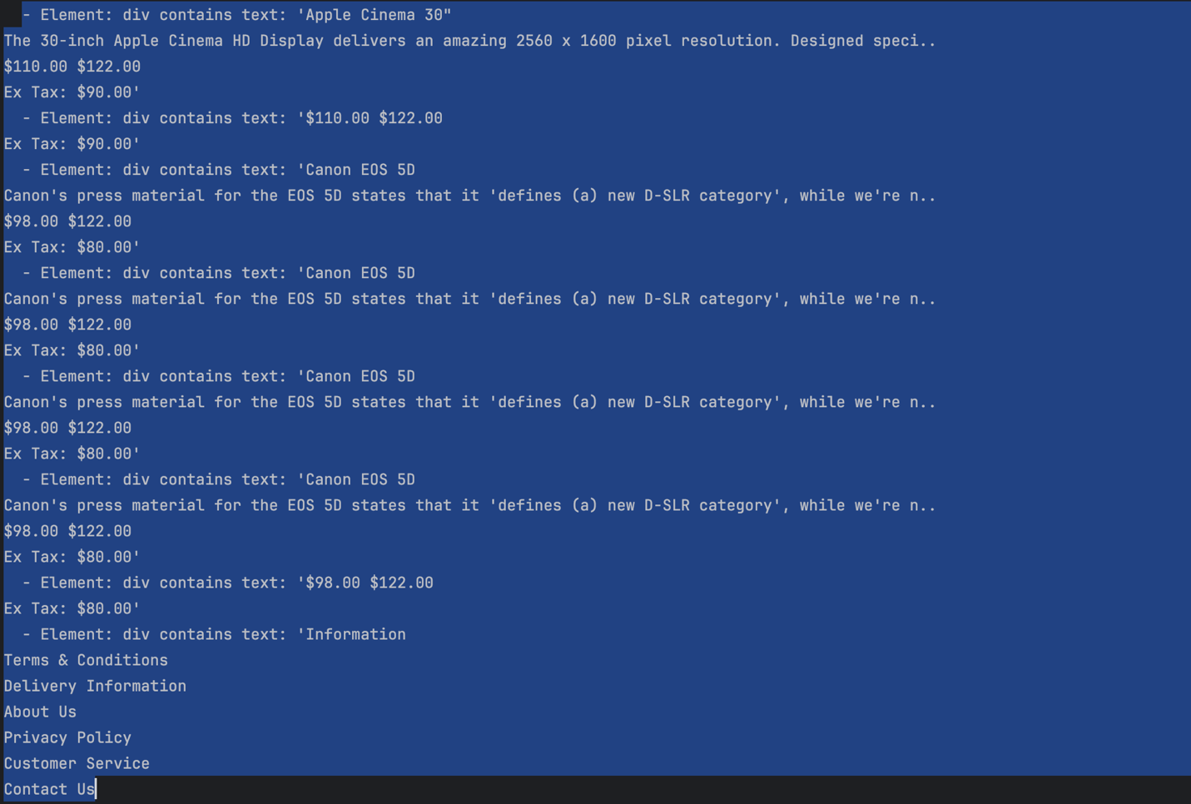
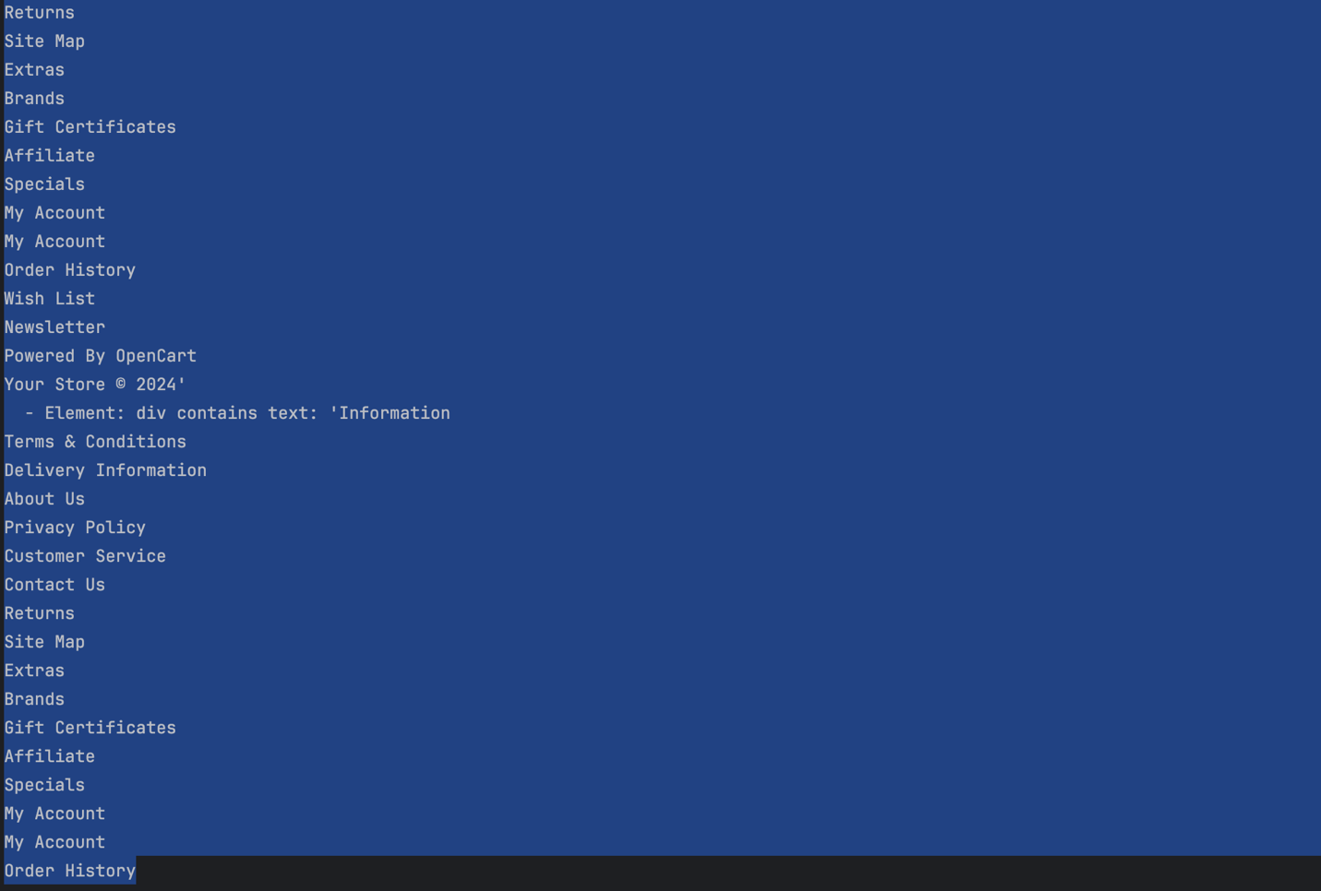
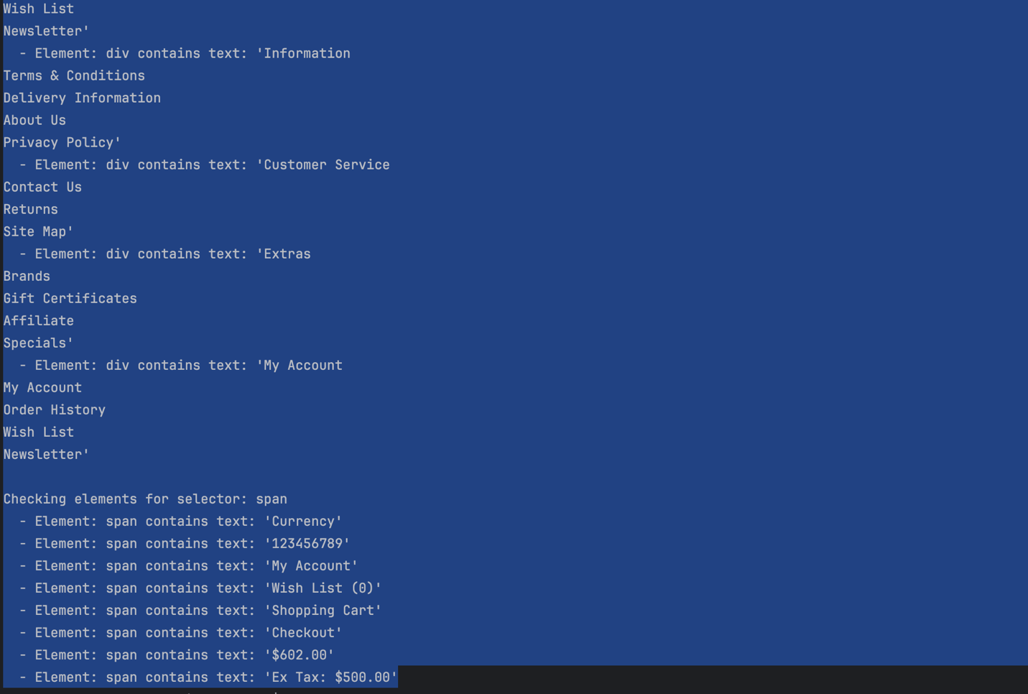
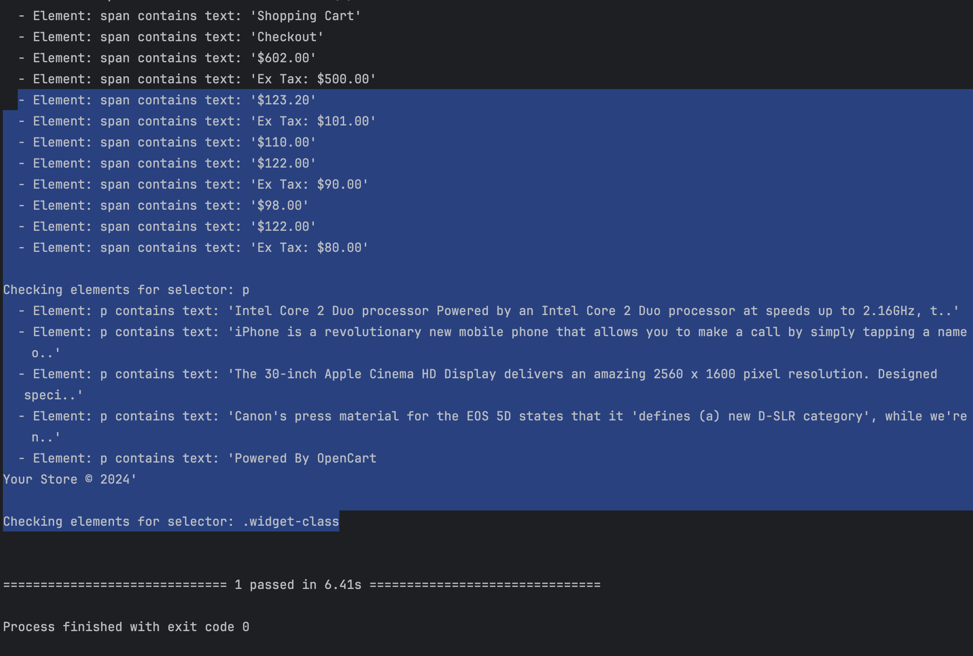

test_check_ui_on_large_screen

TC ID | Description | Steps | Expected Result | Actual Results | Status
TC_028 | Test UI responsiveness on different screen resolutions | 1. Open the website on Chrome and set the browser window size to various screen resolutions (320x480, 480x800, 600x1024, 768x1280, 1366x768, 1920x1080, 2560x1440, 3840x2160).  2. Measure the page load time.  3. Check if important elements (header, footer, main content) are displayed properly and check for unnecessary scrollbars. | 1. The website should load in less than 3 seconds for each resolution.  2. Important elements (header, footer, .container) should be displayed properly without overlap or clipping.  3. There should be no unnecessary scrollbars or missing elements. | 1. The pages load within 3 seconds for all screen resolutions.  2. Header, footer, and .container elements display correctly without overlap.  3. No unnecessary scrollbars. | Pass
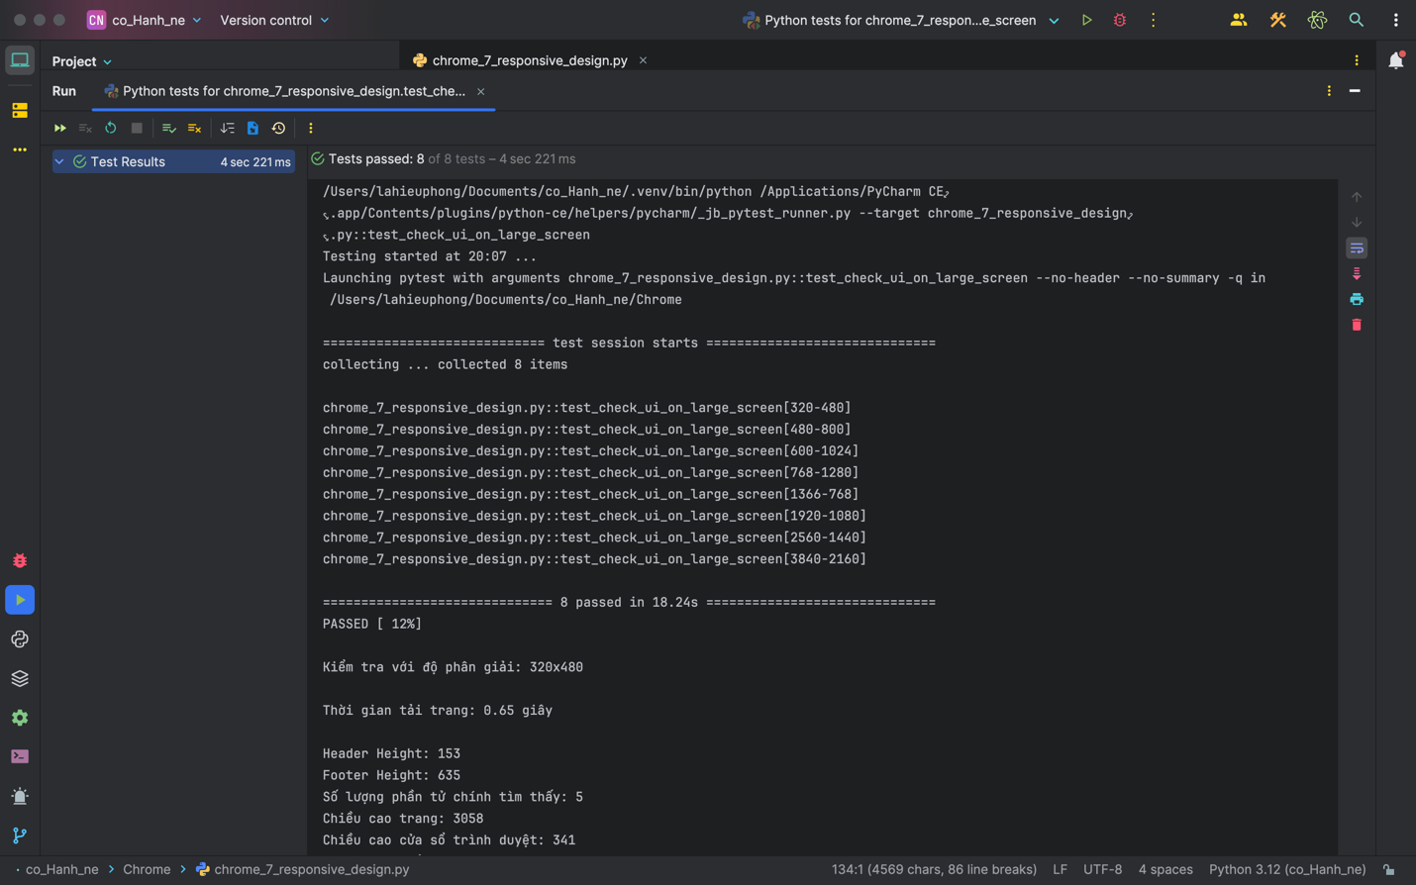
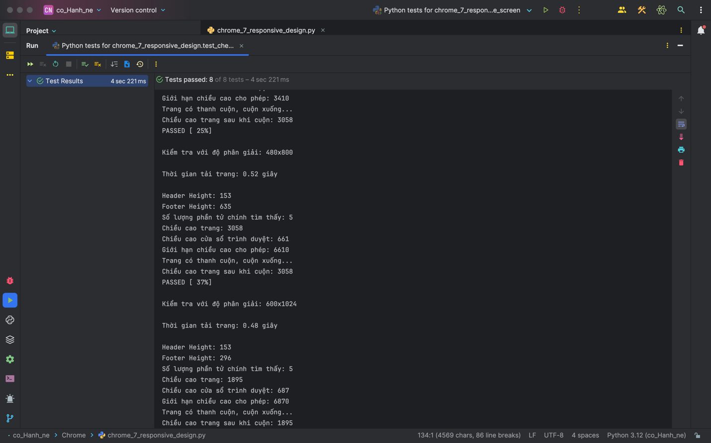
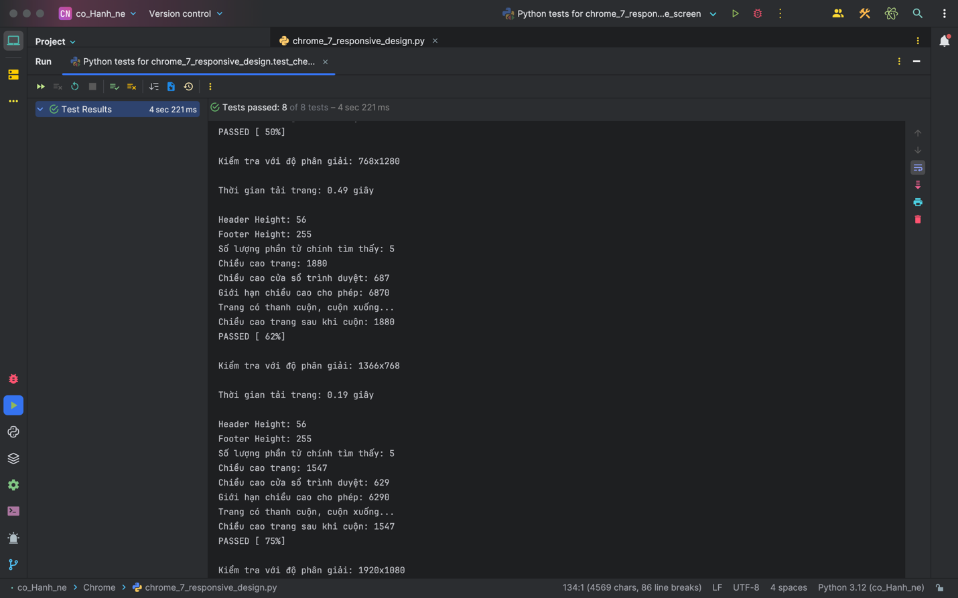
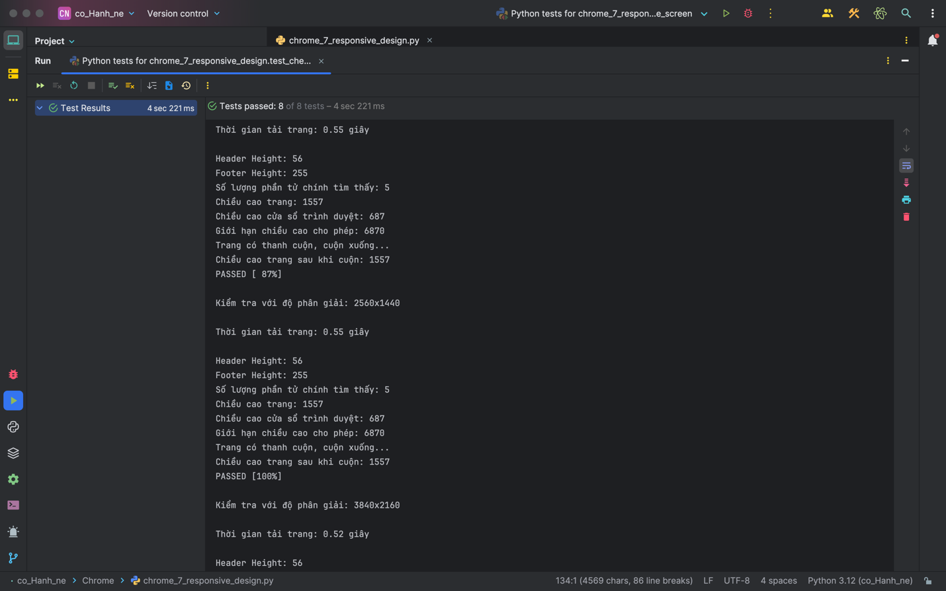
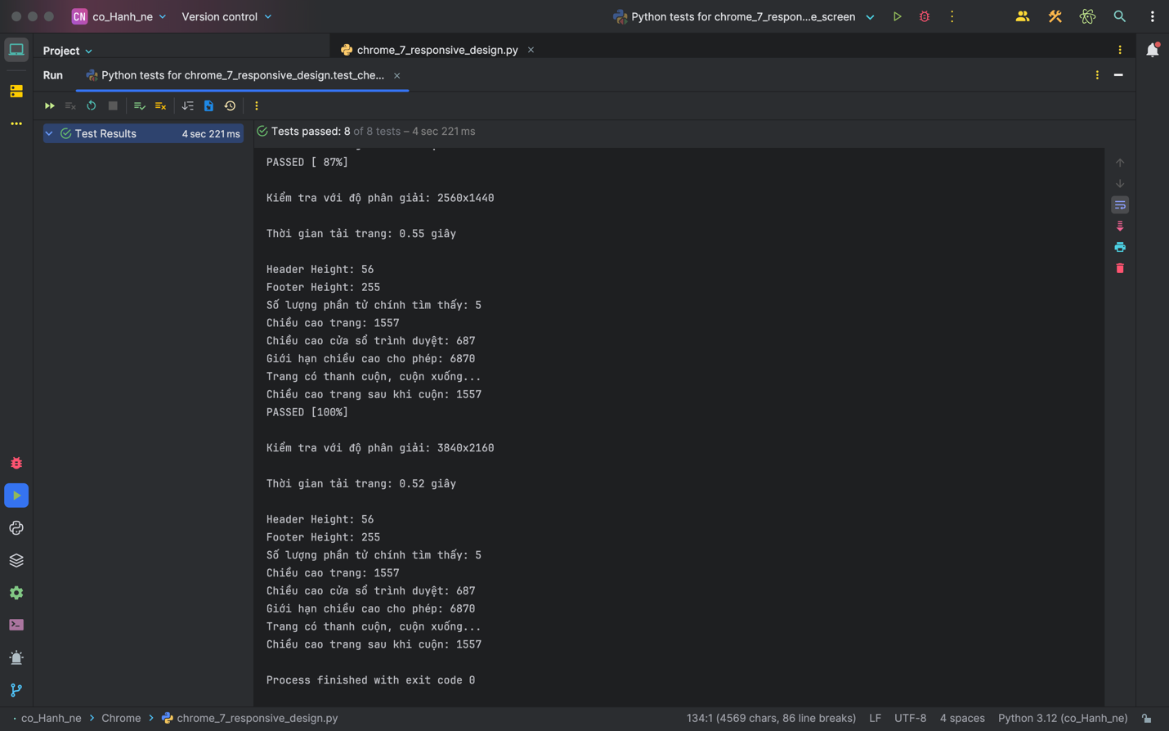

Report Generation:

Test Case Summary:

Test cases Planned | Test cases Executed | Test cases Passed | Test cases Failed
28 | 28 | 22 | 6

Type of Testing Performed
chrome_1_login_logout.py
Test case | Status | Time
test_login_success_chrome | Pass | 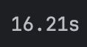
test_login_failure_invalid_username_chrome | Pass | 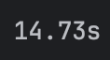
test_login_failure_invalid_password_chrome | Pass | 
test_logout_success_chrome | Pass | 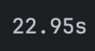
test_lost_session_when_navigating_back_from_order_creation | Fail
Verify Total Execution Time: 1 min 23 sec
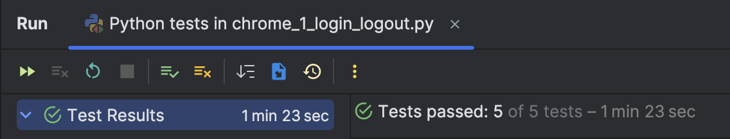

chrome_2_form_submission.py
Test case | Status | Time
test_contact_form_submission_success_chrome | Pass | 
test_contact_form_submission_failure_chrome | Pass | 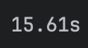
test_submission_of_contact_form_with_special_characters_in_message | Fail | 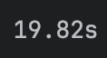
test_contact_form_submission_with_special_characters_in_email | Pass | 
test_contact_form_submission_with_special_characters_in_name | Fail | 
Verify Total Execution Time: 1 min 20 sec
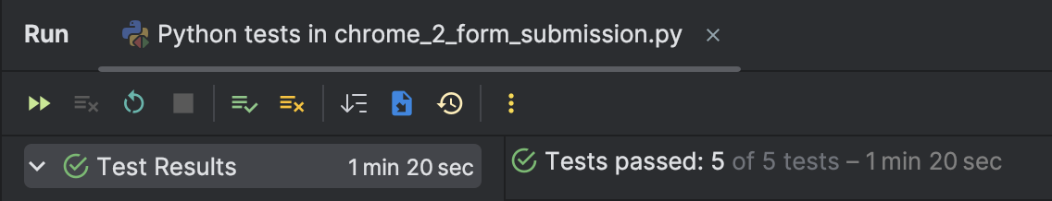

chrome_3_navigation.py
Test case | Status | Time
test_navigate_to_random_product_detail_chrome | Pass | 
test_navigate_to_empty_cart_chrome | Pass | 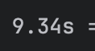
test_navigate_to_shopping_cart | Pass | 
test_navigate_to_checkout | Pass | 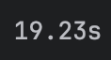
test_navigate_to_sitemap_page | Pass | 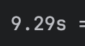
Verify Total Execution Time: 1 min 23 sec
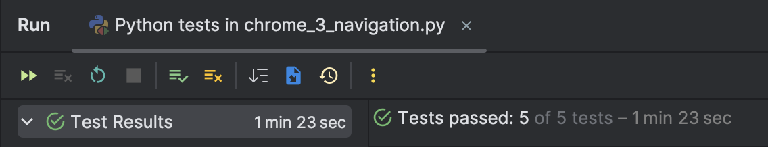

chrome_4_data_validation.py
Test case | Status | Time
test_dashboard_product_info | Pass | 
test_compare_product_info | Pass | 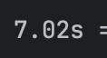
Verify Total Execution Time: 22 sec 955 ms
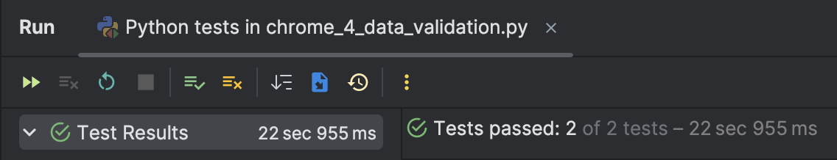

chrome_5_error_handing.py
Test case | Status | Time
test_contact_us_invalid_fields | Pass | 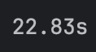
test_registration_invalid_fields | Pass | 
test_error_page_displayed_when_adding_product_to_cart_fails | Fail | 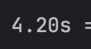
test_error_page_displayed_when_adding_product_with_negative_quantity | Fail | 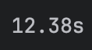
Verify Total Execution Time: 1 min 5 sec
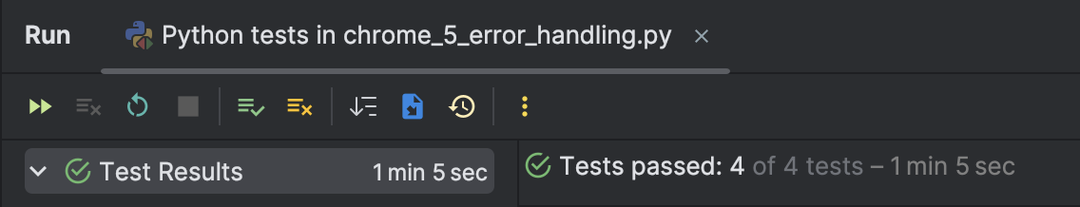

chrome_6_search_functionality.py
Test case | Status | Time
test_search_macbook | Pass | 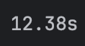
test_search_macbook_fail | Pass
Verify Total Execution Time: 12 sec 292 ms
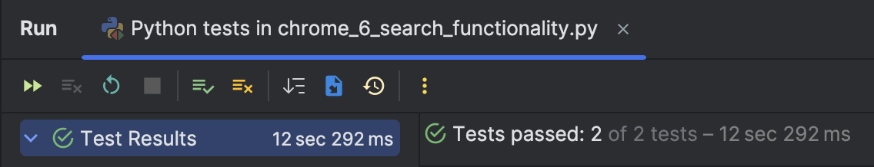

chrome_7_responsive_design.py
Test case | Status | Time
test_open_home_page_chrome | Pass | 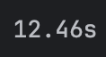
test_open_home_page_firefox | Pass | 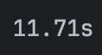
test_check_text_on_widgets | Pass | 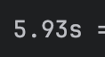
test_check_ui_on_large_screen | Pass | 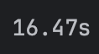
Verify Total Execution Time: 23 sec 520 ms
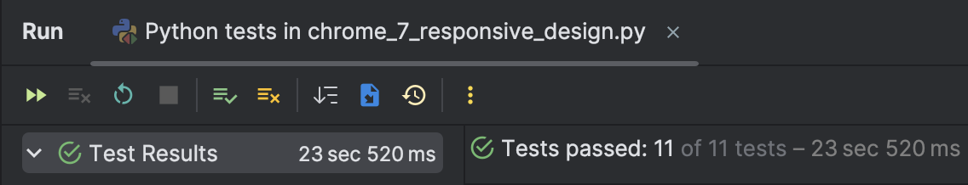

5. Code Review:
Upload Your Selenium Code: Link GitHub: https://github.com/lahieuphong/N9_LaHieuPhong_Assignment2
Provide Detailed Feedback:
- Code Structure: I will examine the structure of the code, assessing whether the sections are organized logically and if the order of testing steps is clear. If necessary, I will suggest improvements to enhance the code's structure.
- Readability: I will assess the readability of the code, paying special attention to clear naming conventions, relevant comments, and layout for easy comprehension by others.
- Reusability: I will check whether the code follows modular principles, making it easy to reuse sections in other test scenarios. I will encourage the separation of common functions to optimize the code's reusability.
- Adherence to Best Practices: I will point out areas where best practices are followed, as well as areas needing further improvement. For instance, I will evaluate the proper use of Selenium WebDriver conventions, appropriate use of wait commands, and effective handling of exceptions.

Incorporate Feedback: Based on the detailed feedback received from peers, I will make necessary adjustments to my code. This process will enhance my code quality and demonstrate my willingness to incorporate valuable input from others while ensuring adherence to Selenium best practices.

