BUG TEMPLATE : DENIAL OF SERVICE & ASSERT VIOLATION

CONTRACT : Marks.sol

Report:

1. Mythril : Not Detected

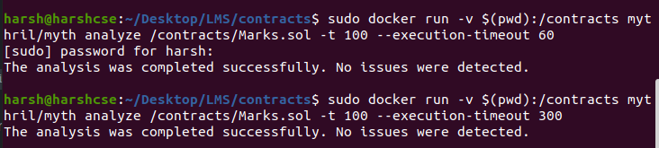
2. Slither : Not Detected
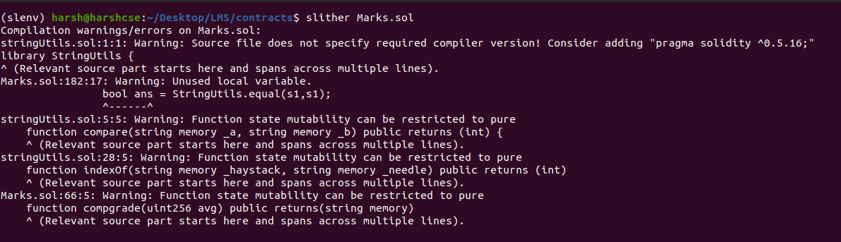
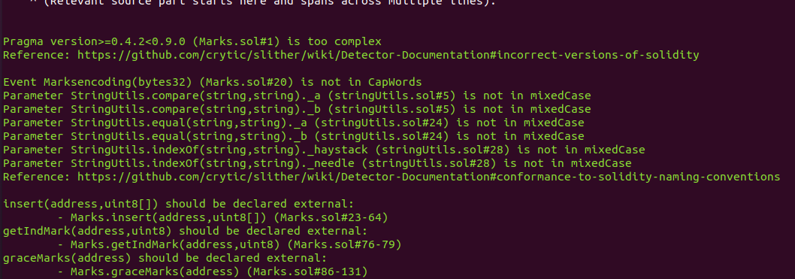
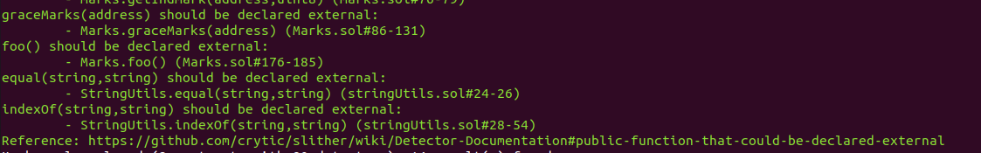

Echidna:

