The Impact of Education, Experience, and Gender on Monthly Sales Income

Descriptive Analysis

Lahiru Wimalarathna

University of Sri Jayewardenepura

Course Number: STA226

Date

2023/11/07

Table of Contents

Methods 4

Results 4

Composition of the Data 4

Associations and Relationships 10

Conclusion 11

Abstract

This study examined the factors that influence the monthly sales income of sales representatives. Sales site, experience, gender, and education level were found to have a significant impact on sales performance. Companies can use these insights to design effective sales training programs, set realistic performance expectations, and implement optimized compensation structures. Gathering data on individual sales performance, sales site characteristics, and sales representative demographics can also provide valuable insights for refining sales strategies and enhancing overall sales success.

Keywords: Sales representative, Monthly sales income, Sales strategies, Performance expectations

The Impact of Education, Experience, and Gender on Monthly Sales Income

Descriptive Analysis

Sales income is an important indicator of the performance and productivity of sales representatives. It reflects the ability of sales representatives to generate revenue for their company and themselves. However, sales income may vary depending on various factors, such as personal characteristics, work environment, and market conditions. Understanding these factors can help sales managers and representatives to improve their sales strategies and outcomes. Therefore, the main objective of this report is to present the factors that could affect the monthly sales income of sales representatives.

# Methods

To achieve this objective, we conduct a statistical analysis of secondary data collected from 250 sales representatives from a research company. The data included information on the following factors: age, gender, experience, educational qualification, coverage area, and site location. The dependent variable was the monthly sales income of each sales representative. We used descriptive statistics, correlation analysis, and regression analysis to examine the factors and the sales income. Minitab 16 was used to conduct the analysis and data cleaning was done by using the box plots for age, experience, coverage, and monthly income. No outliers or missing data found in the sample. All the results of the analysis present in the graphical form using the Pie Charts, Bar graphs, Scatter Plots and Histograms.

# Results

## Composition of the Data

Figure 1 shows that the company has more male sales representatives than female ones. The proportion of male sales representatives is about 67.6%, which is almost twice as high as the proportion of female sales representatives (32.40%).

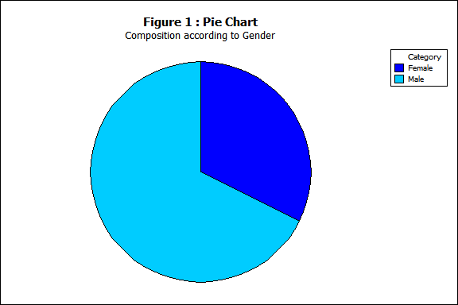

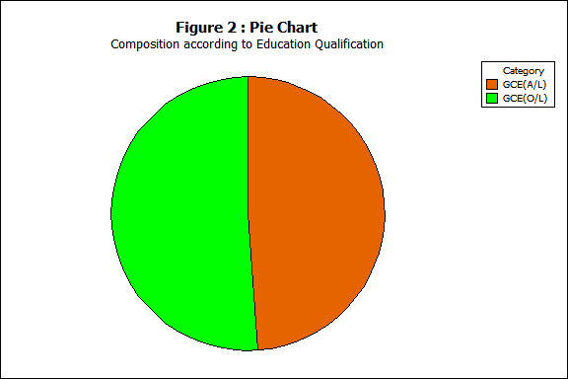Figure 2 shows the composition of the sales representatives by their highest education qualification. The sales representatives with GCE A/L and GCE O/L as their highest education qualification have similar shares, **48.80%** and **51.20%** respectively.

Figure 3 shows the allocation of the sales representatives by their current working area. Most of the sales representatives, **60.4%**, are assigned to the urban area.

### 

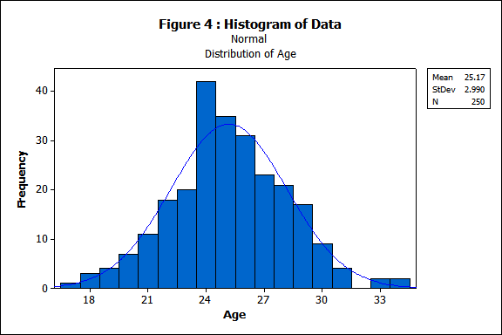Figure 4 shows the distribution of the ages of the sales representatives in this company. The ages of the sales representatives are approximately normally distributed, with a mean of 25 years and a standard deviation of 3 years. This means that most of the sales representatives are between 22 and 28 years old, and very few are younger than 19 or older than 31.

Figure 5 shows the distribution of the sales area of the sales representatives in inches. The sales area is not uniform and there is a clear **bimodal pattern** in the histogram. This suggests that there is a **hidden factor** that divides the sales area into two distinct groups.

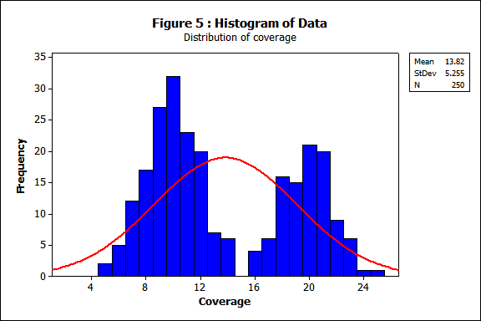

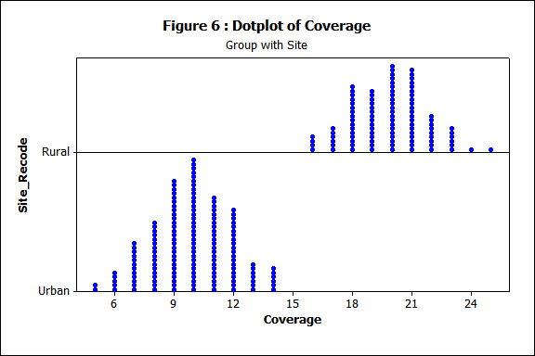Figure 6 shows that the sales site of the employee is a hidden factor that affects the bimodal pattern of Figure 5. Furthermore, the figure indicates that the rural sales site has a smaller coverage area than the urban site.

Figure 7 shows the distribution of the experience of the sales representatives of the company. The experience of a sales representative (in years) has a positively skewed distribution, which means that the median experience of a sales representative in this company is 5 years. This also indicates that 50% of the sales representatives have an experience between 2 and 8 years in this company.

The distribution of the dependent variable, monthly sales income of a sales representative in rupees, is shown in Figure 8. The distribution is approximately normal, with a mean of Rs.10251.00 and a standard deviation of Rs. 987.00. This means that 68% of the sales representatives earn between Rs. 9,264.00 and Rs. 11,238.00 per month, and 95% of them earn between Rs. 8,277.00 and Rs. 12,225.00 per month.

Table 1 shows the composition of the sales representatives by gender and education level. The table reveals that most female sales representatives have GCE O/L as their highest education level, while most male sales representatives have GCE A/L as their highest education level.

**Table 1: composition according to gender and education qualification**

Rows: Gender Columns: Edu Quali

GCE(A/L) GCE(O/L) All

Female 32 49 81

39.51 60.49 100.00

26.23 38.28 32.40

Male 90 79 169

53.25 46.75 100.00

73.77 61.72 67.60

All 122 128 250

48.80 51.20 100.00

100.00 100.00 100.00

Cell Contents: Count

% of Row

% of Column

Table 2 shows the relationship between the site of the employee and the gender. The table indicates that male sales representatives outnumber female sales representatives in both rural and urban sites. Furthermore, the urban site has more sales representatives than the rural site.

**Table 2: composition according to gender and site of the employee**

Rows: Gender Columns: Site Recode

Rural Urban All

Female 29 52 81

35.80 64.20 100.00

29.29 34.44 32.40

Male 70 99 169

41.42 58.58 100.00

70.71 65.56 67.60

All 99 151 250

39.60 60.40 100.00

100.00 100.00 100.00

Cell Contents: Count

% of Row

% of Column

Table 3 shows the association between the site of the employee and the education level. The table demonstrates that the rural site has more sales representatives with GCE O/L as their highest education level, while the urban site has more sales representatives with GCE A/L as their highest education level.

**Table 3: composition according to education qualification and the coverage site**

Rows: Site Columns: Edu Quali

GCE(A/L) GCE(O/L) All

1 40 59 99

40.40 59.60 100.00

32.79 46.09 39.60

2 82 69 151

54.30 45.70 100.00

67.21 53.91 60.40

All 122 128 250

48.80 51.20 100.00

100.00 100.00 100.00

Cell Contents: Count

1 - Rural % of Row

2 - Urban % of Column

## Associations and Relationships

Figure 9 shows the positive but weak effects of age and experience on monthly sales income. The Pearson correlation coefficients are 0.567 and 0.453, respectively.

Figure 10 illustrates that in urban regions, there exists a weak negative linear relationship between sales representative coverage and monthly sales income, while in rural areas, a positive but weak linear relationship exists.

# Conclusion

* There may be underlying differences in sales performance between urban and rural areas.
* The gender disparity in educational attainment among sales representatives, with more male representatives holding GCE A/L as their highest education level, could potentially impact their sales performance.
* The higher proportion of male sales representatives in both rural and urban sites could influence sales dynamics and team interactions.
* The urban site's larger sales representative population could contribute to the higher prevalence of GCE A/L holders in that area, while the rural site's smaller sales representative population could explain the higher proportion of GCE O/L holders.
* The interplay of sales site, experience, gender, and education level likely plays a role in shaping the monthly sales income of sales representatives.
* The company should consider these factors when designing sales training programs, setting performance expectations, and implementing compensation structures.

List of Tables

* Table 1: composition according to gender and education qualification
* Table 2: composition according to gender and site of the employee
* Table 3: composition according to education qualification and the coverage site

List of Figures

* Figure 1: Pie Chart - Composition according to gender
* Figure 2: Pie Chart - Composition according to Education Qualification
* Figure 3: Pie Chart - Composition according to site
* Figure 4: Histogram of Data - Distribution of Age
* Figure 5: Histogram of Data - Distribution of coverage
* Figure 6: Dotplot of Coverage - Group with site
* Figure 7: Histogram of Data - Distribution of Experience
* Figure 8: Histogram of Data - Distribution of monthly income
* Figure 9: Scatterplot of Monthly Sales Income vs Experience, Age
* Figure 10: Scatterplot of Monthly sales Income vs Coverage