Picture 1

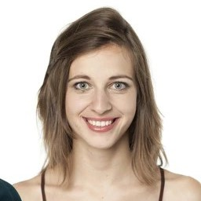

Sam-camera.jpg

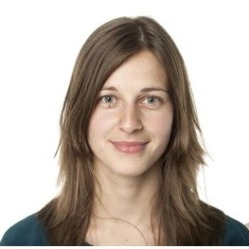

Sam.jpg

Results

-database

-verify()

-who_is_it() / output[2]

