**CLOUD-BASED LECTURE CAPTURING SYSTEM**

Project Id: 18-072

Project Proposal Report

IT15010322, L. C. Tennakoon

IT15021076, H. M. S. V. Mudalige

IT15087898, A. P. Jayasinghe

20 mm

25 mm

40 mm

20 mm

IT15081094, V. R. Wijayagunawardene

BSc. Special (Hons) in Information Technology (Software Engineering)

Faculty of Computing

Sri Lanka Institute of Information Technology

Sri Lanka

March 2017

# Declaration, copyright statement and the statement of the supervisor

We declare that this is our own work and this proposal does not incorporate without acknowledgement any material previously submitted for a degree or diploma in any other university or Institute of higher learning and to the best of our knowledge and belief it does not contain any material previously published or written by another person except where the acknowledgement is made in the text.

|  |  |  |
| --- | --- | --- |
| **Name** | **Student ID** | **Signature** |
| L. C. Tennakoon | IT15010322 |  |
| H. M. S. V. Mudalige | IT15021076 |  |
| A. P. Jayasinghe | IT15087898 |  |
| V. R. Wijayagunawardene | IT15081094 |  |

The above candidates are carrying out research for the undergraduate Dissertation under my supervision.

**Signature of the supervisor: Date:**

**--------------------------------------- ------------------------------**

**Dr. Malitha Wijesundara**

# ABSTRACT

Today, with the fast growth of technology and usage of internet services, e-learning has become one of the newest trends in the education sector. As a result, students tend to prefer e-learning than being physically present in a lecture due to various reasons such as manually taking down notes, inability to instantly understand the content in the lecture, long-distance travel time to get to the lecture, and etc. There are times when a student can miss an important lecture due to various reasons, and never be able to catch up. So, the presence of a smart e-learning platform will solve these problems to a great extent.

The proposed system is a smart cloud-based lecture capture system which facilitates enhanced e-learning techniques. The system allows a lecturer to deliver lectures in the usual way followed by a real-time video recording mechanism. This allows the students to remotely log in and attend the lecture with real-time video streaming. The User Login is followed up by Smart Facial Recognition based authentication, to precisely validate the students who are joining the live lecture via a remote login. The audience comprises of basically two groups of people, namely: the students present in the lecture hall and online users. Attendance is marked automatically for online students after a live-streamed lecture, ensuring the student has followed the lecture from start to end using multiple face recognition processes executing on the server during the lecture time span. Both these parties can interact with the lecturer if they have any doubts or if in need of any clarification regarding the lecture. Online participants can simply make a request to ask a question and the lecturer can then decide whether to give audio and/or video control over to the participant. When it comes to the students who are physically present in the lecture hall, they can show a predefined gesture to the lecturer to ask a question, so that the camera which captures the audience will focus on that student with the support of smart Gesture Analyzing Algorithms developed on the system’s backend. This way, the online participants will also be able to get a clear view and feel like they are also a part of the very classroom. The lecturer can share his/her ideas with the audience depending on the situation. The PTZ cameras are used to capture both the lecturer and the audience thereby providing a clear view of what is going on and to make sure the focus is given to the center of attention.

The expected outcome of this research project is to implement a flexible and a smart cloud-based e-learning platform with real-time video streaming to make the whole learning and teaching process efficient and relaxing.

**Table of Contents**

Declaration, copyright statement and the statement of the supervisor ii

**ABSTRACT** iii

**1.** **INTRODUCTION** 1

1.1 Background Study 1

1.1.1 Literature Review 3

1.1.2 Existing Systems 6

1.2 Research Problem and Research Gap 11

2. **OBJECTIVES** 12

2.1 Main Objective 12

2.2 Specific Objectives 12

3. **METHODOLOGY** 13

3.1 System Overview 13

3.2 Functionalities 14

3.2.1 Audio and Video Conferencing 14

3.2.2 Screen Capturing 15

3.2.3 Attendance Management 16

3.2.4 Enterprise Dashboard 17

3.3 Flow of the Project 18

3.3.1 Requirements Gathering and Analysis 18

3.3.2 Design 19

3.3.3 Implementation 19

3.3.4 Testing 20

3.4 Tools and Technologies 21

3.5 Gantt Chart 24

3.6 Work Breakdown Structure 26

4. **PERSONNEL AND FACILITIES** 27

5. **BUDGET** 29

**REFERENCES** 30

**LIST OF FIGURES**

Figure 3.1: High-level Architecture Diagram 13

Figure 3.5: Gantt Chart 25

Figure 3.6: Work Breakdown Structure 26

**LIST OF TABLES**

Table 1.1.2: Lecture Capturing System Comparison with existing systems. 10

Table 4 : Description of personnel and facilities 27

Table 5 : Estimated Budget 29

# INTRODUCTION

## Background Study

Today, communicating with internet and doing things right from our home is becoming more and more practical because it makes day-to-day life very easier. People always try to find a way to use the easiest way to complete their tasks without utilizing too much time and energy.

The art of learning should evolve over time. Even with the latest technology today, we are still used to physically going to a lecture and listening to the lecturer in real-time and making notes of his/her teachings, what the lecturer sketches on whiteboards or his/her presentation.

We have no way of reviving what the lecturer has told the students if not noted down at the same time. But with the speed of the lecturer, it might not be possible in some cases.

As a result, there is a higher chance that students forget what the lecturer said or taught the very next day because it wasn’t documented properly. There can be many reasons for a student to be absent for a lecture because of unavoidable circumstances such as medical trouble or family emergency.

A live streaming with recording sessions of a lecture would help all the students even if they were present in the lecture itself. The ability to revise what they have missed if the student attends the lecture late and the ability to repetitively go through a previous lecture before attending the next lecture would result in a huge academic improvement.

The main purpose of this system is to offer an effective way to help the students to access learning materials and information from anywhere and to quickly recap any forgotten or absent lectures via the earlier recordings of the sessions.

A system and a method for an interactive Internet-based video conferencing multicast operation which uses a video production studio with a live instructor giving lectures in real-time to the participating students. The video conference multicasting permits the students to interact with the instructor and other installations during the course of the lecture and to later browse the recorded session without a hassle.

**Key Features of Lecture Capturing System is,**

* Automatically focusing on the lecturer in real-time to give the viewers the best viewing angle all the time.
* Sharing lecturer’s computer screen with the students so that they can see what the lecturer is doing on his/her computer such as coding, annotating a PowerPoint slide or any media file the lecturer is going to show.
* Lecturer communicating with students either by voice/video on request of the student so that everyone can see the conversation and clear any doubts regarding the question of the student.
* Generating readable text content after the lecture by intelligently converting the lecturer’s voice into text is a helpful feature for students that are having difficulty hearing and it helps the students revise the lecture more efficiently.
* On the recorded offline video having thumbnails of the chapter makes it easier for students to watch the relevant part they needed without going through the whole video.
* Intelligent bandwidth management to make sure that we use the least possible data bandwidth to transfer the videos to the students.
* Capturing the audience and focusing on a guest speaker in real-time helps the remote logged in students to experience the live classroom environment.
* Biometric authentication of the remotely logged in users via facial recognition to act as a secondary layer of security and to mark the attendance of remote students.

Web Application development skills, Face Recognition, Image processing, & Machine learning techniques are essential. In addition, some basic knowledge of the lecturing process and student behaviors are also required throughout the development of the system.

## Literature Review

Despite the enormous growth of e-learning (electronic learning) in education and its perceived benefits, the efficiency of such e-learning systems will not be fully utilized if the students are not inclined to accept and use the system.

As a result, successful implementation of e-learning tools depends on whether the students are willing to adopt and accept the technology. Thus, it has become imperative for e-learning system developers to understand the factors affecting the user acceptance of web-based learning systems in order to enhance the students’ learning experience and to create a better product to fulfill the necessary requirements of the student.

“Use of E-Learning”, a research was done to find University students’ intention to use e-learning [1]. In this research, Teknologi Malaysia University’s students try to apply and use the theory of technology acceptance model (TAM). They have employed structural equation modeling (SEM) approach with a SmartPLS software to investigate students’ adoption process. Findings indicate that the content of e-learning and self-efficacy have a positive impact and substantially associated with perceived usefulness and student satisfaction, which impact university students’ intention to use e-learning. Although e-learning has gained acceptance in universities around the world, the study of the intention to use e-learning is still largely unexplored in Malaysia. The developed model is employed to explain the university student’s intention to use e-learning. The study concludes that university students in Malaysia have positive perceptions towards e-learning and intend to practice it for educational purposes.

E-Learning is considered as an innovative approach to education delivery via electronic forms of information. Multiple research has been done to find the best way to use the technology and to better fit the students’ needs [1], [2]. The main obstacles that need to be addressed are the insufficient financial support, inadequate training programs, lack of ICT infrastructure, ambiguous policies and objectives, and lack of awareness, interest, and motivation toward e-learning technology are considered as the main barriers to enhance e-learning in Iraqi universities. The lack of training programs and inadequate ICT infrastructure are considered as the key issues which obstruct advancing of the e-learning process in Iraq [2].

Online body tracking by a PTZ camera has been done before to automatically track a single person and focus on that person [3], [4]. Online human body tracking method by an IP PTZ camera based on fuzzy-feature scoring was done. At every frame, candidate targets are detected by extracting moving targets using optical flow, a sampling, and appearance. The target is determined among samples using a fuzzy classifier. Results show that the system has a good target detection precision (> 88%), and the target is almost always localized within 1/4th of the image diagonal from the image center [3]. Autonomous lecture recording with a PTZ camera [4]. This reaches the same viewing experience while watching lectures recorded by an automated system. To accomplish this, they have developed an automatic cameraman (PTZ camera-unit) that is able to:

• Detect and track a single person/lecturer

• Change between different types of shots

• Listen to high-level instructions from a virtual or human director

• Take cinematographic rules into account

• Work in Real-Time

By tracking the lecturer, he is framed well in the picture at any moment and viewers can’t be distracted. Takes cinematographic rules into account, which ensures that the viewer remains focused and the viewing experience is aesthetically more interesting. The action axis is determined by calculating the direction of movement and the gaze orientation. A PID control loop ensures smooth movement of the camera. Because of the speed of the algorithm, it will be easy to downscale for embedded hardware and still perform the calculations real-time.

Remote controlling of the PTZ camera system for lecture rooms [5]. This consist of a simple and inexpensive software solution for remote management of PTZ camera systems. This provides the ability for users to remotely control the PTZ camera system from one place with the simultaneous image capturing ability. Users of this application are able to choose a number of presets and this functionality is provided programmatically by sending queries to CCTV system, which then responds back to the controller. All of the responses are processed immediately into the desired form and stored in a selected row in SQLite database. This method of data storage doesn´t require the installation of SQL database, which makes the solution easier to apply. The program was created using the programming language C#. But this software solution does not support real-time tracking of a person, just several predefined presets so that feature can be improved to real-time operation in Lecture Capturing System. OpenTrack - Automated Camera Control for Lecture Recordings [6] records lecture sessions automatically without the need for a human camera person. A Tabletop Lecture Recording System [7]. This research presents a lecture recording system that employs gestures and digital cameras to facilitate remote distance teaching. Virtual Cameraman [8] uses two PTZ cameras having different utilities. One is named full-shot PTZ camera and the other is movement PTZ camera. To get camera movement information, the system first obtains continuous images from full-shot PTZ camera and then extracts four fuzzified movement features which can represent four characters of audiences' motions respectively. On the other hand, an automatic camera movement model (ACMM) is constructed by recording photographers' habit of CM styles and shot types. The proposed system can select suitable CM styles and shot types by inputting the fuzzified motion features into the ACMM. After that, the system chooses the main target in the input frames obtained from the full-shot PTZ camera by using five aesthetic criteria. Finally, the system operates the movement PTZ camera to finish recording.

Real-time body tracking has been implemented before, but not quite as what we have planned on doing; real-time broadcasting of the footage without any delay. The complete package of having the lecture capturing along with audience if necessary, screen sharing, Face Recognition based remote login and attendance marking for online participants, viewing the lecture in real-time with added features such as reading what the lecturer has told and intelligently generating chapters on the video according to the lecture slides played alongside with this makes Lecture Capturing System a perfect complete package of e-learning. A thorough research related to e-learning systems has led to the identification of some of the most influential factors used in the field of information systems research. More specifically, characteristics as well as the limitations, weaknesses, and strengths of web-based learning systems. Student variables, such as technical issues and adapting to the new ways are important variables that influence student learning, especially in a collaborative e-learning environment. Understanding these variables is now helpful for developers to design meaningful educational activities to promote student knowledge construction and make learning more effective and appealing. In particular, this research helps to better understand the characteristics of students and to understand what the students expect from the learning management systems. This can help the developers achieve the most effective deployment of such systems and also helps them improve their strategic decision making about technology in the future, they can decide on the best approach that fit their students before implementing any new technology.

### Existing Systems

Features of a set of commercially available e-learning platforms were compared with the Lecture Capturing System. Most of the existing systems don’t support real-time live streaming. Some support capturing the lecturer’s movement in real-time to let the viewer have the best possible viewing angle. Biometric facial recognition for authenticating users and marking attendance, intelligently manage data usage for minimum data usage while watching the sessions either live or offline, intelligently converting the lecture’s voice into a text and generating thumbnails according to the lecture slide the lecturer was on are some of the unique features of the Lecture Capturing System.

1. Panopto - Lecture Capture Software

Panopto is an easy-to-use video platform for training, presenting, and communicating that enables users to record videos and rich media presentations and push out to subscribers in many different formats. Panopto is built with the flexibility to record any combination of video sources, in any configuration, in classrooms of any size. And Panopto scales with ease to meet institution’s needs from small departmental deployments to campus-wide installations.

<https://www.panopto.com/panopto-for-education/lecture-capture/>

1. BigBlueButton

BigBlueButton is an open-source web collaboration software utilized by education organizations for e-learning and training. The software offers numerous options for customization and integration as per requirements of the users. BigBlueButton enables users to conduct web-conferencing and share documents, audio and video files for online learning. The software’s “whiteboard” feature allows presenters to mark valuable topics in the presentation. In addition, its “polling” feature engages learners and helps the presenter to receive feedback. BigBlueButton’s “desktop sharing” feature extends beyond slides and allows moderators to share their screen with the audience enabling a better understanding of topics. BigBlueButton supports multiple users in a video conference with no cap on numbers of active webcams. The software also supports voice conferencing via Voice Over IP (VOIP) without additional hardware requirements.

<https://bigbluebutton.org/>

1. Echo360

Echo360 combines video management with lecture capture and active learning to increase student success.

Echo360 keeps notes linked to class presentations and videos so that students can jump straight from their own words to those of the instructor and replay the entire learning experience.

High-quality live streaming supports remote learners and classroom overflow situations. The streaming experience leverages Echo360’s engagement tools so students can engage with classmates and the instructor no matter where they are.

Built on a scalable cloud architecture, the platform allocates the resources needed to process peak loads automatically. Videos are uploaded and processed in real time so the optimized version is available as soon as class is over

<https://echo360.com/>

1. Kaltura

The Kaltura Video Player SDK includes a rich set of APIs for player embedding, customization, white-labeling and integration via JavaScript or ActionScript 3.0. By leveraging the Kaltura Player you can create your own custom players with less effort and at no cost!

* Endless flexibility for creating your own custom design and playback experiences
* Automatically switch between HTML5 video and Flash, maintaining a unified look & feel
* Work with any type of streaming protocols, from adaptive streaming, HTTP streaming, and DRM
* Increase engagement with smart and dynamic playlists, related, and more
* Optimize SEO using Kaltura’s SEO best practices embedding guidelines.

<https://corp.kaltura.com/>

1. Open Broadcaster Software (OBS) (Software Tool)

OBS is a free and open-source streaming and recording program maintained by the OBS Project. The program has support for Windows 7 and later, OS X 10.10 and later, and Ubuntu 14.04 and later.

OBS is a free and open-source software suite for recording and live streaming. Written in C and C++, OBS provides real-time source and device capture, scene composition, encoding, recording, and broadcasting. Transmission of data is primarily done via the Real Time Messaging Protocol (RTMP) and can be sent to any RTMP supporting destination, including many presets for streaming websites

<https://obsproject.com/>

Table 1.1.2: Lecture Capturing System Comparison with existing systems.

|  |  |  |  |  |  |
| --- | --- | --- | --- | --- | --- |
| **Features** | **BigBlueButton** | **Panopto** | **Kaltura** | **Echo360** | **Lecture Capturing System** |
| Support one-to-many users to concurrently access a live stream. | ✓ |  | ✓ | ✓ | ✓ |
|  |  |  |  |  |  |
| Convert the lecturer’s voice into text after recording. |  | ✓ | ✓ | ✓ | ✓ |
| Screen sharing window for share laptop screen | ✓ |  |  | ✓ | ✓ |
| Handle multiple users and course management | ✓ | ✓ | ✓ | ✓ | ✓ |
| Biometric facial recognition for authenticating users |  |  |  |  | ✓ |
| Capture the audience if required and focus on a guest speaker |  |  | ✓ | ✓ | ✓ |
| Intelligently manage data usage for minimum data usage |  |  |  |  | ✓ |

## Research Problem and Research Gap

Today, e-learning platforms are used for knowledge transfer through electronic media. This transfer can address several learning contexts, ranging from conventional classroom delivery to online and offline distance learning tactics.

There are a countless number of e-learning platforms which cover various aspects of learning such as video streaming, capturing the audience in the lecture hall if necessary, and screen sharing. But, the solution we propose is to handle advanced and enhanced features. Biometric recognition of participants to ensure authentication is proposed so that the attendance can be recorded. In addition to this, every lecture will be maintained as an mp4 video with the set of slides used, and the lecturer’s voice relevant to each slide, which provides an easy way of reference to the students who missed a particular lecture. Another important aspect considered in this research is the way of interaction between the lecturer and the students who have any doubts to be cleared during the lecture. For this purpose, when the students who are physically present in the lecture hall are concerned, a gesture-based system is proposed. Here, when the lecturer notices a specific student with the gesture of asking a question, the lecturer will have to perform a gesture for the camera to turn towards the audience and focus on the specific student who has the doubt by once again detecting the gesture performed by the student. When a remotely logged in user has a question for the lecturer, he/she has to signal the lecturer using a specific command, and then the lecturer has to decide whether to give video and/or audio control over to the specific user. As real-time video streaming consumes a lot of quota and bandwidth, the system has to intelligently manage data usage by ensuring the best possible transmission rate with minimum data consumption.

Taking the above facts into consideration, we propose a smart, cloud-based e-learning platform with advanced and flexible real-time video streaming, while ensuring interactivity between the lecturer and the students.

# OBJECTIVES

## Main Objective

The main objective of this research is to implement a cloud-based smart e-learning platform for university students, and lecturers to facilitate lecture delivering and participating in lectures through real-time video streaming while ensuring that, the maximum possible level of interaction between parties is achieved using image processing and machine learning techniques.

## Specific Objectives

* To provide an interface where lecturers and students can interact real time through audio and video.
* To ensure authentication through biometric details along with basic login information.
* To optimize bandwidth and quota management by freezing the unused screens and disabling the cameras where necessary.
* To maintain a record of lecture slides used in accordance with the lecturer’s voice recordings relevant to each slide for easy reference.
* To track the lecturer’s movements and the audience using PTZ cameras to ensure students get a clear picture of what is happening in the classroom.

# METHODOLOGY

This section describes how the Lecture Capturing System will be designed and implemented; explaining the process of each functionality, their flow in the system and the technologies used for their implementation.

## System Overview

The system will be developed as a cloud-based web application, supporting multiple enterprise customers with enhanced interactive capabilities to aid in e-learning. This would be a very useful application for both lecturers and students by revolutionizing the art of learning.

Some research areas that would be covered here are image processing and understanding, machine learning (neural networks), cloud computing, real-time media streaming, and data communication.

Figure 1 describes the high-level architecture which provides an overview of the entire system, identifying the main components that would be developed for the product and their interfaces.

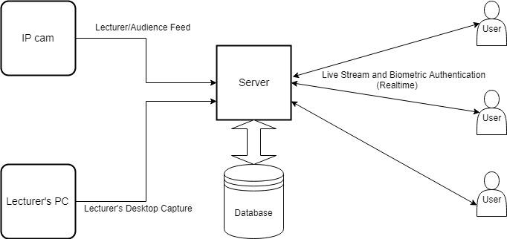

Figure 3.1: High-level Architecture Diagram

## Functionalities

### Audio and Video Conferencing

An IP camera will be used to track the lecturer’s movement and gestures in front of the camera and produce the necessary PTZ signals to pan, tilt and zoom accordingly thus ensuring that the lecturer’s actions are always recorded without missing any detail. This video recording will be immediately compressed ‘on -the-fly’ in order to reduce its file size, then streamed live and also saved in the database for backup purposes and viewing later. Therefore, the students have the choice of attending the lecture via the live stream or listening to the lecture later. This is very beneficial to students since they can also attend lectures without being physically present (remotely) at the lecture. During the live streaming session, the system will decide which video resolution (e.g. 480p, 720p, 1080p) to use for the playback at the student’s end depending on the speed of his/her internet connection.

Live streaming is achieved via Kurento which is a WebRTC (Web Real-Time Communications) media server and a set of client APIs [9]. During the live streaming session, the lecturer also has the ability to share his/her entire computer screen with the participating students if required, making certain that not even the most minute detail is not missed. In the case of having low bandwidth to support this feature, the lecturer has the option to disable the IP cameras in order to save bandwidth. This mode of lecturing provides better participation and interaction between the lecturers and students. An example of this is if a student wants to ask a question, the control would be given to the particular student by the lecturer and the application would support audio only, video only or both audio-video sources of the particular student. But the lecturer has the ability to get back the control of the audio and video sources of the system when required.

### Screen Capturing

During the lecture session, the desktop screen of the lecturer’s computer as well as the lecturer’s voice will be recorded from the beginning to the end of the lecture session. This will be achieved by using a free and open-source video recording software known as Open Broadcaster Software (OBS) Studio [10].

The video will then be saved in FLV (Flash Video) format which is a container for an h.264/AVC video track and an AAC audio track. The FLV file format is used because this container is designed to be started and stopped at any time, resulting in a stable consistent output video file [11].

In the next step, this FLV file will be converted to another format, preferably MP4 (due to its wide availability, support, and compatibility), before sending it to the Kurento Media Server where the next level of processing begins. The video will be analyzed by image processing and machine learning algorithms (e.g. Neural Networks) to split the video for each PowerPoint slide, resulting in multiple videos of various durations; now each video will contain a single presentation slide. The PowerPoint presentation file (the .ppt file) for the relevant lecture will be uploaded to the server. The slides in the .ppt file will be compared with the images of the slides in each of the videos to identify which presentation slide each video contains. At the same time, the audio for each video will be converted to text in order to make it even easier for the students to understand. This is achieved with the help of Google Cloud Speech API which uses powerful neural network models to convert audio to text [12]. After the audio-to-text conversion, it will be verified by the lecturer to ensure that the conversion is accurate.

Therefore, the end result would be a set of videos along with their respective audio, presentation slide, and text. These videos would be stored in the database so that students can access them any time after the lecture session to further understand and clarify their knowledge.

### Attendance Management

Even though students can attend the lecture remotely there should be a way to record their attendance. The initial step in this procedure would be to maintain a database which contains pictures of the students in the university. Next step would be to capture an image of the student’s face (detection) from the webcam in their laptop during the live streaming lecture session and compare this with existing images in the database to identify and verify the student’s identity (recognition) [13].

This can be achieved by using a supervised machine learning algorithm such as a neural network. The neural network would be trained with labeled input data which would be images of students with their names to identify them. The greater the number of training examples, the better the algorithm would learn over time.

The neural network will first search the field of view of the webcam for faces. Once the face is detected, it moves onto the next step to analyze different facial features such as the relative position, size, and/or shape of the eyes, nose, cheekbones, and jaw. These features will then be used to search for images in the database with matching features (Image Processing). Once the face is recognized, previously matched facial features will be stored temporarily in the database or in a YAML file. The temporarily stored facial data will be used multiple times to match with the facial features of the student during the lecture, to verify the student is following the lecture until the end. Once the lecture is over, if all verification counts are passed, the attendance for that particular student is marked as “present” and it is written to the database.

This adds an extra layer of security to the system to ensure that only authorized persons gain access to the university’s content. A comprehensible advantage of this method of biometric authentication of students can be noted during the time of an online exam to verify that the person on the other end is actually who they claim to be.

### Enterprise Dashboard

The enterprise dashboard gives access to different elements of the site's administrative functions.

* User management – The administrator can view all the users and search for a particular user in the system. Also, the administrator can add a new user such as a new lecturer who has been employed, to the system (including creating new login credentials for the user). The administrator can also edit(update) the information of an existing user or delete a user altogether.
* Course management – The administrator can manage courses conducted at the university. When a new course is introduced to the university, the administrator can add it to the system. If any changes are proposed to an existing course (e.g. change the number of credits in the course), the administrator is able to update its details. There would be occasions when an existing course’s learning material gets outdated; in this case, the administrator can delete this course from the system.
* Bandwidth management – Bandwidth (also known as network bandwidth, data bandwidth, or digital bandwidth) defines the maximum throughput in a computer network. Bandwidth management is the process of measuring and controlling the communications (traffic, packets) on a network link, to avoid filling the link to capacity or overfilling the link, which would result in network congestion and poor performance of the network. Bandwidth management is measured in bits per second (bit/s) or bytes per second (B/s).
* Quota management – Quota (also known as bandwidth cap, band cap or a data cap) is an artificial restriction imposed on the transfer of data over a network. The administrator can create quotas for each user to limit the internet data allowed for a month and generate notifications when the quota limits are approached or exceeded.

## Flow of the Project

In order to develop the proposed web application, we are planning to use the agile software development lifecycle model with the following phases:

* Requirements Gathering and Analysis
* Design
* Implementation
* Testing

### Requirements Gathering and Analysis

In a research project, the requirements gathering and analysis part is a very vital step to ensure that the end product has been implemented as expected. Therefore, studying the research area is very important. Prior to starting the implementation of the system, we have to clarify whether the proposed system will give the required solution to the problems we are trying to address. Since the team gathered information from a number of sources, a clear understanding of the requirements was identified. The following methodologies were used to gather the necessary requirements.

* Studying existing systems
* Reading internet resources (e.g. blog posts, articles, journals)
* Reading research papers on previous research carried out
* Discussions with researchers in the same field

By using the above techniques, a distinct gap between existing products and the proposed system was identified.

The next step involves analyzing the gathered requirements and this was carried out to obtain a clear, in-depth understanding of the limitations of the current systems and things which can be done to improvise these management operations. We ensured that the gathered requirements were stable, valid, unambiguous, and complete by detecting and rectifying or eliminating any erroneous requirements.

The research target is to find the optimal and most innovative way to make this e-learning platform. Finally, the software requirements specification (SRS) document will be created and it will consist of all the functional and non-functional requirements of the proposed system. It is not possible to have a complete picture of what is going to be the exact output of the project right now; due to the nature of research itself, these functions may slightly change in the future.

### Design

The design phase involves studying the SRS document and using the specified requirements to create the system design and the software design.

The system design helps in specifying the hardware and system requirements and also helps in defining the overall system architecture. The system design specifications serve as input for the next phase of the model [14]. The selected architectural design defines all the components that need to be developed, user flows and database communications as well as front-end representations and behavior of each component. In the software design phase, we try to convert the requirements into a suitable form for implementation by drawing UML diagrams such as use case diagrams, class diagram, ER diagram, sequence diagrams and activity diagrams.

A design review is conducted at the end of this phase to ensure that the design conforms to the previously defined requirements. This design phase is a very crucial step because without a proper foundation to the system it will not be able to provide the proposed functionality to the users.

### Implementation

The next phase of the software development lifecycle is the implementation or development of the system. In this phase, developers start coding according to the requirements and the design discussed in previous phases. On receiving the design documents, the work is divided into modules/units among the members of the team and actual coding is started. After implementation, each individual unit will be tested (unit testing) to see if it functions properly as a standalone unit.

The implementation phase is usually the longest phase of the software development life cycle [14]. The final target of this phase is to acquire a set of fully functional independently working modules.

### Testing

After the code is developed it is tested against the requirements to make sure that the product actually solves the needs addressed and gathered during the requirements phase. During this phase, all types of functional testing and non-functional testing would be carried out.

Functional testing involves:

* Unit testing - Each individual unit will be tested by the respective team member to see if it functions correctly.
* Component testing - Similar to unit testing but with a higher level of integration. The big difference here is that the testing is done in the context of the application instead of just directly testing the method in question [15].
* Integration testing – This involves integrating modules one at a time until the whole system is set up. At the end of each iteration, the system is tested to ensure there are no errors during integration.
* System testing – After the entire system is set up, system testing is carried out to make sure all the components have been integrated successfully and the system is fully functional.

In non-functional testing, certain attributes of the system such as memory leaks, performance, and robustness of the system are verified. Some of these test phases are performance testing, security testing, load testing, and recovery testing.

## Tools and Technologies

Main Technologies

* ReactJS
* Socket.io - Real-time communication between client and server using web sockets.
* Node.js, Express JS, Mongoose Library - back-end frameworks
* MongoDB – data storage.
* WebRTC Kurento Media Server - open source development framework for creating real-time multimedia applications.
* opencv4nodejs - npm package which allows using OpenCV in a Node.js server.

Unit Testing and Deployment

* Wiremock- API mocking technology for fast testing.
* Mocha - unit testing
* Continuous Integration - Travis CI
* Continuous Deployment - Heroku

Tools

* JetBrains’ WebStorm - front and back-end development
* Studio3T MongoDB GUI and IDE
* ESLint – tool to maintain code quality.
* Chrome Dev Tools – diagnose and identify issues
* Github - version control platform.
* OpenCV – real time computer vision library.
* Operating Systems – Ubuntu 16.04, Windows 10

Technologies used for Scalability

* node cluster module - create multiple child processes to make full use of computers multicore systems
* NGINX - Load Balancer, low - resource compression. (utilize less computational power when compressing) etc.
* node pm2 module - advanced Node.js process manager.

Kurento offers two clients for Java and JavaScript [16]. We will be using the Kurento JavaScript client in a Node.js server since we are familiar with the JavaScript technology stack, furthermore, the development procedure in Kurento Documentation [16] is well documented in JavaScript and among other benefits. Considering the versatility, we will be developing the entire application using JavaScript.

Socket.io will act as an intermediary between client and Node.js server. It will be used to stream data (video, audio etc.) to the client in Real Time using Web Sockets. The main reason to use Socket.io and not pure Websocket API, because of the ability of Socket.io to keep the availability of client and server connection without connection failures. Web sockets can be blocked by proxies and firewalls. Therefore Socket.io ensures availability of the service by establishing XMLHttpRequest connection as a backup and attempts to reconnect with Web Sockets. This feature cannot be seen in Pure Websocket libraries [19] [20].

Face recognition module needs a server-side technology which has to read and write data (facial features, attendance details etc.) multiple times to files/database extremely fast in order to do the face recognition and authentication processes. The best modern server-side technology which can handle this function is Node.js due to its Non-blocking I/O Model. It takes requests without blocking itself from receiving more requests while fulfilling its queue. One of the main reason we chose Node.js as the server-side technology, considering the ability to develop front and back-end of the system in JavaScript. Node.js is a cross-platform language which can run on Ubuntu and Windows. Due to its support for Websockets, Non-blocking I/O model, server-sent event protocols and the active community behind it, it is the ideal server-side technology to be used in this project [17].

In terms of Scalability, Node.js is single threaded (only one Node process) by default. Even though it is single threaded, it has the ability to make multiple copies of node processes using the node cluster module and make full use of computers multicore systems [22]. Face Recognition, Image processing and Gesture recognition processes used in the Lecture Capture System will be distributed among these node processors by a load balancer (NGINX) increasing the overall performance of the system. The built-in gzip compression in NGINX will be used to compress only large files, reducing the usage of CPU resources and bandwidth costs [21].

## Gantt Chart

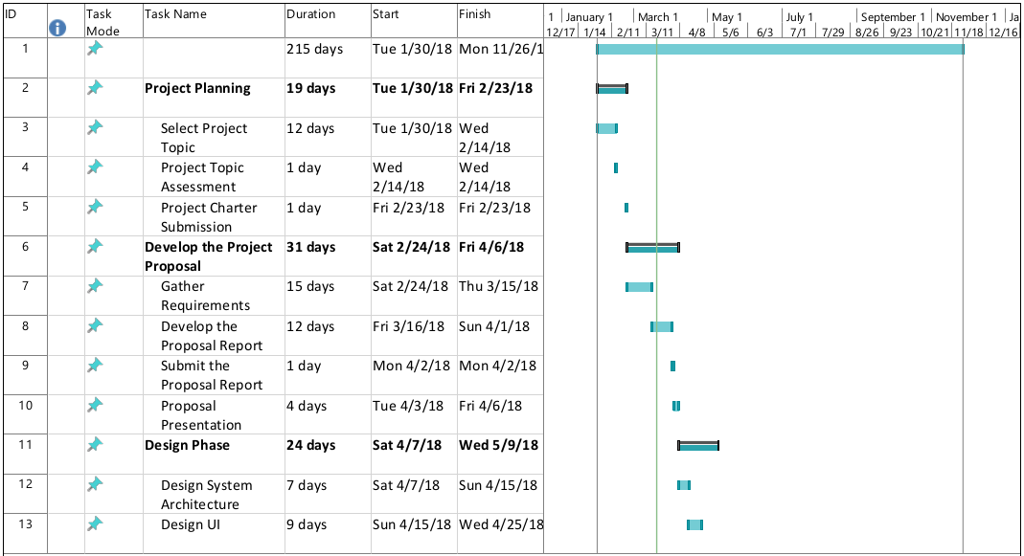

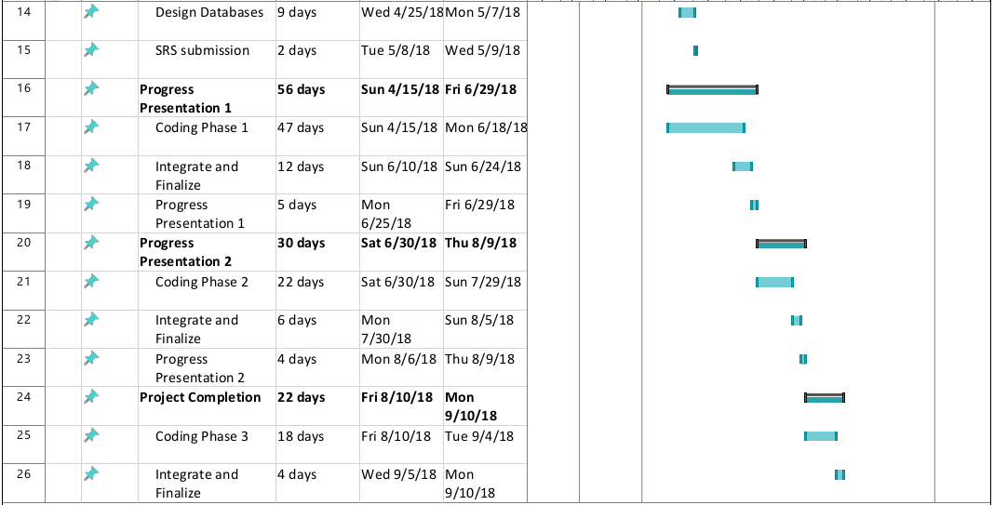

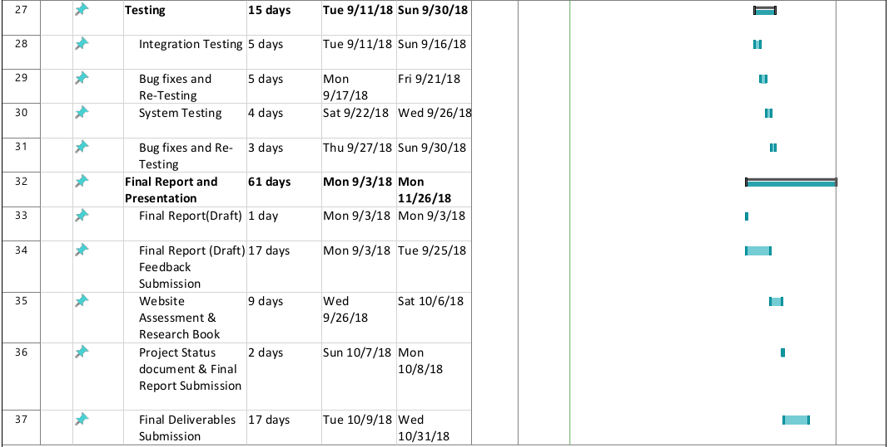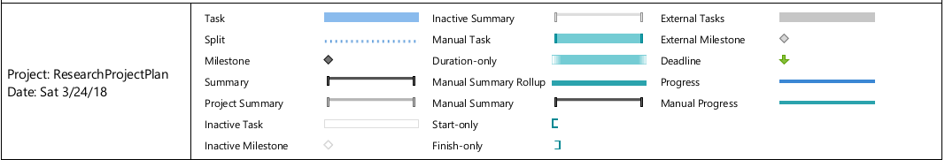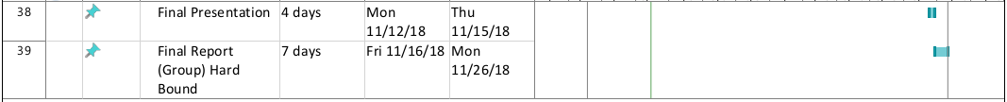

Figure 3.5: Gantt Chart

## Work Breakdown Structure

Figure 3.6: Work Breakdown Structure

Figure SEQ Figure \* ARABIC 3: Work Breakdown Structure.

# PERSONNEL AND FACILITIES

Table 4: Description of personnel and facilities

|  |  |
| --- | --- |
| **Member** | **Tasks** |
| |  | | --- | | L. C. Tennakoon | | 1. The lecturer’s desktop screen and voice will be recorded during the lecture session.  2. The video will be split into thumbnails to represent each presentation slide, and the audio will be converted to text.  3. Must create an enterprise dashboard to handle quota management. |
| |  | | --- | | H. M. S. V. Mudalige | | 1. An IP camera should track lecturer movement in front of the camera and produce necessary PTZ signals to pan, tilt, and zoom.  2. The lecturer can also share their entire computer screen with the students if required.  3. When screen sharing window is active, the IP cameras will be disabled in order to save bandwidth (optional).  4. Must create an enterprise dashboard to handle course management. |
| |  | | --- | | A. P. Jayasinghe | | 1. Using a face recognition filter on the server, should be able to authenticate users and to mark attendance of remotely logged in students.  2. Must create an enterprise dashboard to handle bandwidth management. |
| |  | | --- | | V. R. Wijayagunawardene | | 1. Audio and Video conferencing that supports one to many based on the number of users connected using WebRTC Kurento Media Server.  2. If a student wants to ask a question, the control would be given to the particular student by the lecturer and the application would support audio/video sources of the particular student.  3. Must create an enterprise dashboard to handle user management  4. Must create a cloud administrator dashboard handling multiple enterprise customers.  5. An IP camera should be used to capture the audience. Gesture-based PTZ to capture the speaker and to zoom out. |

# BUDGET

Table 5: Estimated Budget

|  |  |  |  |  |
| --- | --- | --- | --- | --- |
| **Budget item** | **Number of items** | **Cost per item (Rs.)** | **Total cash cost (Rs.)** | **Details** |
| Wireless IP Camera | 1 | 15000.00 | 15000.00 | Support ONVIF protocol,  720P WIFI HD,  Support P2P remote access,  2-way audio, PTZ, Motion-detection, Phone control etc. [18]. |
|  |  |  |  |  |
|  |  |  |  |  |
| **Total** |  |  | 15000.00 |  |

# REFERENCES

[1] W., *“Use of E-Learning,” Universiti Teknologi*. Malaysia, Johor, Malaysia, 2018.

[2] 3] M. A. Mahmod, “E-learning in Iraqi Universities,” in *International Conference on Computing, Engineering, and Design (ICCED), Selangor*, Malaysia, 2017.

[3] 4] P. D. Z. Varcheie, “Online Body Tracking by a PTZ Camera in IP Surveillance System,” Department of Computer Engineering and Software Engineering, Station Centre-ville, Montr´eal, (Qu´ebec), Canada, 2009.

[4] T. G, “Dries Hulens, ‘Autonomous lecture recording with a PTZ camera,’” in *Canadian Conference on Computer and Robot Vision*, Sint-Katelijne-Waver, Belgium, 2014.

[5] 5] M. M. M. H. R. Jacko, “Remote control of the PTZ camera system for lecture rooms,” *Dep. Comput. Inform.*, 2015.

[6] 7] B. Wulff, “OpenTrack - Automated Camera Control for Lecture Recordings,” *IEEE Int. Symp. Multimed.*, 2011.

[7] C.-F. C. a. P.-C. S. Yong-Quan CHEN, “A Tabletop Lecture Recording System,” in *International Conference on Consumer Electronics-Taiwan*, Taiwan, 2015.

[8] Y.-T. T. S. C. a. S.-W. C, “Chiung-Yao Fang, ‘Chiung-Yao Fang, You-Ting Tsai, Shuan Chu, and Sei-Wang Chen,’” Department of Computer Science and Information Engineering, Taiwan, 2015.

[9] “What’s Kurento - Kurento.” [Online]. Available: https://www.kurento.org/whats-kurento. [Accessed: 14-Mar-2018].

[10] “Open Broadcaster Software | Home.” [Online]. Available: https://obsproject.com/. [Accessed: 26-Mar-2018].

[11] “How to convert FLVs to MP4 fast without re-encoding,” *Open Broadcaster Software*. [Online]. Available: https://obsproject.com/forum/resources/how-to-convert-flvs-to-mp4-fast-without-re-encoding.78/. [Accessed: 26-Mar-2018].

[12] “Speech API - Speech Recognition,” *Google Cloud*. [Online]. Available: https://cloud.google.com/speech/. [Accessed: 26-Mar-2018].

[13] S. N. T. Priyo, “Facial Recognition Using Deep Learning,” *Towards Data Science*, 22-Mar-2017. [Online]. Available: https://towardsdatascience.com/facial-recognition-using-deep-learning-a74e9059a150. [Accessed: 14-Mar-2018].

[14] “What are the Software Development Life Cycle (SDLC) phases?” [Online]. Available: http://istqbexamcertification.com/what-are-the-software-development-life-cycle-sdlc-phases/. [Accessed: 14-Mar-2018].

[15] “Unit testing, component level testing and UI testing, what to use and when – Software Musings.” [Online]. Available: https://blogs.msdn.microsoft.com/raulperez/2010/04/29/unit-testing-component-level-testing-and-ui-testing-what-to-use-and-when/. [Accessed: 14-Mar-2018].

[16] Kurento Technologies, “Kurento Documentation,” 2014.

[17] Thribhuvan Hungenahalli Krishnamurthy, “Node.js: Server side JavaScript technology for web applications | Ness Digital Engineering.” [Online]. Available: https://www.ness.com/node-js-server-side-javascript-technology-for-web-applications/. [Accessed: 09-Mar-2018].

[18] “KKmoon Wireless WIFI HD 720P IP Camera ONVIF Night Vision Motion Detection PTZ,” *eBay*. [Online]. Available: https://www.ebay.com/itm/KKmoon-Wireless-WIFI-HD-720P-IP-Camera-ONVIF-Night-Vision-Motion-Detection-PTZ-/302076005872. [Accessed: 27-Mar-2018].

[19] Jonah Nisenson, “How does Socket.io communicate if WebSockets aren’t available in browser.” [Online]. Available: http://www.jonahnisenson.com/how-does-socket-io-fallback-to-xhr-or-jsonp/. [Accessed: 28-Mar-2018].

[20] Curious, “Is there any advantage of using WebSocket API instead of Socket.io if fallback is not needed - Stack Overflow,” 2014. [Online]. Available: https://stackoverflow.com/questions/24473369/is-there-any-advantage-of-using-websocket-api-instead-of-socket-io-if-fallback-i. [Accessed: 28-Mar-2018].

[21] “(8) Scaling NodeJS - Abhinav Rastogi, Flipkart - YouTube,” 2017. [Online]. Available: https://www.youtube.com/watch?v=OsHvD6EUAWM. [Accessed: 01-Apr-2018].

[22] “(8) Load Balancing with NGINX - YouTube,” 2017. [Online]. Available: https://www.youtube.com/watch?v=2X4ZO5tO7Co. [Accessed: 01-Apr-2018].