**Exercise 1: Control Structures**

**Scenario 1:** The bank wants to apply a discount to loan interest rates for customers above 60 years old.

* + **Question:** Write a PL/SQL block that loops through all customers, checks their age, and if they are above 60, apply a 1% discount to their current loan interest rates.

BEGIN

FOR cust IN (SELECT CustomerID, DOB FROM Customers) LOOP

IF MONTHS_BETWEEN(SYSDATE, cust.DOB) / 12 > 60 THEN

UPDATE Loans

SET InterestRate = InterestRate - 1

WHERE CustomerID = cust.CustomerID;

END IF;

END LOOP;

COMMIT;

END; 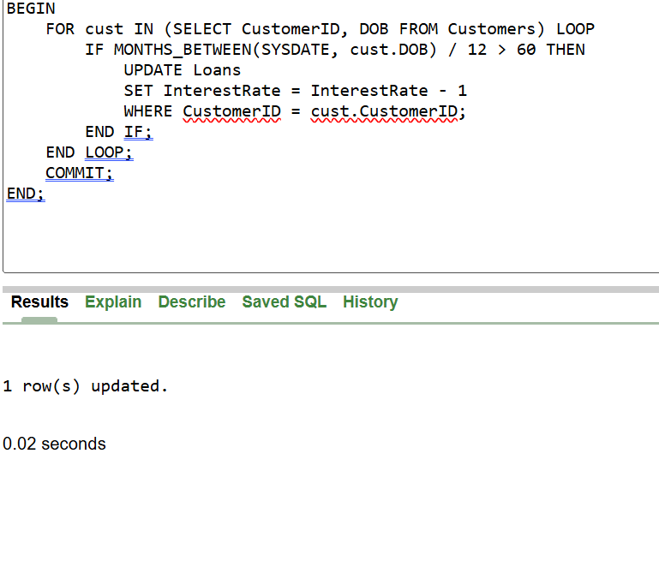

**Scenario 2:** A customer can be promoted to VIP status based on their balance.

* + **Question:** Write a PL/SQL block that iterates through all customers and sets a flag IsVIP to TRUE for those with a balance over $10,000.

ALTER TABLE Customers ADD (IsVIP VARCHAR2(5));

BEGIN

FOR cust IN (SELECT CustomerID, Balance FROM Customers) LOOP

IF cust.Balance > 10000 THEN

UPDATE Customers

SET IsVIP = 'TRUE'

WHERE CustomerID = cust.CustomerID;

ELSE

UPDATE Customers

SET IsVIP = 'FALSE'

WHERE CustomerID = cust.CustomerID;

END IF;

END LOOP;

COMMIT;

END;

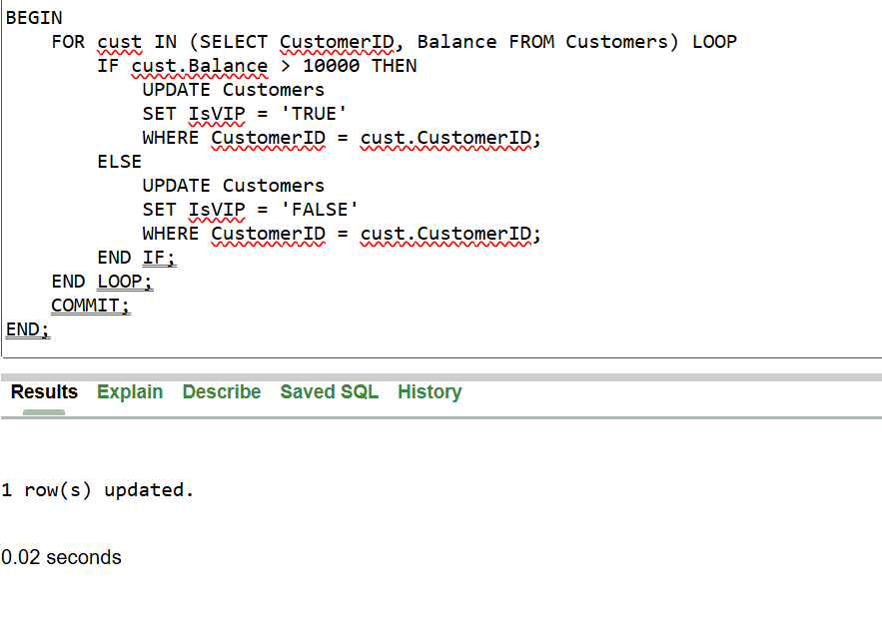

**Scenario 3:** The bank wants to send reminders to customers whose loans are due within the next 30 days.

* + **Question:** Write a PL/SQL block that fetches all loans due in the next 30 days and prints a reminder message for each customer.

BEGIN

FOR loan_rec IN (

SELECT l.LoanID, l.CustomerID, l.EndDate, c.Name

FROM Loans l

JOIN Customers c ON l.CustomerID = c.CustomerID

WHERE l.EndDate BETWEEN SYSDATE AND SYSDATE + 30

) LOOP

DBMS_OUTPUT.PUT_LINE(

'Reminder: Loan ID ' || loan_rec.LoanID ||

' for Customer ' || loan_rec.Name ||

' (Customer ID: ' || loan_rec.CustomerID ||

') is due on ' || TO_CHAR(loan_rec.EndDate, 'DD-MON-YYYY')

);

END LOOP;

END;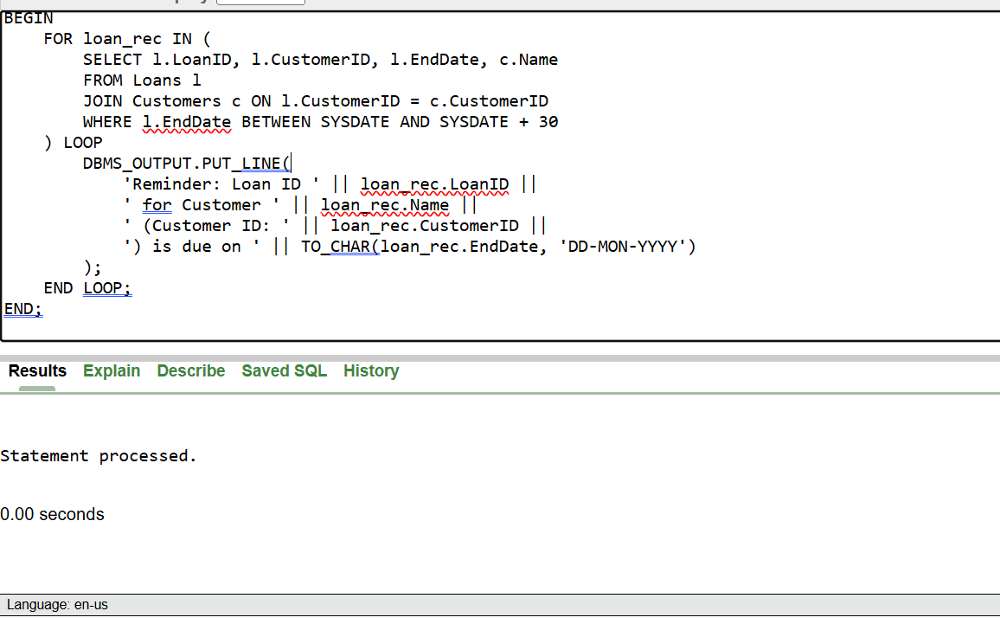

**Exercise 3: Stored Procedures**

**Scenario 1:** The bank needs to process monthly interest for all savings accounts.

* + **Question:** Write a stored procedure **ProcessMonthlyInterest** that calculates and updates the balance of all savings accounts by applying an interest rate of 1% to the current balance.

CREATE OR REPLACE PROCEDURE ProcessMonthlyInterest IS

BEGIN

-- Update balance by applying 1% interest only to Savings accounts

UPDATE Accounts

SET Balance = Balance + (Balance * 0.01),

LastModified = SYSDATE

WHERE AccountType = 'Savings';

COMMIT;

END;

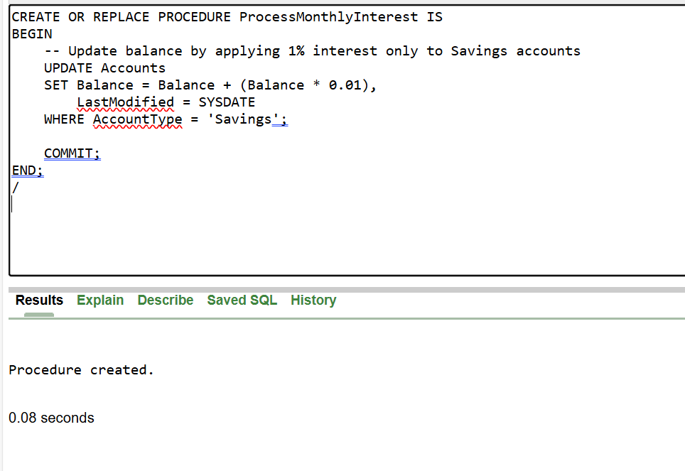

**Scenario 2:** The bank wants to implement a bonus scheme for employees based on their performance.

* + **Question:** Write a stored procedure **UpdateEmployeeBonus** that updates the salary of employees in a given department by adding a bonus percentage passed as a parameter.

CREATE OR REPLACE PROCEDURE UpdateEmployeeBonus(

p_Department IN VARCHAR2,

p_BonusPercentage IN NUMBER -- e.g., pass 10 for 10%

) IS

BEGIN

UPDATE Employees

SET Salary = Salary + (Salary * p_BonusPercentage / 100)

WHERE Department = p_Department;

COMMIT;

END;

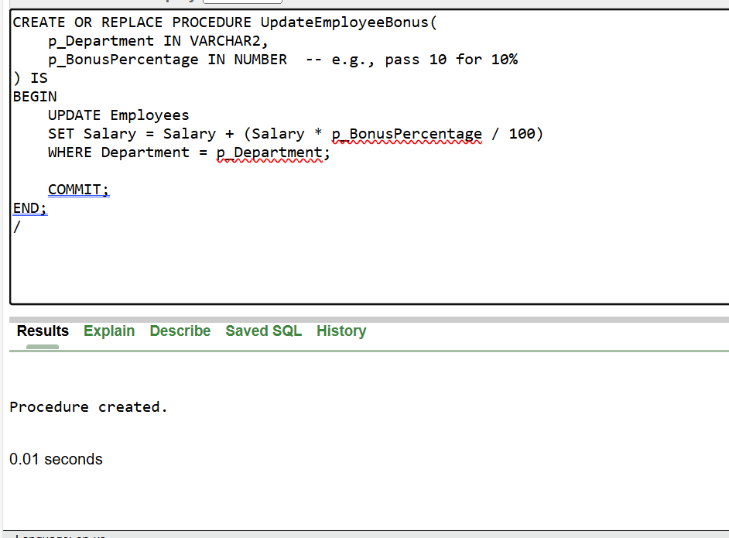

**Scenario 3:** Customers should be able to transfer funds between their accounts.

* + **Question:** Write a stored procedure **TransferFunds** that transfers a specified amount from one account to another, checking that the source account has sufficient balance before making the transfer.

CREATE OR REPLACE PROCEDURE TransferFunds(

p_FromAccountID IN NUMBER,

p_ToAccountID IN NUMBER,

p_Amount IN NUMBER

) IS

v_FromBalance NUMBER;

BEGIN

-- Get the current balance of the source account

SELECT Balance INTO v_FromBalance

FROM Accounts

WHERE AccountID = p_FromAccountID

FOR UPDATE;

-- Check if sufficient balance exists

IF v_FromBalance < p_Amount THEN

RAISE_APPLICATION_ERROR(-20001, 'Insufficient balance in the source account.');

END IF;

-- Deduct from source account

UPDATE Accounts

SET Balance = Balance - p_Amount,

LastModified = SYSDATE

WHERE AccountID = p_FromAccountID;

-- Add to destination account

UPDATE Accounts

SET Balance = Balance + p_Amount,

LastModified = SYSDATE

WHERE AccountID = p_ToAccountID;

-- Log both transactions

INSERT INTO Transactions (TransactionID, AccountID, TransactionDate, Amount, TransactionType)

VALUES (SEQ_TransID.NEXTVAL, p_FromAccountID, SYSDATE, p_Amount, 'Debit');

INSERT INTO Transactions (TransactionID, AccountID, TransactionDate, Amount, TransactionType)

VALUES (SEQ_TransID.NEXTVAL, p_ToAccountID, SYSDATE, p_Amount, 'Credit');

COMMIT;

END;

