UI/UX Testing Report - White Hole Website
The following observations and recommendations are based on the UI and UX review of the White Hole website.

UI-001
Section/Page: Platform Coverage Section
Observation: The entire section uses a yellow background and yellow cards, making the UI visually overwhelming.
Recommendation: Use white cards with subtle shadows to improve visual hierarchy and readability.
Screenshot
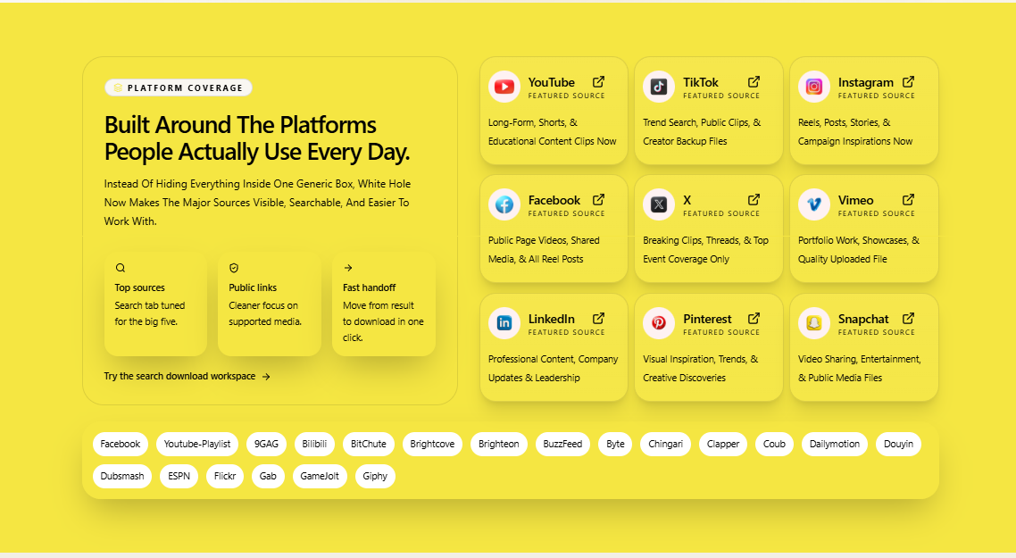

UI-002
Section/Page: Platform Tags
Observation: The pill/tag text styling does not look consistent with the overall design.
Recommendation: Improve the typography and styling of the platform tags.
Screenshot


UX-001
Section/Page: Platform Coverage Section
Observation: The section contains a text link that is easy to miss.
Recommendation: Replace the text link with a proper CTA button.
Screenshot:


UX-002
Section/Page: How It Works Section
Observation: The content overlaps with information already available on the Home page.
Recommendation:Separate home page conetnt and how itworks content.
Merge similar content into a single section/page to reduce redundancy and improve navigation.
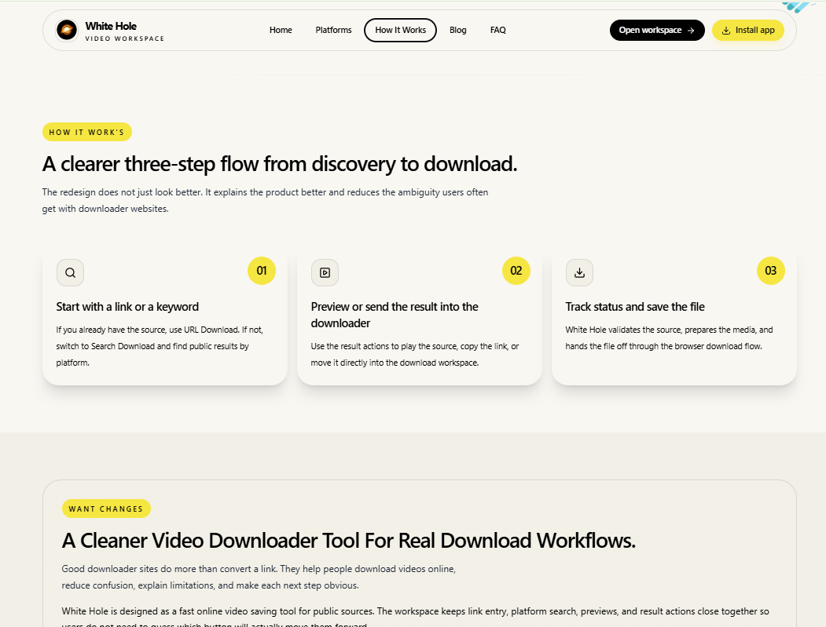

UX-003
Section/Page: Guide Section
Observation: The guide content is lengthy and difficult to scan.
Recommendation: Display the guide in bullet points or step-by-step instructions and place it near the top for better usability.
Screenshot:
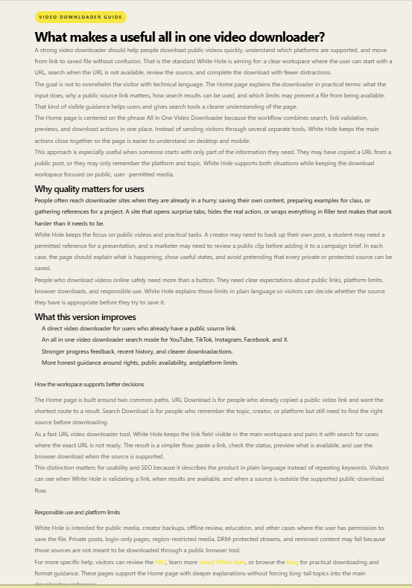

UX-004
Section/Page: FAQ Section
Observation: A dedicated FAQ page already exists, making the Home page FAQ section redundant.
Recommendation: Keep the FAQ content on a single dedicated FAQ page.

UX-005
Section/Page: Layout Hierarchy
Observation: The Trusted section would be more effective if displayed higher on the page.
Recommendation: Move the Trusted section above testimonials or informational content.

Then:
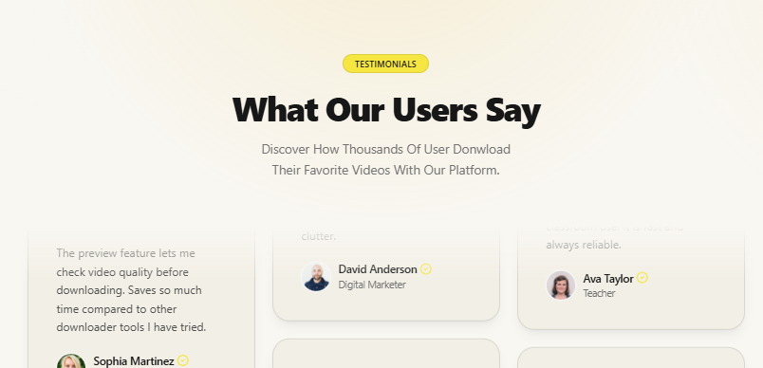

UI-003
Section/Page: Footer
Observation: The footer contains too many links, many of which are already available in the navbar.
Recommendation: Simplify the footer and include only essential information and links.
Screenshot
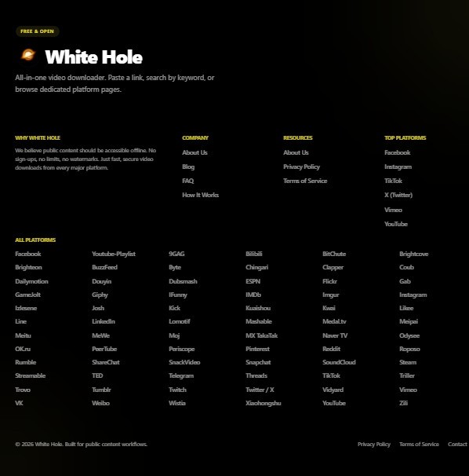

UX-006
Section/Page: Platform Downloader Pages
Observation: The platform-specific pages contain excessive textual content.
Recommendation: Use concise descriptions and bullet points to explain important information.
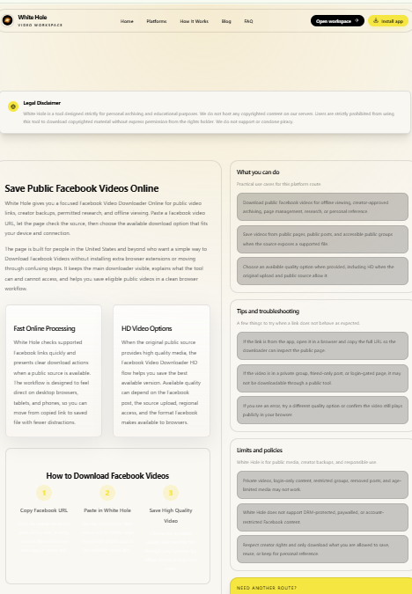

UX-007
Section/Page: Blog Page
Observation: The blog page contains too much content, reducing readability.
Recommendation: Shorten the content and improve content hierarchy.
Screenshot:
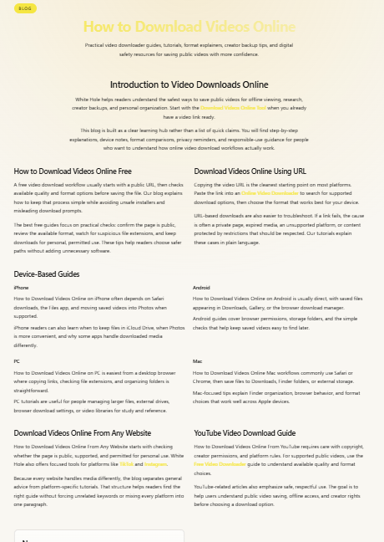

UI-004
Section/Page: Blog Page - New Card
Observation: The New card is visually unclear and easy to overlook.
Recommendation: Place it near the top of the page and improve its visual design to make it more noticeable.
Screenshot:


UI-019 – About Us Page (Heading Visibility)
Observation:
The main heading on the About Us page is displayed in a very light color, making it difficult to read and reducing visual accessibility.
Recommendation:
Use a darker text color with better contrast to improve readability and visual hierarchy.
Screenshot:
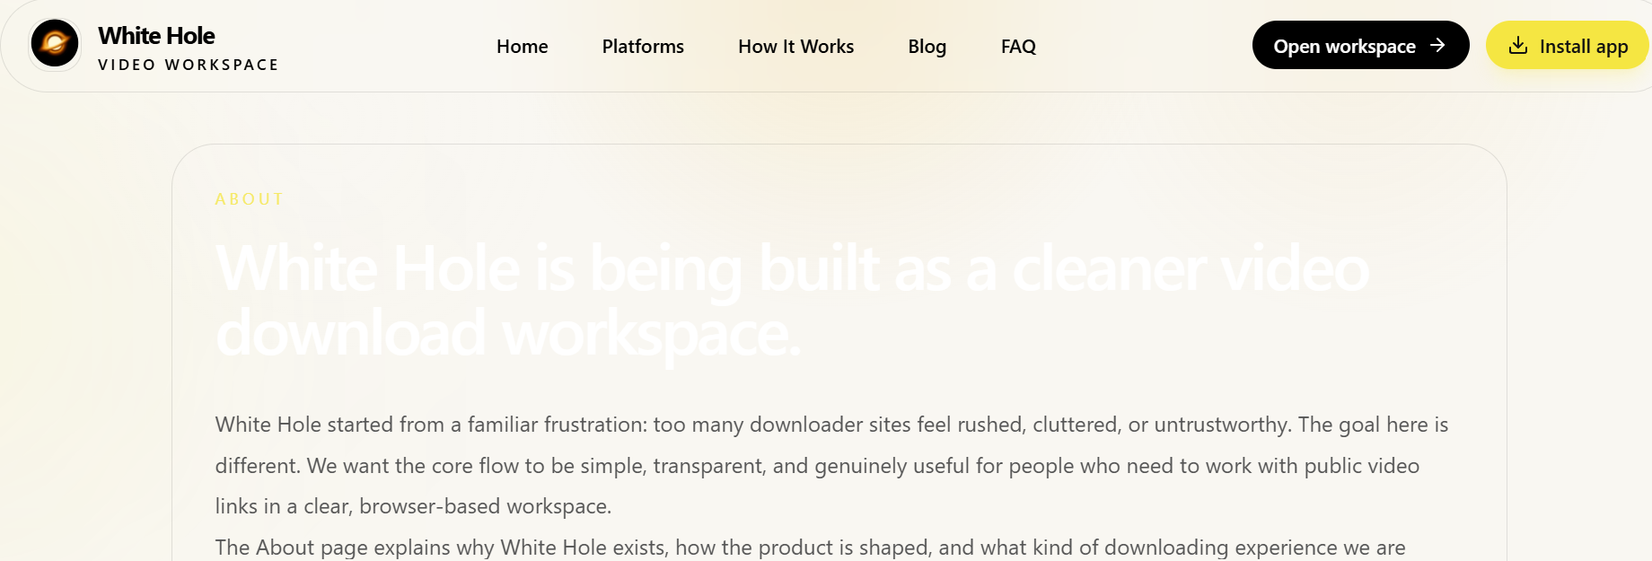

UX-009 – About Us Page Accessibility from Footer
Observation:
The About Us page is only accessible through the footer section, making it difficult for users to discover important company information.
Recommendation:
Move the About Us page link to the main navigation menu or a more prominent location so users can easily access it.
Screenshot:
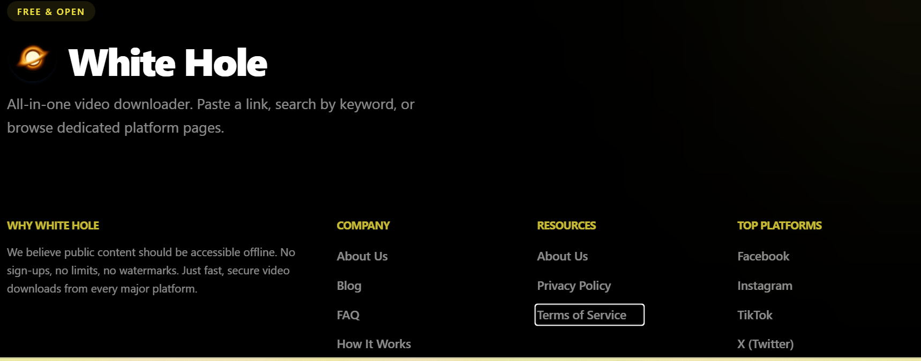

UI-020 – Privacy Policy Page (Heading Visibility)
Observation:
The Privacy Policy page heading uses a very light color that blends into the background, making the page title difficult to read.
Recommendation:
Improve the color contrast of the heading to ensure proper visibility and accessibility.
Screenshot:
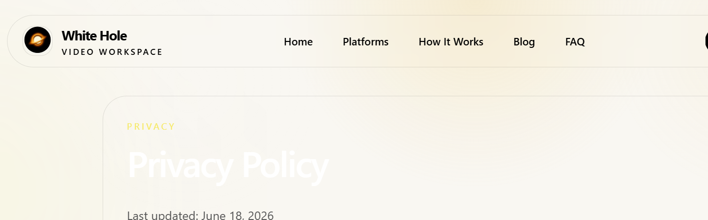

UI-021 – Terms of Service Page (Heading Visibility)
Observation:
The Terms of Service page heading is displayed with insufficient contrast against the background, reducing readability.
Recommendation:
Use a darker heading color and improve text contrast for better user experience and accessibility.
Screenshot:
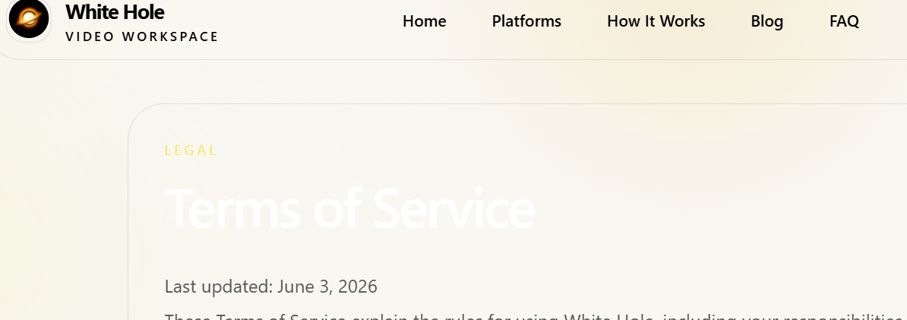

UX-010 – Footer Navigation Structure
Observation:
Important pages such as About Us, Privacy Policy, and Terms of Service are only available through the footer, which reduces their discoverability.
Recommendation:
Keep Privacy Policy and Terms of Service in the footer, but consider adding About Us to the main navigation menu as it is an important informational page for users.
Screenshot:
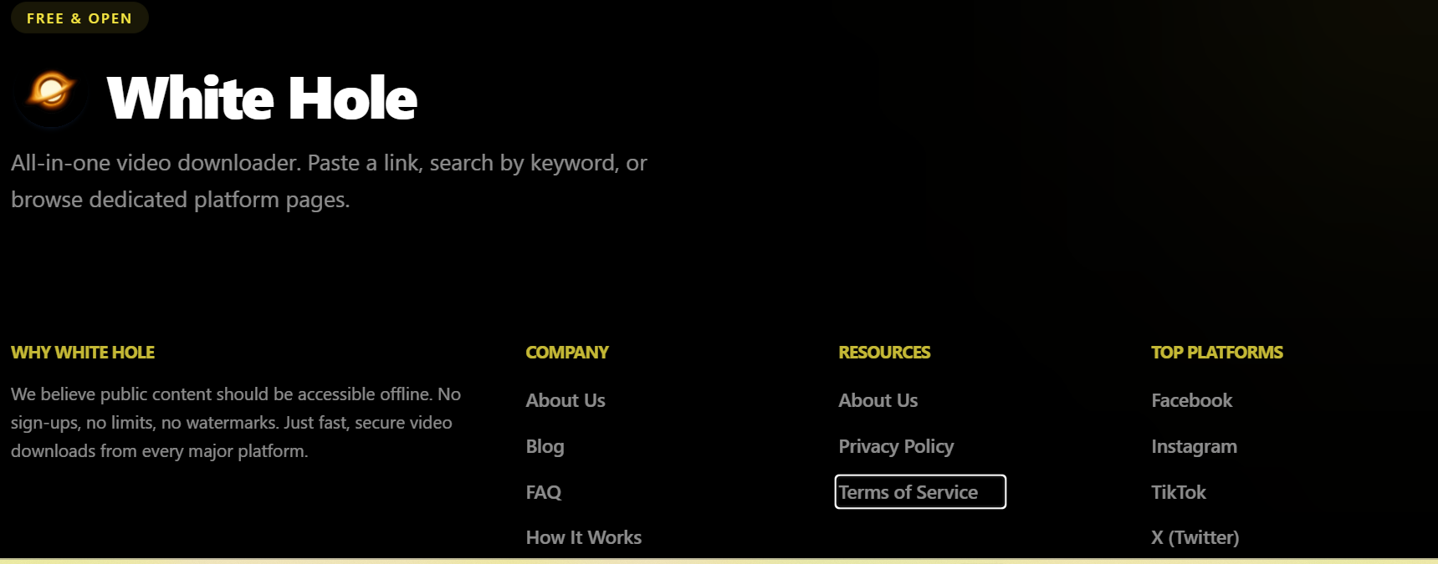

Responsiveness:
UI-012 – Mobile Responsive Design (Platform Page)
- Observation: The navigation menu on mobile devices is not scrollable on the Platforms page, making it difficult for users to access all platform links.
- Recommendation: Make the mobile navigation menu scrollable to ensure users can easily view and access all platform links.
Screenshot:
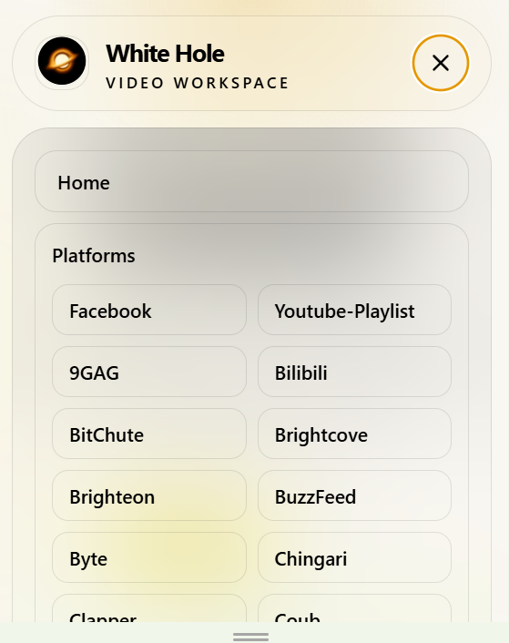

UX-008 – Mobile Responsive Design (Home Page)
- Observation: The Home page contains excessive content in the mobile view, which negatively affects readability and increases unnecessary scrolling.
- Recommendation: Reduce or reorganize the content for mobile devices by using collapsible sections, concise text, or improved content hierarchy to enhance the user experience.

UI-013 – Mobile Responsive Design (Platform Tags Section)
- Observation: The platform tags (pills) occupy excessive space in the mobile view, making the section look cluttered and visually overwhelming.
- Recommendation: Reduce the number of visible tags on mobile devices or display them in a horizontal scrollable slider/carousel. Alternatively, provide a "View All Platforms" button to improve readability and the overall visual appearance.
Screenshot:
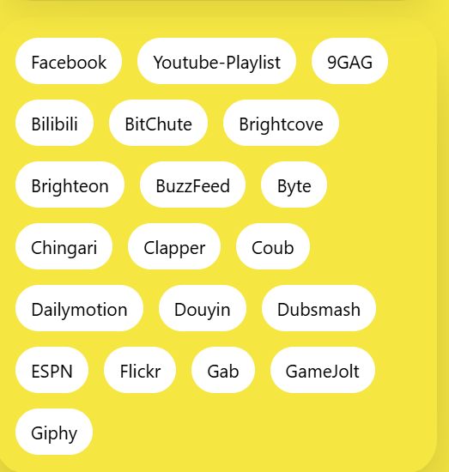

UI-014 – Mobile Responsive Design (How It Works Section)
- Observation: There is excessive empty space displayed before the "How It Works" section in the mobile view, which disrupts the visual flow of the page and requires unnecessary scrolling.
- Recommendation: Reduce the unnecessary whitespace and optimize the section spacing for mobile devices to provide a cleaner and more compact layout.
Screenshot:


UI-015 – Mobile Responsive Design (Footer Section)
- Observation: The footer contains an excessive number of platform links in the mobile view, making it appear cluttered and difficult to navigate.
- Recommendation: Reduce the number of footer links and display only essential information. Consider grouping the remaining links under expandable categories or providing a "View All Platforms" option to improve readability and usability.
Screenshot:
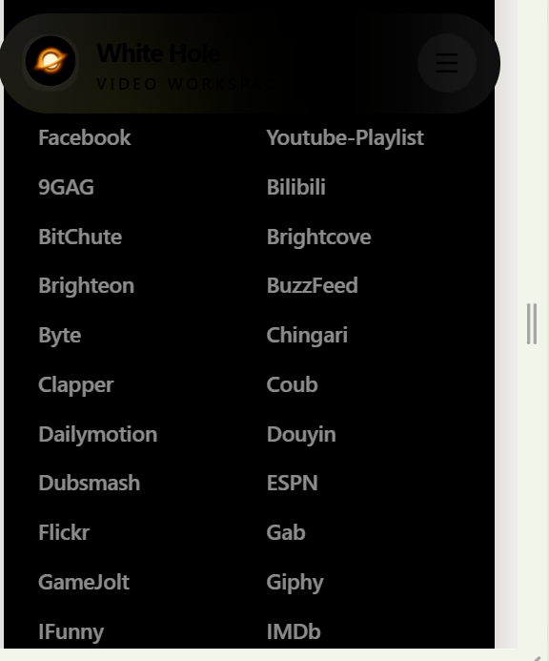

Tablet Responsive Design (Home Page Spacing)
- Observation: Excessive spacing is present between sections in the tablet view, resulting in unnecessary empty space and increased scrolling.
- Recommendation: Optimize the vertical spacing and padding between sections for tablet devices to provide a more compact and visually balanced layout.
Screenshot: 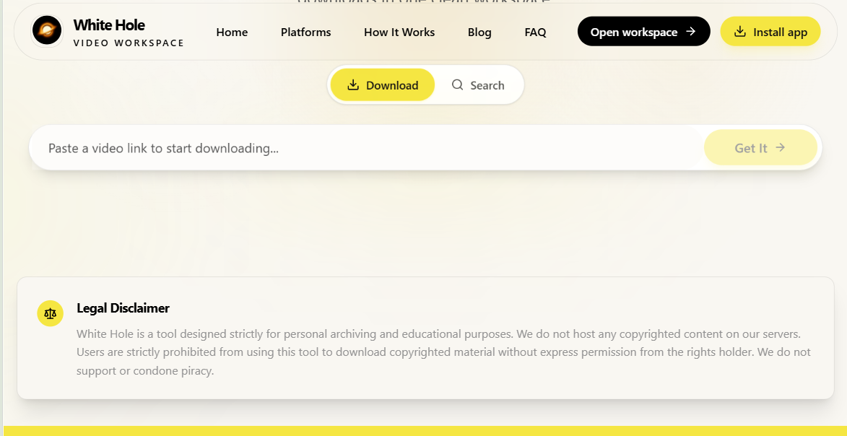

UI-017 – Tablet Responsive Design (Platform List Layout)
- Observation: The platform list is not properly displayed in the tablet view. The layout appears overcrowded and overlaps the page content, affecting readability and usability.
- Recommendation: Improve the responsive layout of the platform list for tablet devices by adjusting the grid structure and spacing to ensure proper alignment and visibility.
Screenshot:
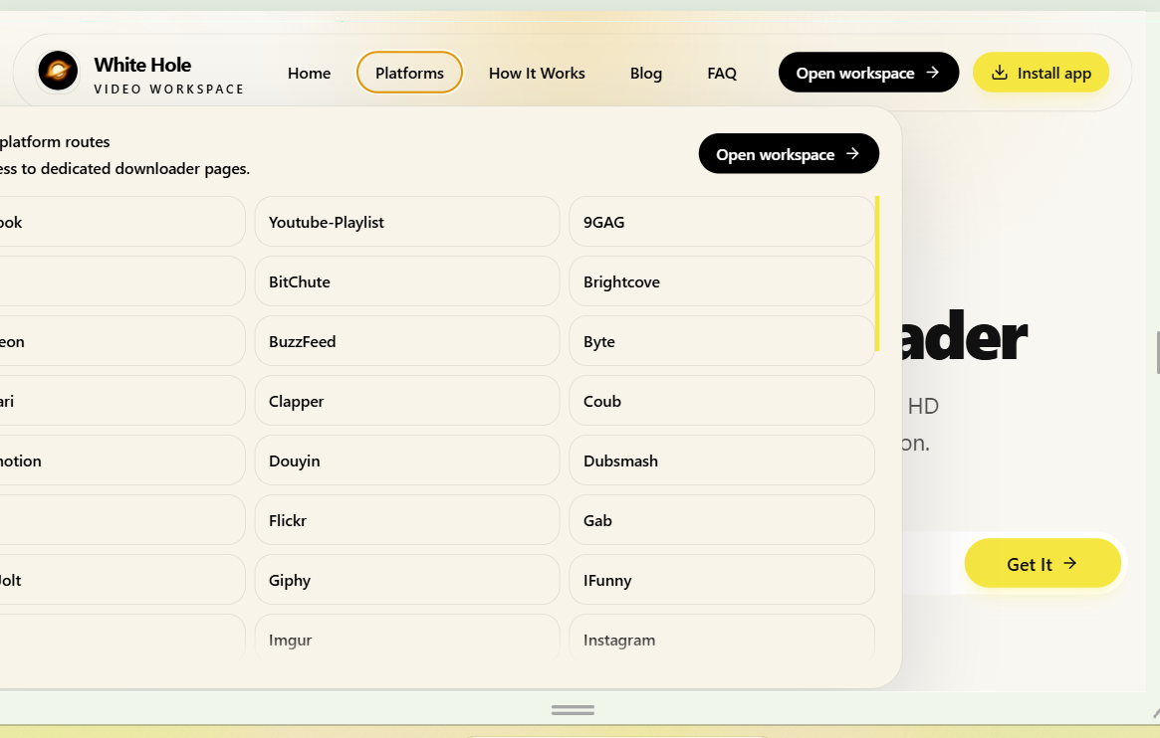

UI-018 – Tablet Responsive Design (Text Visibility)
- Observation: The instructional text in the "How to Download YouTube Playlists" section is displayed in white or a very light color, making it difficult to read against the background.
- Recommendation: Use a darker and more accessible text color to improve readability and ensure sufficient color contrast across tablet devices.
Screenshot:
