Bug Report - White Hole Website

BUG-001 - Email notification service is not configured.
Module/Page: Install App
Steps to Reproduce: Click Install App button and submit an email address.
Expected Result: Users should be able to submit their email successfully.
Actual Result: Email submission failed and displayed "Email service not configured."
Severity: Medium
Priority: Medium
Status: Open
Screenshot:
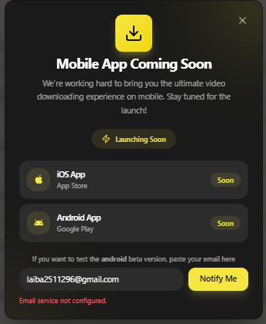

BUG-002 - Search does not return results for all valid keywords.
Module/Page: Search Functionality
Steps to Reproduce: Search using valid keywords across supported platforms.
Expected Result: Relevant search results should be displayed for all valid keywords.
Actual Result: Some valid keywords returned errors instead of results.
Severity: Medium
Priority: High
Status: Open
Screenshot:
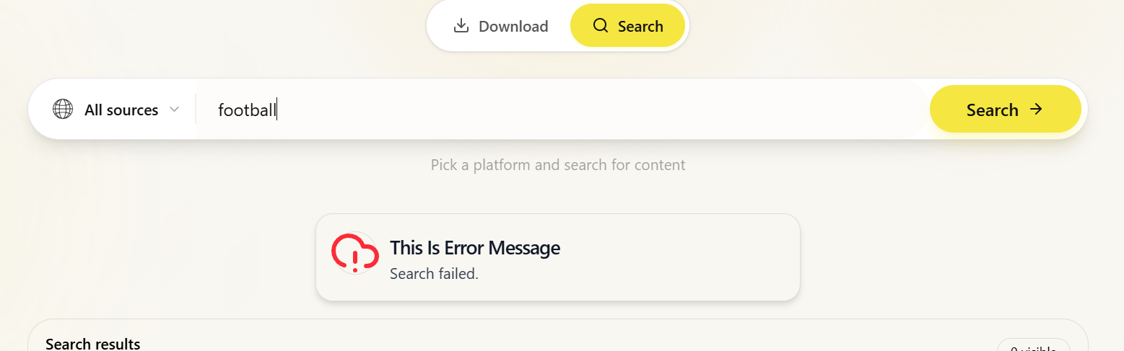

BUG-003 - "Try the search download workspace" link is not working.
Module/Page: Platform Coverage
Steps to Reproduce: Click the link in the Platform Coverage section.
Expected Result: The user should be redirected successfully.
Actual Result: The link did not respond when clicked.
Severity: Medium
Priority: Medium
Status: Open
Screenshot:
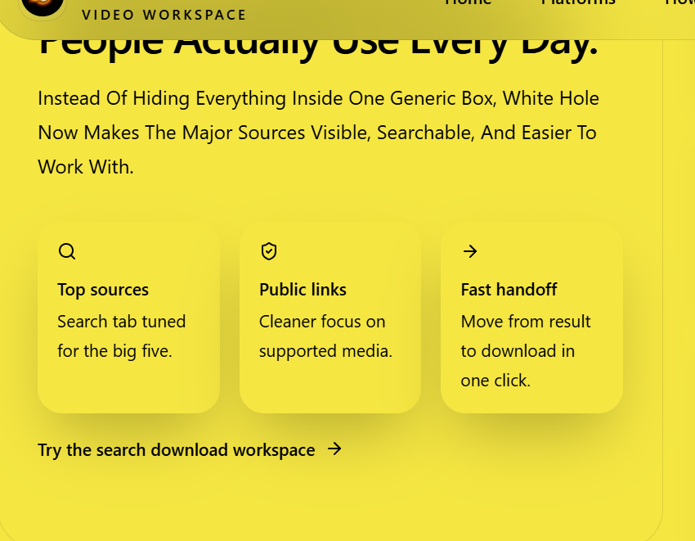

BUG-004 - "Start Now" button is not working.
Module/Page: CTA Section
Steps to Reproduce: Click the Start Now button.
Expected Result: The user should be redirected successfully.
Actual Result: The button did not respond when clicked.
Severity: Medium
Priority: Medium
Status: Open
Screenshot:
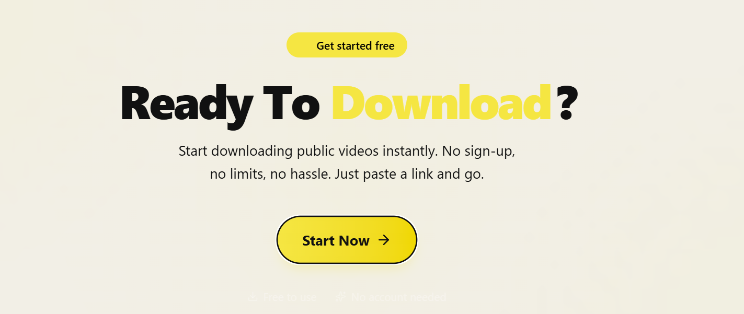

BUG-005 - YouTube Playlist downloader page is not working.
Module/Page: Platform Downloader
Steps to Reproduce: Open the YouTube Playlist downloader page.
Expected Result: The page should open successfully.
Actual Result: The downloader page did not work.
Severity: High
Priority: High
Status: Open
Screenshot
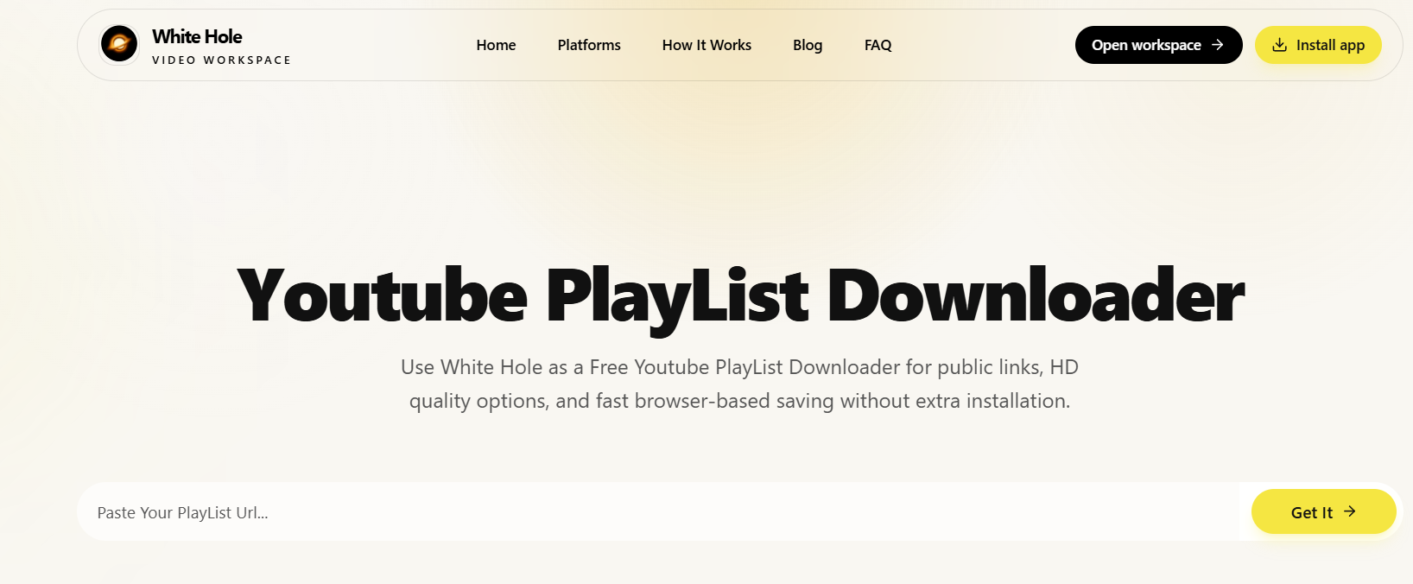

BUG-006 - Blog page loading time is slower than other pages.
Module/Page: Blog Page
Steps to Reproduce: Navigate to the Blog page.
Expected Result: The Blog page should load within an acceptable time.
Actual Result: The Blog page loaded noticeably slower than other pages.
Severity: Low
Priority: Medium
Status: Open

BUG-007 - "New" blog post redirects to an error page.
Module/Page: Blog Page
Steps to Reproduce: Click the New blog card/post.
Expected Result: The corresponding blog post should open successfully.
Actual Result: An error page was displayed after navigation.
Severity: Medium
Priority: High
Status: Open
Screenshot:
