COURSE DESCRIPTION FORM

Bahria University

INSTITUTION

BS (Computer Sciences)

PROGRAM (S) TO BE
EVALUATED

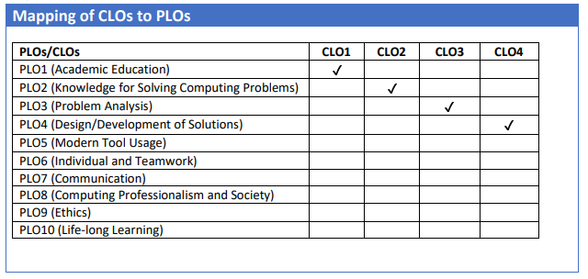
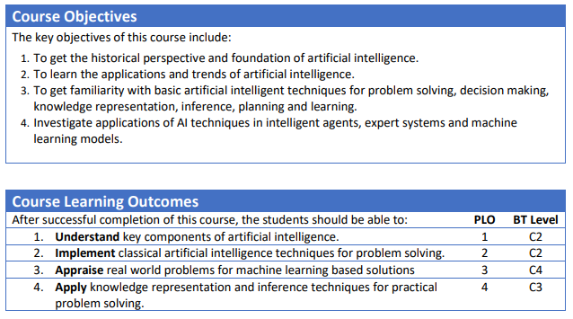

Bahria University Lahore Campus
(Department of Computer Sciences)

Course Code/number | CSC-325
Course Title/Name | Artificial Intelligence
Credit Hours/Contact hours | 3 (Theory)
Degree Program | Bachelors of Science in Computer Sciences (BSCS)
Prerequisites or Co-requisites | Discrete Mathematics
Assessment Methods and Weightage | Assignments 20%  Quiz 10%  Mid-Term Examination 20%  Final Examination 50%  Total 100
Textbook (or Laboratory Manual for Laboratory Courses) | - Artificial Intelligence: A Modern Approach 3rd edition by Stuart Russell and Peter Norvig, ISBN-13: 978-0136042594
Reference Material | - Artificial Intelligence: Structures and Strategies for Complex Problem Solving 6th edition by George F luger, ISBN-13: 978-0-321-54589-3  - Artificial Intelligence: A Modern Approach by Michael Russell and Norvig (3rd Edition)
Web Resources | http://aima.cs.berkeley.edu/
Instructor Name/  Cluster Head/  Lab Engineer | Instructor Name: Dr. Muhammad Saqib Sohail Designation: Senior Associate Professor  Status □ Regular □ Visiting  Cluster Head Name: Dr. Iram Noreen  Labs: Ms Mahreen
Course Description/Catalogue | AI has been studied for more than half a century, we still cannot make a computer that is as intelligent as a human in all aspects. However, we do have many successful applications. This is an introductory course on Artificial Intelligence. The topics may include: AI methodology and fundamentals; intelligent agents; search algorithms; game playing; supervised and unsupervised learning; decision tree learning; neural networks; nearest neighbour methods; dimensionality reduction; clustering; kernel machines; support vector machines; uncertainty and probability theory; probabilistic reasoning in AI; Bayesian networks; statistical learning; fuzzy logic.
Lecture Plan (16 Weeks) | Week # | Lecture # | Topic to be covered | Learning outcomes | Reference Text
 | 1 | 1 | Introduction to AI, Knowledge representation & Agents  What is AI? History of AI, Turing Machine,  State of art applications, AI Paradigms, Intelligent Agents, Agents and environments,  Knowledge representation & Structure of Agents, types of agents |  | Class notes
 | 2 | 2 | Problem Solving and problem representation, Problem Solving by Searching  Problem formulation, goal formulation, trees, graphs, state space, toy problems, Breadth first search, Depth first search |  | Class notes
 | 3 | 3 | Problem Solving by Searching (continued)  Uniform cost search, Bi-directional search, space time complexity of search algorithms |  | Class notes
 | 4 | 4 | Problem Solving By Heuristic Search  Best first search, Hill climbing, Beam search, A*, IDA*, space time complexity of search algorithms |  | Class notes
 | 5 | 5 | AI for Game Playing  Mini-Max, Alpha Beta Pruning |  | Class notes
 | 6 | 6 | Case studies:  8 Queens Problem, 8 Puzzle Problem, Space & Time Complexity |  | Class notes, weblinks
 | 7 | 7 | Introduction to Machine learning  What is machine learning, Supervised Learning, Un Supervised Learning, semi supervised, reinforcement learning, classification vs regression |  | Class notes, weblinks
 | 8 | 8 | Introduction to Machine learning (continued)  Components of a machine learning problem, the ML cycle, features, labels, model structure, loss function |  | Class notes, weblinks
 | 9 | Mid-term Exam
 | 10 | 9 | Optimization Problem  Gradient descent, simulated annealing,  probability theory |  | Class notes, weblinks
 | 11 | 10 | Performance metrics  Confusion Matrix, Accuracy, Precision, Recall (Sensitivity or TPR), Specificity (True Negative Rate, TNR), False Positive Rate (FPR), F1-Score, Matthews Correlation Coefficient (MCC), Area under the receiver operating curve (AUROC), Precision recall curve, mean squared error, mean absolute error |  | Class notes, weblinks
 | 12 | 11 | Perceptron learning algorithm  Neurons, perceptron Model, Artificial Neural Networks, Feedforward & Back propagation, Different activation functions, Learning and Weight Adjustment  A simple ML problem |  | Class notes, weblinks
 | 13 | 12 | ML training  Train-test split, external validation, Overfitting, K-fold cross validation, Data leakage |  | Class notes, weblinks
 | 14 | 13 | The Classification Case Study  Machine Learning Libraries, Learning a classifier from training data in a supervised setting, Linear classifier, ID3 Decision Trees induction algorithm |  | Class notes, weblinks
 | 15 | 14 | Introduction to Recurrent Neural Network and Convolutional Neural Network |  | Class notes, weblinks
 | 16 | 15 | Introduction to Natural Language Processing, Deep Learning, Reinforcement Learning |  | Class notes, weblinks
 | 17 | 16 | Large language models, Gen AI, modern .ai tool |  | Class notes, weblinks
 | 18 | Final Exam

Assignments/ Projects and quizzes Plan | Week # | Assignment No. | Quiz No. | Assignment due date | Assignment/Project Quiz Date | Result Date of Assignment/Project/Quiz
 | 1
 | 2 | Assignment-1
 | 3 | Assignment-2 |  | Assignment-1
 | 4 |  | Quiz-1 |  |  | Assignment-1, Quiz 1
 | 5 |  |  | Assignment-2
 | 6 |  |  |  |  | Assignment-2
 | 7 |  | Quiz-2 |  |  | Quiz-2
 | 8
 |  | Mid Term
 | 9
 | 10 |  | Quiz-3 |  |  | Quiz-3
 | 11 | Assignment-3
 | 12 | Assignment-4 |  |  |  | Quiz-3
 | 13 |  | Quiz-4 | Assignment-3 |  | Quiz 4, Assignment-4
 | 14 |  |  | Assignment-4
 | 15
 | 16
 |  | Final Term
Lab Engineer Name: Ms Mahreen Tariq

Instructor Signature ________________ Date 21 January, 2025

