
Bahria University Lahore Campus
Department of Computer Sciences

Course Code/number | CEL-120
Course Title/Name | Digital Logic Design
Credit Hours/Contact hours | 1
Degree Program | Bachelors of Science in Computer Sciences (BSCS)
Prerequisites or Co-requisites | EEN-210 Basic Electronics
Assessment Methods and Weightage | Lab Journal 10  Lab Evaluation 20  Project 20  Mid Term 20  Final Term 30  Total 100
Textbook (or Laboratory Manual for Laboratory Courses) | Digital Design 5th Edition by Moris Mano  ISBN-13: 978-0-13-277420-8
Reference Material ( With Edition, ISBN#) | Digital Logic Design Lab Manual
Web Resources/ URL (if any)
Instructor Name/Cluster Head/Subject Expert | Instructor Name: Miss. Munaza Sher Status □ Regular □ Visiting  Lab Engineer: Muhammad Umar Nasir  Cluster Head Name: Dr. Irum Noreen
Course Aims: | The aim of this course is to familiarize the students with number system, logic gates, combinational logic analysis, functions of combinational logic latches and flip flops. Another aim of this course is to make base for the computer architecture and organization.
Course Objectives | Following are the objectives of this course:  - Introduce the concept of digital and binary systems  - Be able to design and analyze combinational logic circuits  - Be able to design and analyze sequential logic circuits  - Understand the basic software tools for the design and implementation of digital circuits and systems
Course Learning Outcomes | 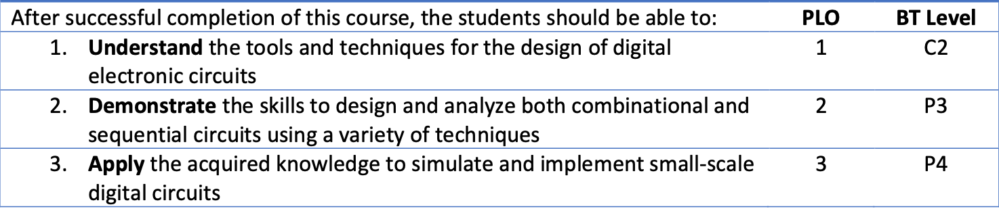
Course Description/Catalogue | This module introduces the concepts of the design and implementation of digital circuits. Laboratory experiments will be used to reinforce the theoretical concepts discussed in lectures. The lab experiments will involve the design and implementation of digital circuits.
Mapping of CLO’s to PLO’s | 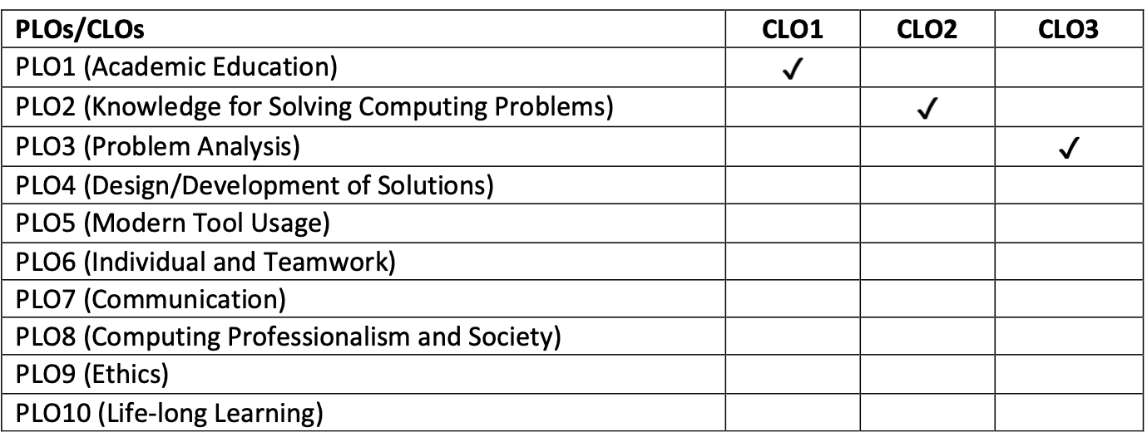
Lab Plan (16 Weeks) | Week # and Date | Lecture/ Contact Hour # | Topic to be covered |  | Learning outcomes | Reference Text
 | Lab 1 | 3 | Introduction of DLD Trainer & Bread board |  | Familiarization with the DLD trainer and its operating phenomena | Lab Manual 1
 | Lab 2 | 3 | Switch and logic |  | Understand the function of switch and relay | Lab Manual 2
 | Lab 3 | 3 | Basic & combinational logic gates |  | Understand the concept of basic & combinational logic gates and verify their outputs | Lab Manual 3
 | Lab 4 | 3 | Complex logical circuits |  | Construct complex logical circuits and verify their outputs | Lab Manual 4
 | Lab 5 | 3 | AND-OR-INVERTER Gate Circuit |  | Able to construct complex circuits using AND-OR-NOT gates | Lab Manual 5
 | Lab 6 | 3 | Logic gates using switches |  | Construct logic gates using switches and verify their outputs | Lab Manual 6
 | Lab 7 | 3 | Half and full adder circuit |  | Able to construct half and full adder circuit and also verify its output | Lab Manual 7
 | Lab 8 | 3 | Mid-term Examination | To evaluate the concepts of Switch & Logic, Basic & Combinational Logic Gates, Complex Logic Circuits, AND-OR-Inverter Gate Circuits, Logic gates using switches and Half & Full Adder Circuits
 | Lab 9 | 3 | Half and full subtractor circuit |  | Able to construct half and full subtractor circuit and also verify its output | Lab Manual 9
 | Lab 10 | 3 | Comparator circuit |  | Able to construct comparator circuit and also verify its output | Lab Manual 10
 | Lab 11 | 3 | Decoder circuit |  | Able to construct 2 to 4 decoder circuit and also verify its output | Lab Manual 11
 | Lab 12 | 3 | Multiplexer |  | Able to construct multiplexer circuit and also verify its output | Lab Manual 12
 | Lab 13 | 3 | S-R Latch and S-R flip-flop |  | Understand the operation of S-R Latch and S-R flip-flop | Lab Manual 13
 | Lab 14 | 3 | D flip-flop |  | Understand the operation of D flip-flop | Lab Manual 14
 | Lab 15 | 3 | J-K flip-flop |  | Understand the operation of J-K flip-flop | Lab Manual 15
 | Lab 16 | 3 | Final Examination | To evaluate the concept of Half & Full Subtractor, Multiplexer, Decoder, Comparator, Latches & Filip Flops.

