
Bahria University Lahore Campus
Department of Computer Sciences

Course Code/number | CSC-330
Course Title/Name | Operating System
Credit Hours/Contact hours | (3+1) Credit hours; contact hours(3+3)
Degree Program | Bachelors of Computer Sciences (BSCS)
Prerequisites or Co- requisites | Computer Architecture & Organization
Assessment Methods and  Weightage | Quizzes 10  Assignments/Projects 20  Mid-Term Examination 20  Final Examination 50  Total 100
Textbook(or Laboratory Manual for Laboratory Courses) | 1. Operating Systems Concepts, 10th edition, Abraham Silberschatz, Peter Baer Galvin, Greg Gagne; Wiley, ISBN 978-1-118-06333-0, 2013.
Reference Material | 1. Modern Operating Systems, 4th edition, Andrew S. Tanenbaum; Prentice Hall, ISBN 978-0133591620, 2014..  2. Operating Systems: Internals and Design Principles, 8th edition, William Stallings; Prentice Hall, ISBN-10: 0133805913, 2014.
Web Resources | http://codex.cs.yale.edu/avi/os-book/OS8/os8c/slide-dir/  http://www.personal.kent.edu/~rmuhamma/OpSystems/os.html  http://www.tutorialspoint.com/operating_system/index.htm  http://faculty.salina.k-state.edu/tim/ossg/Introduction/OSworking.html
Instructor Name/Cluster  Head/Subject Expert | Instructor Name: Muhammad Umar Nasir Designation: Senior Lecturer Status ●Regular  Cluster Head Name: Dr. Iram Noreen  Subject Expert Name: Dr. Muhammad Asim Qureshi

Course Aims | - General understanding of working of how computer and Operating system works.  - Purpose, structure and functions of operating systems  - Illustration of key OS aspects by examples
Course Objectives | - To understand the internal structure of modern operating systems.  - To understand about different kinds of interrupts.  - To understand what a process is and how processes are created, executed and terminated.  - To understand about threads and various CPU scheduling algorithms.  - To understand about Process synchronization and deadlocks and memory management.
Course Learning Outcomes | 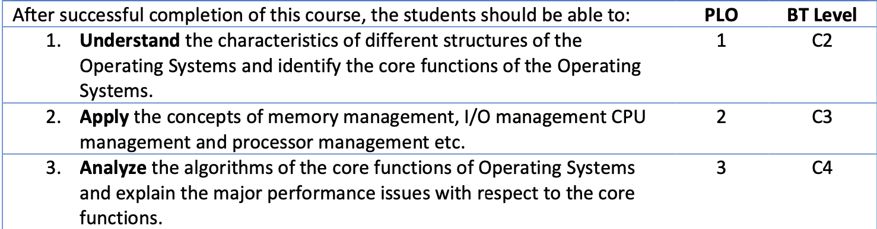
Course  Description/Catalogue | Introduction to operating systems concepts, process management, memory management, virtual memory, input-output, job scheduling, deadlocks, interrupt structures.
Mapping of CLO’s to PLO’s | 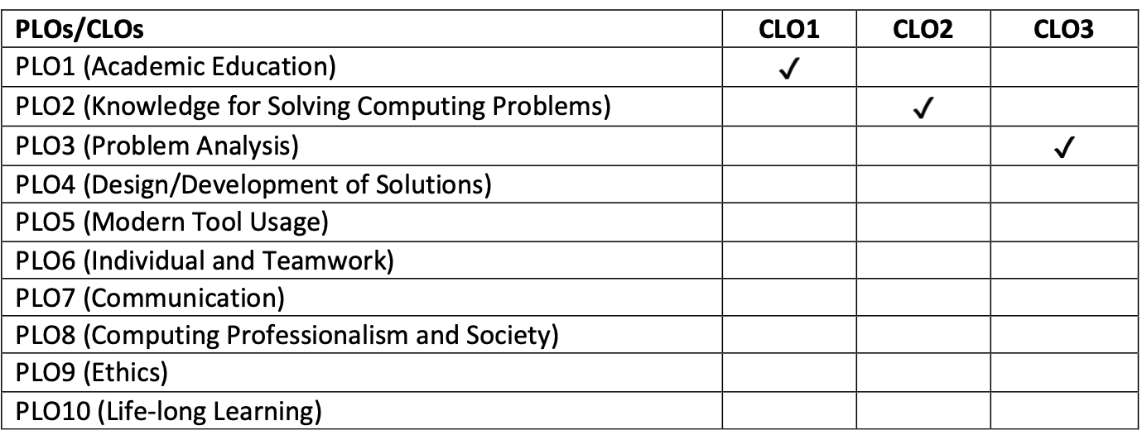

Lecture Plan (16 Weeks) | Week # | Lecture  /Hour # | Topic to be covered | Learning outcomes | Reference Text
 | 1 | 1 | Introduction to Operating systems | Course structure and plan. | Handouts
 |  | 2 | Operating system overview Computer system organization | Understand the basic organization of modern operating systems. | Silberschatz ch-1
 |  | 3 | Device controller, Device drivers | To learn about various devices and device controllers and how they operate. | Silberschatz ch-1
 | 2 | 1 | Computer System structure  Components of a computer system | Students will build an understanding of computer system structure. | Silberschatz ch-1
 |  | 2 | Direct Memory Access and Storage Device Hierarchy | Students will learn about I/O Structure, how the Direct memory access works. | Silberschatz ch-1
 |  | 3 | Software interrupts, hardware interrupts, system calls | Students will learn about various kinds of interrupts works | Silberschatz ch-1  Handouts
 | 3 | 1 | Operating system services, system calls | Learning about the services provided to the user and system programs by OS. | Silberschatz ch-2  Handouts
 |  | 2 | Types of system calls, parameter passing and system programs | Understanding types of system calls according to OS, functionalities provided by system programs. | Silberschatz ch-2  Handouts
 |  | 3 | Simple structure, layered micro kernel and Modular approach | Students will learn the structure of various OS such as DOS, Unix, Solaris, and Linux structure. | Silberschatz ch-2  Handouts
 | 4 | 1 | Process Concept | To give students an overview of a Process. | Silberschatz ch-3  Handouts
 |  | 2 | Process Control Block  2-state and 5-state Process Model | Learn about 2 –state process model and the need for the 5- state process model. | Silberschatz ch -3  Handouts
 |  | 3 | Features of Process: Process creation | Learn about how processes are created, i.e. fork and exec system calls. | Silberschatz ch-3  Handouts
 | 5 | 1 | Process creation examples | Students will understand with the help of programs in C to create multiple process from a single process. | Silberschatz ch-3  Handouts
 |  | 2 | Process execution and termination. | Learn about how processes will execute after creation and system calls required to terminate a process. | Silberschatz ch-3  Handouts
 |  | 3 | Inter Process communication overview | Students will learn about cooperating and independent processes. | Silberschatz ch-3  Handouts
 | 6 | 1 | Shared memory approach and its implementation | Students will get an in-depth knowledge of various inter process communication mechanisms and their implementation. | Silberschatz ch-3  Handouts
 |  | 2 | Message Passing approach  Link implementation and issues | How the links are established for message passing approach. | Silberschatz ch-3  Handouts
 |  | 3 | Pipes and Examples of IPC systems Unix/Linux systems. | Learn about various Linux system calls used for interprocess communication. | Silberschatz ch-3  Handouts
 | 7 | 1 | CPU Scheduling  Basic Concepts | Students will learn about various CPU scheduling algorithms. | Silberschatz ch-6  Handouts
 |  | 2 | Preemptive scheduling  Non preemptive scheduling | Students will get an insight into preemptive and non-preemptive Scheduling algorithms and their implementation. | Silberschatz ch-6  Handouts
 |  | 3 | Scheduling Algorithms:  First Come First Serve, SJF | To learn about first scheduling algorithm and how it operates. | Silberschatz ch-6  Handouts
 | 8 | 1 | Shortest Remaining Job First Algorithm (SRJF)  Priority Scheduling | To learn about second scheduling algorithms, working and implementation. | Silberschatz ch-6  Handouts
 |  | 2 | Round Robin scheduling Algorithm, Multilevel queue scheduling  Multilevel feedback queue scheduling. | Students will learn the criteria and operation of RR scheduling algorithm & implementation also working in multiprogramming systems. | Silberschatz ch-6  Handouts
 |  | 3 | User level threads vs. kernel level threads. | Students will be able to differentiate various user level threads and kernel level threads. | Silberschatz ch-4
 | Mid-Semester Exam
 | 9 | 1 | Threading models: one to one, many to many and many to one, libraries and functions, thread creation and execution. | Students will learn about library and their functions which are used to create and manage threads. | Silberschatz ch-4
 |  | 2 | Threading examples compiling and running multithreaded programs on Linux. | Learn about how to write, compile and run a multithreaded program in C on Linux operating system. | Silberschatz ch-4
 |  | 3 | Thread termination and issues with threads. | Understanding of system calls for thread termination and implementation of signals. | Silberschatz ch-4
 | 10 | 1 | Background of Process Synchronization,  The Critical-Section Problem.  Peterson’s Solution  Synchronization Hardware | In-depth understanding of Process Synchronization. | Silberschatz ch-5
 |  | 2 | Mutex Locks, Semaphores  Classic Problems of Synchronization Monitors. | An understanding of Synchronization Problems. | Silberschatz ch-5
 |  | 3 | Synchronization Examples  Alternative Approaches | An understanding of Synchronization Examples | Silberschatz ch-5
 | 11 | 1 | Introduction to Deadlocks  System Model  Deadlock Characterization  Methods for Handling Deadlocks | Students will learn basics of Deadlocks | Silberschatz ch-7
 |  | 2 | Resource Allocation Graphs | To understand the resource utilization and acquirement of processes. | Silberschatz ch-7
 |  | 3 | Deadlock Prevention,  Deadlock Avoidance,  Deadlock Detection | Handle the system in a way that processes execute in a sequence so that system contains no deadlock. In a case of deadlock recovery algorithm is also produced. | Silberschatz ch-7
 | 12 | 1 | Recovery from Deadlock, Dining Philosophers problem | To learn about of how to recover from deadlock situation in computer system. | Silberschatz ch-7
 |  | 2 | Deadlock Avoidance:  Bankers’ algorithm and safety algorithm | Students will learn about various algorithms like banker’s algorithm of how to avoid dead locks in the system. | Silberschatz ch-7
 |  | 3 | Introduction to Memory Management | Students will learn different memory management techniques. | Silberschatz ch-8
 | 13 | 1 | Memory allocation techniques | Students will learn how memory is allocated with the help of different techniques. | Silberschatz ch-8
 |  | 2 | Fragmentation, Process in size and Multiprogramming issues | To understand the contiguous memory allocation issues. | Silberschatz ch-8
 |  | 3 | Swapping, Base Address, Limit Address | To understand the high and low priority concepts of processes, reading data from main memory. | Silberschatz ch-8
 | 14 | 1 | Paging and mapping, Logical Addresses and Physical Addresses | Students will learn about paging and framing memory management scheme and translation of pages into frames. | Silberschatz ch-8
 |  | 2 | Segmentation | To understand the segmentation concept which is an important memory management technique. | Silberschatz ch-8
 |  | 3 | Virtual memory | Students will understand the concept of virtual memory. | Silberschatz ch-9
 | 15 | 1 | Demand paging, Page Fault | A detailed discussion on demanding a complete process with respect to the demand of certain pages. The reasoning behind page fault and its solution. | Silberschatz ch-9
 |  | 2 | Page replacement algorithms, | Students will understand in detail different page replacement algorithms. | Silberschatz ch-9
 |  | 3 | Thrashing | Understanding the concept of thrashing by considering the relevance of multiprogramming with CPU utilization | Silberschatz ch-9
 | 16 | 1 | Overview of Mass Storage Structure | An introduction to Storage Structure. | Silberschatz ch-10
 |  | 2 | Disk Scheduling algorithms | An introduction to basic Storage management and Scheduling algorithms. | Silberschatz ch-10
 |  | 3 | Project Evaluation and Revision
 | Final Exam

